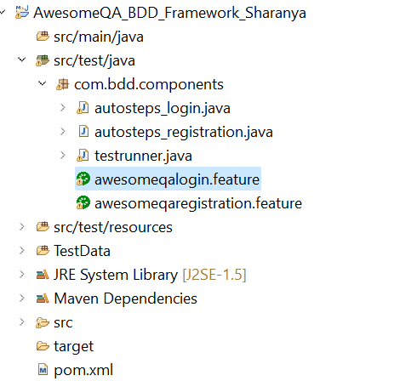

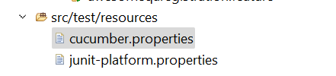

cucumber.properties

cucumber.publish.quiet=true

LoginFeature.feature:

@Test1010

Feature: AwesomeQA Homepage Functionality

@testaqa1

Scenario Outline: awesomeqa login functionality

Given The user is in home page of awesomeqa app

When The user enters the username

And The user enters the password

And The user clicks on Login button

Then The user should be successfully login in awesomeqa app

@tag2

Scenario Outline: awesomeqa login functionality

Given The user is in home page of awesomeqa app

When The user enters the username

Stepsdefinition:

/***************************************

* Author:Gayatri

* Date of creation: 17th Aug 2024

*Scenario-1 : Create a demo to display multiple inheritance

* in java.

* Training Code - 240 Testing

* Room No - 5

*

*

****************************************************/

package com.bdd.components;

import java.io.FileNotFoundException;

import java.io.FileReader;

import java.io.IOException;

import java.util.Properties;

import org.junit.Assert;

import org.openqa.selenium.By;

import org.openqa.selenium.WebDriver;

import org.openqa.selenium.firefox.FirefoxDriver;

import io.cucumber.java.en.And;

import io.cucumber.java.en.Given;

import io.cucumber.java.en.Then;

import io.cucumber.java.en.When;

public class autosteps_login {

WebDriver wd;

Properties P;

FileReader f;

// This is Given annotation to launch the application

@Given("The user is in home page of awesomeqa app")

public void homepage() throws IOException{

// create the browser instance

wd = new FirefoxDriver();

wd.get("https://awesomeqa.com/ui/index.php?route=account/login"); // app invoked

P = new Properties();

f = new FileReader("TestData/login.properties");

P.load(f);

}

@When("The us"

+ "er enters the username")

public void enter_username() {

wd.findElement(By.xpath("//input[@id=\"input-email\"]")).sendKeys(P.getProperty("unm"));

}

@And("The user enters the password")

public void enter_password() {

wd.findElement(By.xpath("//input[@id=\"input-password\"]")).sendKeys(P.getProperty("pwd"));

}

@And("The user clicks on Login button")

public void click_login() {

wd.findElement(By.xpath("//*[@value=\"Login\"]")).click();

}

@Then("The user should be successfully login in awesomeqa app")

public void validate_login() {

System.out.println("Loggedin successfully ");

}

}

TestRunner.java

**package** com.bdd.components;

**import** **static** org.junit.Assert.*;

**import** org.junit.Test;

**import** org.junit.runner.RunWith;

**import** io.cucumber.junit.Cucumber;

@RunWith(Cucumber.**class**)

**public** **class** testrunner {

}