Sample script to read the test data from gherkins file

@Then("^Then perform (.*) and (.*) field to perform login.$")

**public** **void** perform_username_and_password_and_click_to_login_button(String username, String password) **throws** InterruptedException

{

Thread.*sleep*(3000);

driver.findElement(By.xpath("//input[@class=\\\"input_error form_input\\\"])[1]")).sendKeys(username);

Thread.*sleep*(3000);

driver.findElement(By.xpath("//input[@class=\\\"input_error form_input\\\"])[2]")).sendKeys(password);

Thread.*sleep*(3000);

driver.findElement(By.xpath("/input[@class=\\\"submit-button btn_action\\\"]")).click();

Thread.*sleep*(3000);

}

Topics :

* Load the test data in gherkins file and use in test script
* Parameterization-BDD
* Cucumber with POM & Junit
* Cucumber with POM & TestNG
* Cucumber Hooks

Template Code:

To capture screenshots:

File src = ((TakesScreenshot) wd).getScreenshotAs(OutputType.***FILE***);

Files.*copy*(src, **new** File("./Screenshots/regsfunction.png"));

plugin={"json:target/JSONReports","pretty","html:target/HtmlReports"},

plugin={"pretty","html:target/HtmlReports/firstexecution.html"},

Extent Reports :

Global :

ExtentReports ext1; // class

ExtentTest test;//interface

Inside annotation presetup:

ExtentHtmlReporter testreport = **new** ExtentHtmlReporter(".//ReportsHtm//testsubmit1.html");

ext1=**new** ExtentReports();

ext1.attachReporter(testreport);

test = ext1.createTest("user.dir", "test");

Inside annotation @test

test.log(Status.***PASS***,"The app is invoked");

@aftertest

ext1.close();

ext1.flush();

Dependency :

<dependency>

<groupId>com.aventstack</groupId>

<artifactId>extentreports</artifactId>

<version>3.0.0</version>

</dependency>

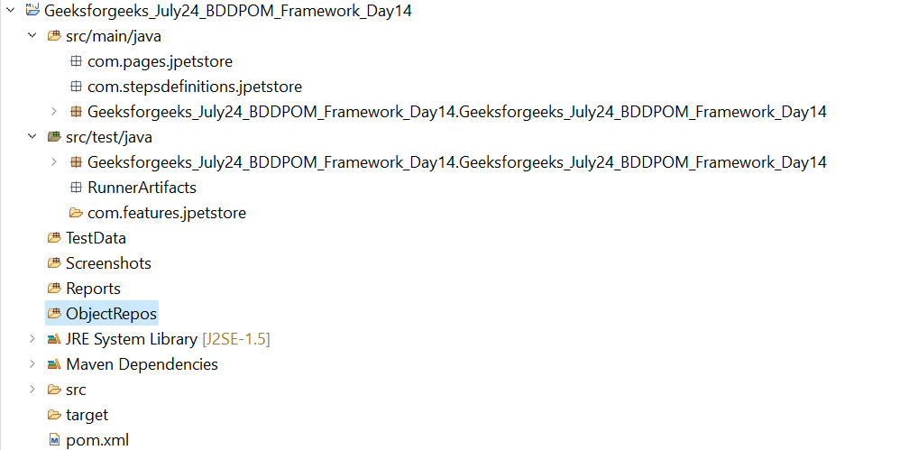

BDD Cucucmber – POM – Junit / TestNG

Locators

HtmlReports

Screenshots

TestData

Com.pages.awesomeqa

Com.Stepdefinitions.awesomeqa

TestRunner [Source Folder]

Com.Awesomeqa.TestFeatures

Src/test/java

Src/main/java

AwesomeQA