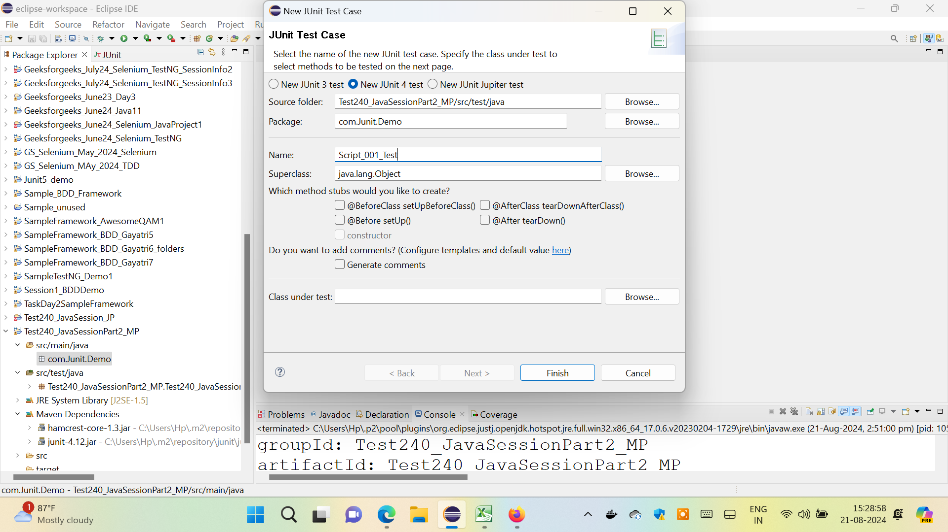

@Test

**public** **void** test() {

*fail*("Not yet implemented");

}

@Test ----

Public void Hello(){

//task

}

BeforeClass

Before

Test

Test

Test

After

AfterClass

<https://github.com/c11472/JDBC-MySQL-Connection.git>

**CREATE ---**

**INSERT PreparedStatement / ExecuteUpdate**

**UPDATE PreparedStatement / ExecuteUpdate**

**DELETE PreparedStatement / ExecuteUpdate**

**SELECT Statement / ExecuteQuery**

**rs.getInt(1)**

**rs.getString(2)**

**rs.getDouble(3)**

**ps.setInt(1, 1564);**

**ps.setInt(2, 104);**

**[Interfaces in JDBC ]**

**Connection ---- To establish the connection**

**Statement ---- execute the statement for extracting data**

**PreparedStatement ---- change and update**

**ResultSet ---Store the output of the query executed . Display the putput**

    Class.forName("com.mysql.jdbc.Driver");

    Connection con = DriverManager.getConnection(

        "jdbc:<mysql://localhost:3306/mydb>", "username",

        "password");

    System.out.println("Connection established.");