A Guide to Installing Anaconda

The Anaconda open source distribution, is a tool that is used from a personal level all the way to enterprise level. It is one of the fastest ways to perform data science/analysis tasks using R and Python and is available on Windows, Linux and Mac OS X. Anaconda comes with two key pieces of software that will be used throughout the Python tutorials. These are; Jupyter Notebook and [Spyder](https://pythonhosted.org/spyder/). For the introduction and beginner elements of the tutorial we will mainly be using Spyder which is an easy to use [IDE (Integrated Development Environment)](https://en.wikipedia.org/wiki/Integrated_development_environment). [Jupyter Notebook](http://jupyter.org/) is an open source web application that allows you to create and share documents that contain live code, equations, visualizations and narrative text. is A high-level overview the architecture of Anaconda is displayed in figure 1 below.

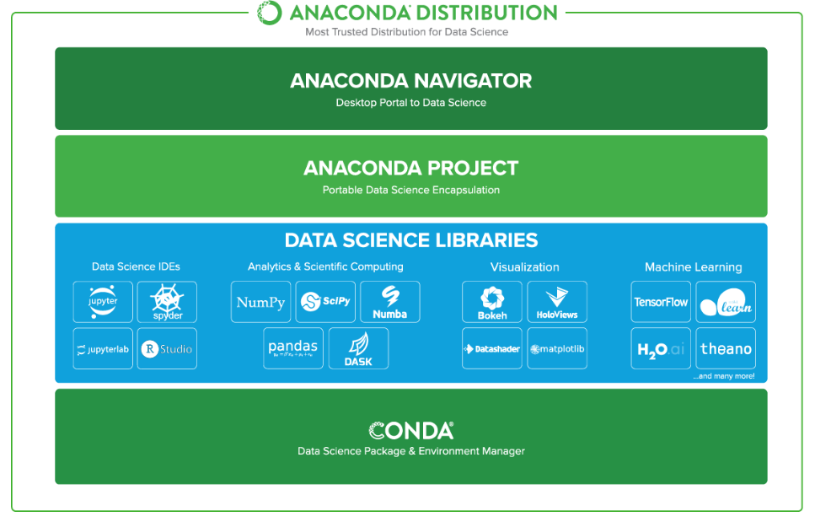

Figure - Anaconda architecture

Requirements

*There are no technical prerequisites or requirements to install and run Anaconda. No admin privileges are required.*

# Downloading Anaconda

The following steps will provide a step by step guide on how to navigate to the correct location to download the Anaconda package and ensure that the correct package is downloaded for your machine.

## Determine Bit Version for Your OS (Operating System)

Anacondas provides either a 32-bit download or a 64-bit download. To ensure you download the correct one follow the steps defined below.

Navigate to: Windows Start > Search and type system information.

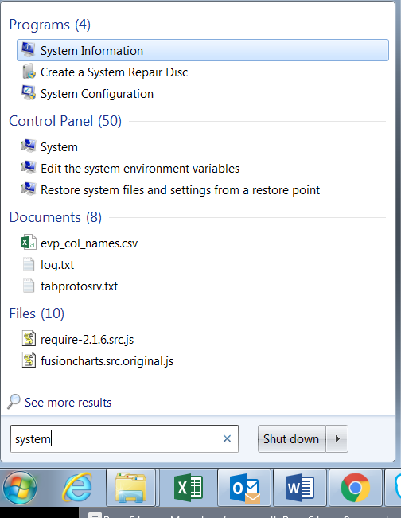

Figure - Opening System Information Program

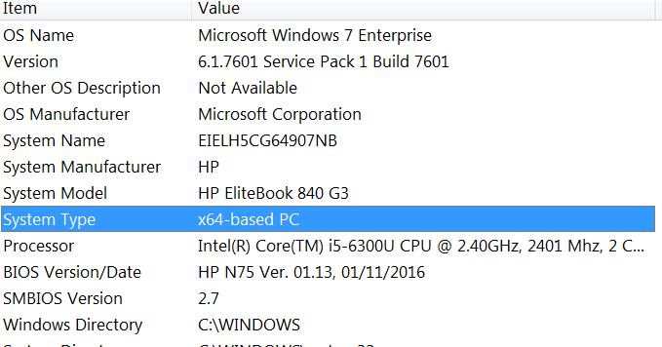

Figure - Finding System Architecture

The system type will tell you what architecture your OS is running. In this case the architecture is 64-bit.

## Locating Download Package

The package download link is located on [Anacondas website](https://www.anaconda.com/download/). (1) Click on option that depicts your current OS (*in this case Windows*) under the heading “Download for Your Preferred Platform” and (2) click Download under ”Python 3.6 Version”.

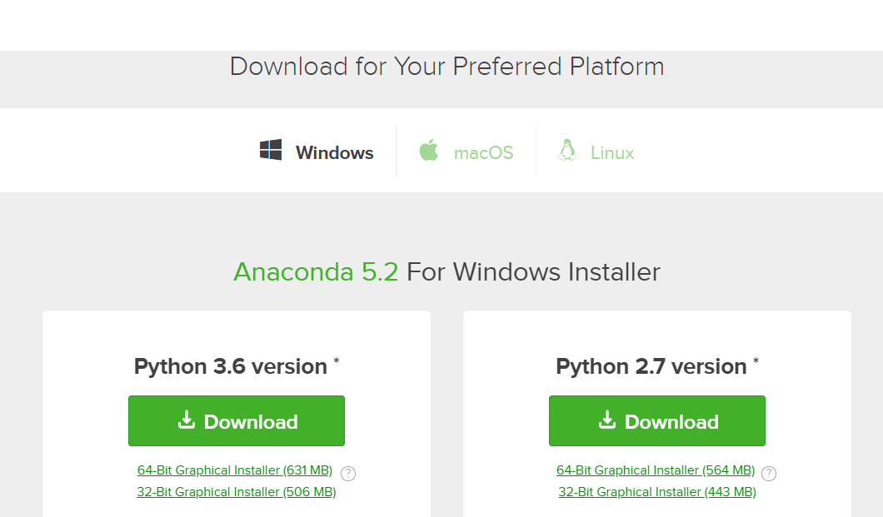

Figure - Downloading Anaconda Process

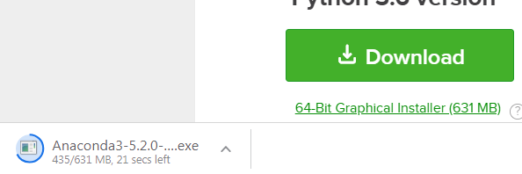

Once downloaded, click the .exe file to start the installation process.

# Anaconda Installation Process

The following process will go through the required steps for correctly installing Anaconda.

1. Click “run” when the following dialog box appears.

## 

1. Click “next” to continue

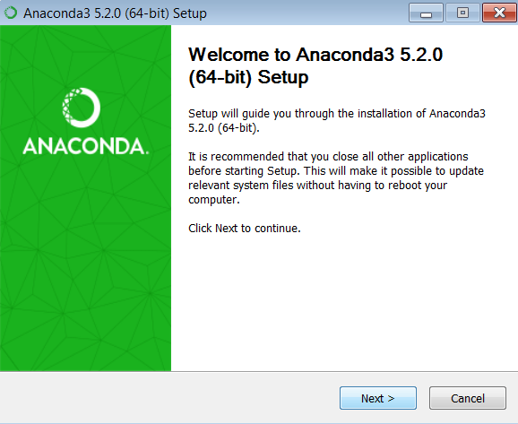

1. Agree to the licence agreement.

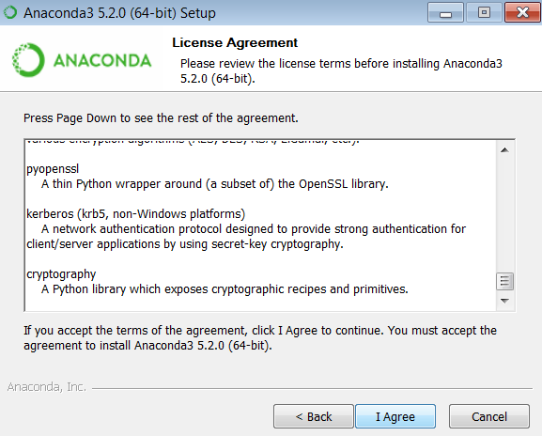

1. Ensure that just the “just me” radio button is selected and click “next”.

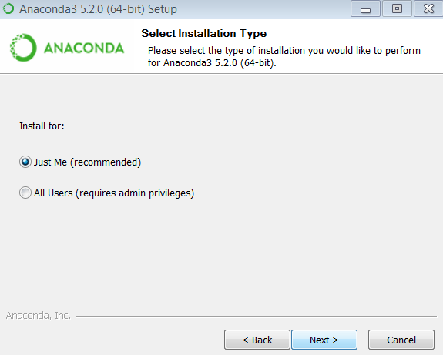

1. Confirming the Install location. Note that this can be left as the default option. Simply click “next”.

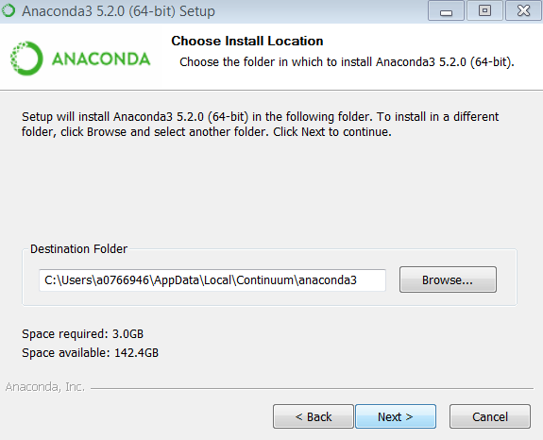

1. Ensure that both check boxes on this dialog box are unchecked and click the “install” option

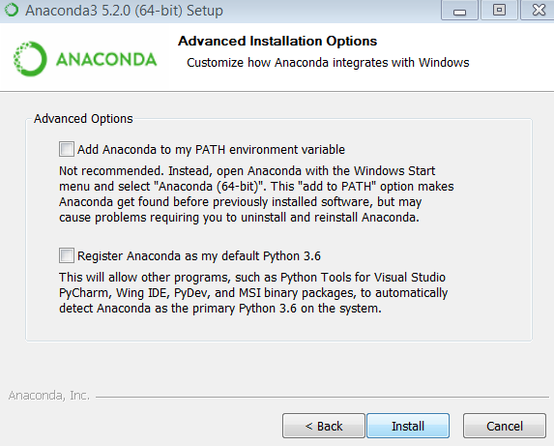

# Confirm Installation Success

Navigate to Windows Start > Search and type “Anaconda Navigator” and select as per figure below.

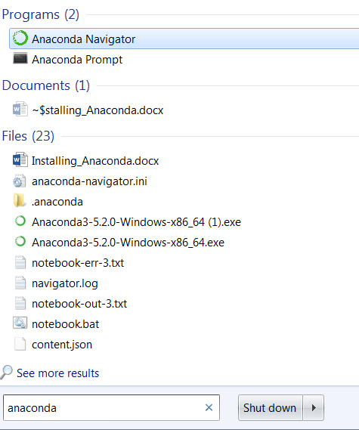

The following interface should now appear on your screen.

