**CS 5500 Operating Systems**

**Section 001**

**Project # 4**

**Memory Management**

**Kevin Cardenas, James Turner, Noah Rodgers**

**05/05/2023**

**Statement: “**We have neither given nor received unauthorized assistance on this work.”

# 1 Virtual Machine Information

Directory and Name of Virtual Machine: kcarden4/vm1

Password for VM Account[1]: cs5500password

Path to Source Code: /home/kcarden4/Desktop/cs5500/p4

# 2 Description

**(You may break up the following into different parts according to the project. If some specific questions are asked, you can customize the following to provide your answers in a clear way.)**

### 2.1 How We Solved the Problems

### Type Here

### 2.2 What We learned

### Type Here

### 2.3 How to Run Our Code

### Type Here

# 3 Screenshots of Output

### 3.1 Code Output Screenshots

### Explain your interpretation of the output.

**PART 1**

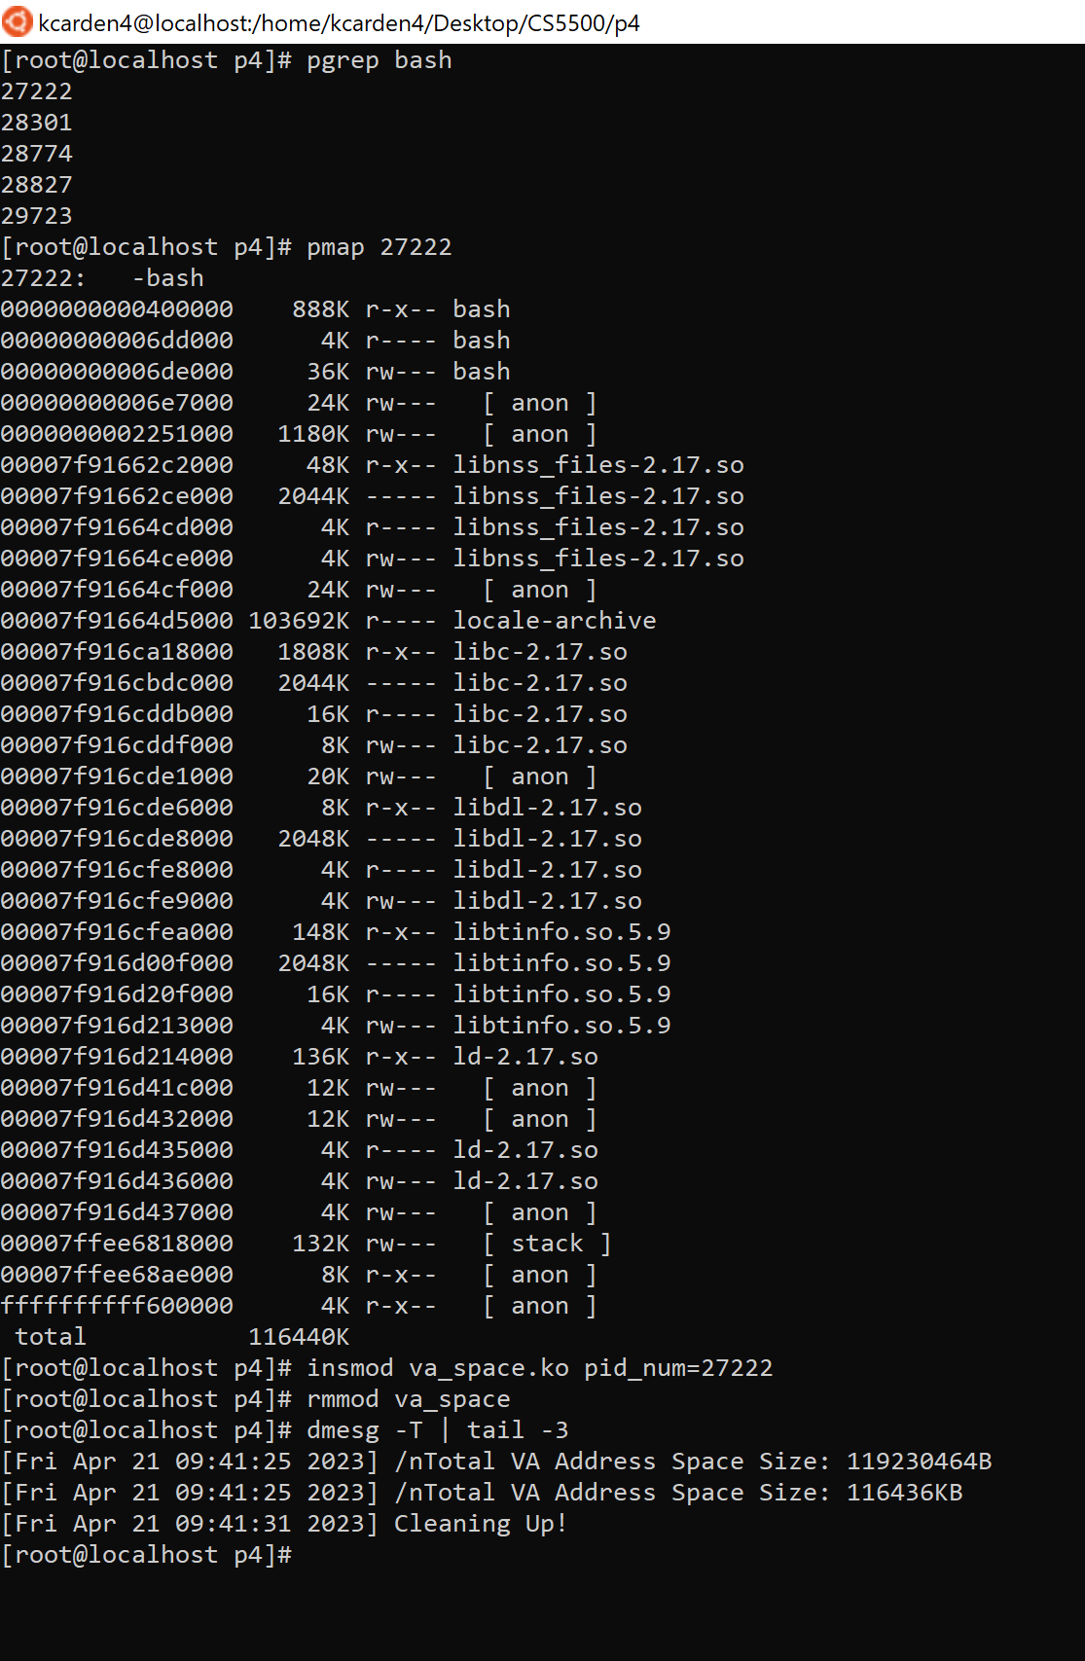

**PART 2**

**Reminder: Submit Source Code with All Projects**

1. Depending on the project requirement, you may need to provide the password of a regular user or the root user.