Fertile egg production from transgenic chicken lines
Transgenic cockerels are used for artificial insemination of 6 hens per cockerel twice weekly. Fresh-laid fertile eggs are collected daily and stored at 14°C until required, and are stored for no longer than 7 days. The maximum number of eggs available from 6 hens is 36-40 eggs per week.

Production of transgenic chickens using lentiviral vectors
This document outlines the steps, procedures and timeline involved in production of transgenic chickens using lentiviral vectors. The procedures with chickens are carried out under animal experiment license. Any potentially deleterious affects of transgene expression must be considered prior to initiating development of a new transgenic line.
The timeline below indicates the approximate time in months for transgenic chicken line production.
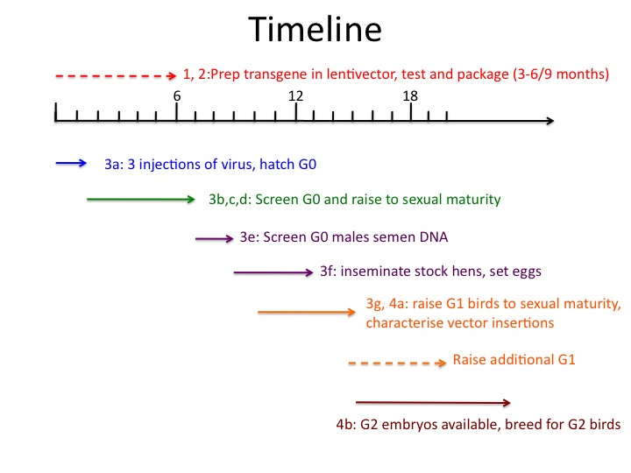

1. Generation of lentiviral vector/transgene construct
a. Design vector and transgene i.e. HIV vector plus specific transgene in silico, assemble all known sequences and develop restriction map. Choose most appropriate lentiviral vector, plus additional elements e.g. cPPT/oPRE if appropriate. Consider issues of Kozak sequence for start transcription, presence of unwanted splice and polyA sites in transgene.
b. Source elements of transgene, consider transgene in vitro synthesis as an option for complex transgenes and time saving. Check that elements to be assembled by restriction mapping/sequencing.
c. Clone transgene into vector. Check by restriction mapping and sequencing.
d. Test transgene expression before and/or after cloning into vector. Expression may be tested by transfection of a suitable cell type or electroporation of chick embryos.

2. Packaging of LV vector to high titre
a. carry out small scale test packaging (single plates) and titre to estimate efficiency. The requirement is to produce concentrated lentivirus at a titre of >10⁷. The higher the titre the more germline transgenic cockerels will be produced and the higher the frequency of fully transgenic offspring of these germline transgenic cockerels.
b. if vector packages to acceptable titre, carry out large scale packaging. Concentrate by ultracentrifugation, resuspend in 60μl TSSM buffer and store at -80C. Keep sample back for titre (aim is titre of 10⁸ or higher but 10⁷ can be used if higher titre is not achievable).

3. Production of transgenic birds to G1 generation
a. Each 60μl aliquot will be used to inject approx 25 embryos in new laid eggs. Injections are carried out weekly on Fridays and for each transgene three injections will be carried out in the first instance ie 3 aliquots of high titre vector are required. The injected embryos hatch 3 weeks after injection. These are G0 birds.
b. Immediately after hatch extract DNA from CAM samples from hatched chicks (and possibly dead embryos over 11 days of incubation) and carry out semi-quantitative PCR screen to detect presence/absence of vector to 1% level. Sex chicks by PCR. Usually only male G0 chicks are kept, G0 females may be kept if useful.
c. Blood sample G0 chicks at 2-3 weeks of age and repeat PCR screen.
d. G0 birds will be raised to sexual maturity, 16-20 weeks for males, 20-24 weeks for females. If it is considered useful PCR can be used to analyse the transgene sequences in G0 birds but this is not often carried out.
e. Cockerels will be tested for semen production from approximately 16 weeks. Extract genomic DNA and screen by semi-quantitative PCR. Cockerels with transgene at a level of 1% (predicted I in 100 transgenic offspring) will be crossed by AI with up to 6 hens.
f. The number of G0 cockerels crossed with standard hens will depend on estimate of transgene frequency etc. Hens will be inseminated, fertile eggs collected daily, stored for a week and set weekly on Tuesdays. The G1 chicks will hatch 3 weeks later (Tuesday/Wednesday) and each individual chick wingbanded and a CAM sample taken from the shell.
g. Extract DNA from CAM samples and carry out PCR screen for presence of transgene, predicted to be single copy level. Repeat screen to confirm and sex chicks on DNA from blood sample 2-3 weeks later.

4. Characterisation of G1 birds and breeding G2
a. At a few weeks of age a blood sample can be taken from G1 birds to prepare genomic DNA for PCR and Southern blot analysis. Carry out Southern blot using a restriction enzyme that cuts once within the vector and a second (or two) that release a fragment that includes most of an integrated copy of the vector (remember this has a different structure from that present in the plasmid clone). Use a probe derived from a sequence within the vector that does not contain chicken genomic sequence. This will allow estimate of number of copies of integrated vector, number of different integration sites of vector in represented in the G1 chicks, any gross deletions. The integration sites can then be determined by inverse PCR and the key parts of the transgenes checked by PCR and sequencing. Lentiviruses inherently are likely to have some mutations (due to RT) and possibly small deletions, plus some transgenes can induce mutations when expressed in the packaging cells e.g. interferons.
b. Identify which G1 birds will be useful to use for breeding G2, and if there are males and females with the same insertion that could be bred to give homozygous G2. G1 birds will be sexually mature at approx 20weeks for breeding G2.

