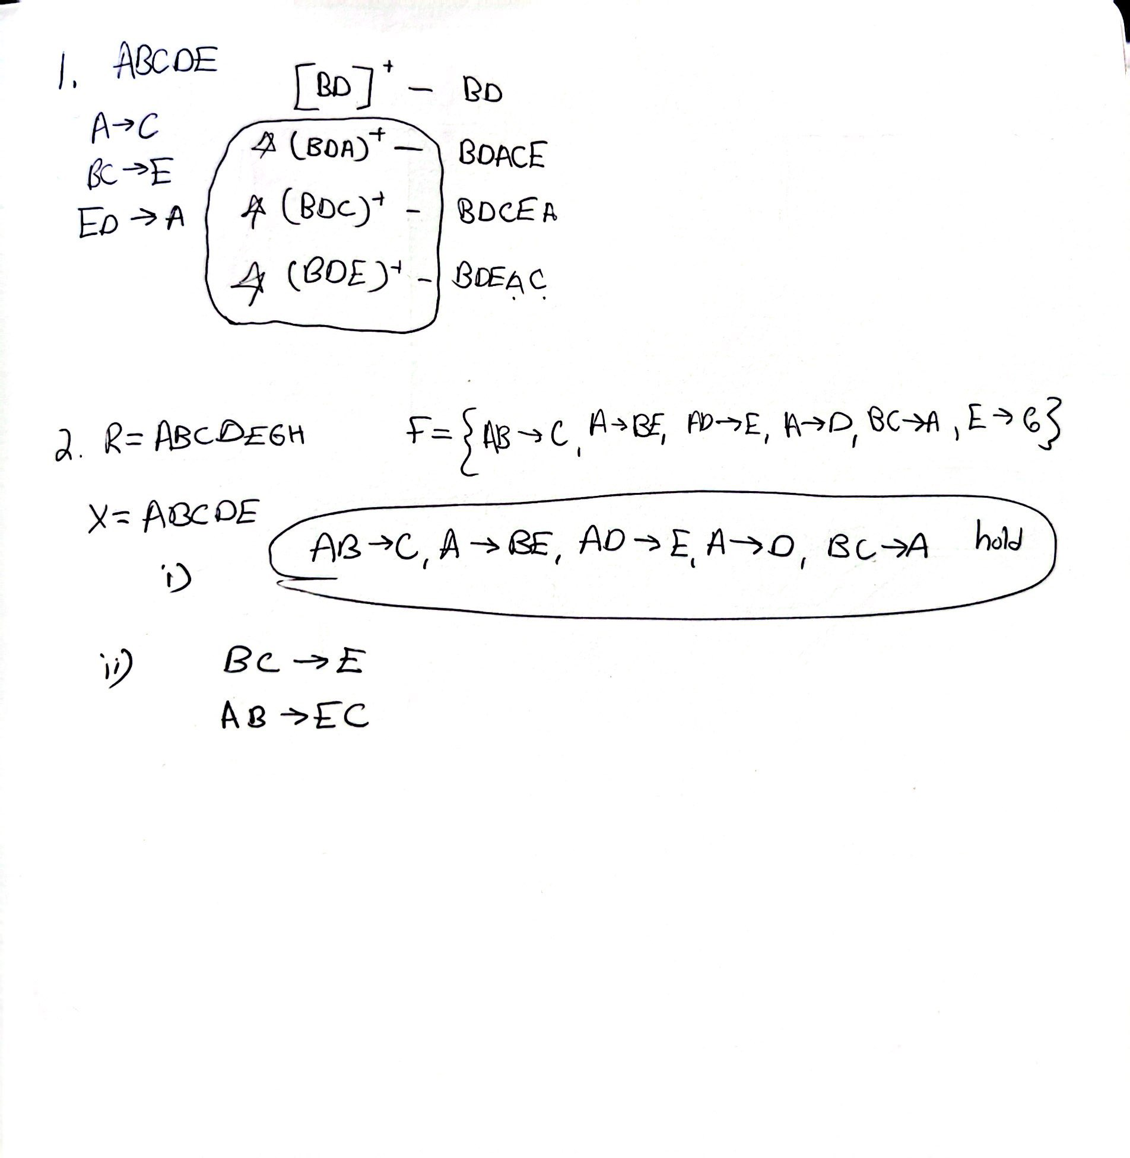

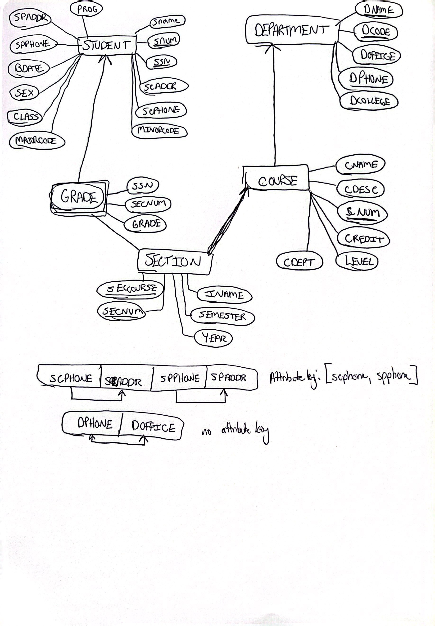

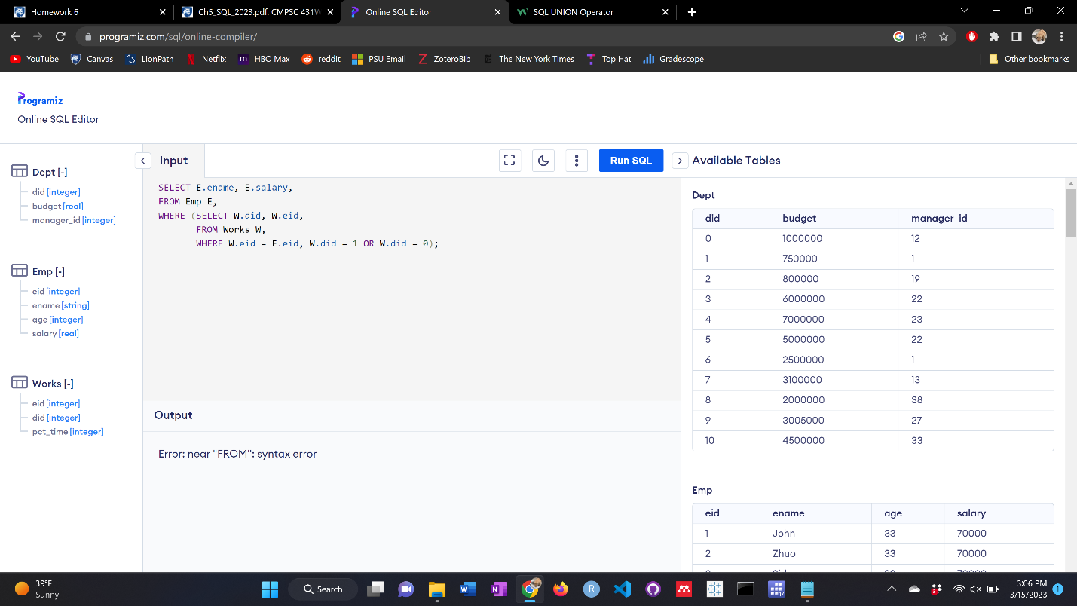

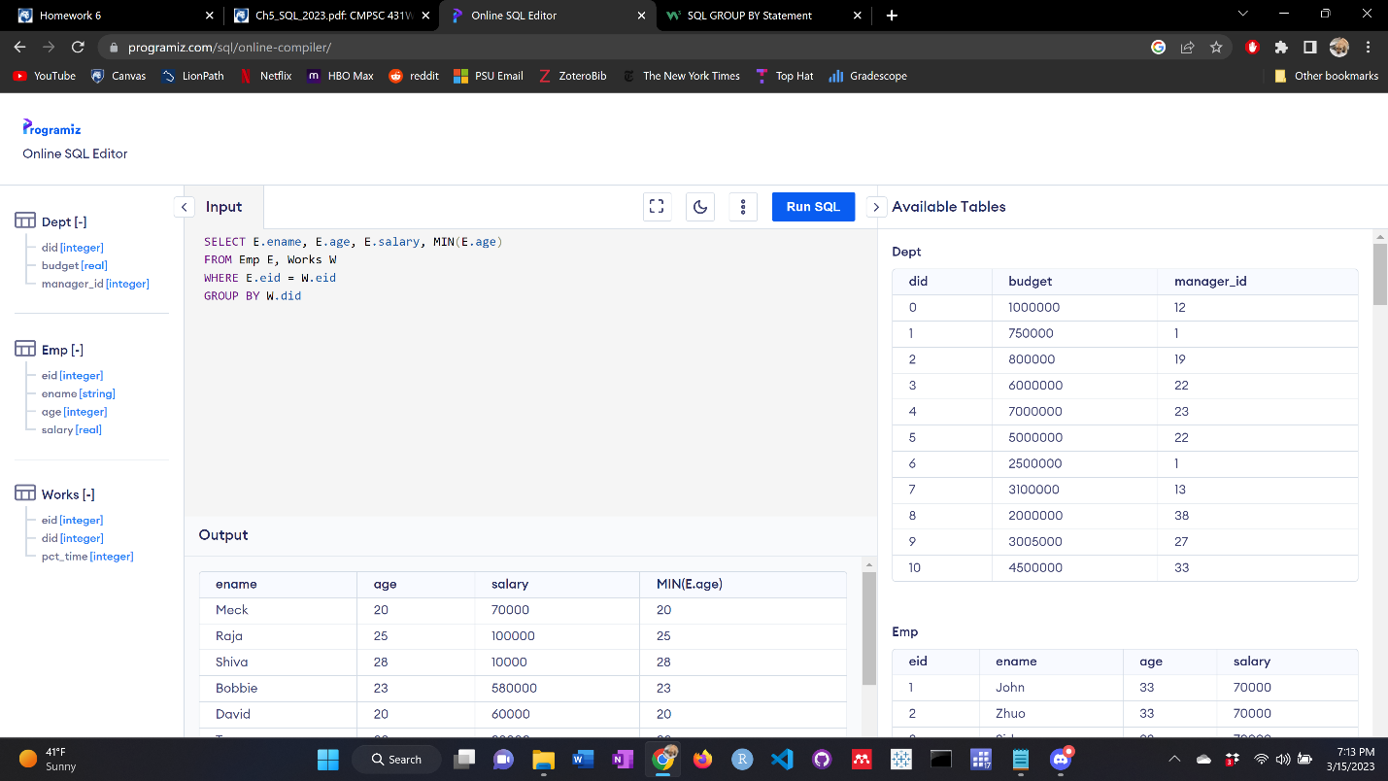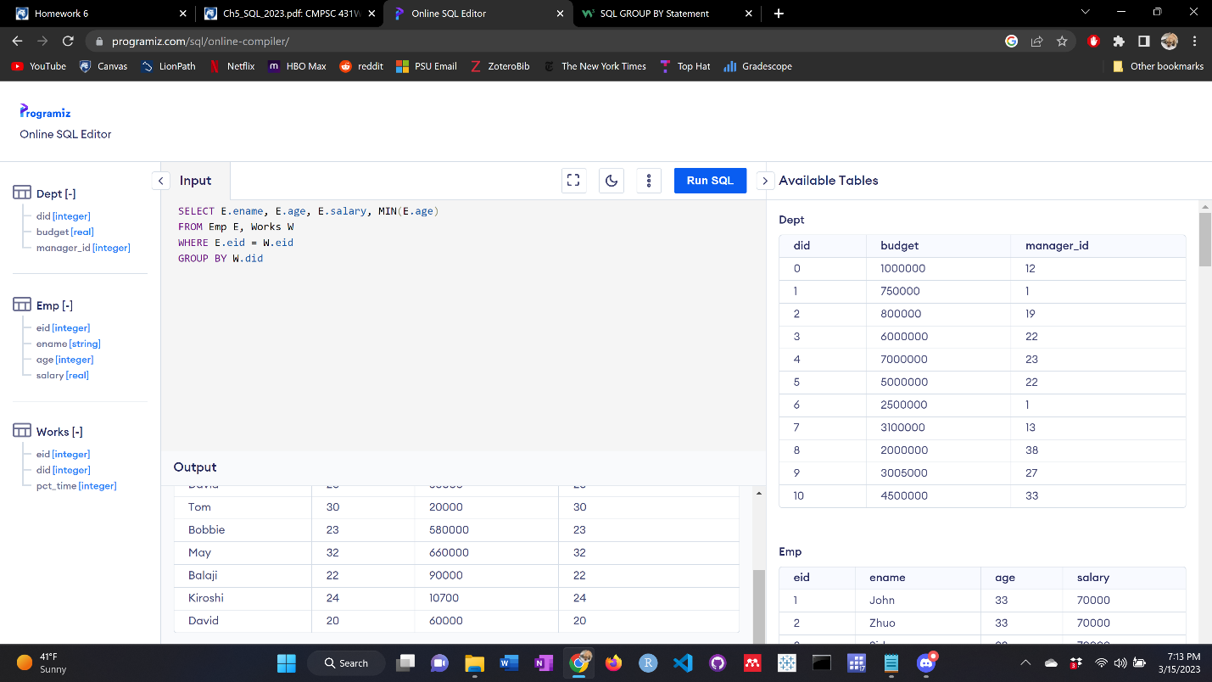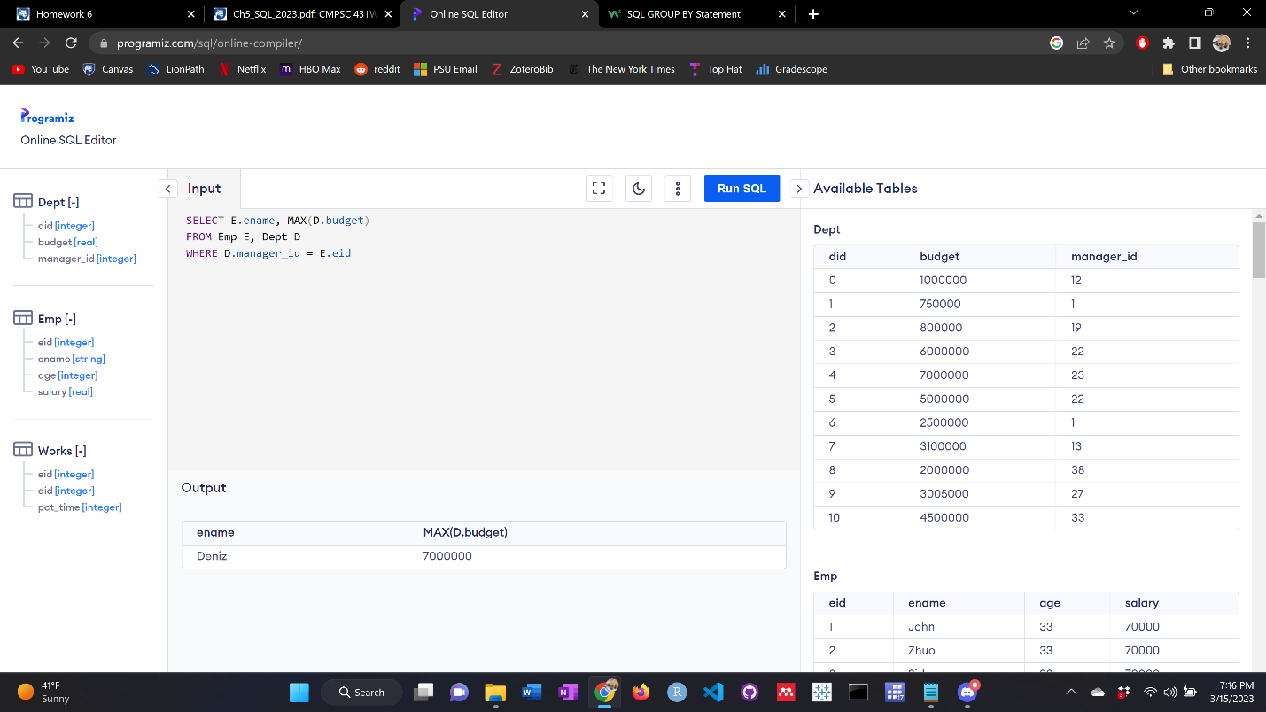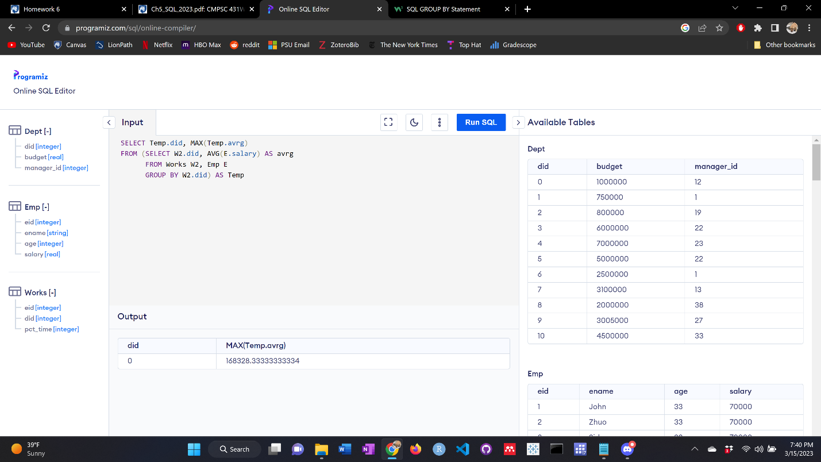

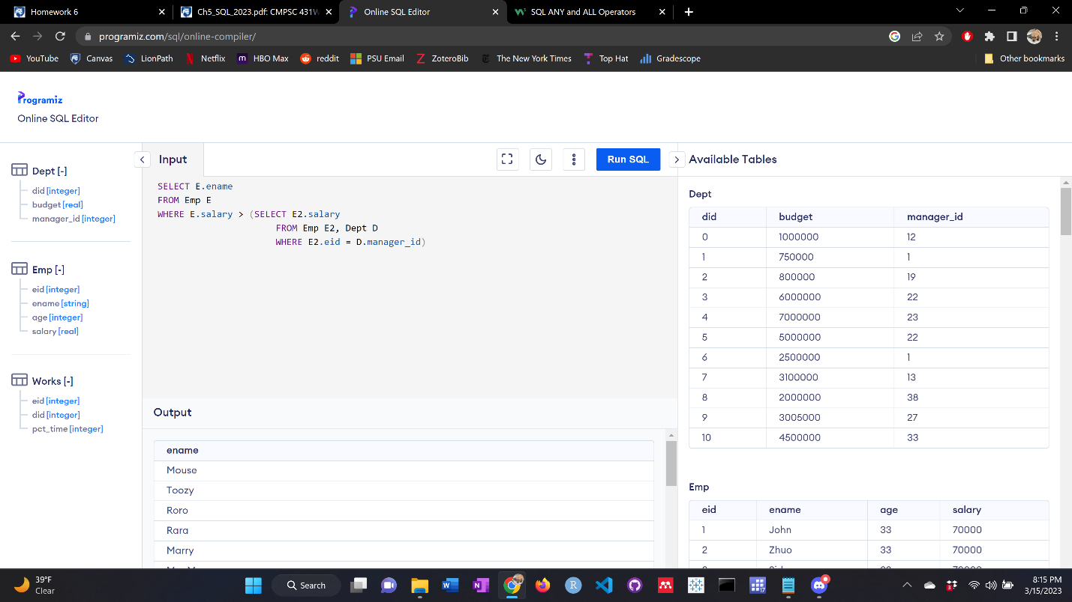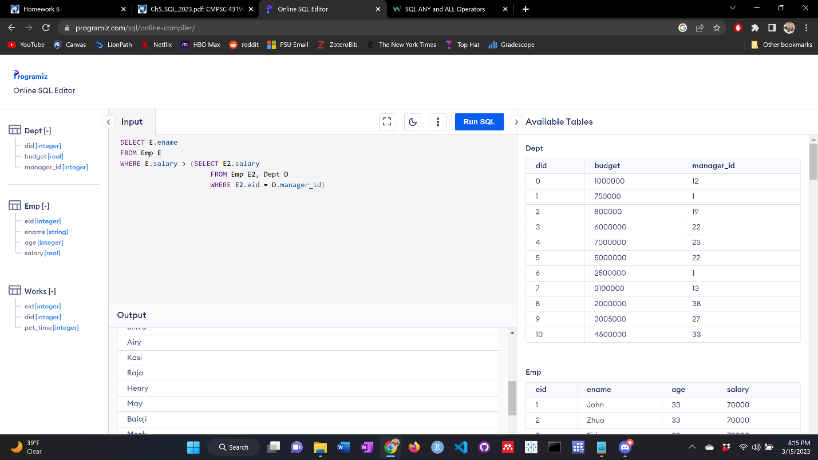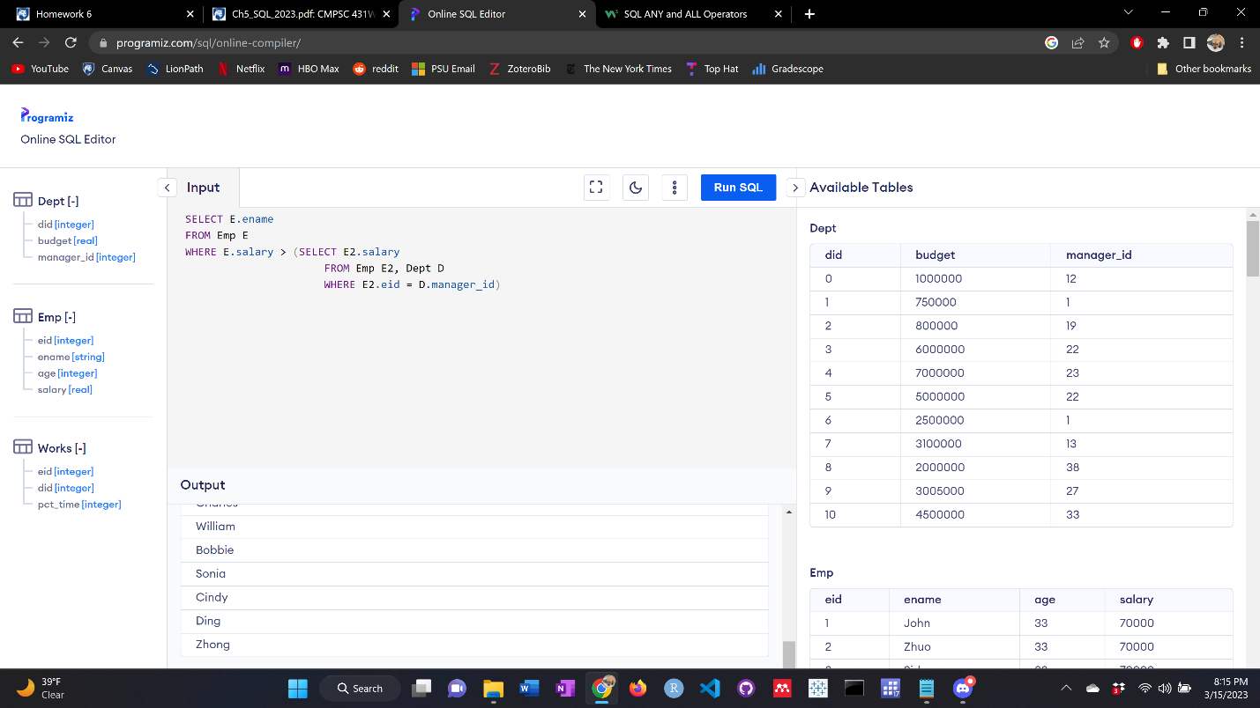

RAW CODE:

CREATE TABLE Emp (

eid INTEGER,

ename STRING,

age INTEGER,

salary REAL,

);

INSERT INTO Emp

VALUES ('1', 'John', '33', '70000.0'),

('2', 'Zhuo', '33', '70000.0'),

('3', 'Sid', '33', '70000.0');

CREATE TABLE Works (

eid INTEGER,

did INTEGER,

pct_time INTEGER

);

CREATE TABLE Dept (

did INTEGER,

budget REAL,

manager_id INTEGER

);

1.

SELECT E.ename, E.salary

FROM Emp E, Works W

WHERE W.did = 1

UNION

SELECT E.ename, E.salary

FROM Emp E, Works W

WHERE W.did = 0;

2.

SELECT E.ename, E.age, E.salary, MIN(E.age)

FROM Emp E, Works W

WHERE E.eid = W.eid

GROUP BY W.did

3.

SELECT E.ename, MAX(D.budget)

FROM Emp E, Dept D

WHERE D.manager_id = E.eid

4.

SELECT Temp.did, MAX(Temp.avrg)

FROM (SELECT W2.did, AVG(E.salary) AS avrg

FROM Works W2, Emp E

GROUP BY W2.did) AS Temp

5.

SELECT E.ename

FROM Emp E

WHERE E.salary > (SELECT E2.salary

FROM Emp E2, Dept D

WHERE E2.eid = D.manager_id)