**LionAuction**

**Christopher Kramer**

### 

### Table of Contents

1. Introduction

2. Requirement Analysis

2.1. Bidders

2.2. Sellers 3

2.3. HelpDesk 4

2.4. Products and Auctions 4

3. Conceptual Database Design 6

4. Technology Survey 8

5. Logical Database Design and Normalization 10

6. Conclusion 12

7. Appendix 13

7.1. Schedule 13

7.2. Deliverables 13

7.3. Milestones 13

# 

# 1. Introduction

LionAuction is a startup company which seeks to create an auction site for LSU, which can be used by students and local businesses alike to buy and sell products in an auction-style format. Students will be able to purchase products from other students and individuals as well as from local businesses and vendors. Items will have categories in order to help bidders find what they are looking for, as well as to help sellers classify their products. The site will also offer a customer support service known as HelpDesk, where buyers and sellers can submit tickets for their various issues and requests. Along with this, HelpDesk will continuously perform market analyses to continue improving the platform, potentially implementing feedback provided by the users. The specifics of the different types of User’s, and what they entail will all be covered in section 2. Moving onto section 3, an ER diagram will be presented to describe the layout of the various relationships present in this project. Section 4 includes a technology survey, describing the various options when tackling a project like this, including the pros and cons of each, and which one we will be moving forward with in the end. And finally, section 5 is the logical database design and normalization of what we’ve developed in sections 2 and 3.

# 2. Requirement Analysis

Here we want to elaborate on the system and data requirements described in the original report from Mr. Dude. The details of the system are described in detail, and the processes behind how each part of the project works are outlined below. Certain assumptions may be made in order to create a clear picture of how the site will operate.

## 2.1. Bidders

Starting with Users, we find User to be the parent of the three different types of users within the website space. There are bidders, sellers, and helpdesk employees, all of which must have an ID (email address) and a password to log into the site. In the case of LionAuction, a bidder can be a seller at the same time, although in order for a bidder to become a seller, they must submit a ticket to the helpdesk. All students are automatically registered as bidders by default, and must provide a host of information, some for their benefit and some for the company’s benefit. They must provide an email, their name, and their address, all of which can be changed in the settings later on. They must also provide their major, their age, their gender, and their annual income, although these pieces of information are solely for marketing analysis. They are assigned an ID within the website which is used to distinguish between users, and this ID cannot be changed unless they submit a ticket through the helpdesk. Bidders must also include payment information to participate in options, which can be changed at any time. Bidders can filter by categories to find the product they want easier, they can send questions about the product to the seller, they can see info about the seller, and related products to the one they are looking at as well. If a bidder wins an auction, they must pay immediately after the bid has ended, and can follow up by leaving a rating out of 5 stars for the seller.

## 2.2. Sellers

Moving on to sellers, once again they have an ID and login with their email and password, same as all Users. Sellers must include a bank routing number in order to make and receive payments, as well as a bank account number, and must have a running balance within the site to keep track of money they’ve made. For a business or vendor, they must also include their business’s name, the business’s address, and a customer service number, should a bidder need to make contact. If a seller ever decides to leave the site for good and delete his account, all his auctions must leave with him, a seller’s item cannot be sold if the seller no longer exists. When listing a product, the seller must include the category of the product, a description of the product, a reserve price which is hidden from the bidders, and the end time for the auction. They can see the questions asked about the item, as well as the reviews left on their account as a seller. If the product they are selling does not fit into one of the predetermined categories, they can contact helpdesk in order to create a new category. Once an auction ends, the product is delisted regardless of whether or not it was sold, and the information surrounding the auction is archived.

## 2.3. HelpDesk

The helpdesk once again carries the same login information as all users, and serves as the support for the site. The helpdesk will deal with a number of requests from both bidders and sellers within the site. If at any time any user wants an ID change, they must contact the helpdesk in order to get it changed, and must provide a valid reason for doing so. In order for a bidder to upgrade his or her account to a seller, they must submit a ticket to the helpdesk. In order for a seller to make a new category for their product, they must submit a ticket to the help desk. The helpdesk is also in charge of using the data from bidders and sellers to perform marketing analysis to continuously improve the site and its functionality.

## 2.4. Products and Auctions

Moving on from the various users, there are certain requirements and specifications that come with the other aspects of the site, such as the products, the auctions themselves, and the different categories used to sort products. Starting with products, each product can only be sold by exactly one seller, and belongs to exactly one category. If multiple of the same product are listed, they are auctioned off together. As said before, each product must have a title, description, category, and reserve price. Additional information can also be included if the seller deems it necessary, and products will disappear if their seller disappears. Bidders can place multiple bids on different products at a time, so long as they are not the seller of any of the products. All bids must be at least $1 higher than the previous bid, and must be placed before the auction is over. Once over, all bidders are notified of what the highest bid was, and the owner of that bid must then pay the seller to complete the transaction. As for categories, each category may have its own smaller subcategories, until you reach the leaves, which is the lowest category form. Buyers can select these categories as filters in order to narrow down their search.

# 3. Conceptual Database Design

Pictured above is a rough ER diagram representing Mr. Dude’s idea for LionAuction. We can see that User is the parent entity that a helpdesk employee, a bidder, and/or a seller all stem from, all inheriting the three main attributes of a user, their ID, their email, and their password. A helpdesk employee has no separate attributes outside of what is provided by the User hierarchy, however we can see that both bidder and seller have their own separate sets of attributes unique to them. We see that bidders have a credit card for payments, as well as a name attribute and a separate address entity that is based off of a street and a zip code, the zip code being used to determine the city and the state. We can also see that a bidder has a set of four attributes on the side that are used solely for market analysis. The seller has its own child entity, a vendor that is a specific type of seller. An individual seller must include some financial information in order to be able to sell their goods, but a vendor must include more information, such as their business name and location, and a customer service number, should a bidder need to get in touch for any reason. We then see the product entity, which holds relationships to bidders and to sellers. A product must have a title, a detailed description, a category, and a reserve price. Each product may only have one category which we can see in the diagram represented by the arrow, and each product can only be sold by one seller, which is also represented by an arrow. Each product also has a current bid price attribute, which will be matched against the bid attribute in the bidding relationship between product and bidder, so that we can confirm each bid is at least $1 more than the current highest bid. This ER diagram roughly represents how Mr. Dude specified LionAuction should work.

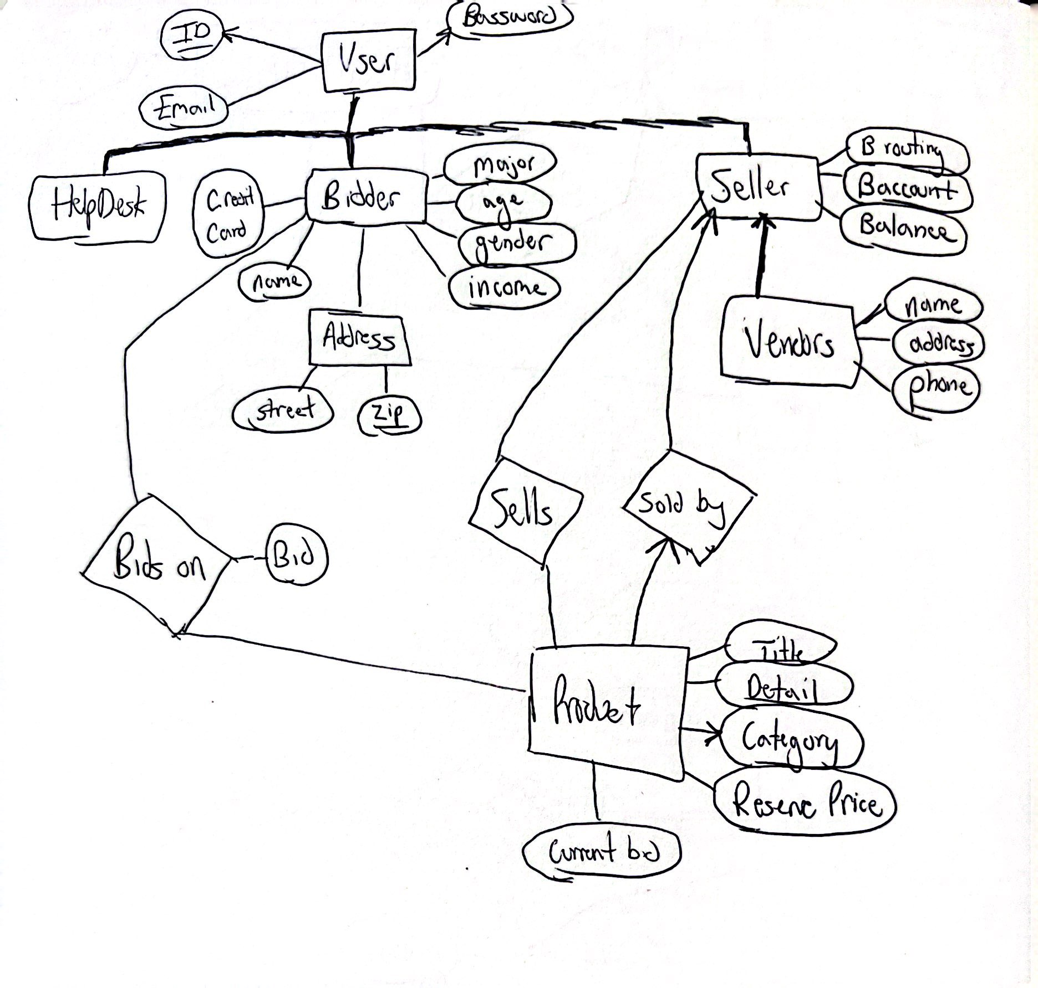

Figure 1 – ER Diagram representing LionAuction

# 4. Technology Survey

When creating a project such as LionAuction, there are many options when it comes to technology. We’ve learned in class primarily about SQL and Python, but those aren’t the sole options. One option is PHP, which is a popular platform that is used to develop complex websites. It has been used many times, and some would consider it a go-to when deciding what to use to create an interactive website such as LionAuction. The pros are that it is free to use, open-source, and can scale very well to the size of your project. The cons however, is that it is not as versatile as some of the other options out there, and it doesn’t debug very well. Both of these are areas that other options may improve on, so PHP is likely not the best option for us. Another option is R. R like PHP is open source, and easy to pick up. However, R is mostly for use on data, and doesn’t have as much utility when developing a website. This means that for handling data, R could be fine, but since this project entails more than just the data side of things, R is not the best option for us. A third option is C#, which is very similar to R in the sense that it has great utility when creating and managing datasets. However, once again creating and managing the dataset is not the only important part of this project, so we will want to stick with an option that is best for the entire project, not just one aspect of it. Despite these options not being the most attractive, that doesn’t mean they are entirely useless. PHP, R, and C# have all had enormous impacts on the world of programming and data science. They all have a niche that they fit, and are very well suited for the purpose they were designed for. It just so happens that our project includes both a dataset and a website aspect, which means we should be using something that can help with both those aspects, as PHP is best with websites and not so much data, which is the opposite for R and C#. This is why I believe using Python for this project is the best option, as the Pandas package handles data very well, arguably better than some of the other options I have outlined, as well as having Flask in order to help organize a working site.

# 5. Logical Database Design and Normalization

In order to confirm that our relational schema are normalized to 3NF, we should start by checking for 1NF and 2NF. By looking at our diagram, we can see that there are no are no atomic values, all attributes are correctly distributed and represented by atomic values only in all cases. This gives us the confidence to declare our model as 1NF at the very least. In order to check for 2NF and 3NF, we must check for partial dependency and transitive dependency respectively. In order to confirm 2NF and 3NF, we change our address entity for bidder and for vendor to have all attributes included in a candidate key. This will make the entire address the candidate key, and remove city and state being dependent on zip code, a part of a candidate key, since they are also part of the key. This is all we need to do to confirm that our model complies with 2NF protocol, and we can move on to checking for 3NF. Here, we are specifically examining our model to find any incidents of transitive dependency. This means we cannot have any non-key attributes that are determining other non-key attributes. At this point we run into an issue with Users, where the password is determined by the email address, as a function of logging into your account. Here we solve this by using email and password to create a candidate key, that distinguishes one user from another while logging in. This means we no longer have two non-key attributes where one determines the other, getting rid of our transitive dependency, and improving our model.

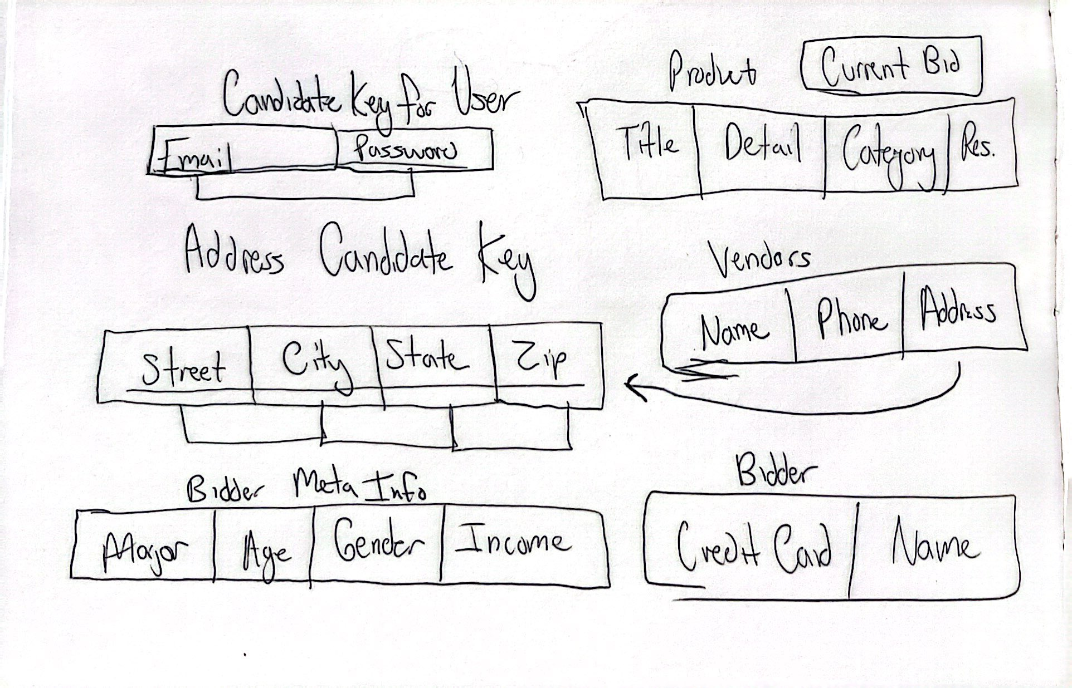

Figure 2 – ER Diagram translated to Relations

# 6. Conclusion

The LionAuction project contains a lot of information that can be interpreted in many different ways. I have done my best to interpret the design specifications to the best of my ability, outlining the various requirements in section 2, as well as describing the relationship model visually using and ER diagram presented in section 3. I have described the various technological options in the technology report found in section 4, and have finished by normalizing the project in section 5. Each section contains justification for the design choices made, as well as the assumptions and liberties assumed in order to create the various models and descriptions.

# 7. Appendix

## 7.1. Schedule

For this project, we are looking to have a working website made within 6 months. We’ll get the site out and usable in this time, using test cases to ensure it is working as expected. Once the site is created and made available to the public, advertising and marketing will begin, attracting customers and local businesses to sign up and use the site. Once we have a stable consumer base, we can begin market analysis to devise new ways to attract and retain customers, as well as beginning to consider and implement customer feedback.

## 7.2. Deliverables

At the time of this report, everything we have to offer is theoretical. If Mr. Dude decides to move forward with our design, we aim to provide a working site prototype within 2-3 months, that will from then on be improved upon, until the final draft is completed within 6 months. At this point we can launch the site, and begin on gathering data about the site’s use, including how it can be improved and refined, and how customers are using it.

## 7.3. Milestones

1. Theoretical report

2. Prototype site

3. Finished site

4. 1,000 Users

5. 10,000 Users

6. 100,000 Users