I believe that the increase in right-wing terrorism in the United States is related to the declining levels of religiosity, specifically the declining levels of Christianity. I believe that high levels of religiosity provide an advantageous position for religious terrorists, and I feel that while in the United States right-wing terrorists are separate from religious terrorists, there is still a connection between religion and right-wing terrorism that has yet to be explored in current literature. I believe that there is a negative relationship between these two variables, meaning that as my independent variable religiosity decreases, my dependent variable right-wing terrorism will increase.

I believe that the connection between religion and right-wing terrorism has not been fully examined before. This is in part because terrorism is divided and classified into sections, where right-wing terrorism is a separate phenomenon from religious terrorism. This leads to a separation of causal factors as well, right-wing factors are often considered to be political and policy-oriented, whereas religious factors are all limited in their causality to just instances of religious terrorism. I believe this makes religiosity overlooked as a potential causal factor related to right-wing terrorism. The foundation of this argument is based on two main principles, one being that for religious terrorism to thrive, traditionally it requires a “home-field advantage”. This is the opposite of ethnonationalism terrorism, which most often thrives when the ethnicity committing the terrorism is in the minority; religious terrorism thrives when the religion of the terrorists is the majority in that country, and often is recognized and/or backed by the government to provide additional power and influence to that particular religion. This means that for religious terrorism to continue, they must not lose the majority of the population, and in turn their political influence. It should then be understood that a terrorist group or individual with a religious foundation would feel threatened by declining levels of religiosity in their country, which might drive them to act more aggressively than before. The second main reason is that I believe there is a connection between religion and right-wing terrorism that hasn’t been fully examined before. In the United States, there is potential for legislative diversity due to the application of Federalism in the government. There can be a wide range of varying legislature between towns, counties, and even states. Because of this, in areas of the country with a higher level of religiosity, we tend to see legislature rooted in religious beliefs, showing the power and influence certain religions have in the United States. This religious influence we see checks all the boxes for an environment where religious terrorism would survive, specifically Christianity. This also connects right-wing terrorism to the most common causal mechanics associated with it such as policy and hate. In areas where religion is heavily intertwined with policy, a clear connection emerges, one where policy goals are bound to religion by nature.

Although I believe there is bound to be a connection between the decrease in religiosity(R. P. Jones et al., 2020) and the increase in right-wing terrorism(S. G. Jones et al., 2020), there are still reasons why some would argue that this is not the case. One could argue that religion and policy cannot always be intertwined, which is why they are usually separated into different categories. However, I believe this cannot be the case when speaking about something as powerful as religion. For someone truly devoted to their religion, the beliefs that come with their faith affect every aspect of their life, and for someone involved in legislature, it would be impossible for their religion to not have any effect at all. Our legislature is meant to be representative of the will of the public who elects them, so naturally, if our legislative representatives are making decisions based on their religion, it must to some extent reflect the nature of the populace that has elected them. This provides the groundwork for my argument that radical right-wing policy is connected to Christianity to some degree, and as a result, right-wing terrorism also shares a connection to the religiosity levels of Christianity(R. P. Jones et al., 2020). This is how I have developed my hypothesis, that decreasing levels of religiosity in the United States, specifically Christianity, plays a role in the increase of right-wing terrorism in the United States.

My hypothesis states that the decreasing levels of Christianity in the United States are leading to the increase in right-wing terrorism in the United States. I believe that religious terrorism when committed by Christians is closely related to right-wing terrorism, and as a result, religious factors apply to right-wing terrorism. This means that losing the majority of the population and losing legislative support would be seen as a threat to right-wing terrorists, leading them to act more violently and increase their number of attacks to lash out at the changes they are seeing in their country.

I am studying the effects of declining levels of Christianity in the United States on right-wing terrorism in the United States. The levels of Religiosity in the US are my independent variable, with the number of right-wing attacks and plots being the dependent variable. For my independent variable, I have the levels of religiosity in the United States as a whole because it was the most complete data I could find. This dataset includes the percentage of Americans identifying as each major religion by year. For my dependent variable, I am using data from the Global Terrorism Database, which includes the time and place of each attack, and as much information as could be gathered about it, such as a summary, the victim, and the nature of the attack. This data comes with some heavy limitations, however: the GTD data only goes up to 2018, which prevents me from including the dramatic rise in right-wing terrorism that has taken place over the last 5 years in the United States. My religiosity data is also lacking in specificity, I would have liked to have state-level data instead, but I was unable to find any smaller-scale data that was complete enough to perform a thorough analysis.

For this project, the amount of data is an issue, as instances of terrorism are thankfully a very rare phenomenon. The entire GTD database through 2018 has about 180,000 events, and when filtered down to only events that occurred in the US, we end up with about 1800. I’ll be using a zero-shot classifier to use the short summary for each event to classify it as either a right-wing terrorist event or non-right-wing. This will likely slim down the data considerably, and provide me with few examples to go off, especially once separated by year of occurrence.

Religiosity will be operationalized as the percentage of people self-identifying with a few major religions, namely Protestant, Catholic, Christian, and no religious affiliation. I will be using the data from a Gallup Poll conducted over several decades. This means that we must take into consideration a potential self-reporting bias on account of each person’s religious identity. Our dependent variable will simply be each instance of a right-wing attack in the United States. It is impossible for the most part for us to discern whether a right-wing attack was inherently motivated by religion, as often the motives are unknown or not clear enough to be categorized one way or another, at least in the case of domestic terrorism in the United States. The GTD includes a summary section, but this is often unreliable in understanding the true motivation behind an attack. A lot of summary and other sections are left blank, and often a lot of information about each attack is still unknown. This means a correlation will have to be established simply through parallel trends surrounding both declining levels of religiosity and increasing levels of right-wing terrorism.

I will use a time series model to compare the trends in right-wing terrorism over time in the US with the levels of religiosity over time. Terrorism is an extremely controversial topic, and there are many varying theories about what truly causes someone to resort to such horrific means of achieving their goals. There are far too many potential confounding variables to take into consideration, and thus any correlation will be nearly impossible to prove causal. There is a possibility my research will not reveal significant results, and I will fail to reject the null hypothesis, this is a reality that cannot be avoided.

**Graphs of Data Trends**

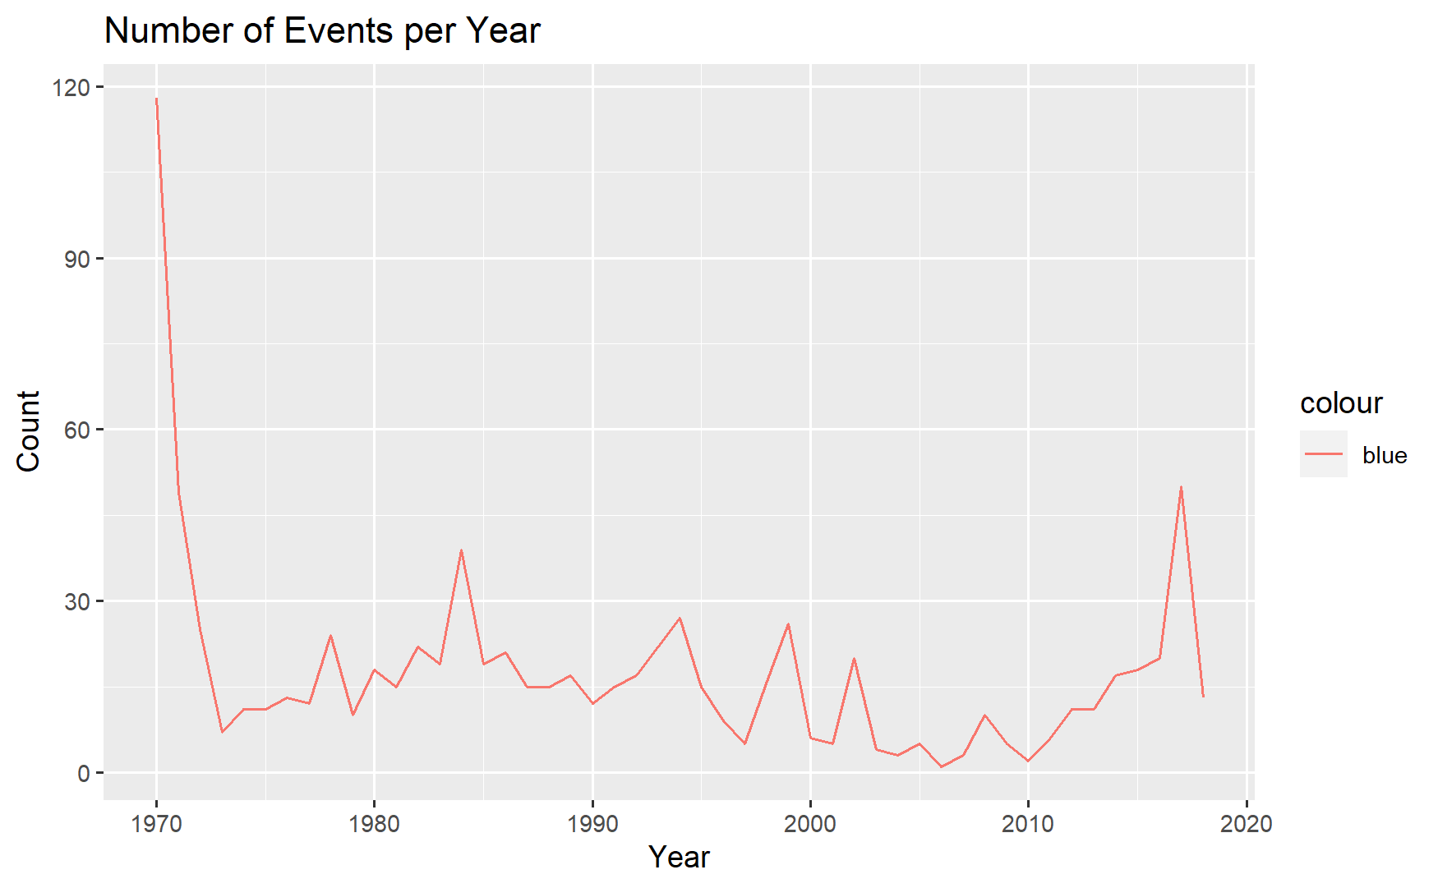

The above graph depicts the number of right-wing terrorist events we see each year.

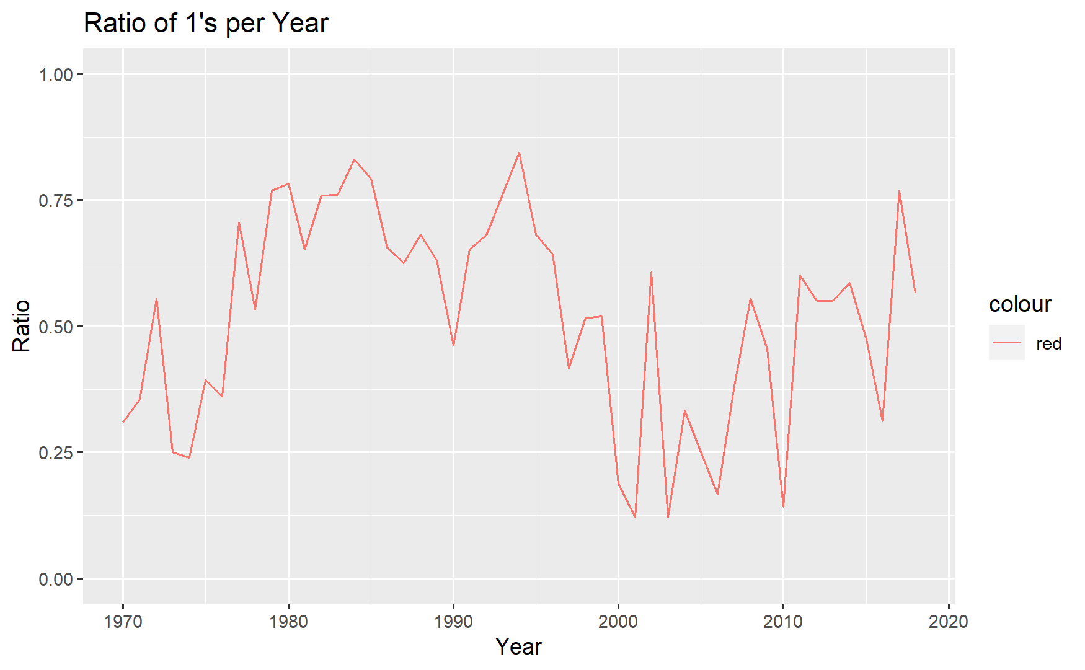The above graph depicts the ratio of right-wing terrorist events compared to all events over the year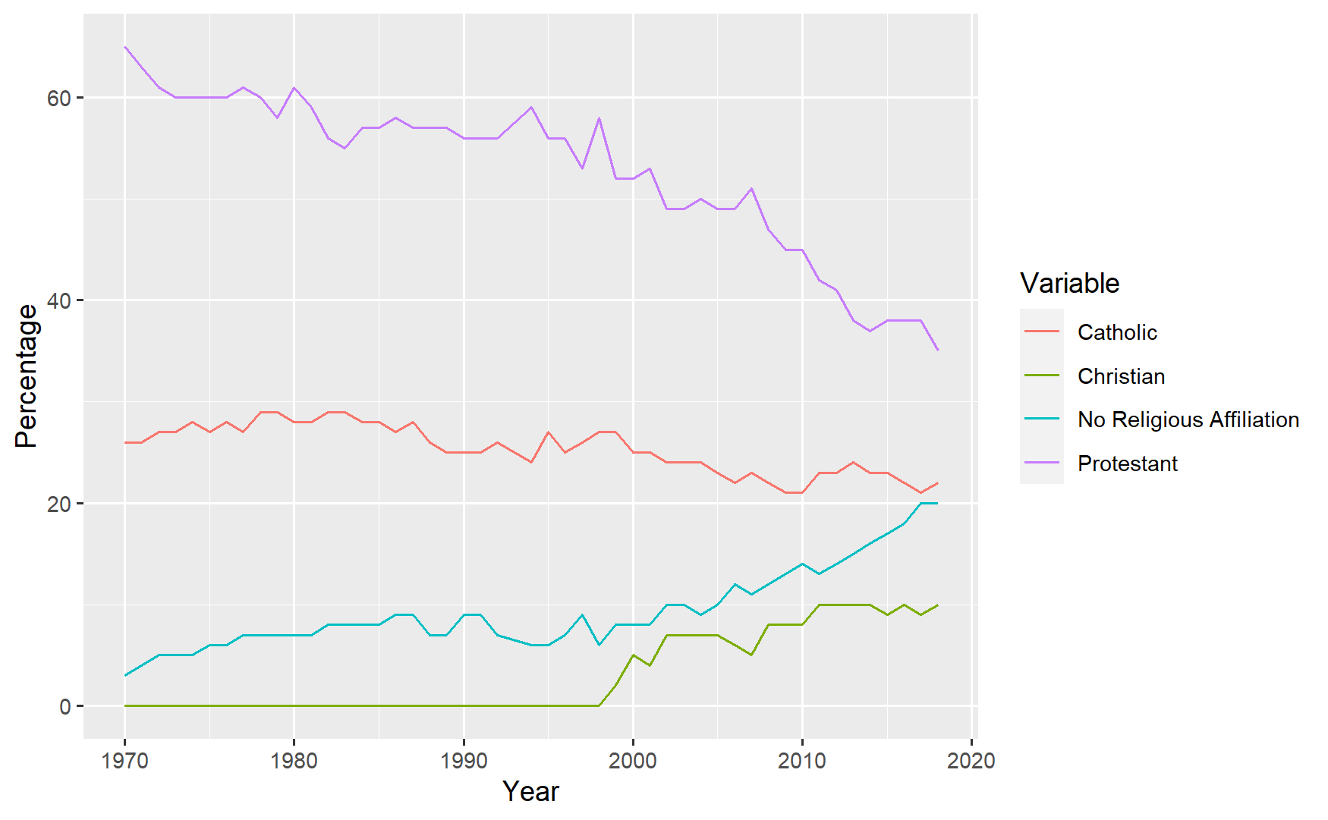

The above graph depicts the changes in various religious identification percentages over the years.

Time Series Regression Results

===============================================

Dependent variable:

---------------------------

ratio

-----------------------------------------------

protestant 0.015

(0.012)

catholic 0.054***

(0.018)

none 0.051**

(0.022)

Constant -2.140**

(0.824)

-----------------------------------------------

Observations 48

R2 0.261

Adjusted R2 0.210

Residual Std. Error 0.182 (df = 44)

F Statistic 5.171*** (df = 3; 44)

===============================================

Note: *p<0.1; **p<0.05; ***p<0.01

Residual standard error: 0.1816 on 44 degrees of freedom

Multiple R-squared: 0.2607, Adjusted R-squared: 0.2103

F-statistic: 5.171 on 3 and 44 DF, p-value: 0.003786

The above table is the results of the time series regression using religiosity as a set of independent variables, and GTD events as dependent.

For my dependent variable, I ended up using the ratio of right-wing terrorist events rather than the full number, since there was a small difference in the number of events over time. As we can see from the graph, there were a lot of events early in the 70s, simply because there were a lot of events back then in general. I didn’t want this anomaly to interfere with the data, so I decided to use a ratio instead, to show that specifically right-wing terrorism is increasing or decreasing, not just terrorism in general. We can see from the graphs that both the number of events and the ratio of events goes up and down over time, both being a bit higher in the 80s and 90s compared to the other decades. This is likely due to the wave of abortion bombings at the time, which my zero-shot model should have classified as all right-wing attacks, specifically Christian-nationalist. Had the dataset gone on a few more years, we should’ve seen another big spike in the last 3-4 years, however, the data stops in 2018 which is why a sudden drop-off can be observed at that time, near the end of each graph. As planned, I used the percentage memberships for each religion as my independent variable, including data for Protestant, Catholic, Christian, and no religious identification. I tried to include major religions that I believed were most associated with right-wing events, not including religions such as Islam or Judaism, which are not associated according to my theory. As we can see from the religion graph, the percentage of Protestants and Catholics has been going down over time, while the percentage of people not identifying with any major religion has gone up. We can also the number of ‘general Christians’ going up over time, although it was only entered as an option in 1999, so I did not include it in the regression. The general Christian option represents the increase in different, smaller sects of Christianity, which represents people breaking from the major organized religions in favor of less traditional options. I included this in the graph because I believe it helps demonstrate the shift from traditional organized religion to independent worship, and the expansion of options and religious progress is something I believe would cause unrest among radical individuals.

I included Protestant, Catholic, and no affiliation as my independent variables in the time series model, with the ratio of right-wing events as my dependent variable. As we can see from the table, Catholic and no affiliation had significant correlations with the ratio of right-wing events, but Protestant did not. This is likely due to the decline of Protestant identification being too steep to be correlated with the trends of right-wing terrorism. Catholic had the most significant correlation, but no affiliation was also significantly correlated. This suggests that the trends in religious identification for those two categories are similar to that of the ratio of right-wing terrorist events over the years. This combined with the overall p-value of 0.003 is enough evidence of a statistically significant correlation to reject the null hypothesis and confirm that I’ve found statistically significant evidence to suggest a correlation between the changing religiosity in the United States and the ratio of domestic terrorist events that are classified as right-wing.

While this discovery is exciting in the sense that it allows me to reject my null hypothesis, when taken at face value there is little in the way of conclusions that can be drawn from these results. This is due to how little we know about what provokes or causes someone to use Terrorism as their primary method of achieving their goals. There is no shortage of literature on the causes of Terrorism, and the most likely causes largely depend on the type of terrorism. For terrorist groups, knowing someone who is already in the group is often cited as the most common reason for joining. For groups that act against the government, their opinion of how well the government represents the interest of the people, and how well their legislative system works largely contributes to whether or not groups turn to terrorism. Sometimes it is a divine sense of purpose that drives someone to terrorism, especially if they feel there is some sort of divine reward waiting for them in the afterlife as a result of their efforts. While all of these theories make sense, none of them are fully accepted nor exist without their share of criticism. There are no definite answers as to what truly causes someone to turn to terrorism, and because of that establishing a causal relationship is virtually impossible. There are too many potentially confounding variables at play that cannot easily be operationalized and included in a model to make a substantial case for a causal relationship. This means for a study of this scale, omitted variables are everywhere, including both ones that we know of yet can’t operationalize, and ones that we haven’t yet realized should be there. I think for this field, omitted variables will always be an issue, because not all variables that should be included, can be included. Even though I cannot claim to have established causality through my research, I believe I’ve found a factor that was once overlooked amid the discussion of what’s causing the increase in right-wing terrorism in the United States and should be taken into consideration more in the future.

**Bibliography**

*Seth G. Jones,Catrina Doxsee,Nicholas Harrington. The Escalating Terrorism Problem in the United States,2020.*

Collins-Mayo, S. (2012). Youth and religion. An international perspective. In *Zeitschrift für Religionspädagogik* (Vol. 11, Issue 1). www.conformation-research.eu

*Inc, Gallup. “How Religious Are Americans?” Gallup.Com, 23 Dec. 2021,* [*https://news.gallup.com/poll/358364/religious-americans.aspx*](https://news.gallup.com/poll/358364/religious-americans.aspx)*.*

Piazza, J. A. (2020). Politician hate speech and domestic terrorism. *International Interactions*, *46*(3), 431–453. https://doi.org/10.1080/03050629.2020.1739033

Riley, K. J., & Hoffman, B. (n.d.). *Domestic Terrorism: A National Assessment of State and Local Law Enforcement Preparedness*.

Zulli, D., Coe, K., Isaacs, Z., & Summers, I. (2021). Media coverage of the unfolding crisis of domestic terrorism in the United States, 1990–2020. *Public Relations Inquiry*, *10*(3), 357–375. https://doi.org/10.1177/2046147X21996015