**登錄**

1. dexter.lsw@gmail.com 2

2. dexter@syscomach.com.tw 2

3. 沒使用mail 2

4. Hugging Face 2

# dexter.lsw@gmail.com

dexter.lsw@gmail.com password DDw566831, *啟動OpenAI

#Vitual Studio password jennnDexter1_ 2025/2/5

#google username Dexter Wang, password jennndexterb

#sketchfab username DexterWang, password jennndexterb

#Kaggle?? username jennndexter password jennndexter1

#reddit username JennnDexter_a

沿用google帳號

#ChatGPT,ollama.com

#invideo AI,Dexter's Workspace # AI製短片

#PowerDirector # 另加password jennnDexter

#clipchamp # 另加password jennnDexter

#civitai username dexterlsw217

#PronptHero.com # username DexterWang, password jennnDexter

# [dexter@syscomach.com.tw](mailto:dexter@syscomach.com.tw)

dexter@syscomach.com.tw

#NVIDIA password JennnDexter1

#Github, Anaconda, username jennndexter password jennndexter1

# 沒使用mail

WSL(windows下之linus) username dexterwang password jennndexter

# Hugging Face

dexter.lsw@gmail.com

JennnDexter1 username(account)

DexterWang fullname

JennnDexter1 password

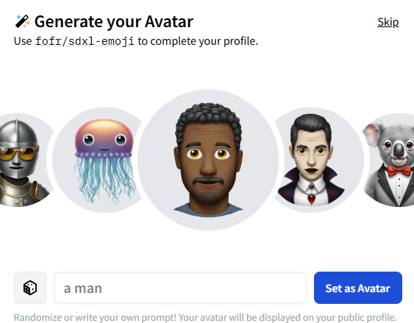

沒使用。