J-Link RDI-DLL

HOWTO configure J-Link RDI DLL
for use with
Analog Devices ADuC702x Series
and IAR Workbench



1 Introduction

2 Purpose of this document
This document explains how to setup J-Link or mIDASLink for use with Analog Devices ADuC702x Series Microcontrollers and IAR Workbench. It refers to the sample project which comes with the document. If you follow all steps in this document, you should be able to use the emulator

3 Versions of the software
IAR embedded workbench: V4.20a
JLinkRDI.dll: V2.60b or mIDASLinkRDI.dll V2.60b

4 Notes on flash breakpoints
The settings shown in the dialogs below enable flash Breakpoints and flash download. These may require separate licenses, which can be obtained from SEGGER.

5 Using the sample project

6 First steps...
- Copy the JLinkARM.dll and either the JLinkRDI.dll or the mIDASLinkRDI.dll into the arm\bin subdirectory of your IAR Systems Embedded Workbench installation directory (e.g. C:\Program Files\IAR Systems\Embedded Workbench 4.0\arm\bin).
- Double click the workspace file (Start.eww).
- Select “Debug_Flash” Config in the Workspace window.
- Open the Project Options through the menu point Project|Options

7 Setup the Sample Project Settings
- Go to the Debugger node and set the driver to RDI:
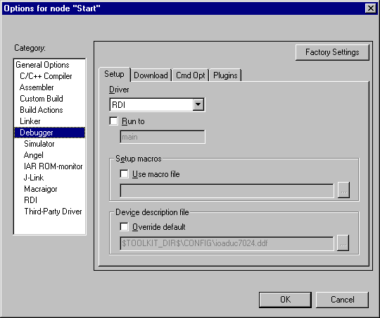

- In the RDI node, please specify the RDI-DLL you want to use. You can click the “…” button to browse to your RDI DLL:
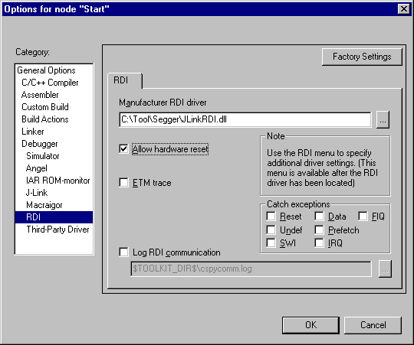
- Check that “Allow hardware reset” is enabled.
- Click “OK” to apply your settings.

8 J-Link RDI Settings

- Select the menu point RDI|Configure and make sure the settings are as shown below.
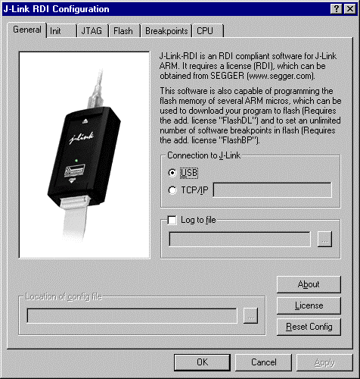 | 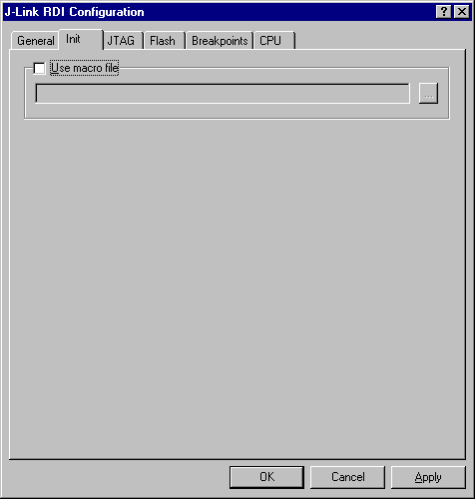
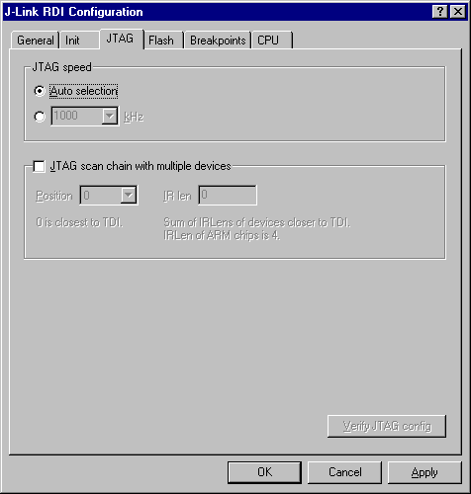 | Please note that you may need to select another flash memory depending which Micro and Revision you are using.  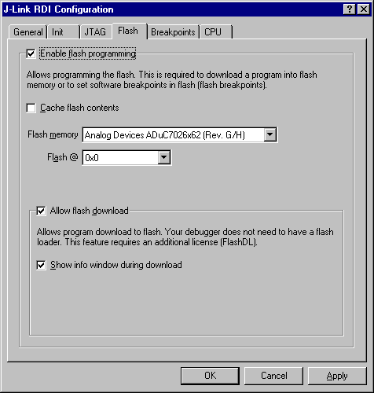
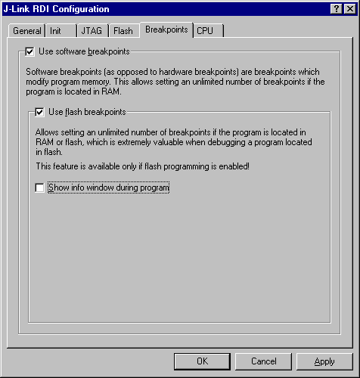 | 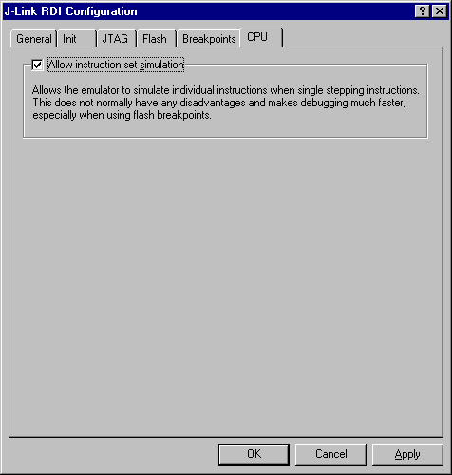

9 Debugging the project:
- Build the project by choosing the Make menu item from the Project menu.
- Click in the toolbar to debug the project in flash.

