Settings for AT91SAM7S64 and KEIL uVision3.

1. Double-click project file (“Blinky.uv2”).
2. Select target “AT91SAM7S Flash”.
3. Open the project options dialog (Menu – Project – Options for Target)
4. Make sure settings are as shown below:

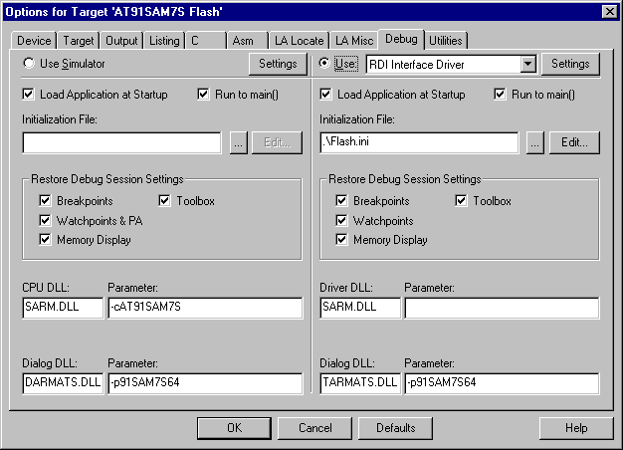

5. Browse to your RDI DLL:

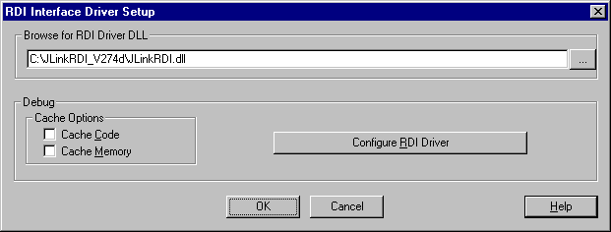

6. Select “Configure RDI Driver”

7. Make sure the settings are as shown below.

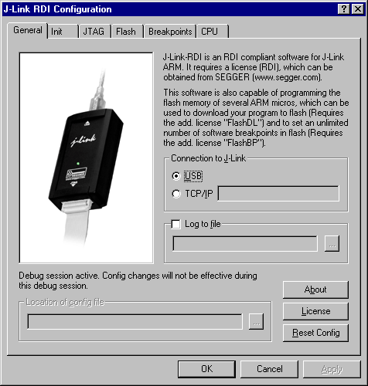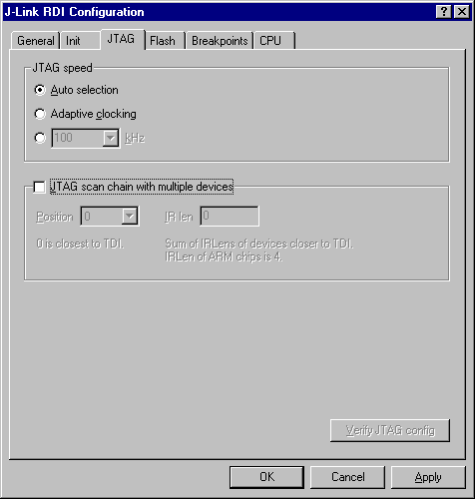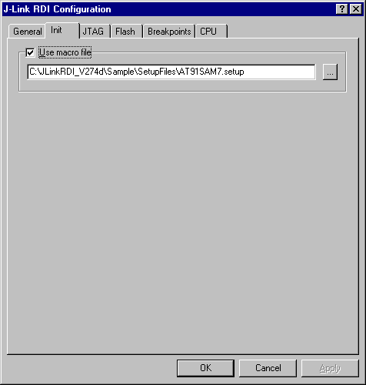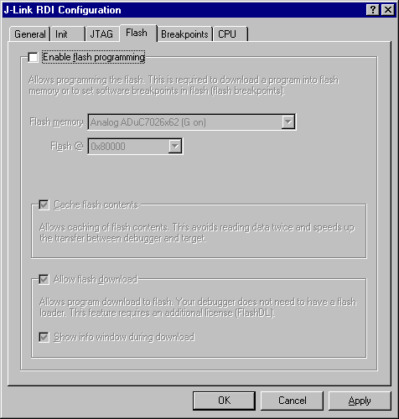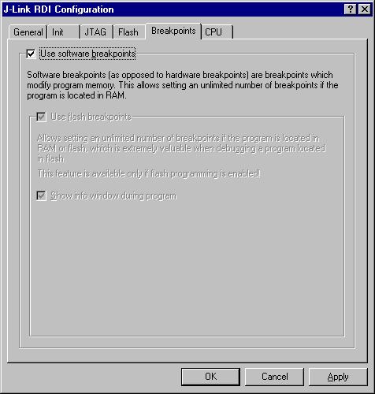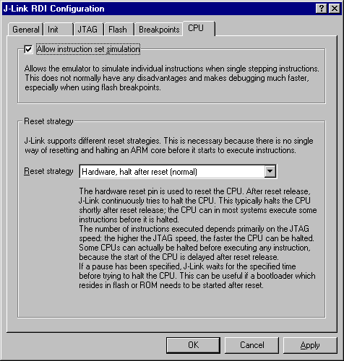
8. Select „RDI Interface Driver“ as driver for flash programming.
9. Select “uVision Flash Programmer”

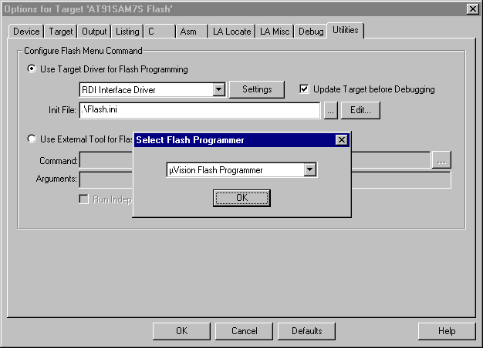

10. Make sure the settings are as shown below.

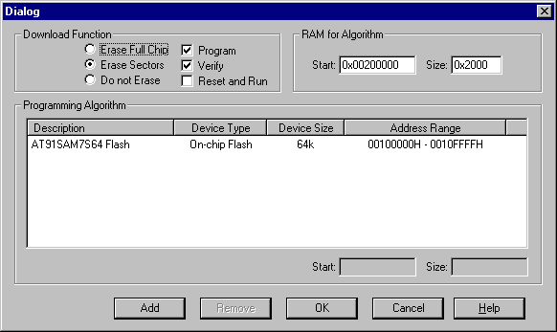

11. Build the target (Menu – Project – Rebuild all target files)
12. Start the debug session

