Advance Health Assessment Program

(AHAP)

CS437 Software Engineering

Software Requirements Document (SRD)/Software Design Document (SDD)

Prepared By

David Perez

Di Shen

Calvin Thanh

Mero Avanessian

March 10th, 2015

Advance Health Assessment Program

(AHAP)

Prepared By:

David Perez

Di Shen

Calvin Thanh

Miro Tzori

Approved By:

__________________________ ___________________

Jose Macias Date

Document Change Log

|  |  |  |
| --- | --- | --- |
| Update | Date Released | Changes |
| Draft #1 |  |  |
|  |  |  |
|  |  |  |

**Table of Contents**

Page

**1.0 INTRODUCTION** 6

**1.1** Purpose 6

**1.2** Scope 6

1.2.1 Document Organization 7

1.2.2 Relationship to Other Documents 7

**1.3** AHAP Architecture 7

1.3.1 Context Diagram (Level 0 Data Flow Diagram) 7

1.3.2 Description and Major Functions 9

1.3.3 Hardware and Software Considerations 9

**1.4** Documentation of the Development Process 9

**1.5** References 10

1.5.1 Controlling Documents 10

1.5.2 Applicable Documents 10

1.5.3 Standards 10

**2.0** **AHAP DETAILED FUNCTIONAL DESCRIPTION** 11

**2.1**  Detailed AHAP Functional Description 11

2.1.1 Level 1 Data Flow Diagram (DFD) 11

2.1.2 Detailed Functional Description of AHAP Major Sub-Units 11

**3.0 AHAP REQUIREMENTS** 14

**3.1** AHAP Functional Requirements 14

**3.2** AHAP Non-Functional Requirements 16

**3.3** AHAP Hardware Requirements 17

**4.0 AHAP DETAILED DESIGN** 18

**5.0 AHAP IMPLEMENTATION** 19

**6.0 AHAP TEST PLAN**  19

**6.1** Introduction 19

**6.2** Functional Requirements Validation Matrix 19

**A. ACRONYMS**  23

**B. DATA DICTIONARY**  24

**C. SOURCES** 25

# **List of Figures**

Figure 1-1. Context Diagram (Level 0 Data Flow Diagram)

Figure 2-1. Level 1 Data Flow Diagram for the HDAM System

# **List of Tables**

None.

**1.0 INTRODUCTION**

**1.1 Purpose**

The purpose of this document is four-fold:

a) Define a full set of requirements for the AHAP.

(These sections correspond to a Software Requirements Document, SRD).

(This is the main Section to be developed during CS337).

b) Define the design for the AHAP.

(These sections correspond to a Software Design Document, SDD).

(This Section will be partially developed during CS337 - only what’s needed).

c) Define the Test Plan for the AHAP.

(These sections correspond to a Software Test Plan, STP).

(This section will not be developed during CS337).

d) Define implement feasible modules for the AHAP.

(These sections correspond to the Software Implementation Document, SID).

(This section will not be developed during CS337).

The complete definition of all AHAP requirements provides the source requirement inputs for the development of the subsequent supporting software subsystems documents.

**1.2 Scope**

The documentation developed as part of this CS337 class, will be completed in the following Software Engineering class, CS437.

The Scope of this document includes the following:

* All functional and nonfunctional requirements on the AHAP are captured. The Section on Verification & Validation (V&V) requirements, as well as inter-software subsystems requirements will be completed in CS437
* A complete set of AHAP Requirements, derived and traceable to the incoming class requirements. These requirements are organized by key AHAP functional units shown on the Level 1 DFD given in section 2.0.
* The following will also be part of CS437: A trace matrix, relating all AHAP functional requirements to functional subunits as expanded in lower level DFDs. Higher level DFDs will be provided as part of the design section 4.0.
* The functional requirements defined in the AHAP Requirements section have been expanded to include more specific hardware requirements.

**1.2.1 Document Organization**

The organization of this document provides a natural ‘flow’ or allocation of requirements to each succeeding section. Details regarding the overall document structure are discussed in sub-section 1.4

**1.2.2 Relationship to Other Documents**

The AHAP SRD/SDD/STP/SID is a complete self contained document. Some relations to other documents in the literature are indicated below in sub-section 1.5.

**1.3 Project Name Architecture**

**1.3.1 Context Diagram (DFD Level 0)**

The AHAP architecture is summarized in the Context Diagram (DFD Level 0) given below. A more detailed Functional Description is given in Section 2 of this document.

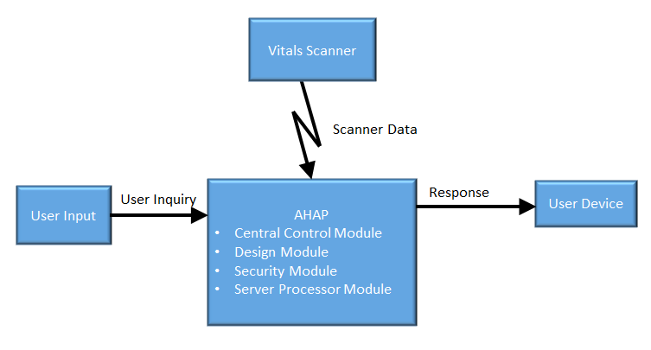

**Figure 1.1:** Level 0 Data Flow Diagram for the AHAP.

The foremost objective of the AHAP is to allow users to be able to analyze and observe their health by frequent monitoring of vital signs and to provide personalized advice on lifestyle and nutrition to ensure optimal health.

AHAP is a software application which provides major functions such as the ones listed below:

* secure log-in and access of data
* data allocation locally and remotely
* data processing and analysis
* updating central database to build upon

AHAP has unique features not offered by other systems with similar characteristics. These unique features include:

* fully automated up-to-date analysis
* ability to integrate personal health history with health service provider
* ability to cross reference large libraries to determine diagnosis

**1.3.2 Hardware and Software Considerations**

AHAP can be implemented on almost any modern operating system, including mobile operating systems. The network AHAP uses to process information is built on a private network that is not accessible to the public. The user must have internet access, a device with a modern operating system, and optionally a backup drive.

The corresponding information is private to each unique user, but AHAP has the capabilities that allow the user to select person(s) whom data can also be sent to. AHAP also offers the user the ability to prioritize particular information. AHAP is severely limited by the reliability of the user's internet connection.

AHAP will manage the raw data from the scanning device, process the data, and display the information to the user. AHAP will receive data on the user's vitals, process the data, and display information dynamically.

**1.4 Documentation of the Development Process**

The AHAP detailed functional description is documented in section 2.0. Basically, Section 2.0 is a succinct software description document. The overall detailed functional description is based on higher level DFDs (above level 1). All major functional units are described in detail in this part of the document.

Requirements affecting the AHAP are captured in Section 3.0 of this document. These requirements are a refinement and completion of requirements first collected as part of a previous Software Engineering project. The document is cited in Section 1.2.2. This section is the one worked in most detail to become a reasonably complete Software Requirements Document (SRD). It includes both functional and non-functional software requirements together with several detailed “rational” paragraphs whenever necessary to complete the understanding of each requirement.

Section 4, **to be developed in CS437,** is the AHAP detailed Software Design Document (SDD). This part of the document includes all higher level DFDs as described in Section 2.0, plus all interface units. The document is higher technical and it is based on Section 2.0 descriptions.

Section 5, **to be developed in CS437,** includes elements of an implementation of the AHAP. This section includes various constraints that effectively limit the implementation, as well as the sub-units that will be coded. The implementation goals are defined, the code and pseudo-code are included as an attachment to this section.

Section 6, **to be developed in CS437,** is the last major section in this document and includes the overall Test Plan (TP) of the AHAP. The test plan details the various techniques used to test the requirements and it also includes a Validation Matrix where each requirement specified in Section 3.0 is listed with its corresponding validation method. In addition, TP specifies the mandated peer reviews needed to validate the stockholders part of the requirements.

**1.5 References**

All references used in the creation of this document are listed below.

**1.5.1 Controlling Documents**

There is no document controlling this document.

**1.5.2 Applicable Documents**

No additional applicable document has been used in the production of this document.

**1.5.3 Standards**

No Standard has been used in the creating of this document. However, some Standards described in textbooks have been examined as a reference. In particular, the IEEE Standard which has been discussed in class.

**2.0 DETAILED FUNCTIONAL DESCRIPTION OF AHAP**

**2.1 Detailed AHAP Functional Description.**

The major tool used to design AHAP is the Data Flow Diagram, DFD. The rational behind the selection of DFDs as the preferred design tool was their simplicity and versatility. In the future more sophisticated tools may be used particularly if a stronger correlation from Design to Requirement to Implementation and Testing is required.

**2.1.1 Level 1 DFD**

The AHAP major functional subunits are shown in the Context Diagram (DFD Level 1) given below.

**Context Diagram (DFD Level 1)**

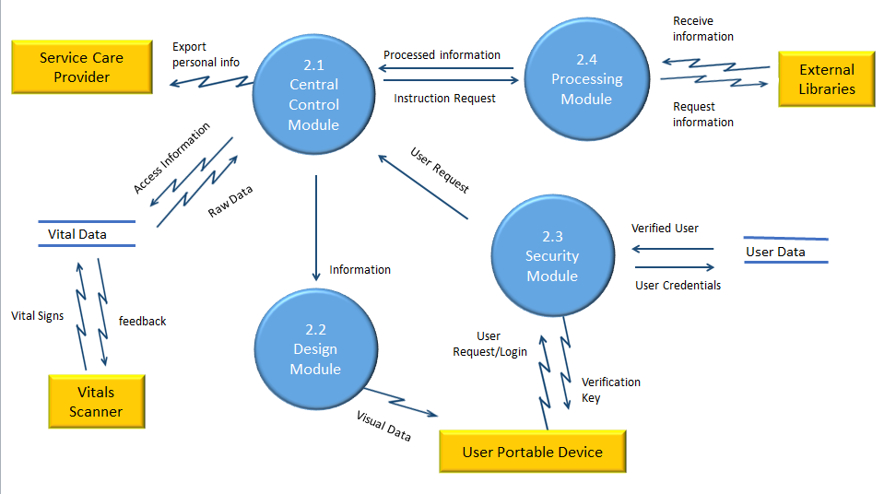

**Figure 2.1:** Level 1 Data Flow Diagram for the AHAP.

**2.1.2 Detailed Functional Description of AHAP’s Major Units.**

The description of the function of the AHAP major functional units shown in Figure 2.1 follows:

Central Control - Module 2.1

The Central Control Module (CCM) essentially directs data flow. Any interaction the user had goes through the Central Control Module. When the user sends in any command, it goes to the CCM.

From the command, the CCM sends an appropriate request to other modules, external devices, and/or servers. The CCM will take in four main commands: scan, send info to external user, login, and view history.

The scan command goes through the CCM and a response is send to the Processing Module. The CCM will await a response from the Processing Module and redirect the contents in the response to the Design Module.

The send info command allows the user to send data to other users. The Central Control Module receives the command and the corresponding data, and redirects it to the other user. The CCM will await a response. If a response is sent back, the response is sent to the Design Module (DM).

The CCM also handles a login requests from the user (along with the login info). The login information is redirected to the Security Module. The CCM awaits a verification status. The verification status is sent back to the user device, either to allow access or deny access.

The CCM also handles a view history command. It takes in the command and sends a request to the DM. The history of a user is stored locally.

Design - Module 2.2

The Design Module (DM) displays the information that is user friendly for the user to interact with AHAP. The DM generally receives data from other modules and uses that to generate an easy-to-read page.

The DM displays an interface for the user to input login and credential information as well as activating the vital scanner to perform a scan. The DM also provides a display for the user to request any personal information, such as login information, profile information, past medical history, and any records.

Any requested information or server generated information (advice or analysis) will be presented to the user’s device from the DM.

Security - Module 2.3

To access and use AHAP, all users are required to have an account to log in the system. Users need to login by using username and password. Once username and password is entered, login information will be encrypted and sent to the Security Module (SM) for verification. When the user logs in successfully, the program will direct the user to the Center Control Module; otherwise, the SM will prompt the user to re-enter his or her login information. In this case, the user have the option to retrieve their username and password.

For intense security, the SM will only allow a maximum of three attempts to login. The user’s account will be locked after three attempts failed. Moreover, the system have the function to automatically log the user out after he or she has been inactive for ten minutes; it will redirect the user to the login page.

Additionally, the SM shall encrypt data sent by user and decrypt retrieving data.

Processing - Module 2.4

The Processing Module (PM) takes in a request and any corresponding data of the user's vitals. When the CCM receives the user's request and the user's data, the CCM routes the request and data to the PM, which will store unidentifiable health information to an anonymous database.

Upon receiving the request, the PM will send out requests to the anonymous database and other databases for information. When the responses are received from the databases, the PM will use an algorithm to produce data that will be relevant to the user. The PM is equipped with an algorithm that utilizes both census data and control data (from both anonymous user info. database and external libraries respectively) to generate relevant data.

The data that the PM produces is data that can be used by the Display Module to display the information to the user. The new data is sent back to the CCM and eventually back to the user’s device.

**3.0 AHAP REQUIREMENTS**

**3.1 AHAP Functional Requirements**

This section collects all the AHAP Functional Requirements. This section includes the complete set of functional requirements with explanation and rationale where the statement of the requirement was deemed insufficient or needing additional background/justification. All requirements relate to the design modules described in Section 2.0. An effort has been made to standardize the correlation between the design modules and the requirements to make their access and organization more consistent. For example, requirement number ‘n’ affecting module 2.1 will be labeled 3.1-n.

|  |  |
| --- | --- |
|  | **Requirements Related to Design Module 2.1: Central Control (CCM)** |
| Requirement No. | Requirement Description |
|  | **CCM Input Submodule (CCMIS)** |
| 3.1.1 | The CCMIS shall receive user’s requests. |
| 3.1.2 | The CCMIS shall receive user’s login input. |
| 3.1.3 | The CCMIS shall receive verification status from the Security Module (SM). |
| 3.1.4 | The CCMIS shall receive data from the Processing Module (PM). |
| 3.1.5 | The CCMIS shall receive all responses from external users. |
| 3.1.6 | The CCMIS shall receive all data from scanner unit. |
|  | **CCM Output Submodule (CCMOS)** |
| 3.1.7 | The CCMOS shall send out display-ready data to the Design Module (DM). |
| 3.1.8 | The CCMOS shall send out login input to the SM. |
| 3.1.9 | The CCMOS shall send out user requests to the PM. |
| 3.1.10 | The CCMOS shall send out any requests to external users. |
| 3.1.11 | The CCMOS shall send out commands to the vitals scanner. |

|  |  |
| --- | --- |
|  | **Requirements Related to Design Module 2.2: Design (DM)** |
| Requirement No. | Requirement Description |
| 3.2.1 | The DM shall receive all display-ready data from the CCM. |
| 3.2.2 | The DM shall use display-ready data to dynamically generate a visual representation of the data. |
| 3.2.3 | The DM shall generate a main menu that redirects the user accordingly. |
| 3.2.4 | The DM shall generate a login page. |
| 3.2.7 | The DM shall generate a logout option. |
| 3.2.8 | The DM shall generate an option to activate the scanner. |
| 3.2.9 | The DM shall dynamically generate a history page based on user input. |
| 3.2.10 | The DM shall notify the user of any warnings, errors, or malfunctions. |
| 3.2.11 | The DM shall send a user interface to a user device. |

|  |  |
| --- | --- |
|  | **Requirements Related to Design Module 2.3: Security (SM)** |
| Requirement No. | Requirement Description |
|  | **SM Login Submodule (SMLS)** |
| 3.3.1 | The SMLS shall verify user login credentials. |
| 3.3.2 | The SMLS shall use a firewall. |
| 3.3.3 | The SMLS shall ensure that login credentials remain valid, otherwise it shall terminate the current session. |

|  |  |
| --- | --- |
|  | **Requirements Related to Design Module 2.4: Processing** |
| Requirement No. | Requirement Description |
| 3.4.1 | The PM shall use control data from MySQL database to calculate user requested data. |
| 3.4.2 | The PM shall use census data to compare user requested data. |
|  | **PM Input Submodule (PMIS)** |
| 3.4.3 | The PMIS shall receive data on user’s vitals from the CCM. |
| 3.4.4 | The PMIS shall receive data from MySQL database. |
| 3.4.5 | The PMIS shall receive all instruction requests from the CCM. |
|  | **PM Output Submodule (PMOS)** |
| 3.4.7 | The PMOS shall send a request to access information MySQL database. |
| 3.4.8 | The PMOS shall send a request to access information to MySQL database. |
| 3.4.9 | The PMOS shall send processed information to the CCM. |

**3.2 AHAP Non-Functional Requirements**

This Section collects all the AHAP Non-Functional Requirements. All non-functional requirements are numbered “NF – n” where “n” indicates the nth requirement.

NF - 1 User must have ability to export a report to a third-party service care provider.

NF - 2 AHAP must maintain a database of health statistics comprised of data users have sent in.

NF - 3 AHAP must have an updated database and access to web search to supplement AHAP’s libraries.

NF - 4 AHAP must have a method of operating the sensors through the user interface.

**3.3 AHAP Hardware Requirements**

This Section collects all AHAP’s electronic hardware requirements. All hardware requirements are numbered “H – n” where “n” indicates the nth requirement.

H - 1 Sensors that have capability to measure vital signs that must include at least body temperature, heart rate, blood pressure, cholesterol.

H - 2 User interface must have a display monitor, a keyboard input method, and a point and click cursor.

H - 3 Remote hosted server must be able to hold Giga Terabytes of data and must have the ability to be scalable to grow. Server must have enough CPU to run millions of processes per second and be scalable.

H - 4 AHAP must run on a standard operating system but shall also be compatible for mobile systems.

**4.0 AHAP DETAILED DESIGN**

In this section the AHAP described in Section 2 with requirements listed in Section 3 will be designed in detail including several higher level DFDs. Each major module detailed design is included in correspondence with the design sections defined in Section 2 and responding to the requirements listed in its correlated sub-section in chapter 3.

The detailed design of each of the four modules discussed in section 2 with requirements presented in section 3 is presented in the Figures below.

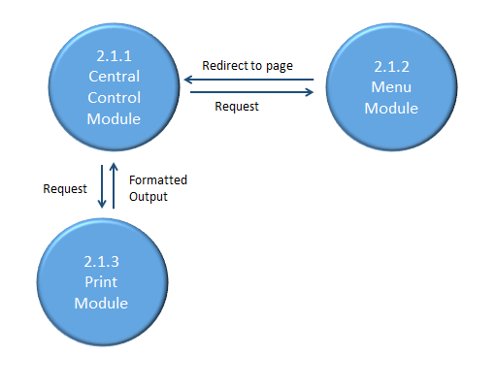

**Figure 3.1:** Level 2 Data Flow Diagram for the AHAP.

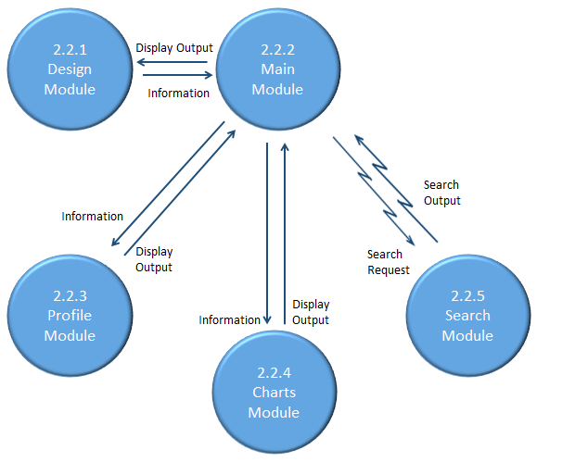

**Figure 3.2:** Level 2 Data Flow Diagram for the AHAP.

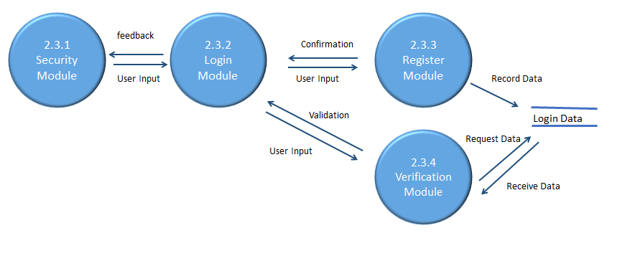

**Figure 3.3:** Level 2 Data Flow Diagram for the AHAP.

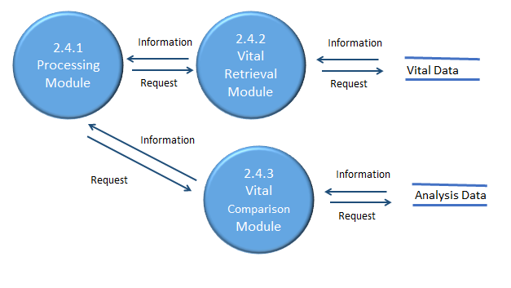

**Figure 3.4:** Level 2 Data Flow Diagram for the AHAP.

**5.0 AHAP ELEMENTS OF IMPLEMENTATION**

In this section (some of) the modules designed in Section 4 with requirements listed in Section 3 will be implemented with code. Each module is implemented in correspondence with the design sections defined in section 2 and responding to the requirements listed in its correlated sub-section in chapter 3.

See attached code documentation.

**6.0 AHAP TEST PLAN**

**6.1 INTRODUCTION**

In this section the testing methodology to be used to V&V each of the requirements listed in section 3.0 has been identified. At points some additional testing may be required and they shall be documented as an attachment to this document.

The methodologies and testing strategies identified at this point include three major approaches with various variations to adapt to the AHAP project:

* Testing using additional ad-hoc created software including a data generator.
* Demonstration of the specified capability
* Inspection of the software code possibly using additional inspection techniques

**6.2 FUNCTIONAL REQUIREMENTS VALIDATION MATRIX**

The AHAP Functional and Performance Requirements Validation Matrix is given below.

|  |  |  |
| --- | --- | --- |
| **Requirements Related to Central Control Module 2.1: Central Control Module** | | |
| Requirement No. | Requirement Description | Testing Methodology |
|  |  |  |
| **Print Submodule** |  |
| 2.1.1 | Print Submodule shall retrieve vital information | Demonstration |
| 2.1.2 | Print Submodule shall Print a report | Demonstration |

|  |  |  |
| --- | --- | --- |
| Requirement No. |  | Testing Methodology |
| **Menu Submodule** |  |
| 2.1.3 | Menu Submodule shall redirect user to requested page | Demonstration |

|  |  |  |
| --- | --- | --- |
| **Requirements Related to Central Control Module 2.2: Design Module** | | |
| Requirement No. |  | Testing Methodology |
| **Main Submodule** |  |
| 2.2.1 | Main Submodule shall display updated vital reading | Demonstration |
| 2.2.2 | Main Submodule shall display analysis of vitals | Demonstration |
| 2.2.3 | Main Submodule shall redirect to Search Module | Demonstration |
| 2.2.4 | Main Submodule shall redirect to Charts Module | Demonstration |
| 2.2.5 | Main Submodule shall redirect to Profile Module | Demonstration |

|  |  |  |
| --- | --- | --- |
| Requirement No. |  | Testing Methodology |
| **Profile Submodule** |  |
| 2.2.6 | Profile Submodule shall display user information | Demonstration |
|  |
| 2.2.7 | Profile Submodule shall compare user’s information to census data | Demonstration |

|  |  |  |
| --- | --- | --- |
| Requirement No. |  | Testing Methodology |
| **Charts Submodule** |  |
| 2.2.8 | Charts Submodule shall display vital data in a visual representation | Demonstration |
|  |
| 2.2.9 | Charts Submodule shall display vital information | Demonstration |

|  |  |  |
| --- | --- | --- |
| Requirement No. |  | Testing Methodology |
| **Search Submodule** |  |
| 2.2.8 | Search Submodule shall automatically search the internet for related information pertaining to respective vitals | Demonstration |
|  |
| 2.2.9 | Search Submodule shall allow user to search internet for related information pertaining to respective vitals | Demonstration |

**(Testing Methodology Omitted for Module 2.3, Security Module)**

|  |  |  |
| --- | --- | --- |
| **Requirements Related to Central Control Module 2.4: Processing Module** | | |
| Requirement No. |  | Testing Methodology |
| **Vital Retrieval Submodule** |  |
| 2.4.1 | Vital Retrieval Submodule shall retrieve user’s vital data | Demonstration |

|  |  |  |
| --- | --- | --- |
| Requirement No. |  | Testing Methodology |
| **Vital Comparison Submodule** |  |
| 2.4.2 | Vital Comparison Submodule shall display user vitals | Demonstration |
| 2.4.3 | Vital Comparison Submodule shall compare and analyze user data with database | Demonstration |

**A. ACRONYMS**

**AHAP** Advance Health Assessment Program

**CCM** Central Control Module

**CCMIS** CCM Input Submodule

**CCMOS** CCM Output Submodule

**DFD** Data Flow Diagram

**DM** Design Module

**GUI** Graphical User Interface

**PM** Processing Module

**PMIS** PM Input Submodule

**PMOS** PM Output Submodule

**SDD** Software Design Document

**SID** Software Implementation Document

**SIS** Software Interface Specification

**SRD** Software Requirements Document

**SM** Security Module

**SMLS** SM login Submodule

**SMDS** SM Data Storage Submodule

**SMLS** SM Login Submodule

**STP** Software Test Plan

**TP** Test Plan

**V&V** Verification and Validation

**B. DATA DICTIONARY**

Personal Data Information: Personal Data Information is defined as any data related to the end user of the AHAP System, to include name, age, sex, address, and medical vitals that are stored to track health patterns.

Vital Data Information: Vital Data Information is defined as any medical vitals stored from the end user of the AHAP System, to include but not limited to heart rate, blood pressure, cholesterol, etc.

External Libraries Information: External Libraries Information is defined as the reference of trusted, verified medical and government websites and databases for the most up-to-date and expanded medical library so that the users of the AHAP System can obtain more information about their health.

**C. SOURCES**

www.heart.org/HEARTORG/GettingHealthy/PhysicalActivity/FitnessBasics/Target-Heart-Rates_UCM_434341_Article.jsp

www.webmd.com/first-aid/body-temperature

en.wikipedia.org/wiki/Human_body_temperature

www.heart.org/HEARTORG/Conditions/HighBloodPressure/AboutHighBloodPressure/Understanding-Blood-Pressure-Readings_UCM_301764_Article.jsp

lungcancer.about.com/od/Respiratory-System-Function/a/Normal-Respiratory-Rate.htm

en.wikipedia.org/wiki/Respiratory_rate

www.webmd.com/cholesterol-management/guide/understanding-numbers

en.wikipedia.org/wiki/Low-density_lipoprotein

en.wikipedia.org/wiki/High-density_lipoprotein

www.nlm.nih.gov/medlineplus/magazine/issues/summer12/articles/summer12pg6-7.html

www.webmd.com/cholesterol-management/guide/understanding-numbers?page=2

www.heart.org/HEARTORG/Conditions/Cholesterol/AboutCholesterol/What-Your-Cholesterol-Levels-Mean_UCM_305562_Article.jsp