Evolutionary Computation Homework 1

1. The Eight Queen Problem
   1. Phenotype space is 8! = 40320. For the first column, we have 8 position to place a queen, and 7 position for the second column, and so on.
   2. For a chessboard configuration like below, we can encode it as [2, 4, 1, 6, 7, 5, 3, 8], each number represents a column.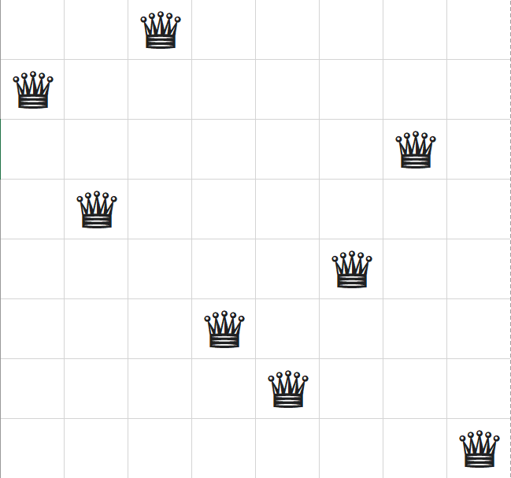
   3. The genotype space is 8! = 40320, as its genotype is a permutation for 1 to 8.
   4. Because that for each different chessboard configuration (phenotype), it can be encoded to a gene series column by column. And for each genotype, it can be converted to a chessboard by putting queen on its corresponding position for each column. The genotype and phenotype space are bijections, so genotype space can cover phenotype space.
2. The needed precision is 0.001, because $2^{-9}$ > 0.001 $2^{-10}$, so we need at least 10 bits to represents its decimal part.
3. 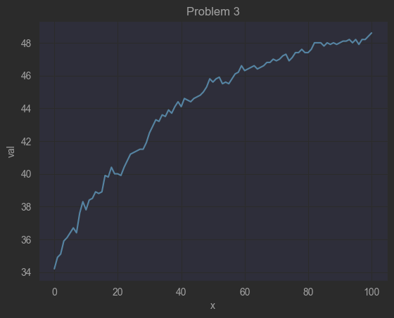
4. 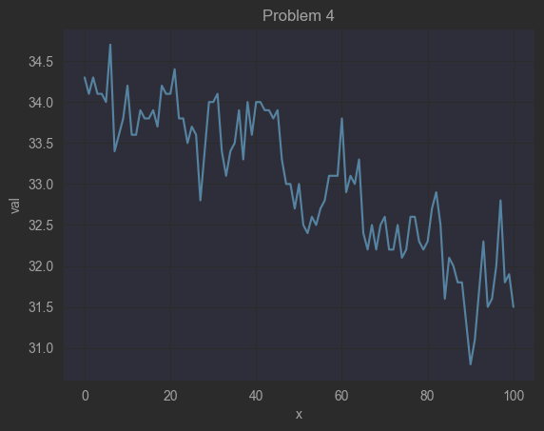
5. 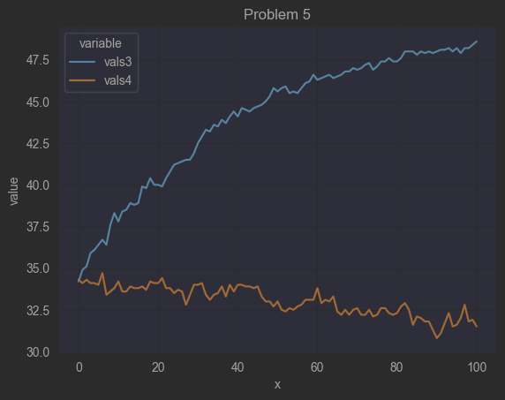 It is obvious that problem 4 fails to converge to a good maximum. I think it’s because of the fitness value does not change a lot among all the genotypes, so its roulette selection would act like a total random choice, propagating any good and bad genotypes to children.
6. 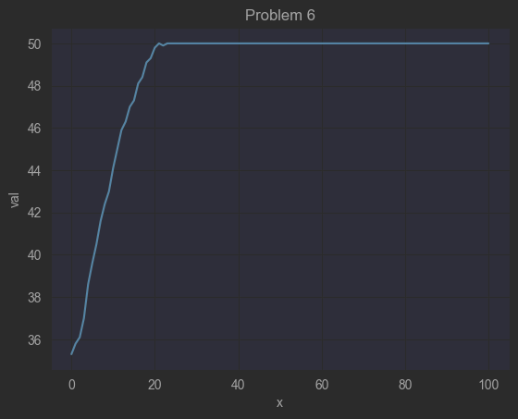
7. 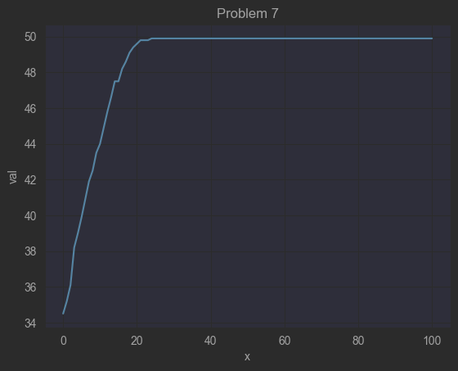
8. 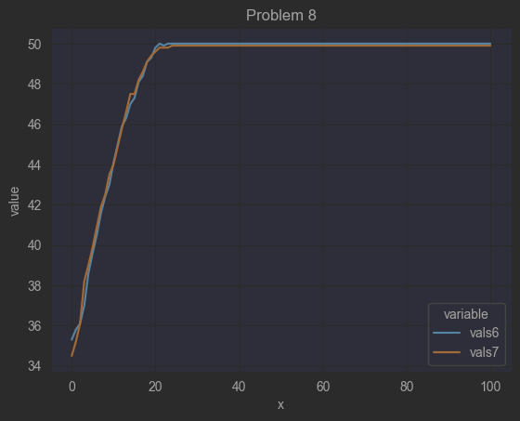 For problem 6 and 7, they converge almost at the same speed, because that tournament selection can distinguish the fitness value even when all values are close to each other, so the change of fitness doesn’t affect a lot.
9. 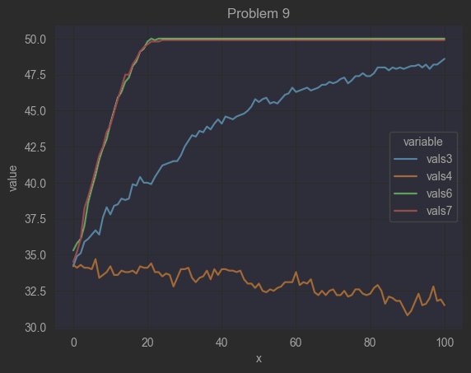 For problem 3, 4, 6, and 7, we can see that tournament selection performs better than roulette selection in the problems. Tournament selection solves the fitness distribution problem in roulette selection.