# SeaUI dev-c++ Compilation method

### Opening DevC, click the button called FILE(文件) in the upper left corner, and a list box appears and select New(新建), then select the project(项目)...... like this

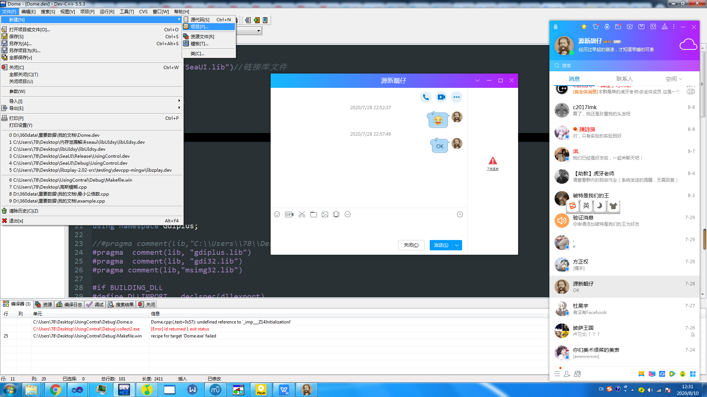

And click it

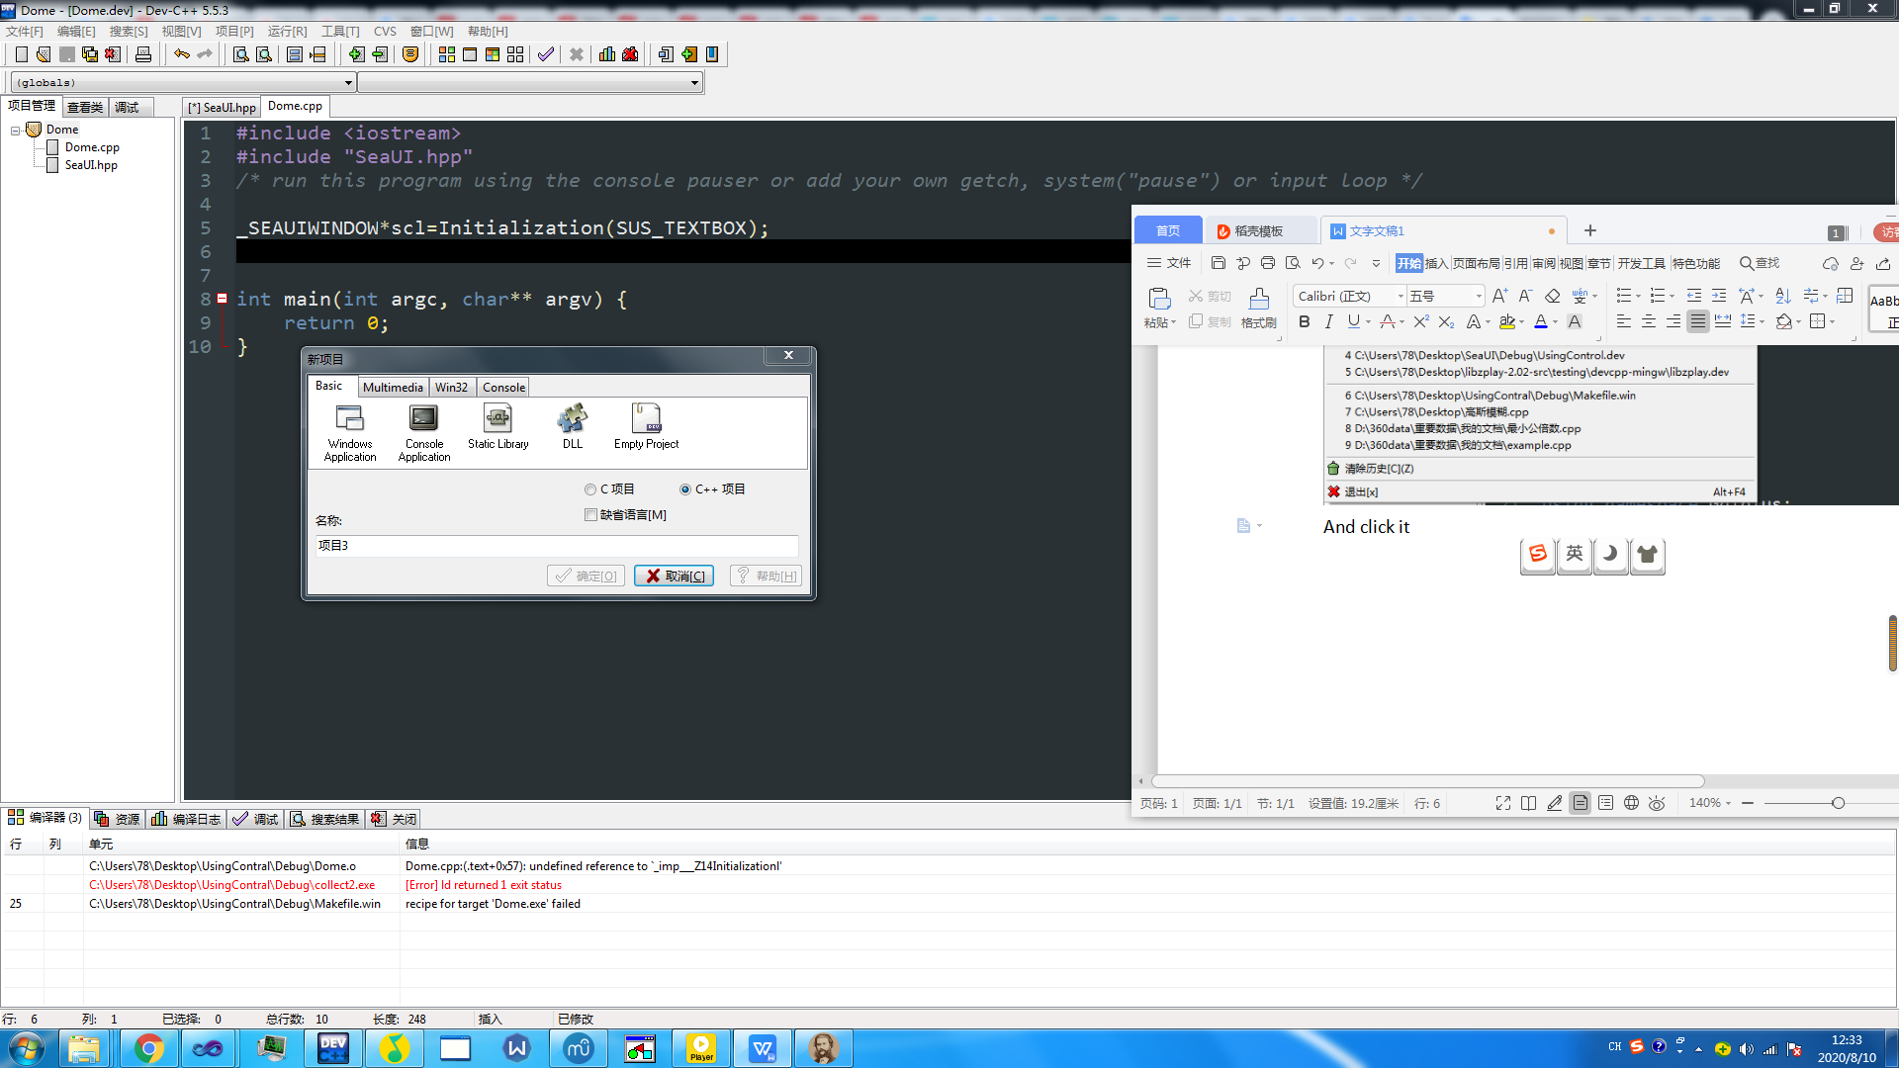

Because the program is developed in Win32,you need to create a project that as Win32 needs.CILIK this 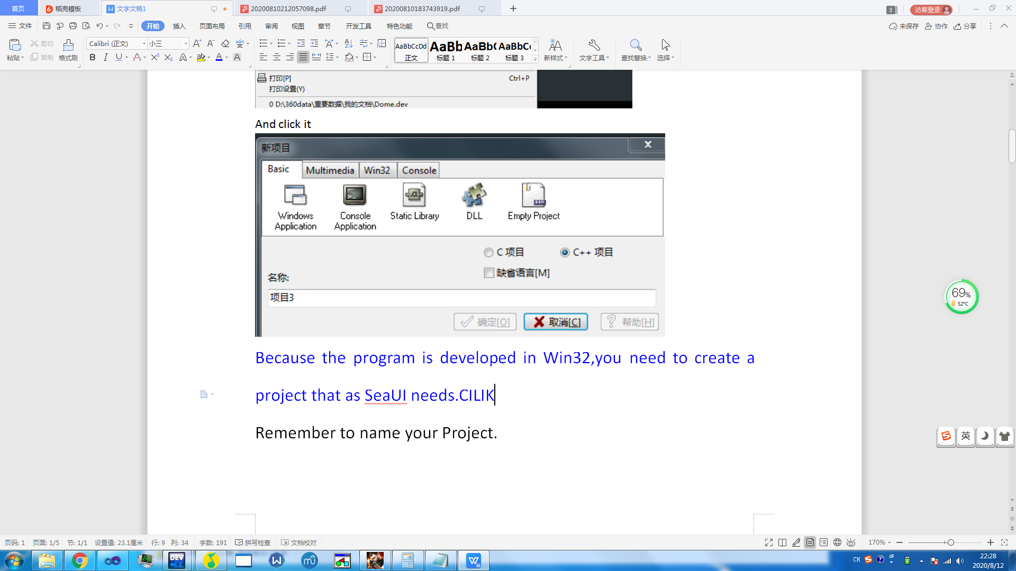button and choose C++ project.

Remember to name your Project.

# Excellent work! You just finished it.

It’s time to work!

### First of all,we should import 4 very important files:

### SeaUI.hpp, SeaUI.a, libgdi32.a, libgdiplus.a

### The codes below show how to import SeaUI.hpp

#include "SeaUI.hpp"//Remember to import it

### [Why I import it by A file instead of LIB file](#_What’s going on when I import it by LIB file)

## But how can I import SeaUI.a,libgdi32.a,libgdiplus.a

Select PORJECT,and choose the Project properties,like this

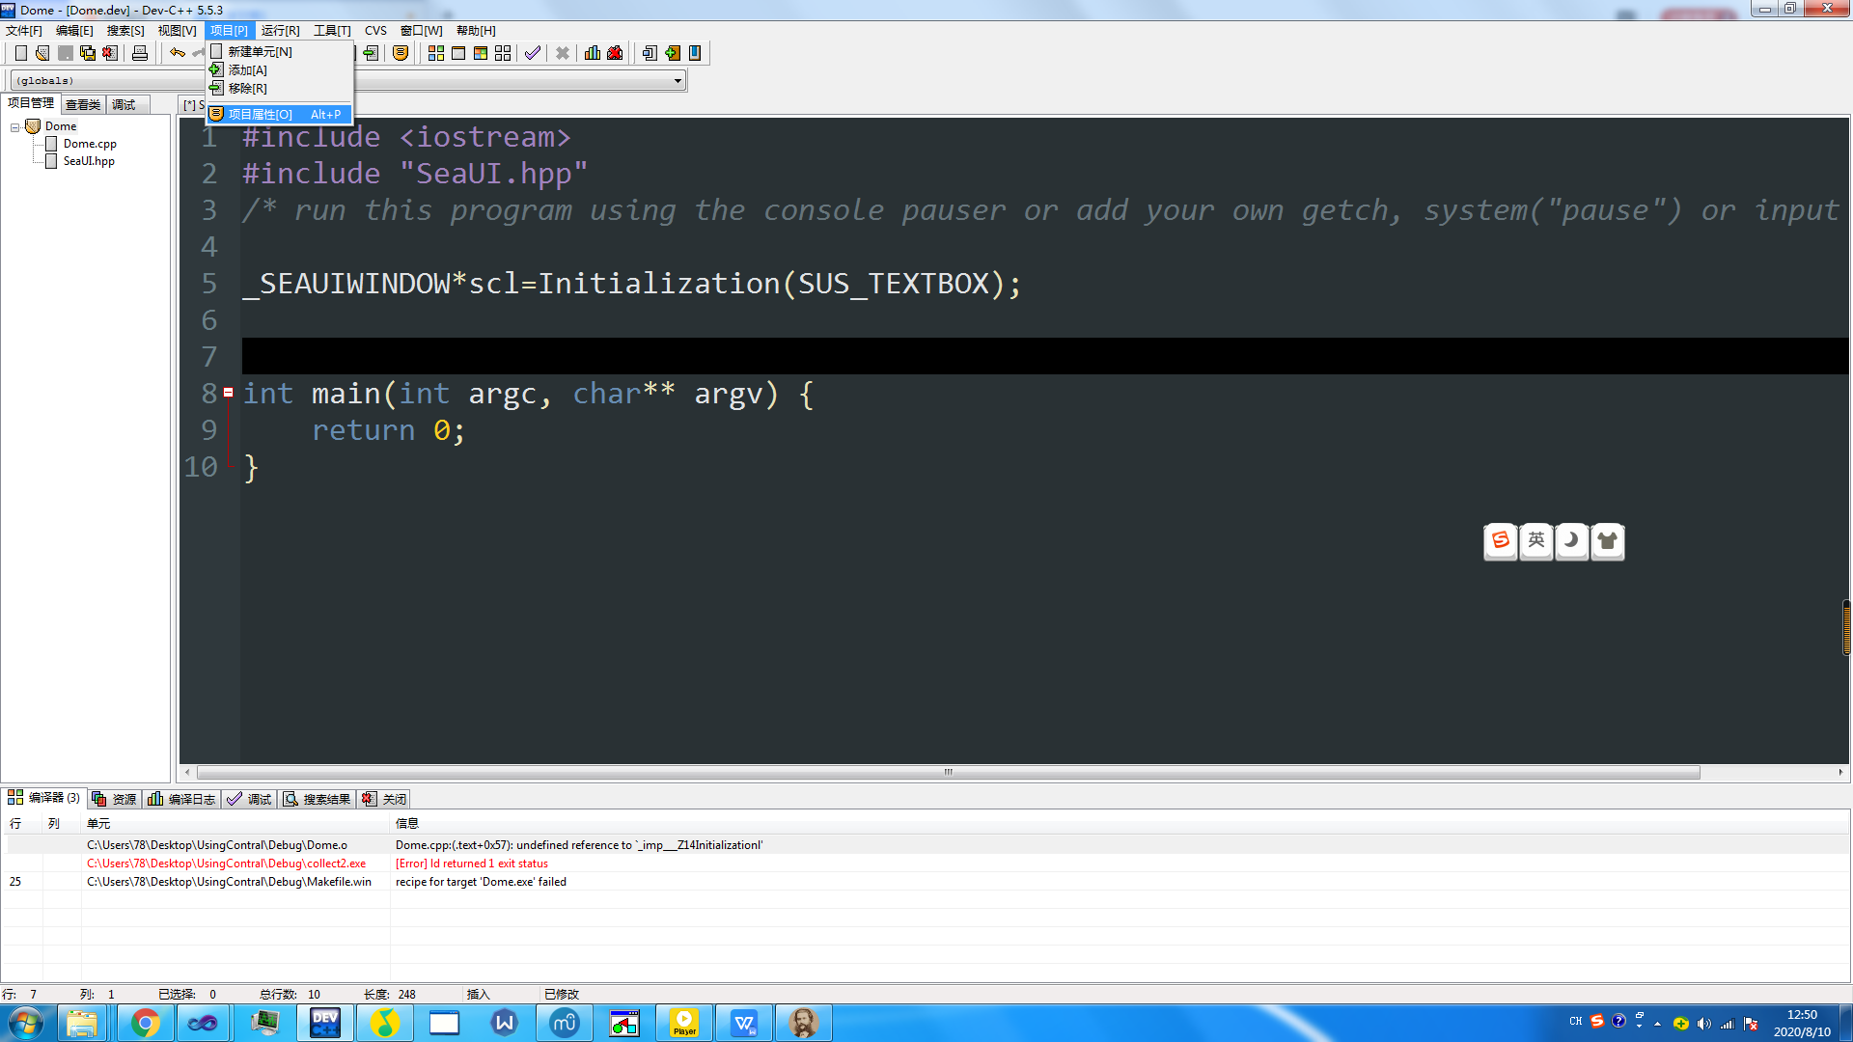

After clicking,you can see:

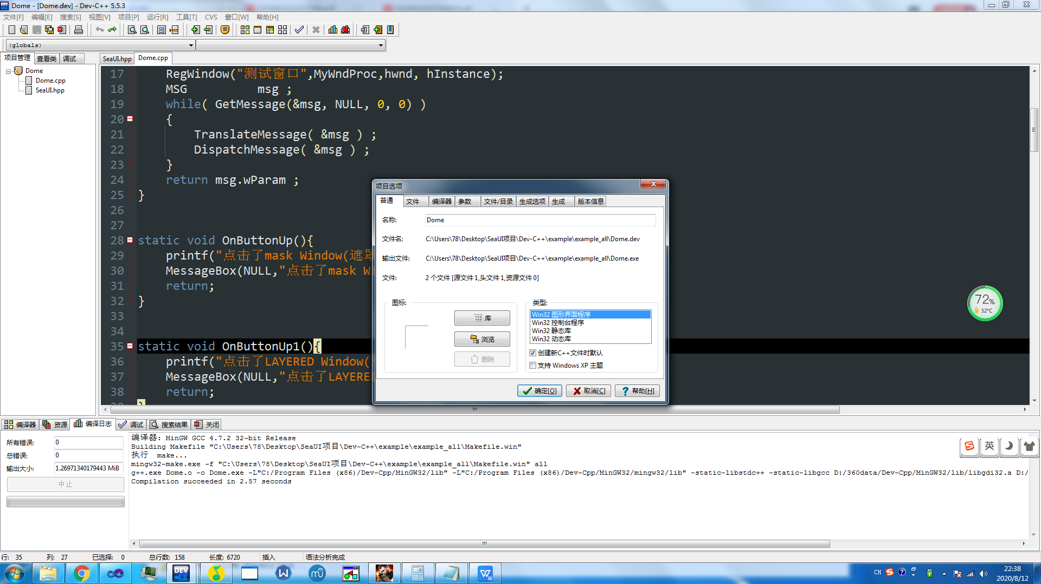

Click the 4th button

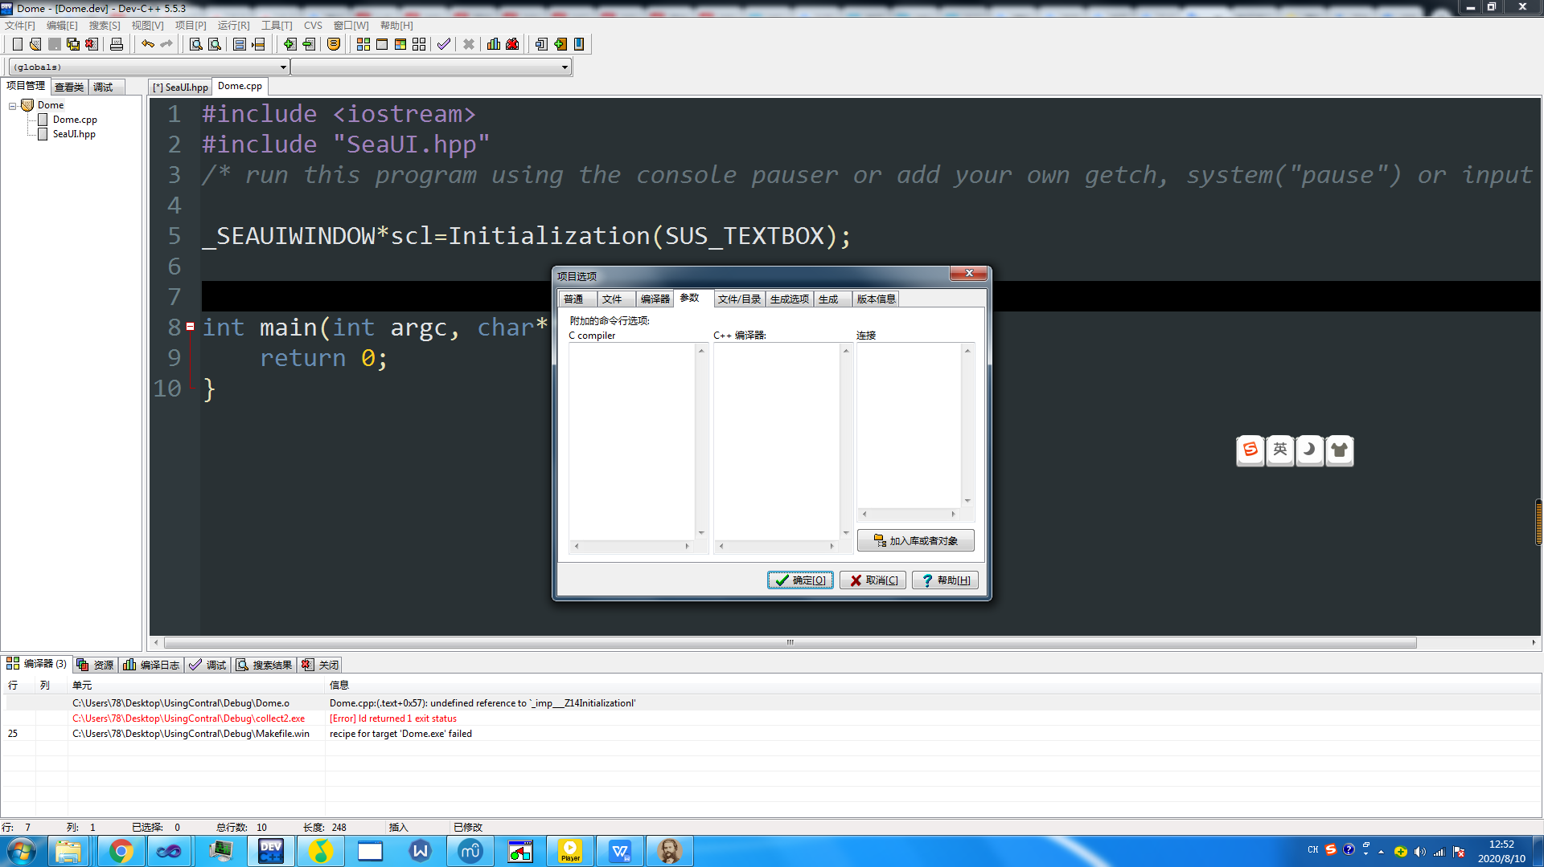

AND CILCK THE BUTTON .

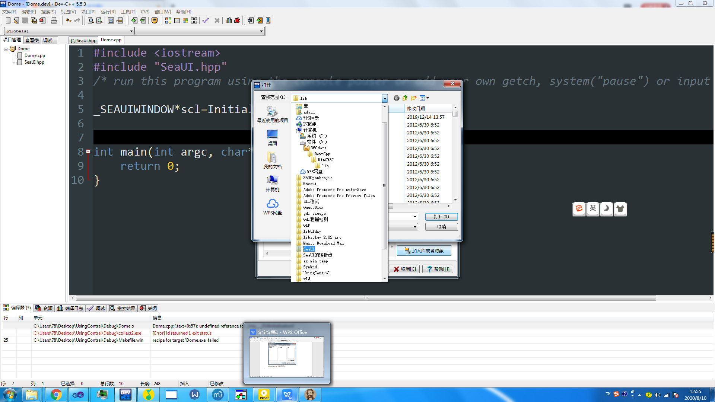

Find the path,you should first import libgdi32.a and libgdiplus.a

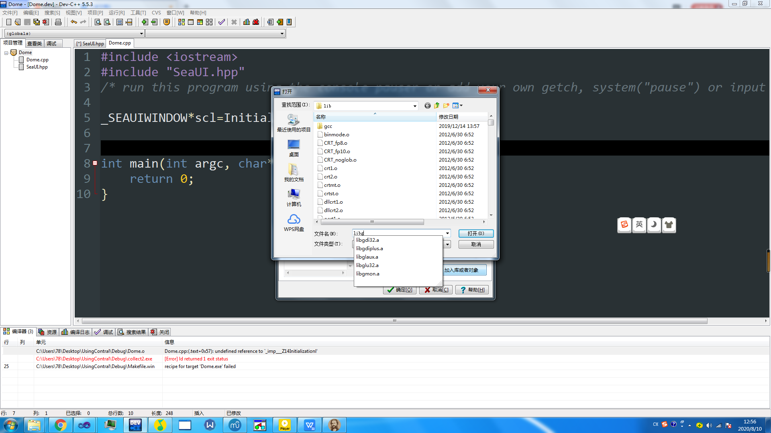

Click it.

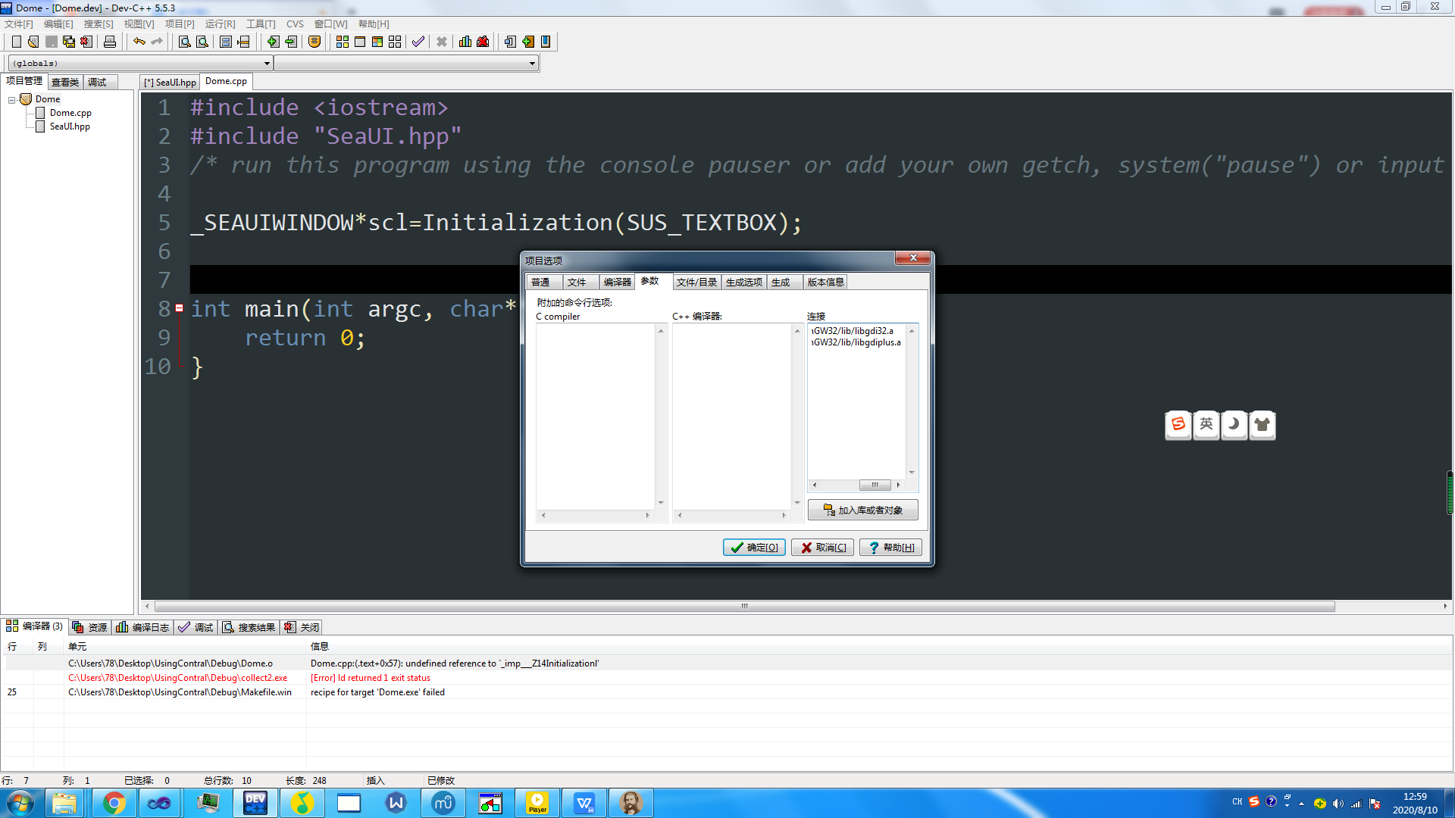

To the same,we can also import SeaUI.a

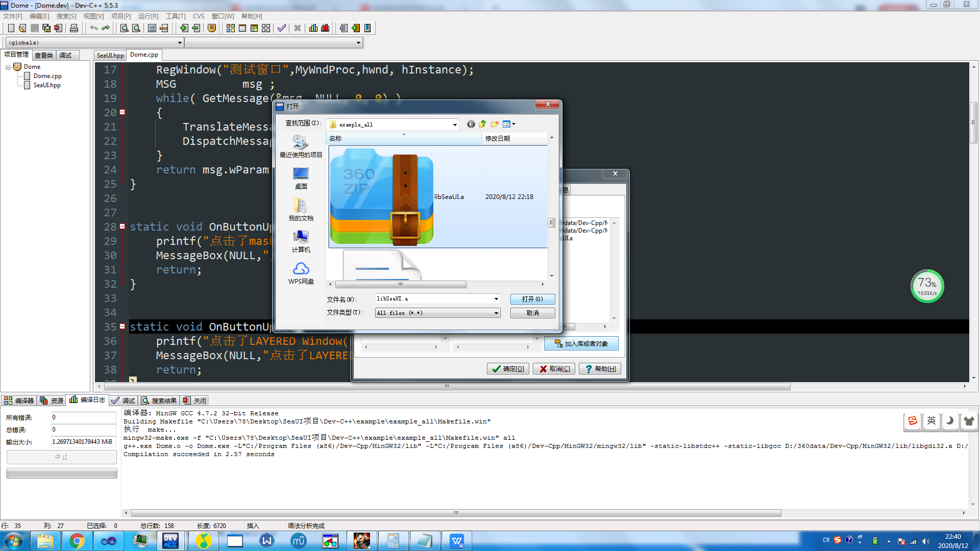

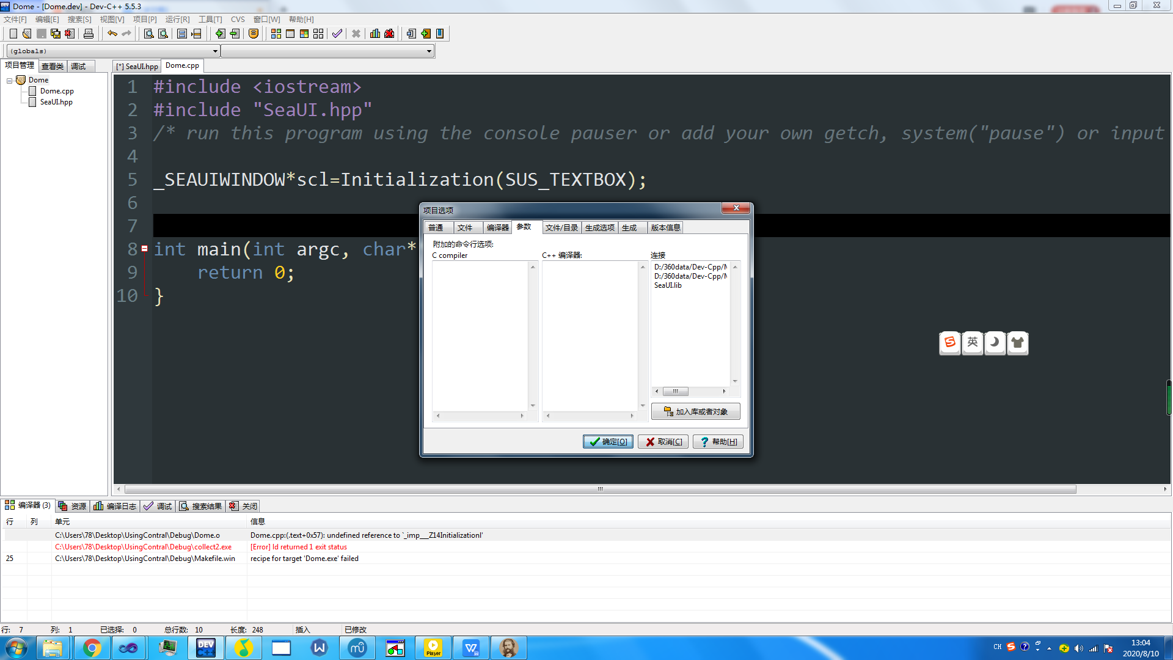

Click Yes

Then compile it.

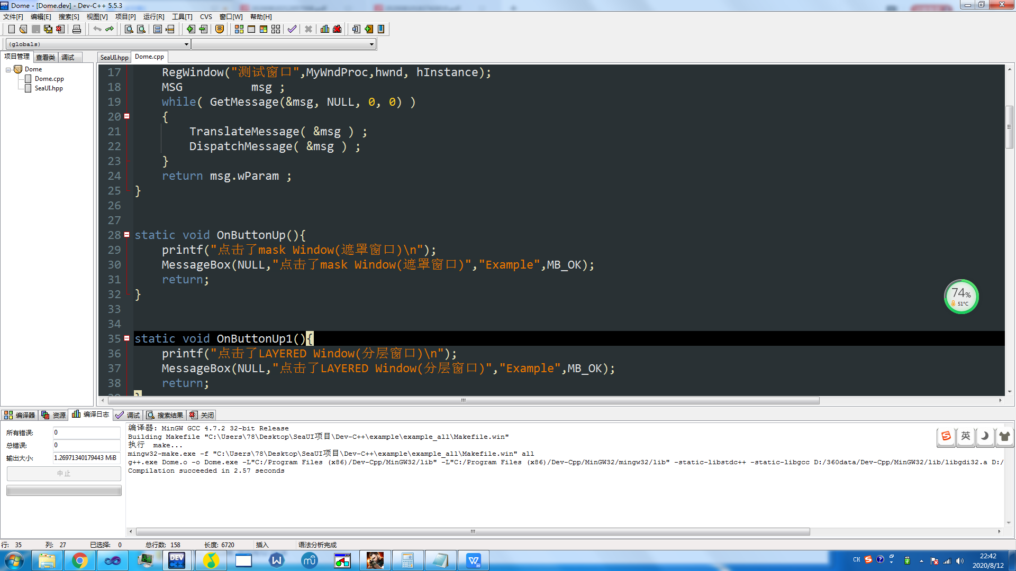

# SUCCESSFUL

# OTHER QUESTIONS

### ---What’s going on when I import it by LIB file

It seems that LIB file is not work in MinGW32 compiler,if you try to import our functions by LIB,you will get this:

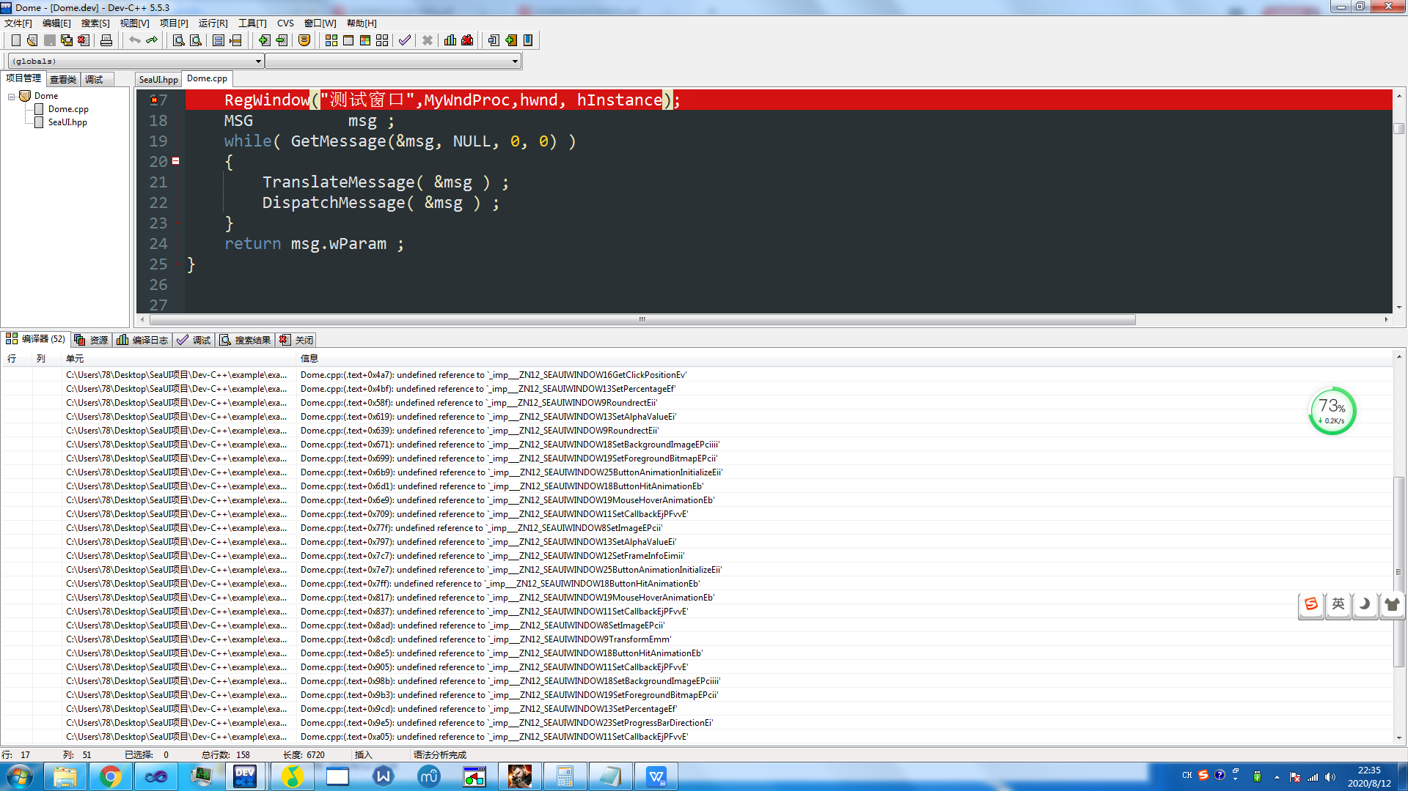

Don’t worry,you just need to import it by “.A” file.the [steps](#_But how can I import SeaUI.a,libgdi32.a,libgdiplus.a) will show you how to import “.A” file