六个样本数据文件如下
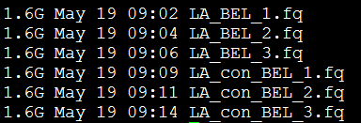
首先进行tophat，需要提前准备参考gtf文件和参考基因组fasta文件
for i in *fq
echo $i
tophat2 -p 13 -G hg19_genes.gtf -o ${i%.*} hg19.fa $id
done <$1
这样就会输出6个样本的tophat文件夹
然后进行cuffdiff找差异
cuffdiff -o LA_BEL -b /home/immune/refer_genome/hg19/hg19 \
-p 18 -L case,control -u merged_gtf/merged.gtf \
./LA_BEL_1/accepted_hits.bam,./LA_BEL_2/accepted_hits.bam,./LA_BEL_3/accepted_hits.bam \
./LA_con_BEL_1/accepted_hits.bam,./LA_con_BEL_2/accepted_hits.bam,./LA_con_BEL_3/accepted_hits.bam

