Systems biology course project #1
Due by 2019.5.7
(hand-in electronically to 11751017@mail.sustc.edu.cn
, write your name on it)

Finished individually, encouraging to discuss with team members, use reference material, and software (Matlab etc) to illustrate your thinking and result. Each student will choose either set 1(problems 1,2, 3) or set 2 (problem 1,2,4)

The problems:
- Try to write the matlab code to solve the enzymatic reaction kinetics without ODE solver (ode45, or any other odesolver), but do the integration yourself. You can modify the week2-3 matlab code, mm.m, mmfunc.m. The time step for the difference equation needs to be chosen carefully. You should choose two time step sizes, and compare the results.

- For equilibrium binding assumption n identical and independent binding sites, please proof (do verification if you cannot proof) the conclusion (in the slide no. 11 of week01-02 ppt)
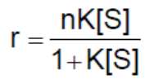
based on Adair equation and other related information on the week01-02 ppt.

- Dilution of proteins due to cell growth

a. A single bacterial cell at time t=0 has volume V₀. After a time interval Td, the doubling time, the cell grows and divides into two cells, each of volume V₀; after another interval Td, there are four cells and so on.

b. Show that the combined volume of cells at time t may be written as V(t)=V₀e^{γt}. Find γ in the terms of Td.
The protein X is created at some rate k(t), so that the total number of molecules of X satisfies 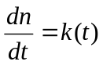. Show the concentration[X]=n/V satisfies
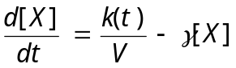
Discuss the origin of the decay term.

c. In addition to the term derived in (b), there should be an extra term that takes into account the degradation of protein by proteinase, which we can model by the effective reaction 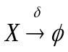. Modify the equation in part (b) in include protein degradation.

4. Gene regulation by sRNA-mediated degradation of mRNA
Considering a target gene M that is transcribed at rate constant θ_{M}, and a repressor gene that co-transcribed a small RNA molecule S at rate constant θ_{s}. Assuming that the messenger RNA of gene M, m, is degraded at rate constant δ_{M}, and the sRNA transcribed off gene S, s, is degraded at rate constant δ_{S}. The small RNA molecules are partially complementary to some portions of the M messenger RNA and when they bind to each other degradation of both molecules is enhanced. We will model this effect by considering the following reaction
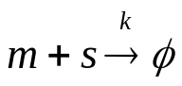

- Write a set of coupled differential equations for describing the time evolution of the concentration of both RNA molecules.
- Solve the steady-state concentration of the M messenger RNA, m∞.
- Plot m∞as a function of the transcription rate constant of the M gene. Explore the behavior for different value of θ_{S} making sure that you include values of θ_{M} much smaller or much larger than θ_{S.}
- In the limit in which θ_{S}>> δ_{S} δ_{M}/k, derive approximate expressions for the behavior of m∞ as a function of θ_{M} for transcription rate constants much smaller and much larger than the sRNA transcription rate constant. Does this system exhibit thresholding behavior?

