**Qi Packet Structure**

**Background:** Qi packets sent between the transmitter and the receiver can offer general information about the charging process. This document will examine the parts of the packet and explain what specific values in each of the parts of the packet signify.

**RECIEVER TO TRANSMITTER MESSAGES**

**Preamble**: The preamble consists of a string of 11 to 25 bits that determine whether the transmitter and the receiver are communicating. If this preamble is all 1’s, that means the receiver is accepting a request, if it is all 0’s that means the transmitter is denying a request, if the preamble alternates between 1’s and 0’s, that means the request from the transmitter is invalid.

**Header:** The header comes after the preamble and is one byte long. The purpose of the header is to provide the size of the message being sent. This value can range from 0x00 to 0xFF. These values represent how many messages and of what size are being sent to the receiver according to the following chart.

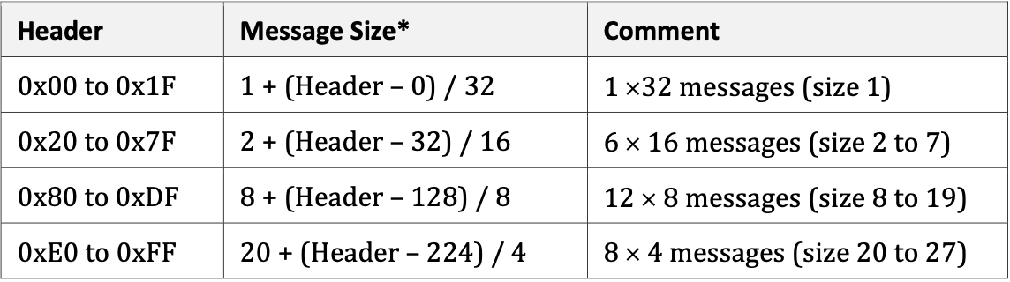

**Message:** Messages between the transmitter and the receiver vary in size and cause various reactions between the two systems. All possible message types are in the table below and will be further described.

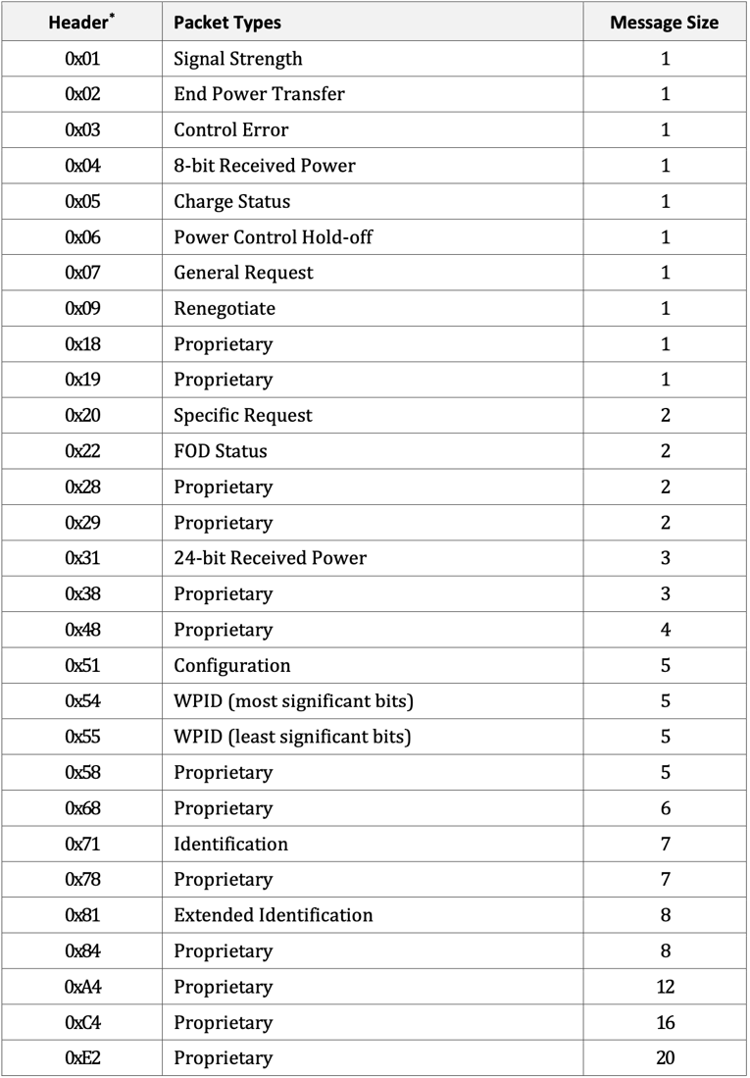

**Signal Strength Packet:** This message is an unsigned integer value that shows the degree of coupling between the primary and secondary coils. This number is based on the rectified voltage, the open circuit voltage, and the amount of received power.

**End Power Transfer Packet:** This packet is an unsigned integer that requests termination of power transfer. If the value is 0x01, it is a request because the battery has received full charge. If the value is 0x00 or between 0x02 and 0x0B, power transfer is ended because a fault has been observed.

**8-bit Received Power Packet:** Indicates how much power has been received within the time window defined in the Configuration Packet.

**Charge Status Packet:** If a mobile device has a energy storage device, this packet will be an integer on the scale of 0 to 100 indicating how charged the batter is. Otherwise, the value will be set to 0xFF.

**Power Control Hold-Off Packet:** Indicates how much time the transmitter should wait in milliseconds after the control error packet is received until it updates the current from the primary cell.

**Configuration Packet:** This packet defines how much power the device can be sent and how the power should be sent to the device. This could be exploited by increasing the max power value so the phone can be overcharged.

**Identification Packet:** Identifies to which revision of this specification the power receiver complies. Also contains manufacturer code that identifies the manufacturer of the receiver. The Basic Device Identifier also contains a unique 20-bit serial number for the device.

**Extended Identification Packet:** Contributes to the identification of the power receiver

**24-bit Received Power Packet:** Tells receiver how much power the phone is receiving

**General Request Packet:** This packet is used to request a specific packet from the transmitter

**Specific Request Packet:** Can request end negotiation, guaranteed power, received power, FSK parameters, and maximum power.

**TRANSMITTER TO RECEIVER MESSAGES**

**Power Transmitter Identification Packet:** Identifies what the manufacturer and ID of the transmitter is. Also identifies to which revision of the specification the transmitter complies.

**Checksum:** The checksum comes at the end of the packet and signifies whether the header is consistent with the message being sent. It does this by comparing what the header states should be in the message to the actual message. Inconsistent values cause the checksum to be invalid and the packet is disregarded by the receiver.