Check cmdb or lcs request for S95 level, before proceeding with below request.

Except for Step 4, all other steps will remain for all levels.

Step 1. Login to saarthi and update target hostname.

update target host in /etc/ansible/hosts under [newinstall], see below



I have taken is-splk-hfwop08.am.lilly.com in this example.

Step 2. Go to location

cd /IIHS_work/Live_Ansible/iihs_playbooks/splunk/



Step 3. Run playbook changepasswdgroup.yml



* take backup of /etc/passwd, /etc/group
* comment any existing entry of splunk-otel-collector & td-agent in both files
* create user and group splunk-otel-collector, tdagent
* it will correct ownership, permission on their respective directories (ignore any error on this if it is new installation).

Step 4. Run playbook newinstall.yml





* this will deploy splunk-otel-collector, td-agent with their dependent libraries.
* Add splunk-otel-collector & td-agent services in systemctl.
* Do initial configuration.
* Restart splunk-otel-collector & td-agent service after install.

Note : If above playbook fail, then do not proceed with Step 5, check for the error message, as it might fail due to connectivity issue, wrong s95, check if that host need some proxy if yes then follow step 4 mention under proxied environment on next page).

Step 5. Run playbook varenv.yml



* This will set systemctl env for (zone, machine role, s95 level variables from ksinput of host) in ./bashrc
* Update custom scripts like adinfo, subscription manager, swap etc.
* Update /etc/otel/collector/agent_config.yaml to include these custom metrics.
* Restart of splunk-otel-collector service.



Note : If no failure received at this point you can proceed with step 6 validation.

Step 6. Validation

Click on below link

<https://lim.signalfx.com/#/home>

* It will take you to below page.
* Click on splunk on upper-left corner and select lilly-prod

* Click on infrastructure

On middle of your screen you’ll notice multiple dashboards, click on hosts

* Click on Add filter

* Select host.name and enter hostname, and it may give two entries like below select the one with fqdn, and click apply filter.

* It should give you below status

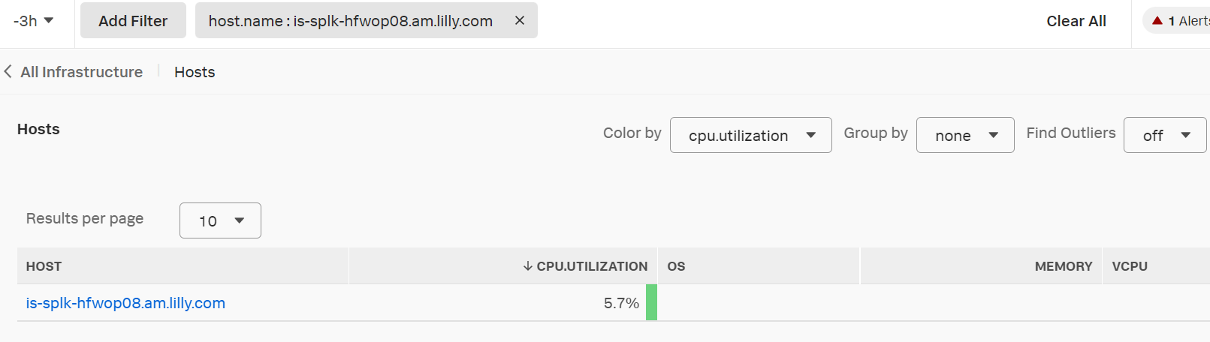

* Deployment Complete.

For Proxied Env (Level 4, 3.5, 3 etc.)

Step 4. Manual installation (for level other than Level4, proxied env.)

Saarthi:/IIHS_work/Live_Ansible/iihs_playbooks/splunk/

scp rh$splunk-otel-collector.sh targethost:/tmp/ (rh7 for rhel7, rh8 for rhel8)

scp l$_override.conf targethost:/tmp/ (l3 for level 3,3.5 and l4 for level4 proxied env)

scp agent_config.yaml targethost:/tmp/

ssh target hosts

mv /tmp/rh7splunk-otel-collector.sh /tmp/splunk-otel-collector.sh

chmod +x /tmp/splunk-otel-collector.sh

rm -rf /etc/yum.repos.d/splunk-otel-collector.repo

rm -rf /etc/yum.repos.d/td_agent.repo

rm -rf /var/cache/yum/*

for rhel7:

/usr/bin/subscription-manager register --org=Eli_Lilly --activationkey=C_RHEL7_SV-Stage-AK –force

For rhel8:

/usr/bin/subscription-manager register --org=Eli_Lilly --activationkey=C_RHEL8_CV-Stage-AK –force

sh -x /tmp/splunk-otel-collector.sh --realm us1 -- Q3t_1A2Jf40oeZUFNyRo5A --mode agent

for rhel7:

/usr/bin/subscription-manager register --org=Eli_Lilly --activationkey=VIRT-AK,C_RHEL7_SV-Prod-AK –force

For rhel8:

/usr/bin/subscription-manager register --org=Eli_Lilly --activationkey=VIRT-AK,C_RHEL8_CV-Stage-AK --force

cp /tmp/override.conf /etc/systemd/system/splunk-otel-collector.service.d/

cp /tmp/override.conf /etc/systemd/system/td-agent.service.d/

mv /etc/otel/collector/agent_config.yaml /etc/otel/collector/agent_config.yaml.old

cp /tmp/agent_config.yaml /etc/otel/collector/

systemctl daemon-reload

systemctl restart splunk-otel-collector.service

systemctl restart td-agent.service

Once done proceed with Step 5 “Run playbook varenv.yml” followed by Step 6 “Validation”.

RHEL6 Procedure

* Follow Step1, 2 & 3 which will create userid & groupId for splunk-otel-collector & td-agent.
* scp RHEL6otel.tar.gz target host:/tmp/
* Extract only td-agent rpm first and install using below commands :

tar -zxvf /tmp/RHEL6otel.tar.gz RHEL6otel/tmp/td-agent-3.8.0-0.el6.x86_64.rpm

rpm -ivh RHEL6otel/tmp/td-agent-3.8.0-0.el6.x86_64.rpm

* Extract everything in RHEL6otel.tar.gz

tar -zxvf RHEL6otel.tar.gz

* copy config files/directories :

rm -rf /etc/otel

rm -rf /etc/td-agent

rm -rf /usr/bin/otelcol

rm -rf /usr/lib/splunk-otel-collector

mv RHEL6otel/etc/init.d/splunk-otel-collector /etc/init.d/

mv RHEL6otel/etc/otel /etc/

mv RHEL6otel/etc/td-agent /etc/

mv RHEL6otel/usr/bin/otelcol  /usr/bin/

mv RHEL6otel/usr/lib/splunk-otel-collector /usr/lib/

* Add splunk-otel-collector service & Start splunk-otel-collector service & td-agent service

chkconfig --add splunk-otel-collector

* Once done proceed with Step 5 “Run playbook varenv.yml” followed by Step 6 “Validation”.

Basic issues :

* Service status is running, but host is not showing/not reporting in UI.

Check if host need proxy.

Look for detailed error in “journalctl --unit=splunk-otel-collector.service -n 100 --no-page |grep -I error”.

Try restarting splunk-otel-collector service.

* Service is not coming up

Check for permissions/ownership of below directories and correct ownership/permission.

Splunk-otel-collector should have rwx permission.

/etc/otel /usr/bin/otelcol /usr/lib/splunk-otel-collector

Check if any error message related to /etc/otel/collector/agent_config.yaml.

Check if custom scripts are available, and with correct permissions.

Escalation & Vendor Support:

* In case you are not able to fix the issue, open an INC with [PLATFORM-SPLUNK-HCS-GLB](https://lilly.service-now.com/sys_user_group.do?sys_id=1db969ab1bc1c950e4d8dd7ebd4bcb11).
* If splunk team need further support they will open a case with vendor and will provide further guidance.