Design
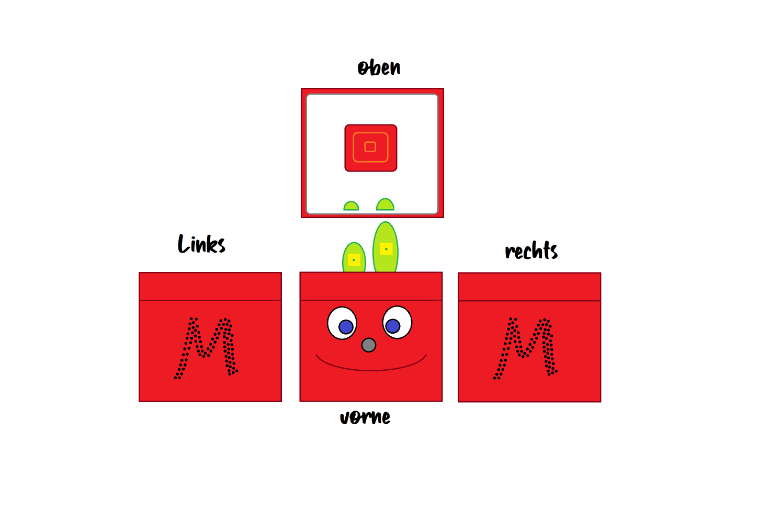
Button leiser
Button lauter
Button zurück
Springen (drücken)
Spulen (halten)
Button vor
Springen (drücken)
Spulen (halten)
Button an/aus
Lautsprecher Löcher

Links
- https://github.com/MiczFlor/RPi-Jukebox-RFID/blob/future3/main/documentation/builders/installation.md#network-management-since-bookworm
- fork:
  - https://github.com/c276/RPi-Jukebox-RFID
  - branch: future3/jimbabox
- https://koboldimkopf.wordpress.com/2020/01/10/tutorial-phoniebox/

RPi GPIO Pinout
RPI4b: https://www.pi4j.com/1.4/pins/rpi-4b.html
https://randomnerdtutorials.com/raspberry-pi-pinout-gpios/
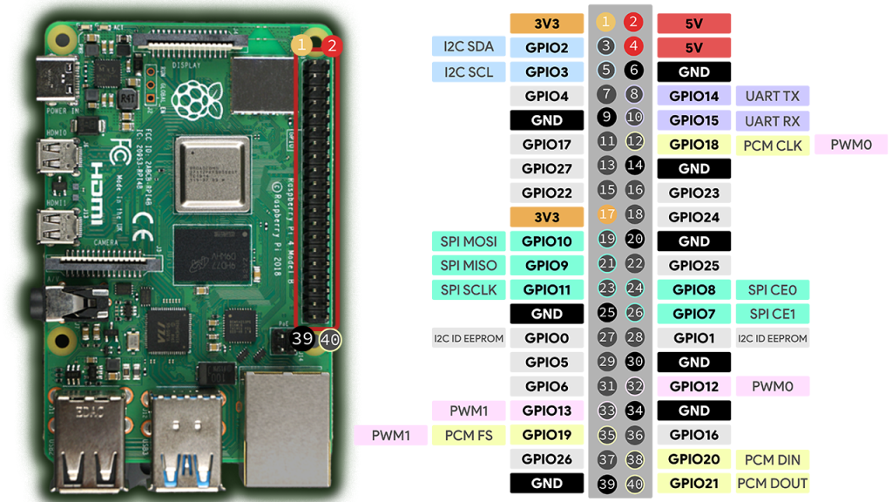

Finale Pinout Belegung

Raspberry Pi
Modul | Pin | Bezeichnung | RPi Pinout | Bezeichnung | Pin | Modul
On/Off Shim  MPU-6050 | 1  1 | 3.3V  VCC | RPi Pinout | 5V | 2 | On/Off Shim
On/Off Shim  MPU-6050 | 3  3 | SCL | RPi Pinout | 5V | 4 | On/Off Shim
On/Off Shim  MPU-6050 | 5  4 | SDA | RPi Pinout | GND | 6 | On/Off Shim
On/Off Shim | 7 | GPLCLK0 | RPi Pinout |  | 8  X | On/Off Shim  x
On/Off Shim  MPU-6050 | 9  2 | GND | RPi Pinout |  | 10  x | On/Off Shim  x
On/Off Shim | 11 | Shutdown | RPi Pinout |  | 12  x | On/Off Shim  x
RFID-RC522 | 7 | RST | RPi Pinout
RFID-RC522 | 8 | 3.3V | RPi Pinout | IRQ | 5 | RFID-RC522
RFID-RC522 | 3 | MOSI | RPi Pinout | GND | 6 | RFID-RC522
RFID-RC522 | 4 | MISO | RPi Pinout
RFID-RC522 | 2 | SCK | RPi Pinout | SDA | 1 | RFID-RC522
Button Previous/Rewind | J06 | - | RPi Pinout
Button leiser | D06 | - | RPi Pinout | - | M06 | Button Next/Fast Forward
Button Board GND | S01 | - | RPi Pinout | - | G06 | Button lauter

Button Board
Board | Button | Board | RPi Pin
S02 – S06 | GND | S01 | GND (39)
D06 | Leiser | D01 | GPIO26 (37)
G06 | Lauter | G01 | GPIO21 (40)
J06 | Zurück | J01 | GPIO19 (35)
M06 | Vor | M01 | GPIO20 (38)
P06 | - | P01 | -

Installation Phoniebox
web-app: http://jimbabox.local / http://192.168.2.102-
jimbabox → check if host is overwritten
pi
12345
ipv6 enabled
ssh m5enabled

autohotspot:
sskd: Phoniebox_Hotspot_jimbabox
pw: PlayItLoud!
Wifi country code: DE
IP: 10.0.0.1

Customize Options
DISABLE_IPv6=false
ENABLE_STATIC_IP=true
ENABLE_STATIC_IP=false
ENABLE_AUTOHOTSPOT=true
AUTOHOTSPOT_SSID=Phoniebox_Hotspot_jimbabox
AUTOHOTSPOT_PASSWORD=PlayItLoud!
AUTOHOTSPOT_COUNTRYCODE=DE
AUTOHOTSPOT_IP=10.0.0.1
DISABLE_BLUETOOTH=true
DISABLE_ONBOARD_AUDIO=false
SETUP_MPD=true
ENABLE_MPD_OVERWRITE_INSTALL=true
ENABLE_RFID_READER=true
ENABLE_SAMBA=true
ENABLE_WEBAPP=true
ENABLE_WEBAPP_PROD_DOWNLOAD=release-only
ENABLE_KIOSK_MODE=true

*******************************************************************************
Equalizer
*******************************************************************************

You may add an software equalizer to the primary output
to compensate for bass deficiencies of small-speaker setups.
If enabled, the default is to lift bass and treble slightly.
You can configure the coefficients in the pulse audio configuration file:
/home/pi/.config/pulse/default.pa

rfid reader:

3 mfrc522 via spi (module rc522_spi/rc522_spi.py)
/home/pi/RPi-Jukebox-RFID/shared/settings/rfid.yaml

SPI CE0 → GPIO8 (Pin 24, not set in guide below)
IRQ → GPIO24 (Pin 18)
Reset → GPIO22 (Pin 15) (SET TO 22, default is 24!)

4-byte-only legacy mode:
Previously the pirc522 library could only read the lower 4 bytes of a card UID. It can now read 4-byte and 7-byte UIDs.
Legacy mode turns back to the old behaviour. This only makes sense,
if you already have an large RFID collection and do not want to re-assign every card
4-byte only legacy mode? [y/N] N

https://pimylifeup.com/raspberry-pi-rfid-rc522/ with modification of https://github.com/MiczFlor/RPi-Jukebox-RFID/blob/future3/main/documentation/developers/rfid/mfrc522_spi.md#board-connections

RFID-RC522 physischer Pin | RFID-RC522 Pin-Bezeichnung | RPi physischer Pin | RPi Bezeichnung
8 | 3V3 | 1 / 17 | 3V3
7 | RST | 15 | GPIO22
6 | GND | 6 / 9 / 14 / 20 / 25 / 30 / 34 / 39 | GND
**5 | IRQ | 18 | GPIO24
4 | MISO | 21 | GPIO9, SPI MISO
3 | MOSI | 19 | GPIO10, SPI MOSI
2 | SCK | 23 | GPIO11, SCLK
1 | SDA | 24 | GPIO8, SPI CE0

** not set in guide at all

RFID-RC522 → RPI:
Pin 1 (3V3) → Pin 1 (3V3)
Pin 2 (RST) → Pin 15 (GPIO22)
Pin 3 (GND) → Pin 6 (GND)
** Pin 4 (IRQ) → Pin 18 (GPIO24) → not set in guide at all
Pin 5 (MISO) → Pin 21 (GPIO9, SPI MISO)
Pin 6 (MOSI) → Pin 19 (GPIO10, MOSI)
Pin 7 (SCK) → Pin 23 (GPIO11, SCLK)
Pin 8 (SDA) → Pin 24 (GPIO8, SPI CE0)

rfid reader: PN5180 (can read tonies with iso15693)
https://www.amazon.de/YOURRYONG-DE-2PCS-PN5180-Module/dp/B0DRWSHRQT/ref=sr_1_1?__mk_de_DE=%C3%85M%C3%85%C5%BD%C3%95%C3%91&crid=3VB1UOPNM043F&dib=eyJ2IjoiMSJ9.YM_9XGNkedvDdYgONezvjxGXHLmh7xkVFkJIpSM7deJQXc_b5FjrnJYr0YiaXO9HwGmh_DjEFg3HL-KLmwngCQ.H4Qdnfp5iIsF-UPQUik2rhrVwK8FNVWSZ8djTZtDX1c&dib_tag=se&keywords=PN5180&qid=1750104000&sprefix=pn5180%2Caps%2C197&sr=8-1
https://www.reddit.com/r/raspberry_pi/comments/ubndwc/using_pn5180_with_a_pi4/

Development
# Make sure the Jukebox service is stopped
$ systemctl --user stop jukebox-daemon

# Edit the file(s)
$ nano ./shared/settings/jukebox.yaml # jukebox config
$ nano /home/pi/.config/mpd/mpd.conf # music player config

# Start Jukebox in console and check the log output (optional)
$ ./run_jukebox.sh
# and if OK, press Ctrl-C and restart the service

# Restart the service
$ systemctl --user start jukebox-daemon

Spotify:

Not working!

https://github.com/MiczFlor/RPi-Jukebox-RFID/issues/1815#issuecomment-1666535983
spotify: https://mopidy.com/ext/spotify/#authentication
[spotify]
client_id = 33640c4b-3588-41ee-bde9-4eba456cfd6e
client_secret = xnN71aH5P3TxMKT9KfVLxK_xY3kJ4BdOy73Ahxz7itA=

spotify-tui + spotifyd
https://github.com/Rigellute/spotify-tui
This combo gives you:
- spotifyd: Plays music via Spotify Connect
- spotify-tui: Terminal UI to control Spotify from the Pi itself (no phone)

🔧 Install it all:
# 1. Install spotifyd
curl -LO https://github.com/Spotifyd/spotifyd/releases/latest/download/spotifyd-linux-armv7-slim.tar.gz
tar -xzf spotifyd-linux-armv7-slim.tar.gz
sudo mv spotifyd /usr/local/bin/

# 2. Configure it (same as before, ~/.config/spotifyd/spotifyd.conf)
Great choice! Since you're running headless, spotifyd is a perfect match. However, there's an important clarification:
⚠️ spotifyd and mopidy-spotify can't be combined — they both play Spotify music independently.
mopidy-spotify uses the now-dead libspotify, and spotifyd uses Spotify Connect.

✅ So the real options are:
- Use spotifyd alone: Your device shows up in the Spotify app and plays whatever you cast to it.
→ Great for simplicity and remote control.
- Use Mopidy for other sources (YouTube, local files, radio) and Spotifyd for Spotify.
→ The best modern setup.

🎯 Goal: Use spotifyd + Mopidy (no Mopidy-Spotify)
You can:
- Use spotifyd to play Spotify from your phone or computer.
- Use Mopidy with extensions like:
  - mopidy-youtube
  - mopidy-local
  - mopidy-radio
- Use Iris (web UI) to manage Mopidy playback.
- Use Snapcast to sync audio between spotifyd and Mopidy if needed.

🛠️ Step-by-Step: Install spotifyd

1. 🚀 Download and install spotifyd

On Raspberry Pi (ARM)
sudo apt install curl unzip -y
curl -LO https://github.com/Spotifyd/spotifyd/releases/latest/download/spotifyd-linux-armv7-slim.tar.gz
tar -xzf spotifyd-linux-armv7-slim.tar.gz
sudo mv spotifyd /usr/local/bin/
For other platforms (x86, x86_64), check: https://github.com/Spotifyd/spotifyd/releases

2. 📝 Create password and config files
echo "your_spotify_password" > ~/.config/spotifyd/spotify_password
chmod 600 ~/.config/spotifyd/spotify_password

mkdir -p ~/.config/spotifyd
nano ~/.config/spotifyd/spotifyd.conf
Paste:
[global]
username = "your_spotify_username"
password_cmd = "cat /home/pi/.config/spotifyd/spotify_password"
device_name = "spotifyd-pi"
backend = "alsa"
volume_controller = "alsa"
use_mpris = false
autoplay = true

echo "your_spotify_password" > ~/.config/spotifyd/spotify_password
chmod 600 ~/.config/spotifyd/spotify_password

3. ⚙️ Enable as a service
Create a systemd unit file:
sudo nano /etc/systemd/system/spotifyd.service
Paste:
[Unit]
Description=Spotifyd daemon
After=sound.target network.target

[Service]
ExecStart=/usr/local/bin/spotifyd --no-daemon
Restart=always
User=pi
Group=pi

[Install]
WantedBy=default.target
Enable and start:
sudo systemctl daemon-reexec
sudo systemctl enable spotifyd
sudo systemctl start spotifyd
Check logs:
journalctl -u spotifyd -f

🧪 Test
- Open Spotify on your phone or desktop.
- In the "Connect to a device" menu, you should see "spotifyd-pi".
- Select it and play music — it streams directly on your Pi!

# 3. Install spotify-tui
sudo apt install cargo libssl-dev pkg-config -y
cargo install spotify-tui
After install, run:
~/.cargo/bin/spt
On first run, it’ll ask for a Spotify token. Follow the prompt in your Pi’s browser (or copy the link to another device).
🎉 Now you can:
- Search songs
- Browse playlists
- Play/pause/skip
- All directly from the terminal on the Pi — no phone needed.

Spotipy + spotifyd
Awesome! Let’s set you up fully with spotifyd + spotipy on your Raspberry Pi for smooth headless Spotify playback and full Python control, including token refresh and systemd service setup.

Step 1: Install and configure spotifyd on Raspberry Pi

1. Install spotifyd
Run:
curl -sS https://spotifyd.org/install.sh | sh
Or if already installed, update it to latest.

2. Create spotifyd config file
mkdir -p ~/.config/spotifyd
nano ~/.config/spotifyd/spotifyd.conf
Add:
[global]
username = your_spotify_username
password = your_spotify_password
backend = alsa
device_name = MyPiSpotifyd
bitrate = 160
volume_control = alsa
Security note: Storing your password in plaintext is insecure. See Step 1.5 below for password manager option.

3. Optional: Use secret-tool to secure your password
If you want to avoid plaintext passwords, use secret-tool (part of GNOME Keyring) to store password and configure spotifyd with:
password_cmd = "secret-tool lookup spotifyd password"
To store your password in the keyring:
secret-tool store --label='Spotify Password' spotifyd password
# It will prompt for password — enter your Spotify password here.

4. Set up spotifyd as a systemd user service
Create service file:
mkdir -p ~/.config/systemd/user
nano ~/.config/systemd/user/spotifyd.service
Paste:
[Unit]
Description=Spotifyd daemon

[Service]
ExecStart=/usr/local/bin/spotifyd --no-daemon
Restart=always

[Install]
WantedBy=default.target
Adjust /usr/local/bin/spotifyd if spotifyd is installed elsewhere (which spotifyd to check).
Enable and start:
systemctl --user daemon-reload
systemctl --user enable spotifyd
systemctl --user start spotifyd
Check status:
systemctl --user status spotifyd
Make sure MyPiSpotifyd appears as a Spotify Connect device on your phone or Spotify client.

Step 2: Set up Spotipy on your control device (can be your Pi or PC)

1. Register Spotify Developer app
- Go: https://developer.spotify.com/dashboard/applications
- Create an app
- Add redirect URI: http://localhost:8888/callback
- Save your Client ID and Client Secret
  - App: https://developer.spotify.com/dashboard/deadcba584e34187b41473e3926c9cff
  - ID: deadcba584e34187b41473e3926c9cff
  - Secret: acfad5acd13f4cc3a323c91b732ff434

2. Install Spotipy
pip install spotipy

3. Create Spotipy control script with token refresh and error handling
Create spotify_control.py:
import spotipy
from spotipy.oauth2 import SpotifyOAuth
import time
import sys

CLIENT_ID = 'YOUR_CLIENT_ID'
CLIENT_SECRET = 'YOUR_CLIENT_SECRET'
REDIRECT_URI = 'http://localhost:8888/callback'
SCOPE = 'user-modify-playback-state user-read-playback-state user-read-currently-playing'

sp_oauth = SpotifyOAuth(client_id=CLIENT_ID,
client_secret=CLIENT_SECRET,
redirect_uri=REDIRECT_URI,
scope=SCOPE,
cache_path=".cache")

def get_spotify_client():
token_info = sp_oauth.get_cached_token()
if not token_info:
print("Please authenticate with Spotify")
auth_url = sp_oauth.get_authorize_url()
print("Open this URL in a browser and paste the URL after login:")
print(auth_url)
response = input("Paste redirect URL here: ")
code = sp_oauth.parse_response_code(response)
token_info = sp_oauth.get_access_token(code)
return spotipy.Spotify(auth=token_info['access_token'])

def get_device_id(sp, device_name="MyPiSpotifyd"):
devices = sp.devices()
for device in devices['devices']:
if device['name'] == device_name:
return device['id']
return None

def play_track(sp, device_id, track_uri):
try:
sp.start_playback(device_id=device_id, uris=[track_uri])
print(f"Playing {track_uri} on device {device_id}")
except spotipy.exceptions.SpotifyException as e:
print("Spotify API error:", e)
# Attempt to refresh token and retry once
token_info = sp_oauth.refresh_access_token(sp_oauth.get_cached_token()['refresh_token'])
sp = spotipy.Spotify(auth=token_info['access_token'])
sp.start_playback(device_id=device_id, uris=[track_uri])
print(f"Retry successful: Playing {track_uri} on device {device_id}")

if __name__ == "__main__":
sp = get_spotify_client()
device_id = get_device_id(sp)
if not device_id:
print("Device not found. Make sure spotifyd is running and connected.")
sys.exit(1)
track = "spotify:track:3n3Ppam7vgaVa1iaRUc9Lp" # Mr. Brightside by The Killers
play_track(sp, device_id, track)

4. Run your script
python3 spotify_control.py
- On first run, it will prompt you to open a URL, log in with your Spotify account, and paste back the redirect URL.
- Afterwards, the token will be cached in .cache and refreshed automatically.

Step 3: Automate spotifyd on boot & troubleshoot
- Confirm systemd user service runs spotifyd and your device appears in Spotify apps.
- If you get discovery errors (Address family not supported), ensure IPv6 is enabled or disable zeroconf discovery by adding in spotifyd.conf:
[global]
disable_discovery = true

Extras and Tips
- To control volume or pause, add more Spotipy API calls (sp.pause_playback(), sp.volume(50), etc.).
- You can run your Python script from anywhere on your network, as it talks to Spotify Web API.
- Keep your spotifyd.conf secure; consider password_cmd method for password.
- If running headless without a browser, do initial OAuth on a PC and copy the .cache file to your Pi.

Alright! I’m upgrading the controller with these new features:
- Volume control (set, increase, decrease)
- Shuffle toggle
- Repeat mode toggle (off, context, track)
- A nicer CLI menu with arrow key navigation using prompt_toolkit
- Cleaner interface with current playback info shown after each command

Here’s the improved Python Spotify controller script:
import spotipy
from spotipy.oauth2 import SpotifyOAuth
from prompt_toolkit import prompt
from prompt_toolkit.completion import WordCompleter
import sys
import time

CLIENT_ID = 'YOUR_CLIENT_ID'
CLIENT_SECRET = 'YOUR_CLIENT_SECRET'
REDIRECT_URI = 'http://localhost:8888/callback'
SCOPE = (
"user-modify-playback-state "
"user-read-playback-state "
"user-read-currently-playing "
"playlist-read-private "
"playlist-read-collaborative"
)
DEVICE_NAME = "MyPiSpotifyd" # Change this to your spotifyd device name

sp_oauth = SpotifyOAuth(client_id=CLIENT_ID,
client_secret=CLIENT_SECRET,
redirect_uri=REDIRECT_URI,
scope=SCOPE,
cache_path=".cache")

def get_spotify_client():
token_info = sp_oauth.get_cached_token()
if not token_info:
print("Please authenticate with Spotify")
auth_url = sp_oauth.get_authorize_url()
print("Open this URL in a browser and paste the URL after login:")
print(auth_url)
response = input("Paste redirect URL here: ")
code = sp_oauth.parse_response_code(response)
token_info = sp_oauth.get_access_token(code)
return spotipy.Spotify(auth=token_info['access_token'])

def refresh_token_and_get_spotify():
token_info = sp_oauth.get_cached_token()
if token_info and sp_oauth.is_token_expired(token_info):
token_info = sp_oauth.refresh_access_token(token_info['refresh_token'])
return spotipy.Spotify(auth=token_info['access_token'])

def get_device_id(sp, device_name=DEVICE_NAME):
devices = sp.devices()
for device in devices['devices']:
if device['name'] == device_name:
return device['id']
print(f"Device '{device_name}' not found. Available devices:")
for device in devices['devices']:
print(f" - {device['name']}")
return None

def list_playlists(sp):
playlists = sp.current_user_playlists()
print("\nYour Playlists:")
for i, playlist in enumerate(playlists['items']):
print(f"{i+1}. {playlist['name']} (Tracks: {playlist['tracks']['total']})")
return playlists['items']

def play_playlist(sp, device_id, playlist_uri):
sp.start_playback(device_id=device_id, context_uri=playlist_uri)
print(f"Playing playlist: {playlist_uri}")

def play_track(sp, device_id, track_uri):
sp.start_playback(device_id=device_id, uris=[track_uri])
print(f"Playing track: {track_uri}")

def playback_control(sp, command, device_id):
try:
if command == "play":
sp.start_playback(device_id=device_id)
elif command == "pause":
sp.pause_playback(device_id=device_id)
elif command == "stop":
sp.pause_playback(device_id=device_id)
elif command == "toggle":
playback = sp.current_playback()
if playback and playback['is_playing']:
sp.pause_playback(device_id=device_id)
print("Paused playback.")
else:
sp.start_playback(device_id=device_id)
print("Resumed playback.")
elif command == "next":
sp.next_track(device_id=device_id)
print("Skipped to next track.")
elif command == "previous":
sp.previous_track(device_id=device_id)
print("Went to previous track.")
elif command == "fast-forward":
playback = sp.current_playback()
if playback and playback['progress_ms']:
new_pos = playback['progress_ms'] + 15000
duration = playback['item']['duration_ms']
if new_pos > duration:
new_pos = duration - 1000
sp.seek_track(position_ms=new_pos, device_id=device_id)
print(f"Fast forwarded 15 seconds to {new_pos} ms.")
elif command == "rewind":
playback = sp.current_playback()
if playback and playback['progress_ms']:
new_pos = playback['progress_ms'] - 15000
if new_pos < 0:
new_pos = 0
sp.seek_track(position_ms=new_pos, device_id=device_id)
print(f"Rewinded 15 seconds to {new_pos} ms.")
elif command == "volume_up":
current = sp.current_playback()
if current:
vol = current['device']['volume_percent']
new_vol = min(100, vol + 10)
sp.volume(new_vol, device_id=device_id)
print(f"Volume increased to {new_vol}%.")
elif command == "volume_down":
current = sp.current_playback()
if current:
vol = current['device']['volume_percent']
new_vol = max(0, vol - 10)
sp.volume(new_vol, device_id=device_id)
print(f"Volume decreased to {new_vol}%.")
elif command == "shuffle_toggle":
current = sp.current_playback()
if current:
shuffle_state = current['shuffle_state']
sp.shuffle(not shuffle_state, device_id=device_id)
print(f"Shuffle {'enabled' if not shuffle_state else 'disabled'}.")
elif command == "repeat_toggle":
current = sp.current_playback()
if current:
repeat_mode = current['repeat_state']
new_mode = {"off": "context", "context": "track", "track": "off"}[repeat_mode]
sp.repeat(new_mode, device_id=device_id)
print(f"Repeat mode set to {new_mode}.")
else:
print("Unknown playback command.")
except spotipy.exceptions.SpotifyException as e:
print("Spotify API error:", e)
print("Try refreshing token and retry.")
sp = refresh_token_and_get_spotify()
playback_control(sp, command, device_id)

def print_current_playback(sp):
playback = sp.current_playback()
if not playback or not playback['item']:
print("Nothing is currently playing.")
return
item = playback['item']
artist_names = ", ".join([artist['name'] for artist in item['artists']])
name = item['name']
is_playing = playback['is_playing']
progress = playback['progress_ms'] // 1000
duration = item['duration_ms'] // 1000
shuffle = playback['shuffle_state']
repeat = playback['repeat_state']
volume = playback['device']['volume_percent']
print(f"\nCurrently {'Playing' if is_playing else 'Paused'}: {name} by {artist_names}")
print(f"Progress: {progress}s / {duration}s")
print(f"Shuffle: {'On' if shuffle else 'Off'}, Repeat: {repeat}, Volume: {volume}%")

def main():
sp = get_spotify_client()
device_id = get_device_id(sp)
if not device_id:
print("Cannot continue without a Spotify Connect device.")
sys.exit(1)

commands = [
"list_playlists", "play_playlist", "play_track",
"play", "pause", "stop", "toggle",
"next", "previous", "fast-forward", "rewind",
"volume_up", "volume_down", "shuffle_toggle", "repeat_toggle",
"exit"
]
completer = WordCompleter(commands, ignore_case=True)

print("Welcome to the Advanced Spotify Controller!")
while True:
sp = refresh_token_and_get_spotify()
print_current_playback(sp)
user_input = prompt("\nEnter command: ", completer=completer).strip().lower()

if user_input == "list_playlists":
list_playlists(sp)
elif user_input == "play_playlist":
playlists = list_playlists(sp)
idx = input("Enter playlist number to play: ").strip()
if idx.isdigit() and 1 <= int(idx) <= len(playlists):
play_playlist(sp, device_id, playlists[int(idx) - 1]['uri'])
else:
print("Invalid playlist number.")
elif user_input == "play_track":
track_uri = input("Enter Spotify track URI (e.g. spotify:track:...): ").strip()
play_track(sp, device_id, track_uri)
elif user_input == "exit":
print("Exiting controller.")
break
elif user_input in commands:
playback_control(sp, user_input, device_id)
else:
print("Unknown command. Try again.")

if __name__ == "__main__":
main()

How to run:
- Install prompt_toolkit (for the fancy input):
pip3 install spotipy prompt_toolkit
- Replace the YOUR_CLIENT_ID and YOUR_CLIENT_SECRET placeholders.
- Run the script:
python3 spotify_controller_advanced.py
- Follow instructions on first run for Spotify auth.

What’s new:
- This script assumes your spotifyd device is called "MyPiSpotifyd". Change DEVICE_NAME if needed.
- "Stop" is implemented as "Pause" because Spotify API has no stop.
- Fast-forward and rewind jump 15 seconds. You can adjust this by changing the 15000 (ms) values.
- Token caching means no repeated auth needed after first run.
- Make sure your spotifyd device is online and visible in Spotify clients.
- Volume up/down: Increases or decreases volume by 10%
- Shuffle toggle: Turn shuffle on/off
- Repeat toggle: Cycles through repeat modes: off → context → track → off
- CLI command completion: Type and tab-complete commands with arrow keys navigation
- Current playback info: Artist, track, progress, shuffle, repeat, and volume status always visible

If you want, I can help you create a systemd service to auto-start this on your Raspberry Pi, or a simple web UI controller next! Want that?

Beschleunigungssensor
MPU6050
https://www.instructables.com/How-to-Use-the-MPU6050-With-the-Raspberry-Pi-4/

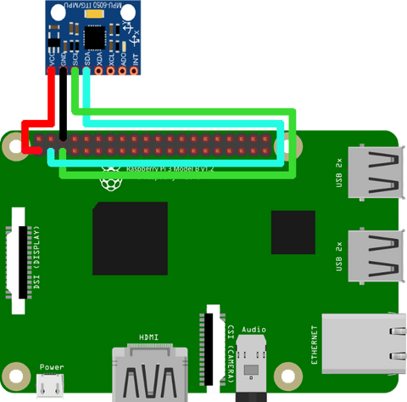
Pin am MPU6050 | Funktion | RPi Pin | RPi GPIO
VCC | Versorgung (3.3 V oder 5 V) | 2 / 4 | -
GND | Masse | 6 / 9 / 14 /  20 / 25 / 30 /  34 / 39 | -
SCL | I2C-Taktleitung | 5 | 3 SCL (I2C)
SDA | I2C-Datenleitung | 3 | 2 SDA (I2C)

On off shim
https://shop.pimoroni.com/products/onoff-shim?variant=41102600138
- watches the state of BCM pin 17
- when pin 17 is pulled low (pressed), it initiates a clean shutdown
- just before your Pi shuts down, BCM pin 4 is pulled low to completely cut power to pi
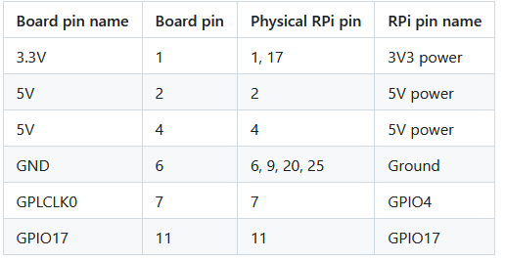
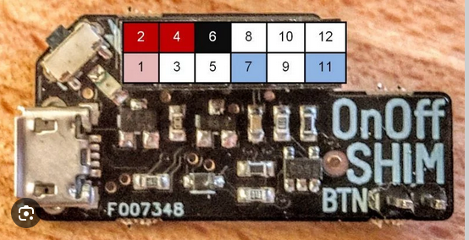

LEDs
https://www.amazon.de/AZDelivery-Leuchtdioden-Sortiment-Emittierende-kompatibel/dp/B08T1YGM8K/ref=sr_1_6?__mk_de_DE=%C3%85M%C3%85%C5%BD%C3%95%C3%91&crid=S57KBI3X3S78&dib=eyJ2IjoiMSJ9.AiqYS-uSLY05hLhHXgfMcpdteiW6PTIFrdc4IP7ZZc0xaoKaR3f-G9_PoWMh3AHbPeTqRJDuWkoryxSJjC4gYyB2cOzhjkF4N-iHqlRVOHrwz3yr8_Hz7Dco2ZmHu6umam0E7ZOBtIe4JSrVMdZRtQljQMhS3pv8yOjZQBP19FGjSEHjOHcAp6V9G3vy9PtOdzXZ-NX6IG9P2O1ksTxr-YfBjSAP8YREKXMB00SeiBFnxqQ9uPhqI2pIHyJDt9umZ3Y_rwSNwYFgzSa0l7qOma7_Y33NHa9CnzjKXLvu2zE.8Ffd2JRWvAkQWLrRMM9lwxircgFo51TwmNaR_TemcDE&dib_tag=se&keywords=led%2Bmicrocontroller&qid=1752683760&sprefix=led%2Bmicrocontroller%2Caps%2C111&sr=8-6&th=1
Ja, die LEDs aus diesem Amazon-Set kannst du problemlos mit dem Raspberry Pi verwenden – mit einem Vorwiderstand und der richtigen Schaltung.

✅ Was ist das für ein Set?
Das Set enthält:
- 5 mm LEDs in verschiedenen Farben
- Standard-LEDs mit Durchlassspannung von ca. 2.0 V (Rot, Gelb) bis ca. 3.2 V (Weiß, Blau)
- Empfohlener Strom: 10–20 mA pro LED
Diese LEDs sind also ganz normale 5mm-Leuchtdioden – perfekt für GPIOs, aber nur mit Vorwiderstand!

⚙️ So schließt du sie an den Raspberry Pi an:

📌 Anschlussplan (für z. B. GPIO17):
GPIO17 (Pin 11) ---> Widerstand (z. B. 330 Ω) ---> Anode der LED (langer Pin)
Kathode der LED (kurzer Pin) ---> GND (Pin 6 oder 9)

💡 Vorwiderstand berechnen (Faustformel):
Für 3.3 V GPIO-Spannung, LED-Spannung ca. 2 V (rot), Strom = 10 mA:
R = (3.3 V – 2 V) / 0.01 A = 130 Ω → nimm z. B. 220–330 Ω
Für weiß/blaue LEDs (ca. 3 V Vf): 3.3 V – 3.0 V = 0.3 V → du brauchst nur 33 Ω, aber nimm lieber 100–150 Ω, um den GPIO zu schützen.

🧪 Beispielcode in Python:
import RPi.GPIO as GPIO
import time

GPIO.setmode(GPIO.BCM)
GPIO.setup(17, GPIO.OUT)

# LED blinken lassen
for i in range(10):
GPIO.output(17, GPIO.HIGH)
time.sleep(0.5)
GPIO.output(17, GPIO.LOW)
time.sleep(0.5)

GPIO.cleanup()

🧯 Wichtige Hinweise:
Thema | Empfehlung
Widerstand | Immer nötig – sonst stirbt dein GPIO
Max. Strom GPIO | ~16 mA pro Pin, ~50 mA insgesamt
Mehrere LEDs? | Dann lieber über Transistor (z. B. BC547 oder N-MOSFET) schalten
Keine direkte Verbindung | Niemals GPIO → LED → GND ohne Widerstand

✅ Fazit
Ja, du kannst jede dieser LEDs aus dem Set an einen Raspberry Pi anschließen. Du brauchst nur:
- Einen passenden Vorwiderstand (z. B. 220 Ω)
- Die LED richtig gepolt anschließen (Anode an GPIO, Kathode an GND)
Wenn du magst, kann ich dir auch eine grafische Schaltung oder ein Fritzing-Diagramm dazu machen.
Merkmal | Anode (+) | Kathode (–)
Pin-Länge | Länger | Kürzer
Gehäuse | Rund | Abgeflacht
Innenstruktur | Kleines Teil | Großes Teil
Multimeter-Test | Rotes Kabel | Schwarzes Kabel

WAS NICHT FUNKTIONIERT HAT

New setup with V2.7
very complicated code, not so nice gui. Will not further use this but continue with v3 and just add custom code

ir remote power setup: NOT WORKING! Sensor defect?
https://wiki.52pi.com/index.php?title=EP-0077 (v.1.22)
* install wiringpi
wget https://project-downloads.drogon.net/wiringpi-latest.deb
sudo dpkg -i wiringpi-latest.deb
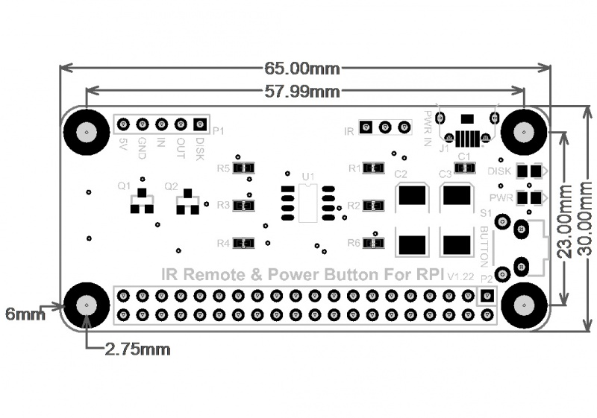
--------- Pin 11 (GPIO17)
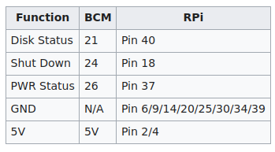

Power Button On/Off
> sudo nano /boot/config.txt
add line: dtoverlay=gpio-shutdown,gpio_pin=3,active_low=1
- gpio_pin must be 3 so wake up works
- active_low: set to 1 if on button press the signal shoots, else 0 (should be default)

pin connection:
- gpio3 (or other pin configured above)
- grnd

Works great. Not sure about the power consumption. Will have to check.
Button needs tob e click button, no on/off switch button!
Cannot be coupled with gyroscope!
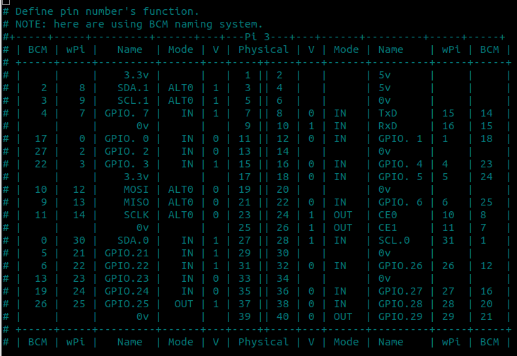
## for example, BCM 26 pin is connected to the board.
shutdownPin=26

#This ListenPin is connected to BCM Pin 24. if BCM pin 24 is waiting for the signal from MCU.
#But shell script are running by gpio read Pin, so must be mapped to wringPi naming system.
# ListenPin=5 means wiringPi's gpio5 = BCM pin24.
ListenPin=5

CONFIG: (chatgpt)
in /boot/config.txt:
dtoverlay=gpio-shutdown,gpio_pin=17,active_low=1 # RPI-Pin11 -> IN # alt: 24
dtoverlay=power-off,gpiopin=26 # RPI-Pin37 -> OUT
dtoverlay=pi3-act-led,gpio=21 # RPI-Pin40 -> LED

5V → Pin 2

GND → Pin 9

IN → GPIO17 (Pin 11): Shutdown-Befehl vom Modul an den Pi

OUT → GPIO26 (Pin 37): Power-Off-Signal vom Pi an das Modul

LED → GPIO21 (Pin 40): Statusanzeige

Modul braucht 5V, 2.5A Stromversorgung.

