# Third report about c++ project

## 流程图：

### Set class

Data:

Private:

char name;//Set name no define

string element;//储存元素字符

vector<int> ele;

string pick_ele(const string &s);//提取元素(exception)

function:

public:

public:

mySet();

mySet(const string s); //s={a,b,c}

//Initialize object by Array n is lenth of array

mySet(const int a[],int n);

mySet(mySet &set);

mySet operator=(mySet &set);

~mySet();

string getEle()const;

//带逗号或者纯元素进行initalize

void setEle(const string s);

void myPrint();

//声明为inline

//1 return the first element index of s

int myFind_ele(const string &s);

int getEleNum();//2

string getSet();//3 return set 形式string

bool Belong();//4 输入一个数判断是否属于set

string sumSet(mySet set);//5 合集

string operator+(mySet set);

string subSet(mySet set);//6 subSet子集

bool isEmpty();//7

string DiffSet(mySet set);//8 差集

string operator-(mySet set);

int subNum();//9 子集个数

bool isSubSet(mySet set); //10 是否为mySet的子集

bool isRealSub(mySet set);//11 是否为mySet的真子集

string oppsDiffSet(mySet set);//12 对称差集

bool isEqual(mySet set); //13 判断是否相等

};

### Relation class

Data:

Private:

String first,second;

String first_set[100],second_set[100];

Int index; //index记录第一元素和第二元素个数

Function:

Public:

Relation();

Relation(string first,string second);

Relation(string s);//可存储数据

Relation(vector<int> a,vector<int> b); //vector的使用

Relation(vector<int> a);//vector方式初始化

Relation(Relation& rela);//复制构造

~Relation();

string getFirst();//第一元素的读取

string getSecond();//第二元素的读取

//1 直接设定第一第二元素

void setFirst_Second(string s1,string s2);

void myPrint();

string toRelaString();

template<typename T>

void get_all_A_B(T first,T second);//2 全域关系

void get_Ia(string s);//3 恒等关系

void get_Bigger(string s);//4 大于关系

void get_Smaller(string s);//5 小于关系

void get_divide(string s);//6 整除关系

//7 包含关系,元素为set数组

void get_Con(string set[100]);

void print_Con(); //8 打印包含关系

Relation get_inverse();//9 逆关系

string dom();//10 定义域

string ran();// 11 值域

string fld();//12 域

## 运行图：

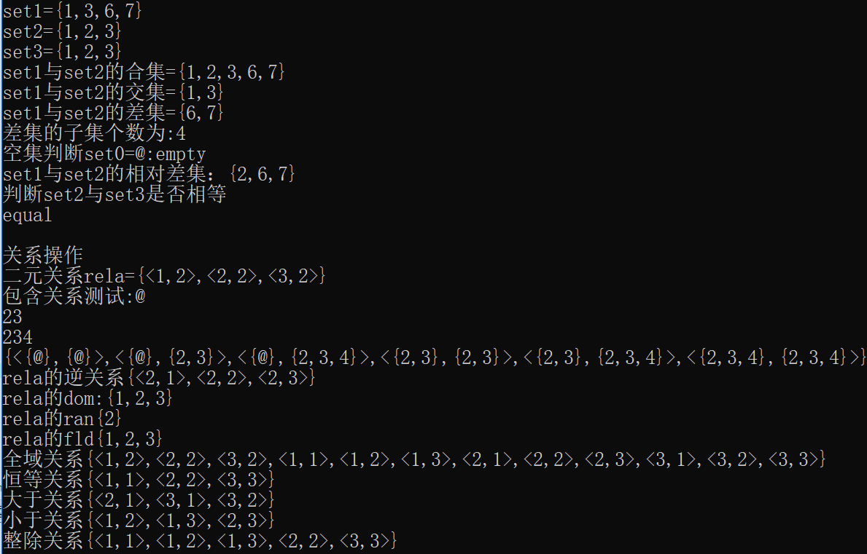

## What I finished

A set class and a relation class and five operators set and relation

Show in above.

Then how to accomplish the requirements.

### The implementation of the copy constructor;

mySet::mySet(mySet &set)

{

this->element=set.getEle();

}

Using the set member function getEle() to copy;

1. In each class, there should be AT LEAST 4 constructors;

Different constructor has different parameters

### Implementation of the destructor;

I did not know what’s I don't know what to put in, so it is empty function now.

### the application of the vector class;

vector was used is used for initialization object data;

### The data of SET and Relationship is stored in files;

All of the data were read from a txt file.

### There should be member variables in a class to store the SET or/and Relationship;

My classed, Set and Relationship, stored their member variable with private fields.

### Some member variables in the class must be defined as private or protected;

They are privated.

### inline function must be used in the class;

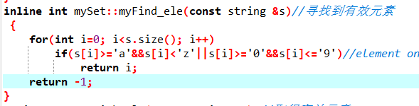I have a simple inline, of course, it also could become non-inline function.

### output member function must be defined in the class;

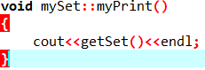output member function is for print my data.

Using other member function getSet() to get object then output,

The getSet return a string, like {1,2,3};

### friend function must be defined in the class;

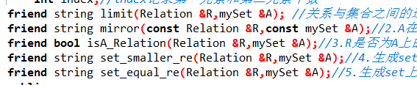for accomplish operations between Set and Relation classes

### const function must be properly used in the class;

I will use the const to ensure I change the data by mistake.

### (12) some operators must be overloaded in the member functions of the class;

string operator+(mySet set);

string operator-(mySet set);

mySet operator=(mySet &set);

Relation operator=(Relation &R);

### (13) exception handling must be used in the class;

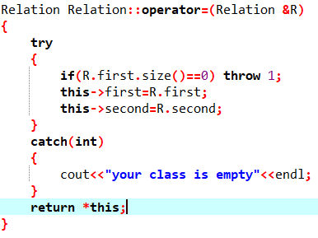if class is empty, can’t be copy.

### (14) The code must be implemented using multiple files. It is strictly forbidden to include all the programs in a single file.

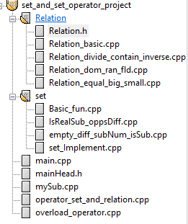I am used to multiple files, and I love to use it when I need program a lot of codes.