C291G40’s Airline Booking program:

The Airline Booking program is an extensive online tool that allows users and airline agents access to their airline booking account. The program has two main functions. First it allows users with the ability to search for direct or round-trip flights. Secondly it provides users with the ability to book flights, view a previous bookings and cancel bookings. In addition to this functionality, airline agents have the ability to update the actual arrival and departure times of a flight which might occur due unforeseen circumstances.

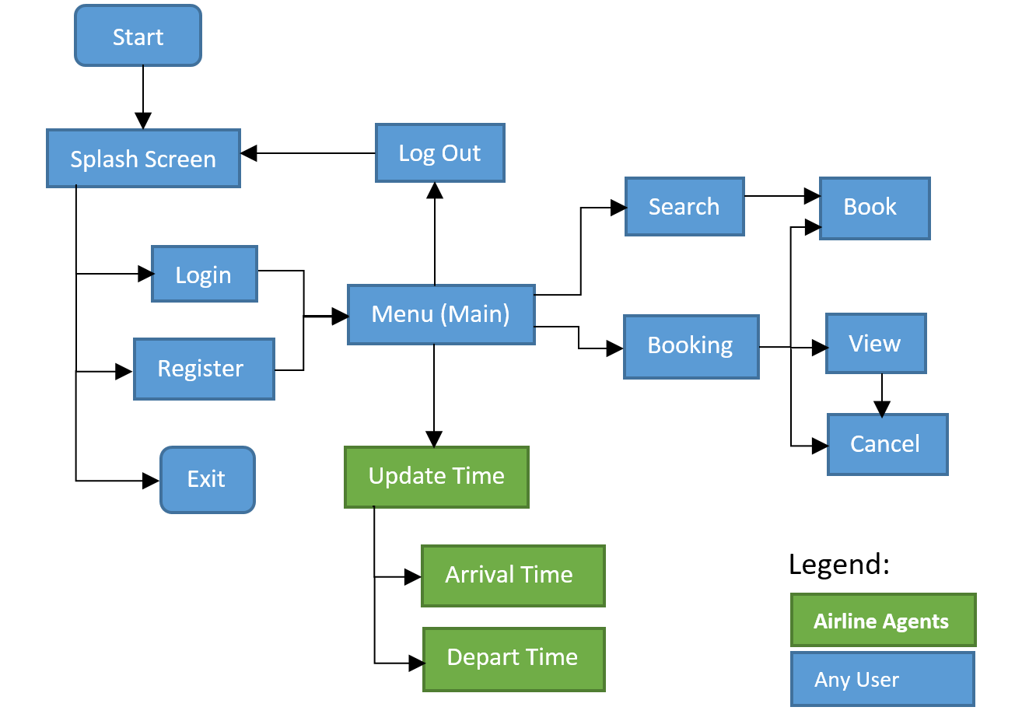

Figure 1: Structural Schematic of the Airline Booking program.

Program Walkthrough:

The program comes with an easy to use menu. To select an option, simply enter the number next to an option.

1. To launch the program launch the following command:  
    Python3 main.py DatabaseUSerName DatabasePassword
2. Once the program has been launched the user has 3 options:
   1. Login: You will be prompted for your email address and password.
   2. Register: You will be asked for an email address (20 characters or less) and a password (4 characters or less. Passwords are **case-sensitive**)
   3. Exit: Exits the program.
3. Once logged in or registered, you will be brought into the main menu. All users will have the following options:
   1. Search for flights: This will ask users for the basic information required to search for a flight. Users have the ability to sort flights by flight and differentiate between direct and non-direct flights). Lastly, users will be prompted with an option to book a flight from the search results.
   2. Book a Flight: This allows users to book a flight if they know the flight number, fare type, and the departure date. It can also be used to book round-trips.
   3. View All Bookings: This lists all the bookings belonging to the user. The user can view more details by selecting “V” and the option number, the user can cancel a booking by selecting “C” and the option number, or press “Q” to return to the main menu.
   4. Cancel A Booking: This will list all the flights belonging to the user and the user will be prompted to cancel a booking based on the results of that list.
   5. Logout: This will logout the user and record the time.

Once an option a, b, c, or d are completed, the user is taken back to the main menu. If a user chooses to logout, the user is re-directed to the login/register screen.

Airline Agents will be presented with two additional options:

1. Record flight departure: This will prompt the agent for flight information and it will update the actual departure time of the flight.
2. Record flight arrival: This will prompt the agent for flight information and it will update the actual arrival time of the flight.

Detailed Design of Software:

1. a detailed design of your software with a focus on the components required to deliver the major functions of your application:

The detailed design of your software should describe the responsibility and interface of each primary class (not secondary utility classes) and the structure and relationships among them. Depending on the programming language being used, you may have methods or functions instead of classes

1. your testing strategy:

The testing strategy discusses your general strategy for testing, with the scenarios being tested, the coverage of your test cases and (if applicable) some statistics on the number of bugs found and the nature of those bugs.

1. your group work break-down strategy:

The group work strategy must list the break-down of the work items among partners, both the time spent (an estimate) and the progress made by each partner, and your method of coordination to keep the project on track

The design document should also include a documentation of any decision you have made which is not in the project specification or any coding you have done beyond or different from what is required.

Start

Splash Screen

Log Out

Book

Search

Login

View

Booking

Menu (Main)

Register

Cancel

Update Time

Exit

Legend:

Arrival Time

**Airline Agents**

Any User

Depart Time