|  |  |
| --- | --- |
| Name: | Edwin Rodriguez (ED04) |
| ID: | Mustafa Abbasi (D07) |
| Project: | Mini-Project 2 |
| Class: | CMPUT 291 |
| Due Date: | Nov 27, 2015 |
| No Collaboration was done for this project. | |
|  |  |

C291G40’s Review Database System:

A1. General Overview

The primary purpose of the Information Retrieval System(IRS) is to facilitate searching for user-defined queries using the physical layer. The input to the IRS is a single file containing user review information for multiple products. Once the IRS begins, it runs several scripts which parse the input file and ultimately creates 4 searchable Berkley DB indices (*rw.idx*, *pt.idx*, *rt.idx* and *sc.idx).* Once a query is run through the IRS, the corresponding indices will be searched and the IRS will return the index and content of the results from the query.



A2. User Guide

The Airline Booking program is an extensive online tool that allows users and airline agents access to their airline booking account. The program has two main functions. First it allows users with the ability to search for direct or round-trip flights. Secondly it provides users with the ability to book flights, view a previous bookings and cancel bookings. In addition to this functionality, airline agents have the ability to update the actual arrival and departure times of a flight which might occur due unforeseen circumstances.

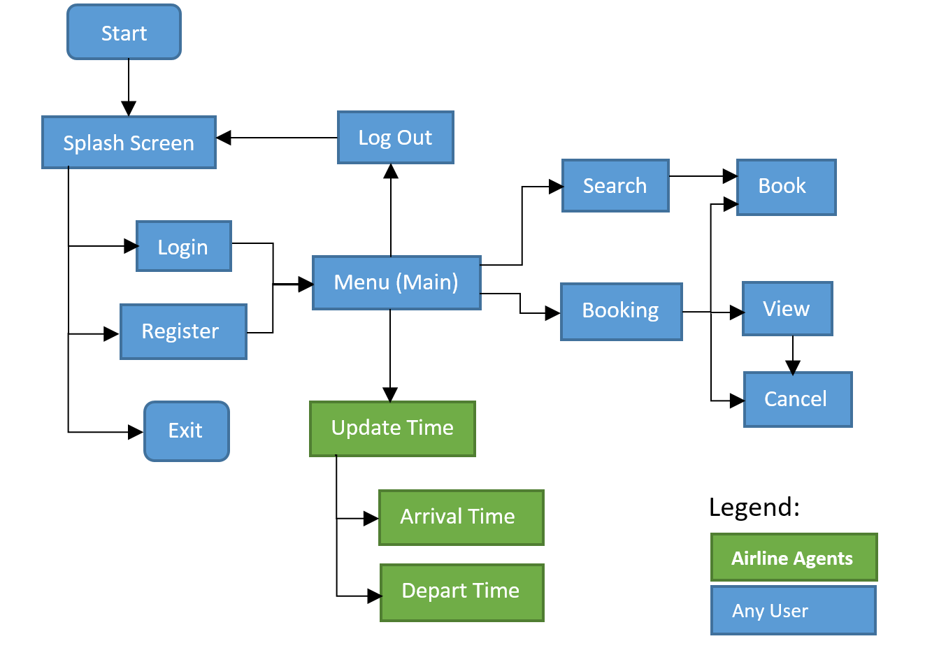

Figure 1: Structural Schematic of the Airline Booking program.

Program Walkthrough:

The program comes with an easy to use menu. To select an option, simply enter the number next to an option.

1. To launch the program launch the following command:  
    Python3 main.py DatabaseUSerName DatabasePassword
2. Once the program has been launched the user has 3 options:
   1. Login: You will be prompted for your email address and password.
   2. Register: You will be asked for an email address (20 characters or less) and a password (4 characters or less. Passwords are **case-sensitive**)
   3. Exit: Exits the program.
3. Once logged in or registered, you will be brought into the main menu. All users will have the following options:
   1. Search for flights: This will ask users for the basic information required to search for a flight. Users have the ability to sort flights by flight and differentiate between direct and non-direct flights). Lastly, users will be prompted with an option to book a flight from the search results.
   2. Book a Flight: This allows users to book a flight if they know the flight number, fare type, and the departure date. It can also be used to book round-trips.
   3. View All Bookings: This lists all the bookings belonging to the user. The user can view more details by selecting “V” and the option number, the user can cancel a booking by selecting “C” and the option number, or press “Q” to return to the main menu.
   4. Cancel A Booking: This will list all the flights belonging to the user and the user will be prompted to cancel a booking based on the results of that list.
   5. Logout: This will logout the user and record the time.

Once an option a, b, c, or d are completed, the user is taken back to the main menu. If a user chooses to logout, the user is re-directed to the login/register screen.

Airline Agents will be presented with two additional options:

1. Record flight departure: This will prompt the agent for flight information and it will update the actual departure time of the flight.
2. Record flight arrival: This will prompt the agent for flight information and it will update the actual arrival time of the flight.

(b) a description of your algorithm for evaluating queries, in particular evaluating queries with multiple conditions and wild cards and range searches and an analysis of the efficiency of your algorithm, (c) your testing strategy, and (d) your group work break-down strategy. The general overview of the system gives a high level introduction and may include a diagram showing the flow of data between different components; this can be useful for both users and developers of your application.  The user guide should have instructions for running your code for phases 1, 2 and 3. The testing strategy discusses your general strategy for testing, with the scenarios being tested and the coverage of your test cases. The group work strategy must list the break-down of the work items among partners, both the time spent (an estimate) and the progress made by each partner, and your method of coordination to keep the project on track. The design document should also include any assumption you have made or any possible limitations your code may have.

Detailed Design of Software:

The detailed design of your software should describe the responsibility and interface of each primary class (not secondary utility classes) and the structure and relationships among them. Depending on the programming language being used, you may have methods or functions instead of classes.

The program is composed of the following classes modules:

1. main.py:
   1. Responsibility:  
      The responsibility of this class is to create the main menu and create the contents of the menu based on the type of user that logged in.   
      It also ensures that once users are logged in to the system, they remain or return to this main menu until they decide to logout.
   2. Interface:

As this is the main arterial of the program, this interfaces with the other 4 components.

This interaction is done within the processMenuSelection method.

* 1. Relationship:

Hub to the entire program.

1. splashScreen.py:
   1. Responsibility:

To direct log in existing users or register new users.

To give the program with sufficient knowledge so that the program may differentiate between normal users and airline agents.

* 1. Interface:

The start() function starts the splashpage and returns true once a user logged in.

getEmail() returns the email of the user

getPassword() returns the password of the user

isAgent() returns true if the user is an airline agent.

* 1. Is accessed by Main.py only

1. booking.py:
   1. Responsibility:

Responsible for making, viewing and canceling all bookings.

* 1. Interface:

makeBooking(email): begins the process of making a booking

cancelBooking(email): begins the process of canceling a booking

listExistingBookings(email): begins the process of listing all bookings

* 1. Is accessed by Main.py only.

1. search.py:
   1. Responsibility:

Responsible for searching for all flight information.

* 1. Interface:

Main(email, connectionString): starts the process of searching for flights

* 1. Is accessed by Main.py only.

1. updateTime.py:
   1. Responsibility:

Responsible for updating actual arrival and departure time of scheduled flights.

* 1. Interface:

updateTime(connectionString, TypeOfFlight): Updates the actual departure or arrival time of a scheduled flight. TypeOfFlight is a string containing “Arrival” or “Departure”.

* 1. Is accessed by Main.py only.

Testing Strategy:

The program was developed under control database conditions where the database had a small data sample. This allowed us to manually verify the output of each of the queries required by the program. Manual verification of the contents of the database was also done to verify updates or deletions from the database that occurred in the program.

Basic input and output from the program was also tested to insure that the program behaved as expected. This led to the development of error checking methods for data inputted from the user. This can mostly be seen in the case of the splash menu, the user menu and date entries into the program.

There was also integration testing which occurred to insure that the program worked after combining all the modules/classes together.

The tests had a small data coverage overall and regression testing ensured that the program maintained its working integrity after big changes occurred.

Bugs:

Most of the bugs that were found within the program were basic input/output bugs based on improper handling of user inputs. Some basic bugs were also found that led the user to input invalid data into the system which led to the program being stuck in an infinite loop. Some bugs also occurred through the translation of user inputs into Oracle queries.

Group Break-Down Strategy:

The project was divided based on the provided requirements. To improve coordination between the group, the separation of tasks revolved around the exclusive ownership of classes (files). This meant that an individual had full control over their work. The project relied on git and github as a way to give the project version control and the ability to allow the group to work with the most current code. For a close look at the github repo please see the following link:

<https://github.com/c291g40/project1>

Break-down:

|  |  |
| --- | --- |
| Edwin | Mustafa |
| Splash Screen and familiarizing with Python:  6.5 hrs – Oct 20 | Search Requirement: 10.5 hrs |
| Main menu (main.py): 2 hrs – Oct 21 | Airline Agent requirements: 2 hrs |
| Logout feature: .5 hrs – Oct 21 | Fixing bugs: 4 hrs |
| Listing Bookings: 2.5 hrs – Oct 22-23 | Implementing Return Flights: 4.5 |
| Making Bookings 1way and 2 way bookings:  4.5 hrs – Oct 24 |  |
| CancellingBookings: 1 hr – Oct 24 |  |
| Merging project: 1 hr – Oct 26 |  |
| Documentation:3.5 hr – Oct 26-27 |  |
| Total: 21.5 hours | Total: 20.5 hours |

Other Design Decisions:

In order streamline the program, the database credentials required command-line arguments. This was done so that the program can quickly recover in-case of an unexpected program termination as the database username and password will hinder the recovery of the program.