Recursos Didácticos Módulo 1
Guia digital sobre LLM
Código: <div style="display:inline-block;vertical-align:top;width:300px;margin:20px auto;color:#333;background:#fff;border:1px solid #ddd;line-height:1.2;text-decoration:none;padding:0"><a href="https://read.bookcreator.com/gdwX_mIor2R47s4cNzke4Fzsyy8MhwaefzhQ07m7-rY/JhvIDoawQDKJGBbkS4xDzQ" style="display:block;color:#333;line-height:1.2;text-decoration:none;padding:0;font-weight:normal" target="_blank" rel="noreferrer"><img src="https://assets.api.bookcreator.com/gdwX_mIor2R47s4cNzke4Fzsyy8MhwaefzhQ07m7-rY/books/JhvIDoawQDKJGBbkS4xDzQ/cover/share" style="max-height:300px;max-width:100%;display:block;margin:0 auto;padding:0;border:none" alt="Guía digital sobre LLM"/></a><div style="display:block;padding:20px;overflow:hidden;overflow-x:hidden;border-top:1px solid #ddd"><div style="display:block;color:#333;line-height:1.2;text-decoration:none;padding:0;font-weight:normal;font-size:21px;margin:0 0 0.25em"><a href="https://read.bookcreator.com/gdwX_mIor2R47s4cNzke4Fzsyy8MhwaefzhQ07m7-rY/JhvIDoawQDKJGBbkS4xDzQ" style="display:block;color:#333;line-height:1.2;text-decoration:none;padding:0;font-weight:normal" target="_blank" rel="noreferrer">Guía digital sobre LLM</a></div><div style="display:block;color:#333;line-height:1.2;text-decoration:none;padding:0;font-weight:normal;font-size:16px;margin:0 0 0.5em"><a href="https://read.bookcreator.com/gdwX_mIor2R47s4cNzke4Fzsyy8MhwaefzhQ07m7-rY/JhvIDoawQDKJGBbkS4xDzQ" style="display:block;color:#333;line-height:1.2;text-decoration:none;padding:0;font-weight:normal" target="_blank" rel="noreferrer">Click to read this book, made with Book Creator</a></div><div style="display:block;color:#455a64;line-height:1.2;text-decoration:none;padding:0;font-weight:bold;overflow:hidden;text-overflow:ellipsis;white-space:nowrap;font-size:14px"><a href="https://read.bookcreator.com/gdwX_mIor2R47s4cNzke4Fzsyy8MhwaefzhQ07m7-rY/JhvIDoawQDKJGBbkS4xDzQ" style="display:block;color:#333;line-height:1.2;text-decoration:none;padding:0;font-weight:normal" target="_blank" rel="noreferrer">read.bookcreator.com</a></div></div></div>
M1_Uso de Copilot: Video mp4:
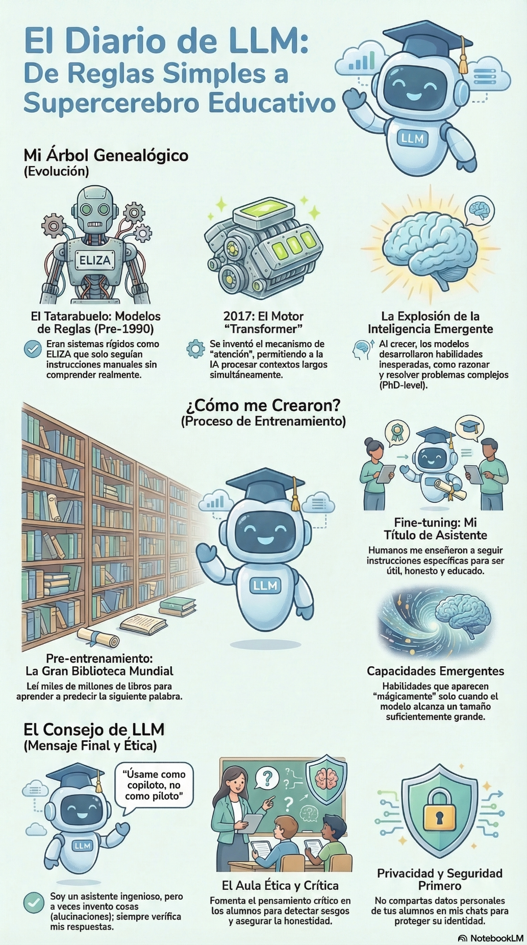
M1_El_Diario_de_LLM_Educativo
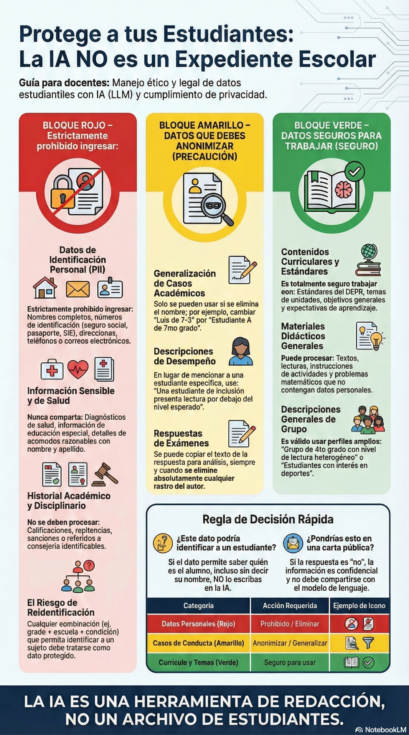M1_Privacidad_Estudiantil_y_la_IA
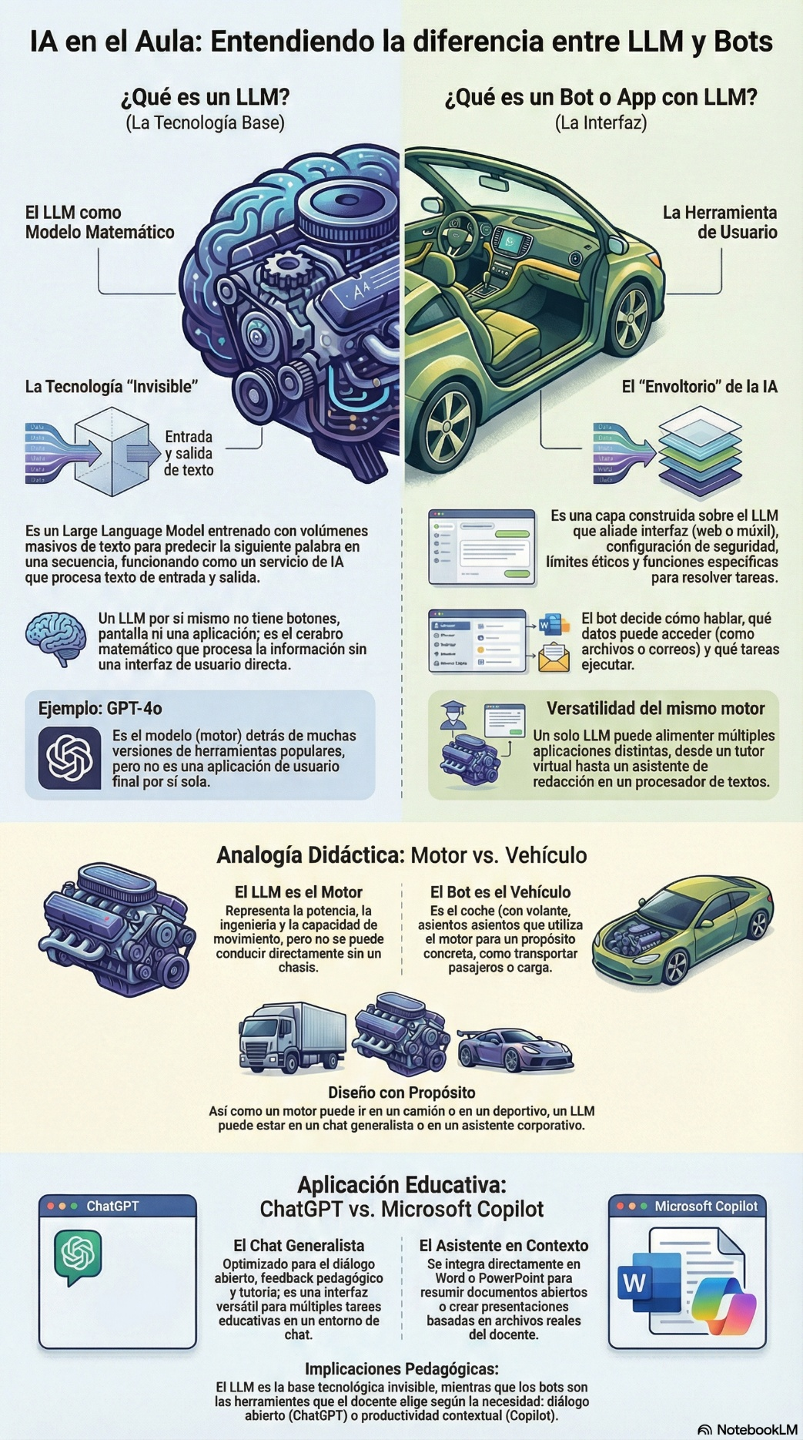
M1_LLM_VS_BOT
Video: https://youtu.be/LPZh9BOjkQs?si=WSE4Iol6HwyiXca4
Video: https://youtu.be/lVGV5-5TdTU?si=tAlNuQY6eGKr-LJs
Video: https://youtu.be/PxYA2NLVdbc?si=4bU_pk2oA2DaOLCZ

