Process & Decision Documentation
This document is used to make your design and development process visible. At this stage of your academic career, you are expected not only to produce finished work, but to articulate how decisions were made, how ideas changed, and how collaboration (for the assignments that include group work) unfolds
In professional and co-op contexts, employers do not only evaluate your final projects in your portfolio. They often ask candidates to explain their process, justify trade-offs, reflect on iteration, and describe their roles within a team.
You will need to submit a modification of this document for every group assignment (A1 – A3) and a shorter version for your individual assignments (Side Quests and A4).
For A1 – A3, this is a group document submitted once per group. Each group member must clearly document their own role and responsibilities. Different roles will naturally produce different design processes.

Process Overview Visualization (Group Work Only)
Include one simple visual representation of your group’s design process. This may take the form of a timeline, flow diagram, loop, branching sketch, or other format that reflects how your project actually unfolded.
This visualization does not need to be polished or visually refined. Hand-drawn sketches or screenshots are acceptable. For assignments that are extensions of previous assignments (A2 and A3), you may resubmit or reuse previous submissions with additional add-ones and context.
Your visualization must clearly show the following elements:
- Roles and responsibilities: Indicate which roles involved at different stages of the project.
- Who did what, and when: Show how work was distributed over time. This can be approximate (e.g., “early,” “mid-project,” “final week”) and does not need exact dates.
- Key stages or phases of work: For example, for A1, can start with research.
- Decision points or pivots: Indicate moments where the group changed direction, simplified scope, or made a significant design decision.
- Iteration or feedback loops: Show where ideas were tested, revised, or reworked (e.g., after playtesting or feedback from instructors).

The purpose of this visualization is not to present an ideal or “correct” design process, but make your actual process visible including parallel work, false starts, and revisions.

Reference examples (for inspiration only)
You may find it helpful to look at well-known design process visualizations you’ve likely seen before, such as:
- Nielsen Norman Group – Design Thinking Overview: https://media.nngroup.com/media/articles/attachments/Design-thinking-101-NNG.pdf
- Design Council – Double Diamond: https://www.designcouncil.org.uk/our-resources/the-double-diamond/
These examples are provided as references, not templates to follow. Your visualization does not need to match these models and will not be assessed based on adherence to any specific framework.

Project/Assignment Decisions
Use this section to document key decisions that shape the direction, scope, or outcome of the assignment. The purpose is to make your judgement and reasoning visible, not to record every action taken.
What you include here should reflect decisions that mattered: moments where you chose one path over another, changed direction, or adapted to constraints.
The expected length and detail depend on the assignment.

Side Quests and A4 (Individual Work)
Keep this section brief, typically 2 to 4 sentences.
Focus on:
- One significant decision or change you made
- Why you made it
- What effect it had on the work
Examples:
- Simplifying a mechanic so it functioned correctly
- Changing an approach after something failed
- Deciding not to pursue an idea due to time or technical limitations
I made a significant change to move all of my code to the Setup() Function. This decision was made sue to the fact that I realized the code did not need to be reloaded every time the draw() loop cycles. Since it is a static image, I could move everything to the Setup() function, which also simplified the debugging process since everything was in one place and the code would stop exactly where it failed with nothing looping.
You are not expected to document every alternative or iteration

A1 – A3 (Group Work)
Provide more details, as decisions are shared, cumulative, and affect multiple roles.
Document decisions such as:
- Scope changes or feature cuts
- Design or analytical pivots
- Outcomes of playtesting or peer/instructor feedback
- Technical or coordination-related trade-offs
- Ethical, representational, or global contexts for design decisions

For each major decision, briefly include:
- What changed
- Why the decision was made
- Who was involved or responsible
This may be written in short paragraphs or bullet points.
This section is not a complete project history. It is a record of decisions that shape the work. Clarity, judgement, and relevance matter more than length.

Role-Based Process Evidence
This section documents how your work developed over time and provides concrete evidence of your process. It is used to make your thinking, iteration, and decision-making visible, whether or not GenAI was used. You may reuse relevant process evidence across documents where appropriate, as long as it accurately reflects the work for that assignment.
For group assignments (A1 – A3), this section is completed collectively, with clearly attributed role-based entries. For the group, your entries should correspond to elements shown in your process overview visualization such as stages, iterations, or decision points.
For individual assignments (Side Quests and A4), this section is completed individually, using a simplified version of the same structure. For Side Quests, you may omit sections below where no meaningful decision-making occurred. For example, for the first side quest which you need to just upload a blank p5.js to GitHub, you must have to remove a significant amount of the process-based evidence as not a lot of design decisions were made.
Examples of acceptable process evidence include (but are not limited to):
- Screenshots of video editing timelines
- Drafts of scripts or research notes
- Annotated sources
- Sketches or diagrams
- Early document outlines
- Prototype screenshots
- Code snippets or commits
- Before-and-after revisions
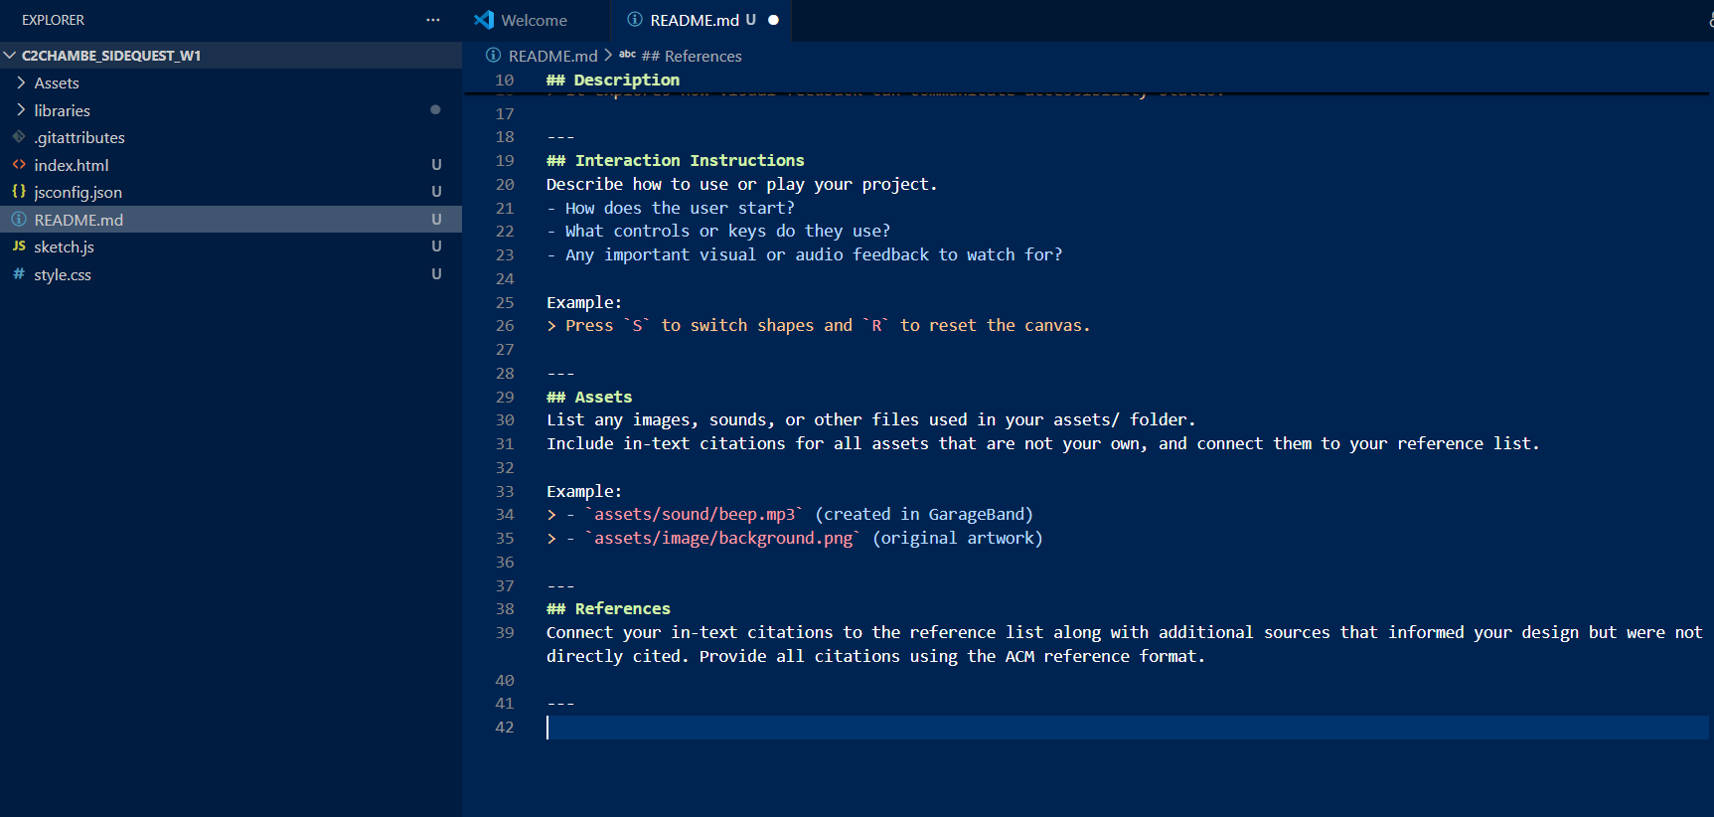
Progress Report: Copy + Pasting required text into README.md in the C2CHAMBE_SIDEQUEST_W1 REPO.
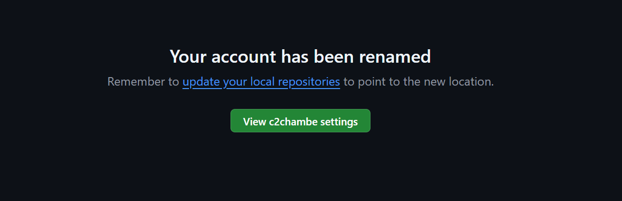
Progress report: Changing username on GitHub

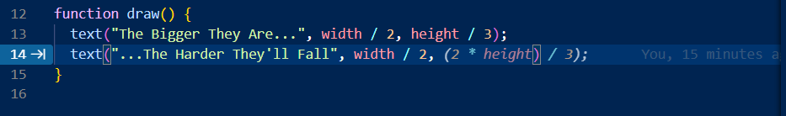
Progress report: The AI is trying to autofill what I was already intending to write.

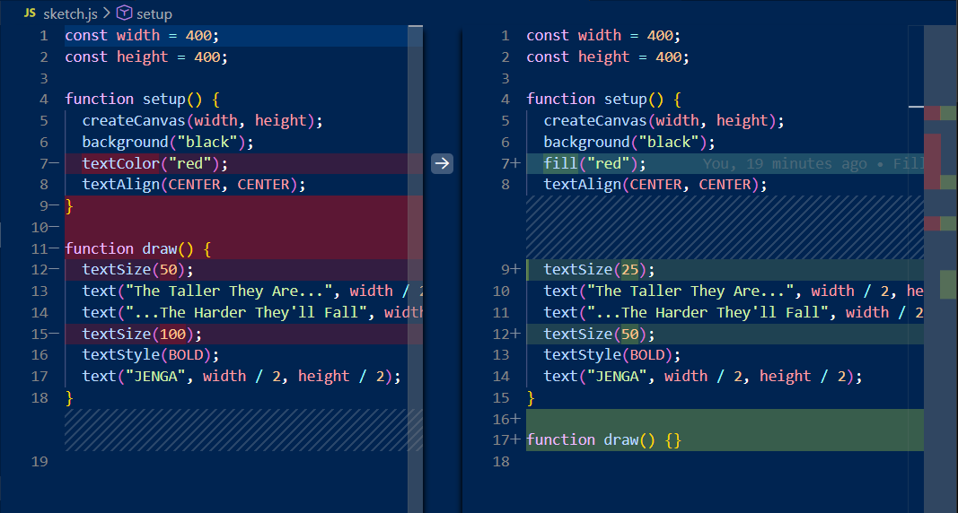
Progress report: Old vs New versions of my code after I had found the error

Entry Header
Name: Clarissa Chamberlain
Role(s): Primary Developer
Primary responsibility for this work: Creating an empty sketch and uploading it to the class repository

Goal of Work Session
Briefly describe what you were trying to accomplish during this phase of the assignment.
Examples:
- Drafting an initial script section
- Refining pacing in the video edit
- Revising a mechanic after playtesting
- Narrowing or reframing research examples
- Debugging or simplifying a feature

Tools, Resources, or Inputs Used
- GenAI tools (if used)
- Lecture Notes
- Teammates
- Prior drafts or code
- Playtesting feedback
- External references (in-text citations with square brackets, ex. [1])

GenAI Documentation
NO GEN AI WAS USED FOR THIS TASK.

Summary of Process (Human + Tool)
Describe what you did, focusing on process rather than outcome. This may include:
- Iteration between drafts or versions
- Discussion with teammates
- Testing and revision
- Moments of uncertainty, failure, or rework
For this task, I followed the set of given instructions, as posted by the professor of this course, Karen Cochrane, in order to successfully set up the tools and software needed in order to complete coursework. Throughout this process, there were several moments of uncertainty, which caused some delays in the completion of the task, such as Terminal being unable to recognize Git as a downloaded service on my laptop, as well as my laptop overheating and shutting itself off before the end of class. Once I had returned back home, I spent the next day writing the code itself, troubleshooting.

Overall, the task was completed alongside the advice of the peers and instructors of the class.

Decision Points & Trade-offs
Describe one or two key decisions you made:
- What options you considered
- What changed
- Why that choice was made
In order to resolve the aforementioned problem, I considered a few different options. After a brief discussion with the professor, I decided to rent out a laptop from the media center within the Stratford school of business and interactive design. This decision was made since I wanted to complete the task by the end of the class, and my personal laptop was temporarily malfunctioning. Once I had reached the data centre, I had a conversation with the head of the media center, who told me that it would not be worth it to restart the process of completing this task today, since there was 20 minutes left of class. Taking this information into consideration, I the returned to class without a laptop, and made the decision to finish the project once I returned home that evening. This decision was made since I knew the laptop needed to be plugged into a charger, which I had at home.

Verification & Judgement
Explain how you evaluated whether your decision or change was appropriate:
Examples:
- Playtesting
- Group discussion
- Peer or instructor feedback
- Comparison with course concepts
- Re-reading assignment criteria
- Ethical, representational, accessible, or global considerations

The decisions I made within this task were sound, thanks to the assistance of several different key people. Firstly, group discussions played a key role in the decision-making process for this task. The discussion I had with a peer was what encouraged me to reach out to the teaching staff for assistance. Consequently, that discussion with the teaching staff encouraged me to seek an alternative route in order to successfully complete the task within the timeframe of the class. I took in several different considerations when making decisions, alongside the advice I was given. Ultimately, once the media center manager advised me to continue this task at home, I chose that option since it saved me the hassle of transporting and tracking a second laptop until the following Tuesday, when I would be back on campus.
Towards the end of the task process, my task was not loading on the webpage made by GitHub. Since it was not working, I did some troubleshooting into the problem. First of all, I was using a function that did not exist within p5.js. The function that I had called was “textColour”, which I then changed to “fill”. Once I fixed that error and re-uploaded the project was still not showing up on the website. I called on the assistance of my father, who is a software developer by trade, so he has much more experience with GitHub than I do. He notified me that the issue may be the result of my web browser’s cache, which was saving a previous instance of the project. Once I forced the page to reload and waited a few minutes, my project was there.

Limitations, Dead Ends, or Open Questions
Note anything that:
- Did not work as expected
- Was left unresolved
- Required compromise or simplification
During this process, there were a few moments of uncertainty that caused some unwanted stress within the completion of this task. One of the main problems was due to Terminal being unable to recognize Git as a downloaded file. Even after downloading Github desktop and downloading Git separately, Terminal was unable to open it. In order to fix this issue, I first asked a classmate, then proceeded to ask the teaching assistants who were in the class at the time. Once they had seen the issue, I was advised to restart my computer. After my computer finished restarting, it automatically shut itself off since its internal temperature was too high. This meant that I could no longer proceed with the assignment.
While the instructions for the task were mostly clear, there were some issues that arose during the process. Firstly, Terminal would not recognize Git as a downloaded file, which halted the process of the task. Secondly, the instructions for the task were a bit unclear at times. An example of this was section 5, step 7b which read, “Fill in the appropriate information for this assignment and save the document as a PDF named: Process_and_Decision_Documentation.pdf” [1]. This instruction felt a bit vague to me, and led to a lack of understanding as to what sections of the document were meant to be filled out. As a student who takes instructions literally, more description for this assignment would have been preferred for this step.
At the very end of my project, once my code had been written, I would correctly push the code to Github, which would then publish it onto its own website. However, the webpage that displayed my task remained blank. After trying to resolve this issue on my own, checking my code over to look for any mistakes, or trying to push the code again, I eventually reached out to my father for guidance. For context, my father is a software developer, and works frequently with GitHub, so I figured he would be the best person to ask. He said that one of the main reasons why it may not be showing up could be due to the browser retaining past instances of the website and not updating them. I took this guidance and then forced the page to reload, and after a few minutes I could finally view my project.
[1] Karen Anne Cochrane and David Han. 2026. GBDA302 Winter 2026 Starter Guide. Retrieved from https://docs.google.com/document/d/1Mzv_mLKSALTxhIlc3_KDgZ2Xg5iK5sXfH3y4Xfb7nxQ/edit?tab=t.0

Appendix
Please include a full transcript of your conversation with the GenAI. GenAI transcripts are used for transparency and verification only and are not assessed for writing quality or completeness.
Note: If GenAI is used in another language, you must include both the original language and a translated transcript in the appendix

GenAI was not used for this task.
There were a few times when I would be typing basic code, and the AI would try and autofill in the code for me, however, I chose to ignore the AI and instead type out what I wanted. There was a bit of a grey area where the AI was giving me the exact code that I wanted, and it would seem like I was just typing out the code the AI gave me, but the code was very basic and predictable, which is why the AI was most likely able to suggest options with such precision.

