# Create XSteps

1. Access the activity using one of the following navigation options:

|  |  |
| --- | --- |
| SAP Menu | Logistics → Production-Process → Master Data → Master Recipe → Recipe and Material List → Change |
| Transaction Code | C202 |

1. On the Change Master Recipe: Initial Screen screen, enter your recipe group for using XSteps (for example, MR-11021/1).
2. On the Change Master Recipe: Recipe screen, choose XSteps (Ctrl+Shift+F8).
3. On the Master Recipe MR-11021 screen, choose Create XStep Tree.
4. To assign the control recipe destination to the master recipe, right-click XStep Tree and choose Properties → Tab: Destination.
5. In the Standard folder, select the control recipe destination: CRD for Chemicals Plant 1000, control recipe destination Y1, address CHEMICALS GRANULATION and choose Create.
6. Choose Close.
7. Create XSteps for phase 0110, 0115, 0120, 0130, 0210 and 0310 for the master recipe.
8. Right-click the XStep Tree and choose Create → XStep.
9. Right-click the <New XStep> and choose Properties → Tab: General.
10. Maintain the description Layout.
11. To assign destination and context to the XSteps, right-click Layout and choose Properties → Destination.
12. In the Standard folder, select the control recipe destination: *Work Instructions*/PI-Sheet and choose Create.
13. Choose Close (context is not required for XStep Layout).
14. Right-click the XStep Tree and choose Create → XStep.
15. Right-click the <New XStep> and choose Properties → Tab: General.
16. Maintain the description Dispense materials.
17. Right-click XStep Preparing and Dispensing and choose Properties → Destination.
18. In the Standard folder, select the control recipe destination: *Work Instructions* /PI-Sheet and choose Create.
19. Choose Close.
20. Right-click XStep Preparing and Dispensing and choose Properties → Context.
21. Expand the structure of the context and select Phase 0110.
22. Choose Create.
23. Choose Close.
24. Repeat the steps above according to the following table:

| Phase | Description | Destination | Context |
| --- | --- | --- | --- |
| - | Layout | *Work Instructions* /PI-Sheet | - |
| 0115 | Phase 0115:Read critical sensor values | *Work Instructions* /PI-Sheet | Phase 0115 |
| 0120 | Phase 0120: Add materials | *Work Instructions* /PI-Sheet | Phase 0120 |
| 0130 | Phase 0130: Perform Extrusion | *Work Instructions* /PI-Sheet | Phase 0130 |
| 0210 | Phase 0210: Quality inspection | *Work Instructions* /PI-Sheet | Phase 0210 |
| 0310 | Phase 0310: Nozzling and chopping | *Work Instructions* /PI-Sheet | Phase 0310 |

1. When you are done, the XStep Tree should appear as shown below:

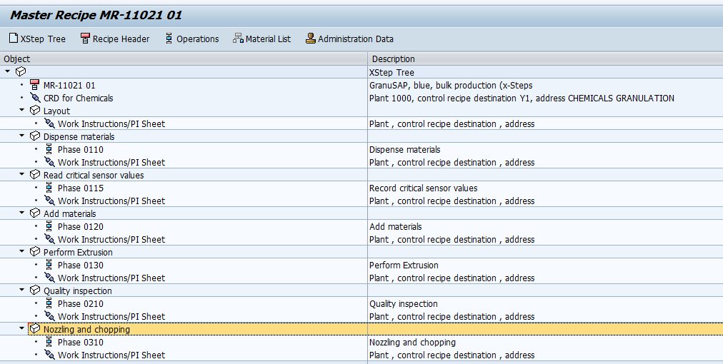

1. To create SXS (Standard XStep) reference in the XStep Tree, right-click XStepLayout and choose Create → SXS Reference.
2. Right-click <New SXS Reference> and choose Properties → Tab: Reference.
3. Expand the structure of folder Standard XSteps, then expand the Layout folder.
4. Select the Standard XStep Layout_1 and choose Create.
5. Choose Close.

tip

If the respective Standard XStep has not been released in the Standard XStep Repository the entry Layout_1 will appear in light gray and cannot be selected. In that case, go back to the Standard XStep Repository and follow the procedure to release a Standard XStep.

1. Create Standard XSteps references according to the following table:

| Phase | Folder | Standard XStep |
| --- | --- | --- |
| - | Layout | Layout_1 |
| 0110 | General Instructions | General Instruction_6_0010 |
| 0110 | General Instructions | General Instruction_6a_0010 |
| 0110 | General Instructions | General Instruction_6b_0010 |
| 0110 | Goods Issue and Material List | Goods Issue and Material List_1 |
| 0115 | General Instructions | General Instruction_1 |
| 0115 | Others | Actual_Temparature1 |
| 0120 | General Instructions | General Instruction_2 |
| 0130 | General Instructions | General Instruction_3 |
| 0130 | Others | Actual_Temparature |
| 0130 | Others | Air flow with validation formula |
| 0130 | Others | RPM with validation formula |
| 0210 | General Instructions | General Instruction_4 |
| 0210 | Others | SXS: Record Inspection Results |
| 0310 | Final Status11 | Phase Status_Start11 |
| 0310 | General Instructions | General Instruction_5 |
| 0310 | Goods Receipt | Goods Receipt_1 |
| 0310 | Signatures | Signature_4 |
| 0310 | Signatures | Signature_5 |
| 0310 | Final Status11 | Phase Status_Finish11 |

1. Save your entries.
2. The **XStep Tree** of the master recipe appears as follows:

