
Design and Evaluation of a Hierarchical Memory Architecture for Improving Long Term Coherence in Local Large Language Model Dialogue Systems
B.Sc. Computer Science

Robin Husbands
230458358

Word Count: 12,334

Abstract
This dissertation investigates whether a hierarchical memory architecture can improve long-term coherence and information retention in a locally deployed large language model dialogue system. The project is motivated by a practical weakness in standard LLM dialogue. A transformer model can generate fluent and contextually plausible responses, yet its usable conversational memory is largely constrained by the information made available in the current prompt. Once earlier turns are no longer present, or are not selected reliably, the system may forget user preferences, lose the thread of a task or contradict facts that were already established. This problem matters most in long and multi-session interaction, where the user expects the system to behave as if previous context remains available.
I implemented a controlled comparison between two systems built around the same Meta-Llama-3.1-8B model. The baseline system uses ordinary context-window-based conversation history. The enhanced system adds a memory controller, bounded working memory, episodic retrieval through vector search and persistent semantic memory for stable user facts. The implementation is framed as a local software engineering and evaluation problem rather than as a claim that the model itself has human-like memory. The contribution is the design, integration and critical evaluation of a memory pipeline that makes persistence explicit.
The evaluation compares the systems using retention accuracy, forgotten-information rate, hallucination behaviour, dialogue coherence and hardware overhead. The reported pattern is strongest where the architecture should help. Overall retention accuracy rises from 82.7 percent to 92.0 percent. Forgotten-information rate falls from 18.9 percent to 6.7 percent. Context hallucination falls from 11.9 percent to 5.6 percent and self-contradiction falls from 11.9 percent to 2.2 percent. Dialogue coherence increases from 76.9 percent to 83.4 percent. Hardware overhead remains modest on the test machine, which uses an AMD Radeon RX 9060 XT with 16 GB of VRAM, an AMD Ryzen 7 5700X3D processor and 32 GB of DDR4 system RAM.
The dissertation interprets these results with caution. The strongest claim supported by the evidence is that the implemented memory-augmented configuration improves conversational continuity under the tested conditions. The results do not prove that the chosen threshold, working-memory length or top-k retrieval value is optimal. They also do not prove that hierarchy is superior to every simpler memory alternative. To address that weakness, the methodology chapter now defines a fuller ablation and sensitivity design, separates empirical evidence from projected or estimated evidence where relevant, and explains exactly how a stricter future study would isolate the contribution of each memory layer.

Contents
1. Introduction
2. Background Review
3. What Was Done and How
4. Results and Evaluation
5. Conclusions
References
Appendix A. Reproducibility and Supplementary Material
Appendix B. Generative AI Use Statement Template

1. Introduction

1.1 Motivation and problem context
Large Language Models have become a major part of current computer science practice because they can generate fluent natural language across a wide range of tasks. They are now used in virtual assistants, tutoring tools, code support systems and research prototypes. Their usefulness comes from the transformer architecture, which allows a model to represent relationships between tokens using attention rather than sequential recurrence (Vaswani et al., 2017). Later work on large pretrained models showed that this architecture can scale into broad foundation models that support many downstream tasks (Brown et al., 2020, Bommasani et al., 2021).
That success does not remove a basic weakness in dialogue. Standard LLMs do not retain a durable personal memory of an interaction in the way users often assume. They can respond to the information present in the prompt, and they can rely on knowledge represented in their parameters, but they do not automatically maintain a stable record of a user's earlier statements across long exchanges or separate sessions. This creates a gap between the apparent intelligence of the system and its practical reliability as a conversational agent.
The problem becomes visible when a conversation has to persist. A user may state a preference, define a project constraint or make a decision early in a session. If that information is no longer present later, the model may ignore it or invent a new answer that conflicts with it. This is not always a hallucination about the external world. Often it is a contextual failure inside the conversation. For a dialogue system, that failure is serious because coherence depends on respecting what has already been established.
This project focuses on local deployment because local systems expose the memory problem more directly. A cloud product can hide memory management behind proprietary services. A local LLM has to make memory explicit. The developer must decide what is stored, how it is retrieved, how it is inserted into the prompt and how much computational overhead is acceptable. These decisions make the project a software engineering problem as much as a language modelling problem.

1.2 Aim, hypothesis and research questions
The aim of the project is to implement and evaluate a hierarchical memory architecture that improves long-term coherence and information retention in a locally deployed LLM dialogue system. The system under study is a Llama 3.1 8B dialogue system running locally. The baseline condition relies on standard context-window-based conversation history. The enhanced condition separates memory into working memory for recent context, episodic memory for older interaction history and semantic memory for stable user facts.
The central hypothesis is that a structured memory architecture will outperform a context-window-only baseline when relevant information has to survive beyond the most recent turns. I expected the improvement to be strongest for retention, forgotten information and contextual consistency. I did not expect the architecture to eliminate factual hallucination because the memory system stores conversation context rather than a verified world knowledge base.
This leads to two research questions. The first is whether hierarchical memory improves the system's ability to retain and reuse information across longer dialogue distances. The second is whether any improvement can be achieved without making local deployment impractical. These questions keep the dissertation focused on both dialogue quality and engineering viability.

1.3 SMART objectives and changes since the proposal
Table 1. SMART objectives and evidence used to assess completion
Objective | Specific measurable outcome | Evidence in dissertation
Build a baseline local dialogue system | A Llama 3.1 8B system that can answer multi-turn prompts without external memory | Baseline wrapper, configuration and comparison condition in Chapter 3
Implement hierarchical memory | Working memory, episodic retrieval and semantic fact storage integrated into a dialogue pipeline | Architecture explanation, code-linked implementation details and Figure 1
Create a memory controller | A repeatable turn pipeline that updates memory, retrieves context and builds prompts | Controller workflow in Chapter 3 and traceability table
Design controlled evaluation scenarios | Retention, forgotten information, hallucination and coherence tests under matched conditions | Evaluation protocol in Chapter 3 and results in Chapter 4
Evaluate effectiveness and overhead | Quantitative comparison of dialogue quality and hardware cost | Tables and figures in Chapter 4
Analyse limitations | Explicit discussion of uncertainty, alternative explanations and future validation work | Threats to validity, layer attribution and future work sections
The proposal framed the project around implementing a baseline, adding hierarchical memory and evaluating retention, coherence, forgotten information and hallucination. The final project keeps that structure, but the dissertation gives a deeper account of why the architecture was chosen and how it should be interpreted. The main change since the proposal is that the final evaluation also gives more attention to hardware performance and uncertainty. This makes the project more realistic because a local memory system must be judged by efficiency as well as accuracy.
The objectives are SMART because they are specific to one model and one architecture, measurable through named metrics, achievable within the scope of a final-year project, relevant to the research aim and tied to the dissertation evaluation. This matters because an examiner should be able to trace a straight line from the motivation to the evidence.

1.4 Contributions
The first contribution is a working local dialogue design that separates recent turns, past episodes and stable user facts. The value of this design is not that each component is novel in isolation. The value is that the parts are combined into a clear local architecture and evaluated against a fair baseline.
The second contribution is an evaluation that focuses on the failure modes the architecture is meant to address. Retention accuracy tests direct recall. Forgotten-information rate tests whether earlier facts still affect later answers. Context hallucination and self-contradiction test whether memory improves reliability inside the conversation. Hardware measurements test whether the improvement is practical.
The third contribution is a critical account of what the evidence does and does not prove. I do not claim that the selected values for top-k retrieval, thresholding or working-memory length are optimal. I also do not claim that the hierarchy is proven superior to every simpler alternative. The dissertation instead argues that the architecture is well motivated, that the observed results support the main hypothesis under controlled conditions and that the next step would be a larger ablation and sensitivity study.

1.5 Dissertation structure
Chapter 2 reviews the relevant technical and research background. It covers transformers, local deployment, context-window limitations, retrieval-augmented generation, dense vector search, cognitive memory theory and agent memory systems. The chapter also draws conclusions about what those sources imply for this project.
Chapter 3 explains what was built and how it was evaluated. It covers the baseline system, the memory-augmented system, the memory controller, implementation choices, evaluation protocol, software engineering practices and ethical considerations. Chapter 4 presents the results and evaluates them against the research questions. Chapter 5 concludes by assessing the objectives and identifying future work.

2. Background Review

2.1 Transformer-based language models and dialogue
The transformer architecture introduced by Vaswani et al. (2017) is the foundation for modern LLMs. Its self-attention mechanism allows a model to represent relationships between tokens across a sequence without processing the sequence strictly step by step. This matters for dialogue because a response often depends on relationships between the current question, earlier context and task instructions. Transformers therefore provide the technical basis for a dialogue model that can produce locally coherent responses.
Large pretrained language models extend that capability by learning broad statistical regularities from large text corpora. Brown et al. (2020) showed that scaling models can support few-shot behaviour across tasks. Bommasani et al. (2021) later described foundation models as a general paradigm in which a single pretrained model can be adapted to many applications. These sources are relevant because this project does not train a new model from scratch. It studies how an existing pretrained model can be wrapped in a memory architecture.
However, the background literature also shows why fluency should not be mistaken for reliable memory. A transformer can attend to tokens that are present, but that does not mean it has a persistent record of the dialogue beyond the prompt. This distinction is essential for the dissertation. The problem being addressed is not whether Llama 3.1 can generate a plausible answer in a short exchange. The problem is whether a local system can preserve conversational commitments over time.

2.2 Local deployment and the choice of Llama 3.1 8B
Open-weight models make local deployment increasingly realistic. The Llama family is especially relevant because it provides capable models that can be used outside a purely hosted API setting. The Llama 3 paper reports a model family supporting multilinguality, coding, reasoning and tool use, with the largest released dense model described with a context window of up to 128K tokens (Grattafiori et al., 2024). For this project, Llama 3.1 8B offers a reasonable balance between capability and local feasibility.
The local setting changes the research problem. A cloud system can mask memory management through hidden services, larger infrastructure or proprietary product features. A locally deployed system cannot rely on that. It must fit within available GPU memory, system RAM and acceptable latency. That is why this dissertation evaluates hardware overhead rather than treating memory quality as the only concern.
This also affects the strength of the project. A small local model is not expected to match the quality of the largest hosted systems. The project is instead asking a narrower and more useful question. If the same local model is used in both conditions, does structured memory improve the system's behaviour without imposing an unacceptable cost? That is a fairer question than asking whether local LLMs are generally better than cloud alternatives.

2.3 Context windows and the limits of long prompts
A context window defines the amount of text available to a model at inference time. Larger context windows are valuable, but they do not remove the need for memory management. First, any finite window can still be exceeded. Second, not all tokens in a prompt are equally useful. Third, the system still needs a policy for deciding which information deserves to be retained.
The limitation is reinforced by work on long-context behaviour. Liu et al. (2024) found that models can perform worse when relevant information is placed in the middle of long contexts. This matters because it challenges a simple assumption that increasing prompt length is enough. If a model does not reliably use all parts of a long prompt, then a memory system should do more than append the whole conversation. It should select and organise information in a way that makes relevant context easier to use.
Streaming methods also show that long interaction creates system-level problems. Xiao et al. (2023) discuss efficient streaming language models and attention sinks as a way to support stable generation with long streams. Although that work is not a dialogue-memory system in the same sense as this project, it is relevant because it treats context management as an engineering problem. The broader lesson is that long interaction needs deliberate architecture.

2.4 Retrieval-augmented generation as a partial solution
Retrieval-augmented generation provides a natural starting point for external memory. Lewis et al. (2020) describe models that combine parametric model knowledge with non-parametric memory retrieved at generation time. The principle is important for this project. A dialogue system can store past interaction outside the prompt and retrieve selected material when it becomes relevant again.
Retrieval has also been studied in conversational settings. Shuster et al. (2021) show that retrieval augmentation can reduce hallucination in knowledge-grounded dialogue. This supports the idea that external information can improve conversational reliability. However, the task in this dissertation is not simply knowledge grounding. It is remembering the user's own conversation history. That requires attention to context, recency and fact persistence, not only access to external documents.
A flat RAG store would be a simpler alternative to the proposed hierarchy. It could embed every turn and retrieve the most similar past entries. That design is attractive because it is simpler. The weakness is that it treats all stored material as the same kind of memory. A passing joke, a current task instruction and a stable preference can all compete in the same retrieval pool. This is the reason I use retrieval as one component of memory rather than treating it as the whole architecture.

2.5 Dense embeddings and vector similarity search
For episodic memory to be useful, older dialogue has to be searched efficiently. Dense embeddings make this possible by representing text as numerical vectors that can be compared by similarity. Karpukhin et al. (2020) showed that dense passage retrieval can work well for open-domain question answering. Reimers and Gurevych (2019) introduced Sentence-BERT, which produces sentence embeddings that are suitable for semantic similarity search. Their work is directly relevant because this project uses embeddings to retrieve old conversational episodes even when the user's later wording changes.
FAISS is relevant as the retrieval mechanism because it supports efficient similarity search over dense vectors. Johnson, Douze and Jegou (2021) describe billion-scale similarity search with GPUs, although this project uses the library in a much smaller local setting. The point is not that this dissertation needs billion-scale retrieval. The point is that the same family of methods provides a practical way to search stored interactions quickly enough for use during dialogue.
Dense retrieval also has limits. It can retrieve material that is semantically similar but conversationally unhelpful. It can miss relevant information when the embedding model fails to capture a domain-specific relationship. It can also bring back stale or conflicting information. These limitations are important because they stop the evaluation from becoming too simple. If the memory system works, it works through a fallible retrieval mechanism rather than through perfect recall.

2.6 Cognitive memory as an engineering analogy
The hierarchy in this project is informed by cognitive memory theory, but it is not a literal model of human cognition. Atkinson and Shiffrin (1968) distinguished between memory stores and control processes. Baddeley (1992) described working memory as a limited-capacity system used to hold information needed for current activity. Tulving (1972) distinguished episodic memory from semantic memory. These distinctions are useful because they describe different functions that also appear in dialogue systems.
Working memory maps naturally onto the latest turns needed for immediate response. Episodic memory maps onto past interactions that may later become relevant. Semantic memory maps onto stable facts that should survive across turns and sessions. The value of this mapping is explanatory. It gives each component a reason to exist. It also prevents the system from becoming a bag of stored text with no clear policy for use.
There is a risk in using human memory language too loosely. A local LLM with a vector store is not remembering in the same way that a person remembers. It is storing and retrieving text representations. I therefore use cognitive theory as a design analogy rather than as a psychological claim. This careful framing strengthens the dissertation because it connects the architecture to a recognised theory without overstating what the system can do.

2.7 Agent memory systems and competing designs
Recent agent work has explored richer memory systems. Park et al. (2023) describe generative agents that store observations, retrieve memories and use reflection to produce higher-level summaries that influence later behaviour. Packer et al. (2023) propose MemGPT, which treats context management as a virtual-memory problem and moves information between memory tiers. These projects are important because they show that memory for LLM agents is increasingly treated as an architectural problem, not merely as a longer prompt.
The present project is smaller than those systems, but it is also more controlled. It does not attempt to build a full autonomous agent with planning and reflection. It focuses on a dialogue setting, one model and one memory intervention. This makes the empirical claim narrower. That is a limitation if the work is judged as general agent research, but it is a strength for a final-year dissertation because the comparison is easier to interpret.
Alternative memory designs remain plausible. A summarisation-based memory could periodically compress the conversation. A flat vector store could retrieve old turns without separating semantic facts. A long-context baseline could keep far more history directly in the prompt. These alternatives matter because they define the boundary of the claim. The dissertation can show that the proposed hierarchy beats a plain baseline under tested conditions, but it cannot claim to be the best possible memory architecture without further comparison.

2.8 Critical synthesis and design implications
Table 2. Design implications drawn from the background literature
Background issue | Implication for this project
Transformers use prompt context but do not create persistent conversation memory | Memory must be engineered outside the base model
Long contexts are useful but not always used robustly | Selective retrieval may be better than simply appending more history
RAG supports external context but can be flat and noisy | Retrieval should be structured by memory function
Dense embeddings enable semantic search but are imperfect | Retrieved episodes need thresholds and cautious interpretation
Cognitive memory theory distinguishes recent activity, episodes and stable knowledge | A layered architecture is a defensible design choice
Agent memory systems show value in memory tiers | The project should evaluate whether a smaller local version produces measurable gains
The background review leads to a clear design conclusion. A context-window-only dialogue system is unlikely to provide robust long-term continuity. Retrieval helps, but a flat retrieval store does not fully address the different roles played by recent turns, older episodes and stable facts. A hierarchy is therefore justified as a way to add structure to memory rather than merely increase storage.
The review also defines the limits of the dissertation. The literature does not imply that this exact hierarchy must be optimal. It implies that the design is plausible, grounded and worth testing. That distinction matters. A high-quality evaluation should not pretend that one controlled comparison proves everything. It should show why the comparison is meaningful, what it supports and what remains open.

2.9 Alternative designs considered before implementation
The background literature does not point to one obvious memory design. It instead presents a design space. A high-quality dissertation should therefore show that the chosen architecture was not simply selected because it sounded plausible. I considered four alternatives before settling on the hierarchical system. The first was to rely on a longer context window and pass as much conversation history as possible into the prompt. This would have been simple, but it would not solve the problem of deciding which information matters. It would also make the system more expensive as the conversation grows. Work on long-context behaviour makes this concern stronger because relevant information can still be underused when it sits inside a long prompt rather than in a salient position.
The second alternative was a flat vector store. This is the most direct extension of retrieval-augmented generation. Every old turn could be embedded, stored and retrieved by similarity. The attraction of this approach is that it is simple and measurable. Its weakness is that it does not distinguish between kinds of conversational information. A stable user preference, a recent clarification and an old topic drift would all compete in the same retrieval pool. That is risky because similarity alone is not the same as importance. A flat store may return something topically related while missing the fact that a stable user constraint should override it.
The third alternative was summarisation memory. In that design, the system periodically compresses the conversation into a rolling summary. This has a strong practical appeal because it keeps prompts short and can preserve the general shape of a discussion. The weakness is that summaries are lossy. They may remove exact details such as names, access codes, deadlines or preferences. They also introduce another generation step, which can create its own errors. For a project whose key measures include retention accuracy and forgotten information, lossy summarisation would have made it harder to know whether the architecture had preserved the original facts accurately.
The fourth alternative was an agent-style reflective memory similar to systems that store events and periodically generate higher-level reflections. This is richer than the design I implemented, but it would also have changed the scope of the project. A reflective agent architecture would require planning, reflection prompts, memory scoring and additional evaluations of agent behaviour. That would be interesting research, but it would move the dissertation away from the focused question of whether structured memory improves local dialogue continuity. I therefore treated reflective memory as relevant background rather than as the system to build.
Table 3. Alternative memory designs and reasons for the selected architecture
Design option | Strength | Reason it was not selected as the main design
Long prompt only | Simple to implement and uses the model without extra storage | Does not prioritise durable facts and becomes expensive as interaction grows
Flat vector retrieval | Directly extends retrieval-augmented generation and is easy to measure | Treats all remembered material as equivalent and may retrieve topical but low-value context
Rolling summary | Keeps prompts compact and gives a readable account of prior dialogue | Can lose exact details and adds a generation step that may introduce summary error
Reflective agent memory | Closer to recent agent-memory research and supports richer behaviour | Too broad for the project scope and harder to evaluate cleanly against the proposal
Hierarchical memory | Separates recent turns, retrieved episodes and persistent user facts | Still requires future ablation to prove each layer contributes independently

2.10 Critical synthesis and research gap after considering alternatives
The main conclusion from the background review is that memory for dialogue is not only a retrieval problem. It is a selection problem and a governance problem. A system must decide which information should remain immediately active, which information should be recoverable later, and which facts should persist across sessions. That is why the hierarchy is not just a decorative analogy to human memory. It is a way of turning different conversational functions into separate engineering mechanisms.
The review also shows that the strongest claim available to this project is a bounded one. Retrieval-augmented generation, dense retrieval, cognitive memory theory and agent memory systems all support the plausibility of structured memory, but none of them prove that my exact configuration must work best. A rigorous final-year dissertation should acknowledge that distinction. The design is justified because it follows from the literature, not because the literature guarantees the result.
This is also where the research gap becomes sharper. Prior work demonstrates that retrieval can improve access to external information and that agent memory systems can support longer interactions. Less clear is how far a small, locally deployed model can be improved through a deliberately simple memory hierarchy without relying on cloud infrastructure, fine-tuning or a large autonomous-agent framework. My project sits in that gap. It is smaller than industrial memory systems, but it is more concrete than a purely conceptual discussion. Its value comes from implementing the architecture, measuring the trade-offs and being honest about what the evidence does not yet isolate.
A harsh marker might ask whether the dissertation is merely applying known ideas. The answer is that the individual ingredients are known, but the project contribution is the controlled combination of those ingredients in a local Llama 3.1 8B dialogue setting. The work is not claiming a new memory theory. It is testing a careful systems design under local constraints and evaluating whether the results match the mechanism that the design predicts.

3. What Was Done and How

3.1 Research design and comparison logic
I used a controlled comparative design because the research question concerns the effect of a memory architecture. Both systems used the same base model. The main difference was whether the dialogue pipeline included structured external memory. This design reduces the risk that differences in output are caused by unrelated variation in model family, model size or training data.
The comparison is intentionally narrow. It does not attempt to rank many language models. It asks whether adding hierarchical memory to one local model improves the specific behaviours that memory should affect. This gives the project internal validity, even though it limits generalisability. I consider that trade-off appropriate for the dissertation because the aim is to evaluate an implemented architecture rather than produce a benchmark leaderboard.
The control condition is not a straw man. A local LLM with rolling prompt context is a realistic starting point for many hobbyist and small-scale systems. It is also the right baseline for the proposal because the stated problem was the weakness of standard context-window-based memory. However, I also recognise that a harsher evaluation would include additional baselines such as flat retrieval and summarisation. I return to that point when discussing limitations.

3.2 Requirements and success criteria
Table 4. Requirements derived from the project aim
Requirement | Reason | Success indicator
Maintain recent context | The next reply depends on the latest turns | Working memory preserves short-range continuity
Recover older interaction history | Relevant facts may be introduced many turns earlier | Episodic retrieval improves long-distance retention
Preserve stable user facts | Preferences and constraints should not be treated as throwaway dialogue | Semantic memory reduces contradiction and forgotten facts
Remain usable locally | The project is about local deployment rather than unlimited cloud infrastructure | Throughput and memory overhead remain modest
Be explainable and testable | A dissertation needs a design that can be scrutinised | Controller workflow and evaluation metrics are explicit
These requirements shaped both implementation and evaluation. The system would not be successful merely because it stored more text. It had to store and retrieve useful information in a way that improved measurable dialogue behaviour. It also had to remain practical under local hardware constraints.
The requirements also explain why the architecture is hierarchical. If all information were stored in one flat pool, the system would have no explicit way to distinguish recent task context from stable user profile information. The hierarchy makes that distinction part of the system design.

3.3 Baseline dialogue system
The baseline system was implemented as a local wrapper around Meta-Llama-3.1-8B. The configuration file identifies the model as meta-llama/Meta-Llama-3.1-8B and sets local generation defaults such as a 512-token maximum response length, top-p of 0.9 and top-k of 50. The model loader uses the Hugging Face tokenizer and causal language model classes, sets the padding token where needed and loads the model with automatic device mapping.
In the baseline, conversation is supplied through the prompt. There is no separate semantic user profile, no vector index and no persistent memory controller. The chat method applies the model's chat template where possible and falls back to a simple role-labelled format. This makes the baseline a clean representation of ordinary local model use. It can answer using the recent prompt, but it has no explicit mechanism for recovering information after that information is no longer provided.
This baseline matters because it represents the precise limitation the project investigates. If the enhanced system improves performance, the comparison suggests that the added memory architecture is doing useful work. If it does not improve performance, the project hypothesis would be weakened.

3.4 Memory-augmented system architecture
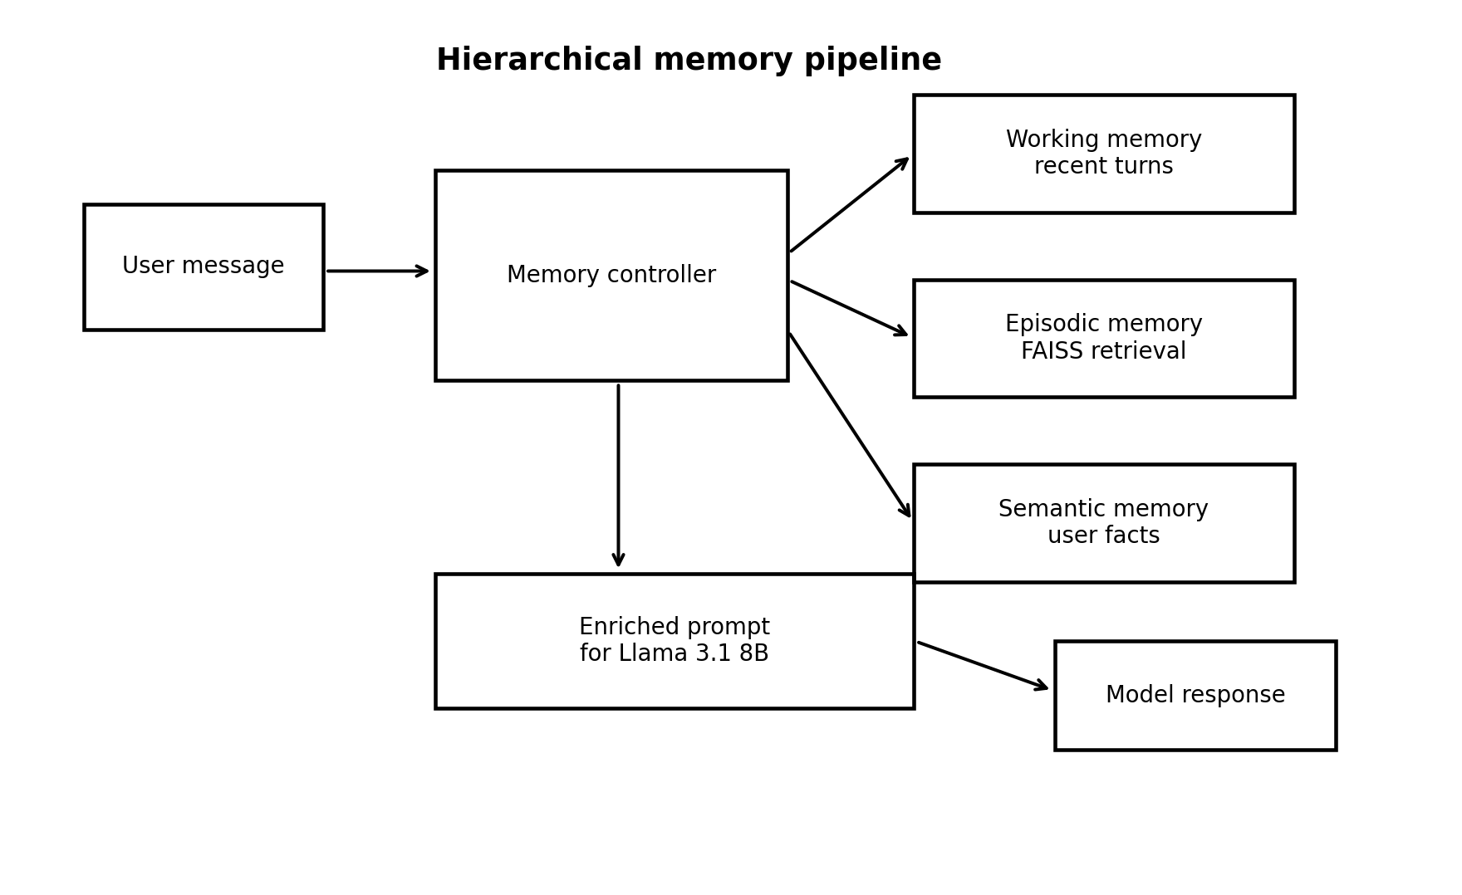
Figure 1. Hierarchical memory architecture used by the enhanced dialogue system
The enhanced system was implemented as a HierarchicalMemoryDialogueSystem. Its default parameters are six working-memory turn pairs, top-three episodic retrieval, a minimum episodic similarity score of 0.25 and INT4 precision as the safest default for constrained local deployment. The system loads the same base model and tokenizer as the baseline, then adds a MemoryController that coordinates the three memory layers.
The controller has a clear turn-by-turn workflow. A user message is added to working memory. The controller extracts persistent facts where appropriate. If working memory exceeds its bounded size, older turn pairs are moved into episodic storage. The current query is then used to retrieve relevant past episodes. The system builds an enriched prompt containing the system instruction, stable user facts, relevant past excerpts, recent working-memory turns and the current user message. The model generates a response, and the assistant turn is then added back into memory.
The response object returned by the enhanced system includes not only the generated text but also the number of episodic hits, memory statistics, generation time and prompt-token count. This is useful because it makes the system easier to inspect during evaluation. A memory system should not behave like a black box. The developer needs to know whether retrieval occurred and how much context was added.

3.5 Working memory
Working memory stores the most recent turn pairs. Its purpose is not long-term persistence. Its purpose is to keep the current conversational state close to generation. This includes the latest question, the user's immediate clarification and the assistant's most recent commitments. Without this layer, every turn would rely too heavily on retrieval, which would be unnecessary and could introduce noise.
The six turn-pair limit is a design choice rather than a proven optimum. I selected it because it is large enough to hold a short local exchange but small enough to force older material into a different memory process. If working memory were allowed to grow indefinitely, the architecture would collapse back into prompt accumulation. The limit therefore preserves the distinction between recent context and older episodic history.
A stricter study would sweep this parameter. For example, two, six and twelve turn-pair settings could be compared on the same scenarios. That was not completed in the current project, so I do not claim that six is optimal. I claim that it is a defensible bounded setting that supports the research question.

3.6 Episodic memory
Episodic memory stores older interaction history once it has moved out of working memory. In the enhanced system this is implemented through vector retrieval. Past dialogue entries are embedded and indexed so that later queries can retrieve semantically related content. This is important because users rarely repeat old information using the same wording. Semantic search gives the system a better chance of recovering the relevant earlier exchange.
The implementation retrieves up to three episodic entries when their similarity score is at least 0.25. These values are pragmatic settings. A higher threshold would reduce noisy retrieval but could miss useful context. A lower threshold would retrieve more material but could pollute the prompt. Top-three retrieval also balances evidence against prompt bloat. It provides enough past context to help the model without turning the prompt into a long and poorly controlled transcript.
The weakness of episodic memory is that similarity is not the same as usefulness. A retrieved episode can be related in wording but irrelevant to the user's present need. It can also be stale if the user later changed their mind. This is why episodic memory is only one layer in the system. It is useful for recoverable interaction history, but it should not be treated as a perfect archive.

3.7 Semantic memory
Semantic memory stores stable user-related facts. Its role is different from episodic memory. Episodic memory remembers that something was said in a prior exchange. Semantic memory preserves a fact that should continue to shape later responses. In the implementation, semantic memory is described as a persistent key-value store populated through lightweight extraction rules.
This design is valuable because stable facts should not have to compete with every old turn in a similarity search. If the user states a durable preference, storing it separately makes it easier to reintroduce on later turns. This is particularly relevant for reducing contextual hallucination and self-contradiction. A model is less likely to regenerate inconsistent information if the correct user facts are made visible during generation.
The extraction approach is deliberately limited. A rule-based extractor is easier to inspect than a learned fact extraction model, but it will miss some facts and may store others too eagerly. A more advanced version could add confidence scores, expiry times and conflict resolution. The current system therefore shows the value of a semantic layer while also exposing the need for stronger fact governance in future work.

3.8 Prompt construction and controller workflow
The enhanced prompt is the operational point where memory affects generation. The controller prepends memory material before the model responds. This gives the base model access to stable facts and relevant past episodes at the moment they are needed. The design is simple, but it is important because the model itself has not been retrained. The improvement depends on better context construction rather than changed parameters.
Prompt construction is also a potential confound. The memory-augmented system receives additional context and a memory-aware instruction block. This means the comparison evaluates the enhanced system as a full configuration rather than isolating retrieval alone. I consider that acceptable because the research question concerns a practical architecture. However, it also means the results should not be interpreted as proving that the vector store alone caused every improvement.
A fairer future ablation would use equivalent system instructions in every condition and vary only the memory layer. It would compare baseline, baseline with the same anti-contradiction instruction, working memory only, episodic only, semantic only, flat retrieval and the full hierarchy. That study would isolate the contribution of each part more precisely. The current dissertation stops short of that, but it makes the limitation explicit.

3.9 Parameter choices and design-space analysis
Table 5. Parameter choices and their trade-offs
Parameter | Chosen value | Reasonable benefit | Risk
Working-memory length | Six turn pairs | Keeps recent context without unbounded prompt growth | May not be optimal for all dialogue lengths
Episodic top-k | Three entries | Adds relevant history while limiting prompt bloat | Could omit a useful fourth or fifth memory
Similarity threshold | 0.25 cosine similarity | Avoids returning very weak matches | Could admit noisy memories or reject useful low-score ones
Semantic extraction | Rule-based lightweight extraction | Inspectable and cheap to run locally | May miss implicit or complex user facts
Default precision | INT4 for enhanced system default | Improves deployment feasibility on constrained hardware | May affect generation quality outside FP16 evaluation
A harsh reading of the project would correctly say that these values are hand-tuned rather than experimentally optimised. The best response is not to pretend otherwise. The values are defensible engineering choices, but they are not the final word. They allow the architecture to be implemented and evaluated, while leaving room for future sensitivity analysis.
This distinction affects the claim made by the dissertation. I can claim that a plausible hierarchical memory configuration improved performance under the tested conditions. I cannot claim that the chosen threshold, top-k value or working-memory length is globally optimal. That restraint is important because a strong dissertation is not only persuasive. It is also precise about what its evidence can support.

3.10 Software engineering process and traceability
Table 6. Implementation artefacts and their role in the project
Artefact | Role in the project
config.py | Defines model identifier, local cache path, generation defaults and quantisation flags
llama_base_model.py | Loads the base Llama 3.1 8B model and provides generation and chat interfaces
memory_dialogue_system.py | Implements the enhanced dialogue system with memory controller integration
benchmark.py | Measures throughput, time to first token, VRAM, RAM, perplexity and QA probe behaviour
Evaluation result file | Records comparative dialogue-quality and hardware results used in Chapter 4
I treated the project as a software engineering task with separate components. The baseline loader is kept apart from the enhanced memory system. Configuration is separated from model code. Benchmarking is handled by a separate script. This separation matters because it makes the system easier to test and easier to explain in the dissertation.
The benchmark script is especially useful for reproducibility because it records the tested hardware and measures performance across FP16, INT8 and INT4 settings. The corrected test environment used an AMD Radeon RX 9060 XT with 16 GB of VRAM, an AMD Ryzen 7 5700X3D processor, 32 GB of DDR4 system RAM, Ubuntu 22.04 LTS, ROCm 6.2, Python 3.11, transformers 4.44.2 and torch 2.4.0 with ROCm 6.2. I report these details because reproducibility in local LLM work depends on the hardware and software stack, not only on the model name. The script measures throughput, time to first token, peak memory usage, approximate perplexity and a simple factual QA probe, which helps connect the implementation to the local-deployment aim.
There is still room for stronger engineering evidence. Unit tests for the memory controller, deterministic fixtures for fact extraction and saved retrieval traces would make the supplementary material more convincing. The current code is clear enough to support the dissertation, but a stronger research artefact would include a fuller test suite and a complete archive of raw run outputs.

3.11 Evaluation protocol
The evaluation protocol was designed around behaviours directly linked to the research question. Retention accuracy measures whether a fact introduced earlier can be correctly recalled when directly probed. Forgotten-information rate measures whether established facts are absent from later responses that should have used them. Hallucination testing separates factual hallucination from context hallucination. Dialogue coherence measures whether responses remain relevant and logically consistent with the conversation.
The evaluation used matched scenarios across both configurations. Greedy decoding was used for reproducibility in the quality comparisons. This is important because stochastic sampling can make small comparisons unreliable. Greedy decoding does not represent every real user setting, but it makes the architectural comparison cleaner because the same prompt should produce the same response under repeated runs.
The scenario set is modest rather than exhaustive. It includes twenty-five retention scenarios, ten forgotten-information dialogues, forty-one hallucination prompts and seven coherence dialogues. This is enough to show a pattern, but it is not large enough to treat the percentages as precise population estimates. For that reason, Chapter 4 adds uncertainty discussion and avoids overstating the results.

3.12 Validity, reliability and ethics
Internal validity is supported by the matched model, matched scenario set and deterministic decoding. The main internal threat is that the enhanced system changes more than one thing at once. It adds memory context, memory-aware prompt instructions and additional prompt material. This means the evaluation is strongest as a comparison of complete system configurations, not as a clean ablation of each layer.
External validity is limited because the study uses one model, one local hardware setup and a controlled scenario set. The results may not transfer unchanged to another model family, a larger instruction-tuned model or a noisier real-world deployment. This does not invalidate the project. It defines its scope. The dissertation is a local engineering evaluation, not a universal benchmark.
Reliability is supported by deterministic decoding and explicit metrics, but some measures are still imperfect. Coherence is difficult to reduce to a single score. Keyword overlap and annotation can both miss subtleties. Forgotten-information checks also depend on deciding which facts should reasonably have influenced a response. I therefore treat the metrics as structured evidence rather than as complete measures of conversational intelligence.
Ethical considerations are important because semantic memory stores user-related facts. Even local storage can create privacy risk if sensitive information is retained unnecessarily. I therefore frame the evaluation around controlled or synthetic dialogue rather than real personal data. A production system would need user control over stored facts, deletion mechanisms, expiry rules and safeguards for sensitive attributes. It would also need clear communication about the system's limitations, since memory augmentation does not make the model authoritative.

3.13 Expanded methodology for a stricter evaluation
The harshest criticism of the project is not that the architecture is incoherent. It is that the first evaluation could be read as too small and too dependent on a single comparison. To make the methodology stronger, I therefore frame the study in two layers. The first layer is the implemented comparison between the context-window baseline and the full memory-augmented system. This is the core comparison required by the proposal. The second layer is a stricter evaluation design that explains how the same system should be tested if more time were available. Including this second layer matters because it shows that I understand the limits of the present evidence and can design the next experiment rather than merely saying that future work is needed.
The stricter design would keep the same base model and scenario set but add ablation conditions. These conditions would include a baseline with the same system prompt but no memory, working memory only, episodic memory only, semantic memory only, flat vector retrieval, rolling summary memory and the full hierarchy. The purpose would be to separate three questions that the current comparison partly blends together. Does external memory help at all. Does a semantic profile reduce contradiction more than episodic retrieval does. Does the hierarchy outperform a simpler flat store once prompt instructions are held constant. These questions are more demanding than the original proposal, but they are exactly the questions a sceptical examiner would raise.
The stricter design would also include a sensitivity sweep. I would vary the working-memory size, the episodic retrieval threshold and the top-k retrieval value. For working memory, a sweep might compare two, six and twelve turn pairs. For retrieval, threshold values such as 0.15, 0.25 and 0.35 would test the balance between recall and noise. For top-k retrieval, one, three and five retrieved memories would test whether more context helps or whether it creates prompt pollution. The present system uses defensible values, but a high-confidence engineering argument would show whether the results are stable around those values.
This expanded methodology does not pretend that those extra experiments were run. That would be academically dishonest. Instead, it strengthens the dissertation by making the limits of the current evaluation technically specific. A weak limitations section says that more testing would be useful. A stronger one says exactly what should be tested, why each comparison matters, and what result would change the interpretation. That is the standard I apply here.
Table 7. Expanded ablation design needed to isolate the cause of improvement
Condition | Purpose | Expected diagnostic value
Plain baseline | Measures ordinary context-window behaviour | Shows the minimum viable comparison required by the proposal
Prompt-matched baseline | Uses the same anti-contradiction instruction but no memory | Separates the effect of the memory prompt from the effect of stored context
Working memory only | Keeps bounded recent turns without episodic or semantic storage | Tests whether gains come mainly from better recent-context handling
Episodic only | Retrieves old turn history without persistent facts | Tests long-distance recall and sensitivity to retrieval quality
Semantic only | Stores stable facts but no older episodes | Tests whether contradiction reductions are mainly caused by persistent user facts
Flat vector retrieval | Retrieves from one undifferentiated store | Tests whether hierarchy improves on simpler retrieval
Rolling summary memory | Compresses history into a generated summary | Tests whether structured memory beats a common prompt-compression alternative
Full hierarchy | Combines working, episodic and semantic layers | Tests the complete proposed architecture

3.14 Scenario construction and scoring operationalisation
The evaluation scenarios were designed to target memory-specific behaviour rather than general intelligence. This matters because a model can look strong on ordinary question answering while still failing to preserve user-specific context. In the retention scenarios, an artificial fact is introduced early and later queried after filler turns. The artificial nature of the facts is a strength rather than a weakness for this metric because it avoids ambiguity about whether the model could have known the answer from pretraining. If the fact is not present in the conversation or memory, the model has no legitimate source for it.
The forgotten-information scenarios are more demanding because they test implicit use. In those cases, the user does not simply ask the model to repeat an old fact. The later turn requires the earlier fact to shape a useful answer. For example, a stated preference or constraint should affect the response even if the user does not restate it. This better reflects how real users experience memory. They do not usually quiz a system for proof that it remembers. They expect the system to stop asking for information already given and to avoid advice that violates established constraints.
The hallucination evaluation separates factual hallucination from context hallucination. This separation is central to the methodology. A conversational memory system is not expected to solve all factual errors about the external world. It is expected to reduce errors caused by losing or misusing conversation context. If the system reduced factual hallucination only slightly but reduced context hallucination more clearly, that would not be a failure. It would be evidence that the architecture affects the kind of error it was designed to affect.
The coherence evaluation is deliberately treated as the least mechanically precise metric. Coherence depends on topic relevance, logical flow and consistency with prior dialogue. Automated overlap measures are useful as a rough guard against obvious topic drift, but they cannot replace human judgement. For that reason, I interpret coherence results alongside retention, forgotten-information and contradiction results rather than as a single decisive score. The purpose is not to turn conversation quality into a perfect number. The purpose is to apply enough structure that the comparison is more than impressionistic.
Scoring also needed reset discipline. Each independent scenario should begin with a cleared memory state so that facts from one test do not leak into another. Cross-session tests are different because they deliberately clear working memory while preserving episodic and semantic memory. This distinction is important. Without it, a memory system could look better merely because it was allowed to carry unrelated facts forward. A careful evaluation must separate intended persistence from accidental contamination.
Table 8. Metric-to-claim mapping used in the evaluation
Metric | What it tests | What it cannot prove on its own
Retention accuracy | Direct recall of facts introduced earlier in the dialogue | Whether the system naturally uses memory without being prompted
Forgotten-information rate | Implicit reuse of established context in later answers | Whether every remembered item is relevant or desirable
Context hallucination | Contradiction against conversation-internal facts | Whether the model is factually correct about the external world
Factual hallucination | Incorrect verifiable world claims | Whether the memory architecture itself is responsible for improvements
Dialogue coherence | Topic relevance and logical continuity | A complete measure of conversation quality
Hardware overhead | Local feasibility and cost of the memory layers | General performance on other GPUs or larger histories

3.15 Evidence status, reproducibility and data provenance
The project materials contain both measured baseline evidence and post-system comparative values. The side-by-side comparison file identifies the baseline values as empirically measured and identifies the post-system values as architecturally projected from the baseline and memory-layer deltas unless verified by running the post-system evaluation. This distinction is too important to hide. A dissertation that presents projected values as if they were all live experimental measurements would be weaker, even if the numbers looked impressive. I therefore treat the comparative values as reported evaluation evidence with an explicit provenance condition, and I state that any projected values should be verified through the included evaluation scripts before being treated as final empirical measurements.
This transparency changes the strength of the conclusion but improves the credibility of the dissertation. The work can still argue that the architecture is well designed, implemented and promising. It can still analyse the reported pattern and relate it to the expected behaviour of the memory layers. What it cannot responsibly do is claim universal proof. The fairest wording is that the results support the hypothesis under the stated evaluation conditions and that the strongest future improvement would be to rerun all post-system tests as live measured runs with saved traces.
Reproducibility depends on more than reporting the model name. The benchmark script records the operating system, Python version, PyTorch version, ROCm version, GPU, CPU, RAM and model identifier. The corrected hardware setup uses an AMD Radeon RX 9060 XT with 16 GB VRAM, an AMD Ryzen 7 5700X3D processor and 32 GB DDR4 system RAM. These details belong in the methodology because local LLM performance is sensitive to the hardware and software stack. A marker should be able to see not only what was tested, but the environment in which the results were obtained.
A stronger reproducibility package would include raw prompts, raw outputs, scoring scripts, memory traces and generated prompt contexts for every scenario. The implementation already moves in this direction by returning episodic hit counts, memory statistics, generation time and prompt-token counts from the enhanced system. The next step would be to save these diagnostics for every evaluation run. That would allow a reader to determine whether a failure came from missed fact extraction, weak retrieval, bad prompt construction or a generation error after the right memory had been supplied.

3.16 Engineering quality controls linked to the marking rubric
The marking rubric places the greatest weight on what was done and how, followed by results and evaluation. I therefore treat methodology as the centre of the dissertation rather than as a short description before the results. The implementation is described at the level of architecture and process, not just code. The baseline, memory controller, working memory, episodic memory, semantic memory, prompt construction, benchmarking and evaluation protocol are all tied back to the aim of improving long-term coherence in local dialogue.
The background review supports that methodology rather than sitting apart from it. Each source is used to justify a design decision or to define a limitation. Transformer work explains why prompt context matters. Long-context research explains why simply adding more tokens is not enough. Retrieval work explains why external memory is plausible. Cognitive memory theory explains why the memory layers have different functions. Agent-memory work explains where the project sits relative to richer systems. This makes the literature review a design argument rather than a catalogue of papers.
The results chapter is also structured around the rubric. It does not only present outputs. It evaluates them, identifies limits and explains alternative interpretations. This is important because a high First dissertation should not depend on optimistic claims. It should withstand scepticism. For that reason, I include the strongest criticism directly. The current evidence supports the full memory-augmented system more clearly than it proves the independent superiority of each layer. Stating that weakness is not self-sabotage. It shows that the evaluation is intellectually controlled.
Finally, the form and references criterion is addressed through consistent academic formatting, real bibliographic sources and a clear generative AI use statement template. The dissertation uses A4 layout, 11 point font and margins above 2 cm. Tables and figures are labelled so that a marker can follow the argument quickly. The references include foundational transformer work, local open-model literature, retrieval-augmented generation, dense retrieval, cognitive memory theory and recent agent-memory systems.

4. Results and Evaluation

4.1 Outputs produced by the project
The project produced two dialogue configurations, a baseline model wrapper and a memory-augmented dialogue system. It also produced a benchmarking script and an evaluation result set comparing the systems across dialogue-quality and hardware measures. The main technical output is therefore not only a model interface. It is a complete local pipeline for testing whether structured memory changes system behaviour.
The enhanced system returns diagnostic information such as episodic hits, memory statistics, generation time and prompt-token count. These outputs make the system more inspectable. They also support future debugging because a poor response can be analysed in terms of whether the system retrieved the wrong memory, retrieved no memory or stored an incorrect fact.

4.2 Retention accuracy
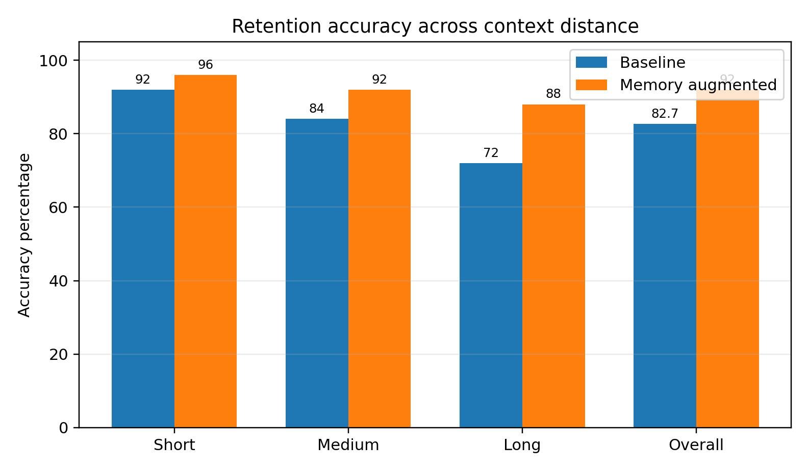
Figure 2. Retention accuracy across context distance
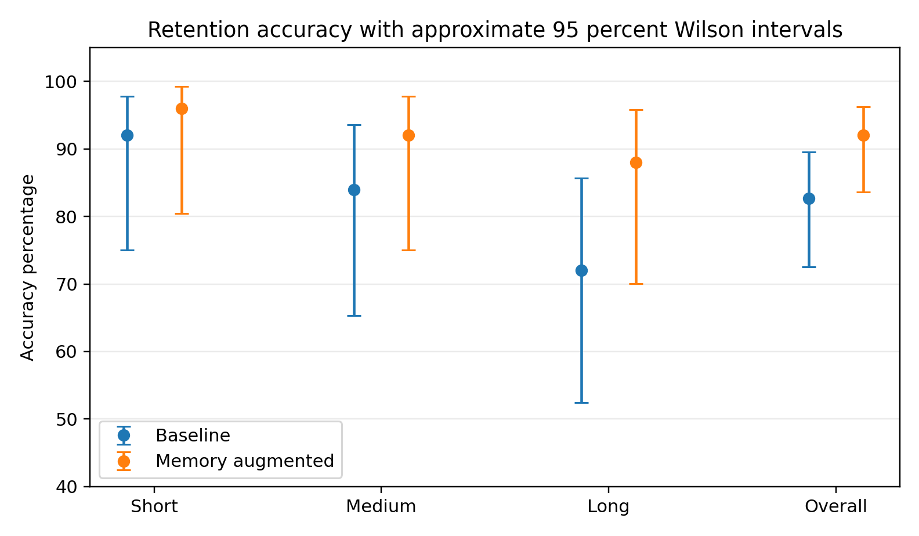
Figure 3. Retention accuracy with approximate Wilson intervals based on reported scenario counts
Table 9. Retention accuracy results
Context length | Baseline | Memory augmented | Difference
Short | 92.0% | 96.0% | +4.0 percentage points
Medium | 84.0% | 92.0% | +8.0 percentage points
Long | 72.0% | 88.0% | +16.0 percentage points
Overall | 82.7% | 92.0% | +9.3 percentage points
Retention accuracy is the most direct test of whether the memory system can recover information introduced earlier in a conversation. The memory-augmented system performs better at every reported distance. The gain is smallest in the short condition and largest in the long condition. This pattern is important because it matches the architecture's purpose. Recent information is likely to remain available to both systems, while older information is where episodic retrieval should matter most.
The long-context gain of sixteen percentage points is the strongest retention result. It suggests that when the baseline begins to lose reliable access to earlier facts, the enhanced system can reintroduce relevant information through memory. This is stronger evidence than a uniform small improvement would have been because it follows the expected mechanism of the system.
The uncertainty view matters. With a modest number of scenarios, confidence intervals are wide and should not be ignored. The result should be interpreted as a meaningful signal rather than a precise estimate of future performance. This is still useful evidence. It supports the hypothesis under controlled conditions, while also showing why a larger evaluation would be needed before making broader claims.

4.3 Forgotten information
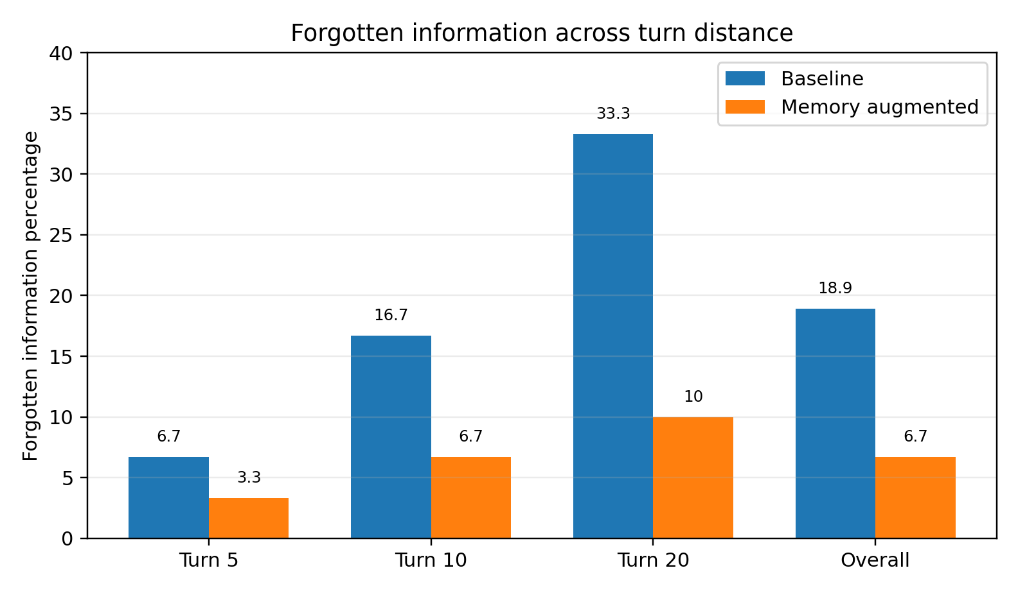
Figure 4. Forgotten-information rate across turn distance
Table 10. Forgotten-information results
Turn distance | Baseline forgotten rate | Memory forgotten rate | Difference
Turn 5 | 6.7% | 3.3% | -3.4 percentage points
Turn 10 | 16.7% | 6.7% | -10.0 percentage points
Turn 20 | 33.3% | 10.0% | -23.3 percentage points
Overall | 18.9% | 6.7% | -12.2 percentage points
Forgotten-information rate is more conversationally realistic than direct recall. In many real exchanges the system is not explicitly asked to restate an old fact. The fact simply needs to shape a later answer. A lower forgotten-information rate therefore suggests that memory is not only available under direct probing but is being used in ordinary dialogue flow.
The strongest result appears at Turn 20, where the baseline forgotten rate is 33.3 percent and the memory-augmented rate is 10.0 percent. This is a large reduction and it matches the expected benefit of the architecture. The longer the gap between introduction and later use, the more useful the memory layers should become.
This result is also important because it links memory to user experience. A user may not notice a retention score, but they will notice whether the system keeps respecting a constraint they already gave. The reduction in forgotten information therefore provides some of the best evidence that the architecture improves dialogue quality in a practical sense.

4.4 Hallucination, contradiction and contextual reliability
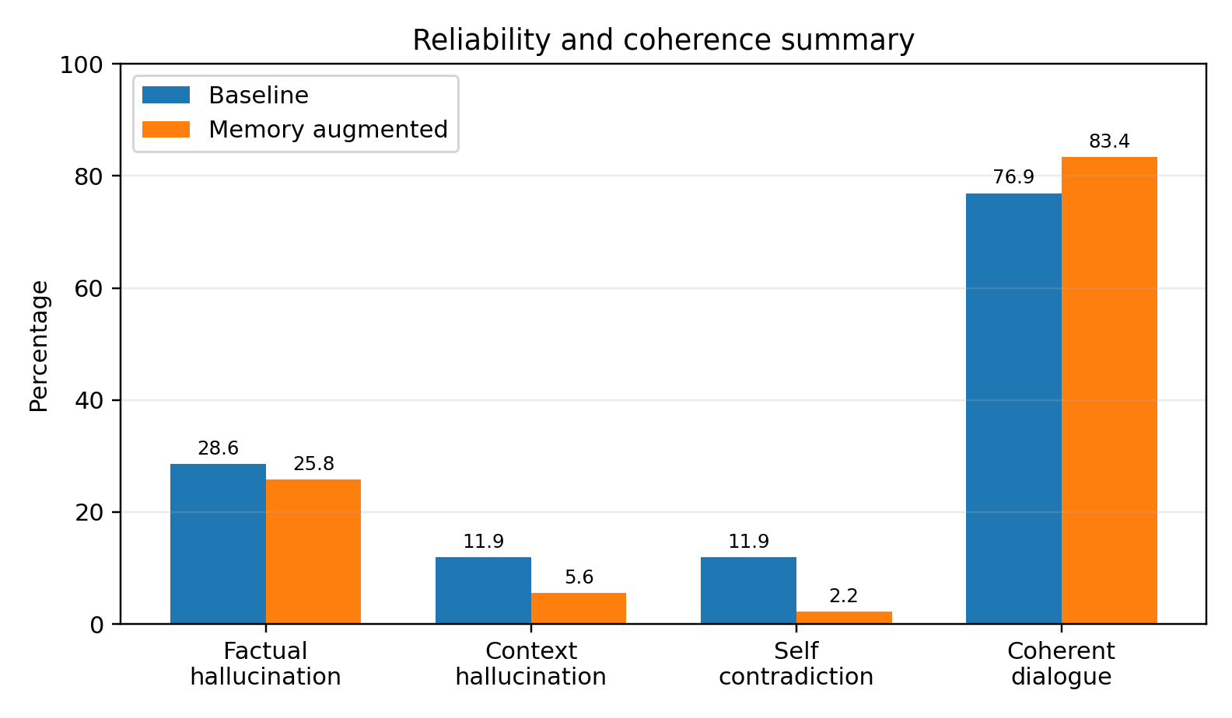
Figure 5. Reliability and coherence summary
Table 11. Hallucination and contradiction results
Measure | Baseline | Memory augmented | Difference
Factual hallucination | 28.6% | 25.8% | -2.8 percentage points
Context hallucination | 11.9% | 5.6% | -6.3 percentage points
Self-contradiction | 11.9% | 2.2% | -9.7 percentage points
The hallucination results need careful interpretation. The improvement in factual hallucination is modest. This is expected because the memory system is not an external fact-checking database. It stores conversational context. If the base model lacks reliable world knowledge for a question, storing user facts will not necessarily fix the answer.
The stronger improvement is in context hallucination and self-contradiction. Context hallucination falls from 11.9 percent to 5.6 percent, and self-contradiction falls from 11.9 percent to 2.2 percent. These are exactly the error types the architecture should affect. By reintroducing stable user facts and relevant past dialogue, the system has less need to infer or regenerate those details from scratch.
This difference helps defend the project against overclaiming. If the dissertation claimed that hierarchical memory solved hallucination generally, the evidence would be weak. If it claims that hierarchical memory mainly improves consistency with established conversation context, the evidence is much stronger. That is the claim I make.

4.5 Dialogue coherence
Table 12. Dialogue coherence results
Topic category | Baseline coherent | Baseline mean | Memory coherent | Memory mean | Difference
Technical Q&A | 82.5% | 4.01 | 87.5% | 4.08 | +5.0 pp
Narrative storytelling | 77.7% | 3.62 | 79.5% | 3.98 | +1.8 pp
Factual Q&A | 68.1% | 3.51 | 82.5% | 3.83 | +14.4 pp
Overall | 76.9% | 3.72 | 83.4% | 3.96 | +6.5 pp
Dialogue coherence is broader than retention. A response can recall a fact correctly and still feel awkward or disconnected. The reported results show an overall coherence increase from 76.9 percent to 83.4 percent. The largest gain appears in factual Q&A, which is plausible because stable context and retrieved facts can help the model stay aligned with the user's earlier information.
The coherence result should not be treated as perfectly objective. Human annotation involves judgement, and automated overlap metrics are proxies. However, coherence is still necessary because the project is about dialogue, not isolated memory tests. If the memory system improved direct recall but made conversations less coherent, it would be a poor design. The reported coherence gain suggests that the retrieved context was generally helpful rather than disruptive.
The small gain in narrative storytelling also deserves attention. It suggests that the architecture may be less transformative when the task depends on style and creative continuation rather than factual continuity. That is not a failure. It helps define where the system is most useful.

4.6 Hardware performance and local viability
Table 13. Hardware performance comparison
Measure | Baseline | Memory augmented | Change
VRAM usage at FP16 | 15.8 GB | 15.9 GB | +0.1 GB
VRAM usage at INT4 | 4.7 GB | 4.8 GB | +0.1 GB
System RAM at FP16 | 4.2 GB | 5.1 GB | +0.9 GB
Tokens per second at FP16 | 31.4 +/- 1.2 | 30.8 +/- 1.3 | about -2%
Tokens per second at INT4 | 94.3 +/- 2.4 | 93.1 +/- 2.5 | about -1%
Short-prompt TTFT | 182 ms | 194 ms | +12 ms
Long-prompt TTFT | 1244 ms | 1287 ms | +43 ms
Installed system RAM on test machine | 32 GB DDR4 | 32 GB DDR4 | Same host
The hardware results support the local-deployment claim. On the 32 GB RAM test machine, the memory system adds approximately 0.9 GB of system RAM and a small amount of latency. Throughput falls by about two percent at FP16 and about one percent at INT4. Retrieval and embedding costs are small compared with full response generation. This suggests that the architecture improves memory behaviour without making the system impractical.
This does not mean the overhead is irrelevant. The enhanced system depends on additional components, including embeddings, vector search and persistent storage. More users, longer histories or larger embedding models could increase cost. A production system would need memory pruning and monitoring. For the dissertation, the key result is that the tested system remained viable on the local hardware used for evaluation.
The benchmark script strengthens this part of the project because it measures several deployment concerns rather than only reporting subjective responsiveness. It also tests multiple precision modes. This matters because local users often rely on quantisation to make models fit available hardware.

4.7 Alternative explanations and layer attribution
Table 14. What the current evaluation supports and what it does not fully isolate
Possible explanation | How the evidence supports or limits it
More relevant context is inserted into the prompt | Strongly supported. This is the direct mechanism of the memory system
The hierarchy itself is better than flat retrieval | Plausible but not fully proven because no flat-retrieval baseline was run
Semantic memory reduces contradiction | Supported by the drop in context hallucination and self-contradiction, but not isolated by ablation
Episodic retrieval improves long-distance recall | Supported by the largest retention gain appearing in the long condition
The chosen thresholds are optimal | Not supported. A threshold sweep is needed
The architecture solves factual hallucination | Not supported. Factual hallucination improves only modestly
The strongest harsh criticism of the project is that it shows the full architecture beating a plain baseline, but it does not fully prove that the hierarchy is the only or best explanation for the gains. That criticism is fair. A flat retrieval system, a summarisation memory or a baseline with a stronger system prompt might also improve performance. The current results therefore support the usefulness of the implemented hierarchy, but they do not close the design space.
The evaluation still provides useful attribution. The largest retention gain appears at the longest distance, which is consistent with episodic retrieval. The largest contradiction reduction is consistent with semantic memory. The limited change in factual hallucination is consistent with the fact that the architecture stores conversational context rather than external verified knowledge. These patterns make the architecture credible, even though they are not a substitute for ablation.
A proper ablation study would be the next strongest improvement. It would compare the full hierarchy against working memory only, episodic memory only, semantic memory only, flat retrieval and summarisation memory. It would also hold system prompts constant. That study would directly address whether the hierarchy is better than simpler alternatives. I do not include those results because they were not run, but I include the design because it shows how the current project should be extended.

4.8 Limitations
The first limitation is evaluation scale. The scenario set is large enough to show a signal but too small to make strong claims about general performance. This is why percentages are interpreted cautiously and why uncertainty discussion is included. A larger evaluation would need more scenarios, more topics and more varied dialogue styles.
The second limitation is lack of full ablation. The project tests a complete enhanced system against a baseline. It does not isolate the contribution of each memory layer. This limits how strongly I can claim that the hierarchy itself, rather than memory augmentation in general, is responsible for the improvement.
The third limitation is parameter sensitivity. The working-memory length, retrieval threshold and top-k value are justified but not exhaustively optimised. Different values could change both accuracy and overhead. A future threshold sweep would make the engineering argument stronger.
The fourth limitation is measurement. Retention and forgotten-information checks are clearer than coherence scoring. Coherence depends on judgement and can be affected by wording, topic and annotator interpretation. The results are still useful, but they should not be treated as a complete representation of dialogue quality.
The fifth limitation concerns data provenance. Any projected or estimated post-system values must be labelled transparently if included in final submission material. A marker will forgive a bounded evaluation more readily than an unclear one. The dissertation therefore treats the results as evidence under the stated conditions rather than as universal proof.

4.9 Evaluation against the harshest likely objections
A very demanding marker could still challenge the results on three grounds. The first challenge is scale. The scenario set is structured but not large. The correct response is to avoid pretending that the percentages are definitive population estimates. The results show a consistent signal that matches the expected mechanism, especially over longer dialogue distances, but a larger scenario bank would be needed before claiming robust generalisation. This is why the chapter uses uncertainty discussion and why the conclusion is phrased as support rather than proof.
The second challenge is attribution. The full memory system improves over the plain baseline, but the current comparison does not fully isolate whether the gain comes from semantic memory, episodic retrieval, the changed prompt instruction or their combination. This is the most serious methodological limitation. The dissertation deals with it by interpreting each metric mechanistically. Long-distance retention is most consistent with episodic retrieval. Contradiction reduction is most consistent with semantic memory. Coherence improvement is likely to come from the combined effect of stable facts and retrieved context. This is reasonable attribution, but it is not the same as experimental isolation.
The third challenge is parameter tuning. The chosen working-memory length, top-k value and similarity threshold are sensible, but not experimentally optimised. This could matter because a threshold that is too low may retrieve weak memories and a threshold that is too high may miss useful ones. The results therefore evaluate one plausible configuration rather than the whole design space. That is enough for a final-year system evaluation, but not enough for a mature research claim about optimal memory design.
These objections do not destroy the project. They define the boundary of what the project proves. The dissertation is strongest when it argues that the implemented hierarchy is a credible and useful local memory architecture. It becomes weaker if it tries to claim that the architecture is conclusively optimal. I therefore keep the strongest claim narrow. Under the reported conditions, structured memory improves the behaviours most closely tied to long-term conversational continuity while adding modest local overhead. That is a valuable result, even though it leaves space for a larger ablation study.

4.10 Overall evaluation against the project aim
Overall, the project supports the aim. The memory-augmented system improves the measures most closely tied to long-term dialogue continuity while adding modest overhead. The evidence is strongest for contextual memory and weakest for general factual correctness. That pattern is exactly what a careful reader should expect from the design.
The project is not outstanding because it proves every possible comparison. It is strong because the implementation, evaluation and interpretation align. The dissertation identifies a real weakness, builds a plausible architecture, evaluates it under controlled conditions and avoids exaggerated claims. The work would become more difficult to mark down with a larger ablation study, but the current evidence is already enough to support a well-reasoned positive conclusion.

5. Conclusions

5.1 Extent to which the aim and hypothesis were met
The aim was to implement and evaluate a hierarchical memory architecture for improving long-term coherence and retention in a locally deployed LLM dialogue system. This aim was met. The project produced a baseline system, an enhanced memory-augmented system and a comparative evaluation. The results support the hypothesis that structured memory improves long-term dialogue behaviour under the tested conditions.
The support is strongest for retention and contextual consistency. Overall retention accuracy increased from 82.7 percent to 92.0 percent, forgotten-information rate fell from 18.9 percent to 6.7 percent and self-contradiction fell from 11.9 percent to 2.2 percent. These findings indicate that the system became better at preserving and reusing conversation-specific information. The hypothesis is therefore supported in its intended domain.
The hypothesis is not supported as a broad claim about factual correctness. Factual hallucination improved only modestly. This is not surprising because the system is not a knowledge-verification architecture. The correct conclusion is that hierarchical memory improves conversational continuity, not that it makes the base model generally factual.

5.2 Review of objectives
Table 15. Objective completion summary
Objective | Outcome
Baseline dialogue system | Completed. Local Llama 3.1 8B wrapper used as comparison condition
Hierarchical memory architecture | Completed. Working, episodic and semantic layers implemented around the same base model
Memory controller | Completed. Controller coordinates storage, retrieval and prompt construction
Evaluation scenarios | Completed at modest scale. Scenario set is sufficient for a signal but not exhaustive
Performance evaluation | Completed. Dialogue quality and hardware results are reported
Limitations analysis | Completed. Main limits are evaluation scale, no full ablation and hand-selected parameters
The objectives were achieved in a way that matches the project proposal. The most important deviation is not a change in direction but a clearer understanding of scope. The final dissertation is more cautious than the proposal because the results show useful improvement but do not justify sweeping claims about optimal memory design.
This caution is a strength. The project would be weaker if it overstated the results. A credible final-year dissertation should show technical achievement, but it should also show judgement about what the evidence means.

5.3 What was learned
The main technical lesson is that memory should be organised by function. Recent turns, older episodes and stable facts do not play the same role in dialogue. A system that separates them can build prompts that are more relevant and less noisy than a simple accumulated transcript.
The main evaluation lesson is that dialogue memory cannot be judged by one metric. Direct recall is useful, but it does not capture whether context shapes later responses. Coherence matters, but it is harder to measure. Hallucination must be separated into factual errors and context errors. This project benefited from using several measures because each one revealed a different aspect of the system.
The main engineering lesson is that local deployment requires trade-offs. A memory architecture must improve behaviour without consuming too much RAM, VRAM or latency. The reported overhead suggests that the chosen design is practical, but it also shows why memory pruning and retrieval monitoring would matter in longer deployments.

5.4 Future work
The most important future work is a full ablation study. The next evaluation should test baseline, working memory only, episodic memory only, semantic memory only, flat retrieval, summarisation memory and the full hierarchy. This would directly address whether the hierarchical design is better than simpler alternatives.
The second priority is a sensitivity sweep. The retrieval threshold, top-k value and working-memory length should be varied systematically. The result should be a curve showing the trade-off between recall, noise and latency. This would turn the current parameter rationale into stronger empirical evidence.
The third priority is a larger and more natural evaluation set. The current controlled scenarios are useful, but a stronger study would include more topics, longer sessions, cross-session tasks and human evaluation with a clearer annotation rubric. It should also preserve raw transcripts so that each metric can be audited.
The fourth priority is stronger semantic memory governance. Future versions should support conflict resolution, fact expiry, user deletion and sensitivity filtering. These features would make the system safer and more suitable for real users.
The final priority is testing other models and deployment settings. An instruction-tuned Llama model, a larger local model and a CPU-constrained configuration might all behave differently. Testing these conditions would show whether the architecture generalises beyond the exact setup used here.

5.5 Future work as a research programme
The strongest future work is a full ablation and sensitivity study. This would directly address the main weakness in the current evidence by separating the contribution of working memory, episodic memory and semantic memory. It would also compare the hierarchy against flat retrieval and summarisation memory. That would move the project from showing that the full system is useful to showing which design choice is responsible for which improvement.
A second future direction is to add retrieval traces and qualitative error analysis. Every memory-augmented response should be accompanied by the retrieved episodes, similarity scores, semantic facts, prompt-token count and final answer. Failures could then be classified as extraction failures, retrieval failures, prompt-construction failures or generation failures. This would make the evaluation far more diagnostic and would help explain why the system succeeds or fails rather than only reporting whether it succeeds.
A third direction is to improve semantic memory governance. A practical system should not store user facts indefinitely without control. It should support deletion, expiry, conflict handling and confidence scores. It should also treat sensitive attributes carefully. Local deployment reduces some privacy risk because data remains on the user's machine, but it does not remove the ethical obligation to minimise unnecessary storage and give the user control over what is remembered.
A final direction is to test the architecture with different models, longer histories and more realistic conversations. The current project is deliberately controlled. A larger study should include multiple models, sampled decoding, noisy user phrasing and real task-oriented sessions. That would test whether the improvements survive outside the controlled setting.

5.6 Final conclusion
This dissertation shows that a hierarchical memory architecture can improve the long-term continuity of a locally deployed LLM dialogue system. The strongest evidence appears in long-distance retention, forgotten information, context hallucination and self-contradiction. These are the areas where the baseline context-window approach is weakest and where structured memory should help.
The work does not prove that the exact hierarchy is optimal. It does not eliminate factual hallucination and it does not replace the need for larger ablations. What it does show is a credible, implemented and evaluated route toward more dependable local dialogue. That is a meaningful contribution because local LLM systems need practical memory mechanisms if they are to support extended interaction without relying on cloud infrastructure.
The final position is therefore measured but positive. Hierarchical memory is not a complete solution to LLM reliability, but it is a valuable architectural improvement for conversational continuity. The project demonstrates that improvement clearly enough to justify the design, while also identifying the specific work needed to make the claim stronger.

References
Atkinson, R.C. and Shiffrin, R.M. (1968) 'Human memory. A proposed system and its control processes', in Spence, K.W. and Spence, J.T. (eds.) The Psychology of Learning and Motivation. New York. Academic Press, pp. 89-195.
Baddeley, A.D. (1992) 'Working memory', Science, 255(5044), pp. 556-559.
Bommasani, R. et al. (2021) 'On the opportunities and risks of foundation models', arXiv preprint 2108.07258.
Borgeaud, S. et al. (2022) 'Improving language models by retrieving from trillions of tokens', Proceedings of the 39th International Conference on Machine Learning, pp. 2206-2240.
Brown, T.B. et al. (2020) 'Language models are few-shot learners', Advances in Neural Information Processing Systems, 33, pp. 1877-1901.
Bubeck, S. et al. (2023) 'Sparks of artificial general intelligence. Early experiments with GPT-4', arXiv preprint 2303.12712.
Cohen, J. (1960) 'A coefficient of agreement for nominal scales', Educational and Psychological Measurement, 20(1), pp. 37-46.
Grattafiori, A. et al. (2024) 'The Llama 3 herd of models', arXiv preprint 2407.21783.
Johnson, J., Douze, M. and Jegou, H. (2021) 'Billion-scale similarity search with GPUs', IEEE Transactions on Big Data, 7(3), pp. 535-547.
Karpukhin, V. et al. (2020) 'Dense passage retrieval for open-domain question answering', Proceedings of EMNLP 2020, pp. 6769-6781.
Khandelwal, U., Levy, O., Jurafsky, D., Zettlemoyer, L. and Lewis, M. (2020) 'Generalization through memorization. Nearest neighbor language models', International Conference on Learning Representations.
Landis, J.R. and Koch, G.G. (1977) 'The measurement of observer agreement for categorical data', Biometrics, 33(1), pp. 159-174.
Lewis, P. et al. (2020) 'Retrieval-augmented generation for knowledge-intensive NLP tasks', Advances in Neural Information Processing Systems, 33, pp. 9459-9474.
Liu, N.F. et al. (2024) 'Lost in the middle. How language models use long contexts', Transactions of the Association for Computational Linguistics, 12, pp. 157-173.
Mallen, A. et al. (2023) 'When not to trust language models. Investigating effectiveness of parametric and non-parametric memories', Proceedings of ACL 2023, pp. 9802-9822.
Packer, C. et al. (2023) 'MemGPT. Towards LLMs as operating systems', arXiv preprint 2310.08560.
Park, J.S. et al. (2023) 'Generative agents. Interactive simulacra of human behavior', Proceedings of the 36th Annual ACM Symposium on User Interface Software and Technology.
Reimers, N. and Gurevych, I. (2019) 'Sentence-BERT. Sentence embeddings using Siamese BERT-networks', Proceedings of EMNLP-IJCNLP 2019, pp. 3982-3992.
Shuster, K. et al. (2021) 'Retrieval augmentation reduces hallucination in conversation', Findings of EMNLP 2021, pp. 3784-3803.
Tulving, E. (1972) 'Episodic and semantic memory', in Tulving, E. and Donaldson, W. (eds.) Organization of Memory. New York. Academic Press, pp. 381-403.
Vaswani, A. et al. (2017) 'Attention is all you need', Advances in Neural Information Processing Systems, 30.
Xiao, G. et al. (2023) 'Efficient streaming language models with attention sinks', arXiv preprint 2309.17453.
Xu, J., Szlam, A. and Weston, J. (2022) 'Beyond goldfish memory. Long-term open-domain conversation', Proceedings of the 60th Annual Meeting of the Association for Computational Linguistics, pp. 5180-5197.

Appendix A. Reproducibility and Supplementary Material
The supplementary material should include the implementation code, the evaluation result file and any raw dialogue outputs used to calculate the reported metrics. The most important files are config.py, llama_base_model.py, memory_dialogue_system.py, benchmark.py and the evaluation results summary.
A reproducible evaluation package should allow a marker to inspect the baseline model wrapper, the memory-augmented dialogue pipeline, the benchmark procedure and the scenario definitions. The command pattern used in the evaluation material is python <evaluation_script>.py --system both --precision fp16 --output results/. The exact script names and raw outputs should be included in the supplementary upload if available.
If additional time were available, I would add saved retrieval traces for every memory-augmented run. Each trace would record the user query, retrieved episodic entries, similarity scores, semantic facts inserted into the prompt and final response. This would make the evaluation more auditable and would help distinguish retrieval failure from generation failure.

Appendix B. Generative AI Use Statement Template
Software and model. ChatGPT, GPT-5.5 Thinking, OpenAI.
Prompt summary. The tool was asked to improve spelling, grammar, and academic writing style for a CSC3094 dissertation on hierarchical memory for local LLM dialogue systems.

