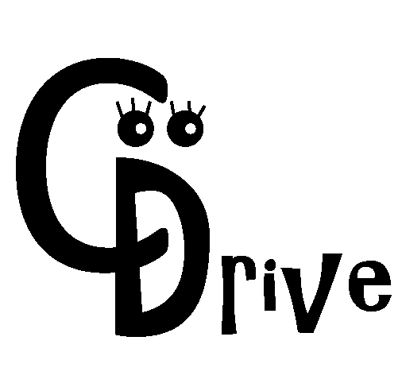

DOCUMENTATION

OPEN DATA HACHATHON 2018

**Dictionary**

For the purpose of this document and any subsequent mention of the App, cDrive shall mean the Cautious Drive mobile App.

**What is cDrive?**

cDrive is a mobile app that helps a vehicle driver to focus on the road by forcing the driver to have minimal interaction with the mobile device while behind the steering wheel.

The app detect movement of the car and if the user is the driver and he/she tries to use the phone, then the app disables services that the driver was trying to use as well as disable other application that mostly distract drivers when driving.

It also informs road users about traffic congestions and accidents within a radius of certain km from their co-ordinates.

**Functions**

**Traffic congestion**

* When any user wants to post an occurrence of traffic jam incident on a certain road, the app has just that capability of allowing him/her to do so.

* Other users near the same road will then get the notification.

**Accidents**

* Users can also post an event of an accident on a certain road.

* This is more important as other user will get notification and be warn to drive cautiously when approaching the accident occurrence spot.

* The app can as well be able to inform the police and Emergency response unit.

**Traffic lights out of order notification**

* Driver are as well notified about 'robots' that are out of order/ not working.

**High risk accident zone**

* The app warn users to be cautious when approaching high risk accident zones
* High accident zones will be displayed on the map

**Why should a driver want to have cDrive?**

Apart from been notified about traffic congestion, accidents, traffic lights that are not working in a certain are or high accident zones, cDrive can potentially save the driver’s life when he/she is involved in an accident. The app will sense if there is a sudden change in speed, if there driver was driving on a certain speed and there is no gradual decrease in speed until the vehicle stops but instead stead it’s a sudden stop then the app will wait for a minute or so to determine if the vehicle will continue to move, if not then it will assume that an accident has occurred and send out a report.

**Flow chats**

**Control systems: cDrive**  **Informative: cDrive (sender)**



**Informative: cDrive (receiver)**  **Informative: cDrive**



**cDrive mobile App**

**Home screen**

 

 