NUTeams onboarding Portfolio
This is your NUTeams training portfolio. Download and complete this document as you complete onboarding exercises and submit it as evidence these tasks have been completed.
All tasks are required, all evidence is required for each task.
It is acceptable for you to have completed tasks before 2026 and have them counted, however you will need to provide appropriate evidence, as agreed by Malcolm or Dylan. If you do not have evidence you will need to redo the task.
Most evidence will require an Approver. The Approvers for 2026 are:
Malcolm Sidney, Adam Minett (NURacing), John Wong (NUMarine), Rylie Heller (NURocketry), Ben Erwin (NUMarine), Riley Wollen (NURacing), Oliver O’Grady (NURocketry), and Dylan Cuskelly – note you do not need to get an approver from your team at this stage, any availible approver can mark you off.
Deadlines for tasks are as listed with each task. All tasks must be completed before the deadlines. No extension will be granted for any reason. You may need to submit this document periodically throughout the onboarding process. You do not have to work though it linearly, do task in whatever order is most efficient.
It is your responsibility to manage your time appropriately as a professional. Your ability to complete tasks on time and to an appropriate standard is one of the components being measured.
If you are having trouble completing tasks or collecting appropriate evidence reach out early.
If you are uncomfortable having your photo taken please reach out so we can organise other arrangements.
Submission requirements
You are required to name this document: Firstname_lastname_c1234567_NUTeams2200Onboarding2026.
You are required to submit this document to canvas as a .docx as ‘Assignment 1’ BEFORE 5pm Friday 11/09/26. Some tasks must be completed before this date.

Required software.
Join the following with your firstname.lastname@uon.edu.au account:
ASANA - https://asana.com/logged-in Go to setting, under profile, add your full name and a photo of yourself. Under Settings, under notifications, under Email turn off everything except someone mentions @username. No items will be purchased unless your photo can be verified.
OnShape - https://www.onshape.com/en/education/sign-up
ILab - https://uon.ilab.agilent.com/account/saml/uon - search "NU Teams" - don't enter a phone number, it is not required.
GitHub - https://github.com/ - you may sign up using your existing GitHub if you already have one.
Zero to Hero online modules: https://training.nuteams.org/
CESE WHS 2026 Canvas site
Self enrol link DO THIS FIRST: https://canvas.newcastle.edu.au/enroll/CLTM6M
NUTeams safety induction quiz (sometimes referred to as the Building induction – you must do the quiz in this link): https://canvas.newcastle.edu.au/courses/36450/quizzes/194427
EC lab induction: https://canvas.newcastle.edu.au/courses/36450/quizzes/194388
EC Student Workshop General Induction Quiz: https://canvas.newcastle.edu.au/courses/36450/quizzes/194424
ABEW induction (now confusing also called student workshop): https://canvas.newcastle.edu.au/courses/36450/quizzes/194371/take?preview=1
Uncorded power tools: https://canvas.newcastle.edu.au/courses/36450/quizzes/194407
Marking tools: https://canvas.newcastle.edu.au/courses/36450/quizzes/194429
Impact tools: https://canvas.newcastle.edu.au/courses/36450/quizzes/194395
Cutting tools: https://canvas.newcastle.edu.au/courses/36450/quizzes/194430

OnShape learning centre
Intro to part design short course: https://learn.onshape.com/courses/introduction-to-part-design
AND Introduction Exercises (2 parts in the video link): https://youtu.be/5xpckT8siig

After completing the appropriate Zero to Hero
TA Mcha Lab Induction (Only to be completed AFTER Lab Tools Zero to Hero): https://canvas.newcastle.edu.au/courses/36450/quizzes/194394
TA Prusa 3D Printer induction (Only to be completed after 3D printing Zero to Hero): https://canvas.newcastle.edu.au/courses/36450/quizzes/194382
Sign up for Online systems – Deadline 14/08/26
Sign up to the online systems OnShape, Ilab, GitHub and ASANA.
Once you have signed up post in the #role-request channel. It should have the formatting
Student number
@uon email address
Github user name
Requesting Role FYP
Provide a screenshot of your discord message from the role request channel

Your Discord user name must be your name as it appears in canvas.

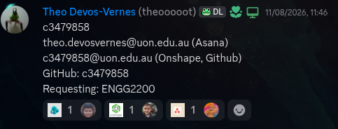
Online Inductions prt1 – Deadline 14/08/26
Provide evidence in the form of screenshots that you have completed and have 100% for all required inductions excluding those that need a Zero to Hero (i.e. you do NOT need to complete the online TA Mecha lab induction or the online TA Prusa 3D printing induction).
Each screenshot be taken such that your name can be seen as well as your grade.
If it helps the Print Grades button in canvas should allow you to generate a PDF what has your name at the top of each page.
Multiple grades may be captured in a single screenshot provided all required information is present.
Ensure you have followed the links to get to the quizzes. Canvas has several quizzes with similar names. You MUST do the ones in the links.
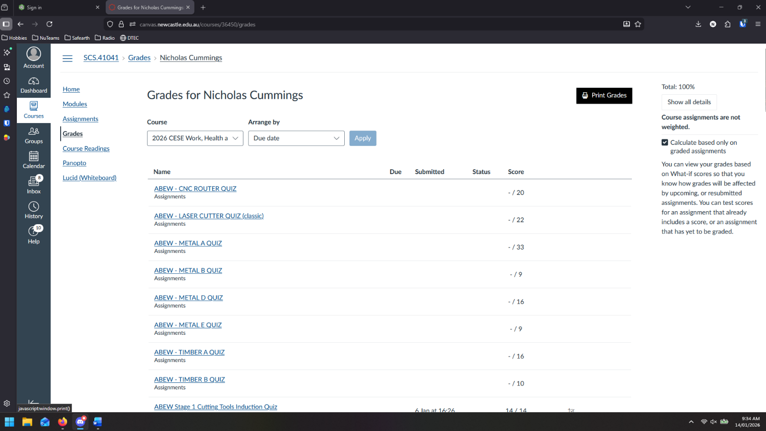
Figure 1 It is hard to get both your name and grade on screen in Canvas gradebook - Use the print grades button for an easier screenshotable PDF.

Your name needs to be somewhere
Quiz name score/score

Include as many screenshots as required.
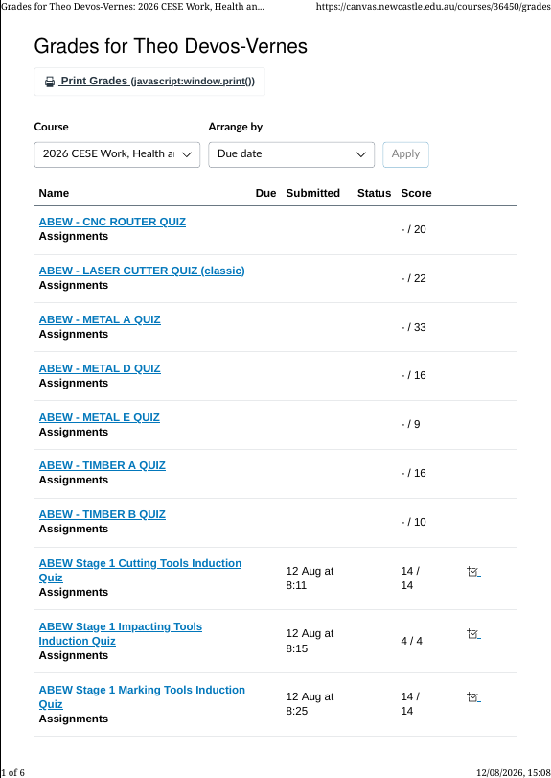
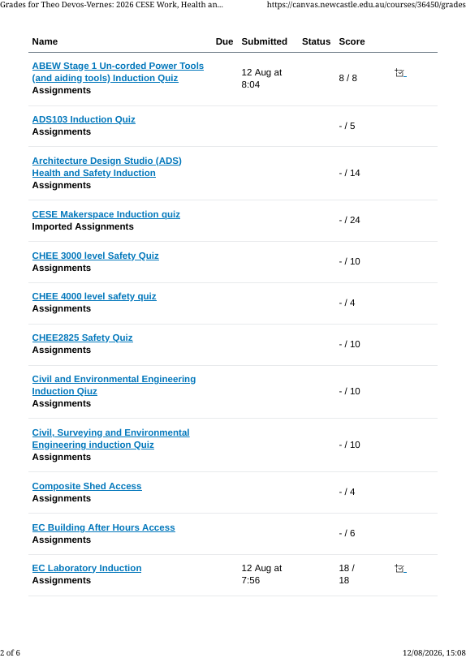

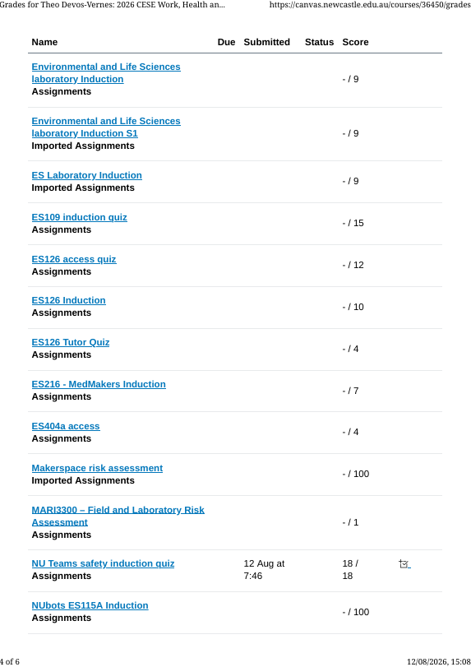
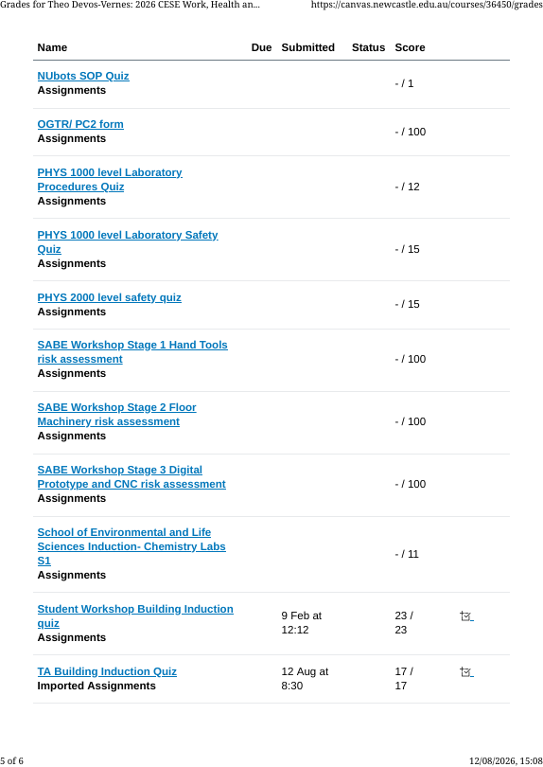
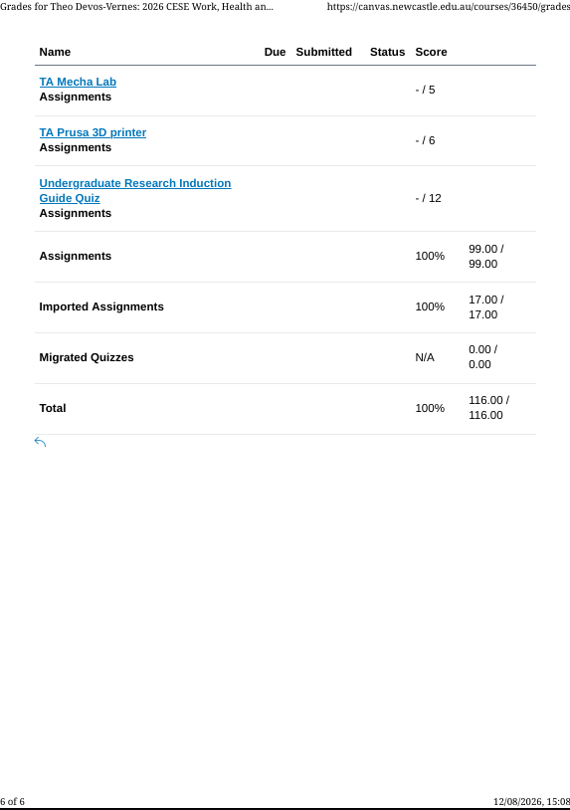
Online Inductions prt2 – Deadline 11/09/26
Provide evidence in the form of screenshots that you have completed and have 100% for the online TA Mecha lab induction and the online TA Prusa 3D printing induction.
Each screenshot be taken such that your name can be seen as well as your grade.
If it helps the Print Grades button in canvas should allow you to generate a PDF what has your name at the top of each page.
Multiple grades may be captured in a single screenshot provided all required information is present.
Ensure you have followed the links to get to the quizzes. Canvas has several quizzes with similar names. You MUST do the ones in the links.
Your name needs to be somewhere
Quiz name score/score

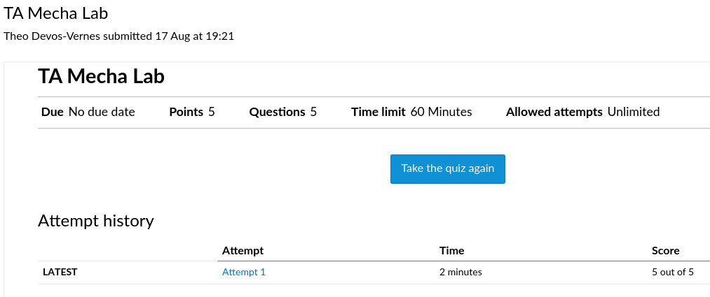
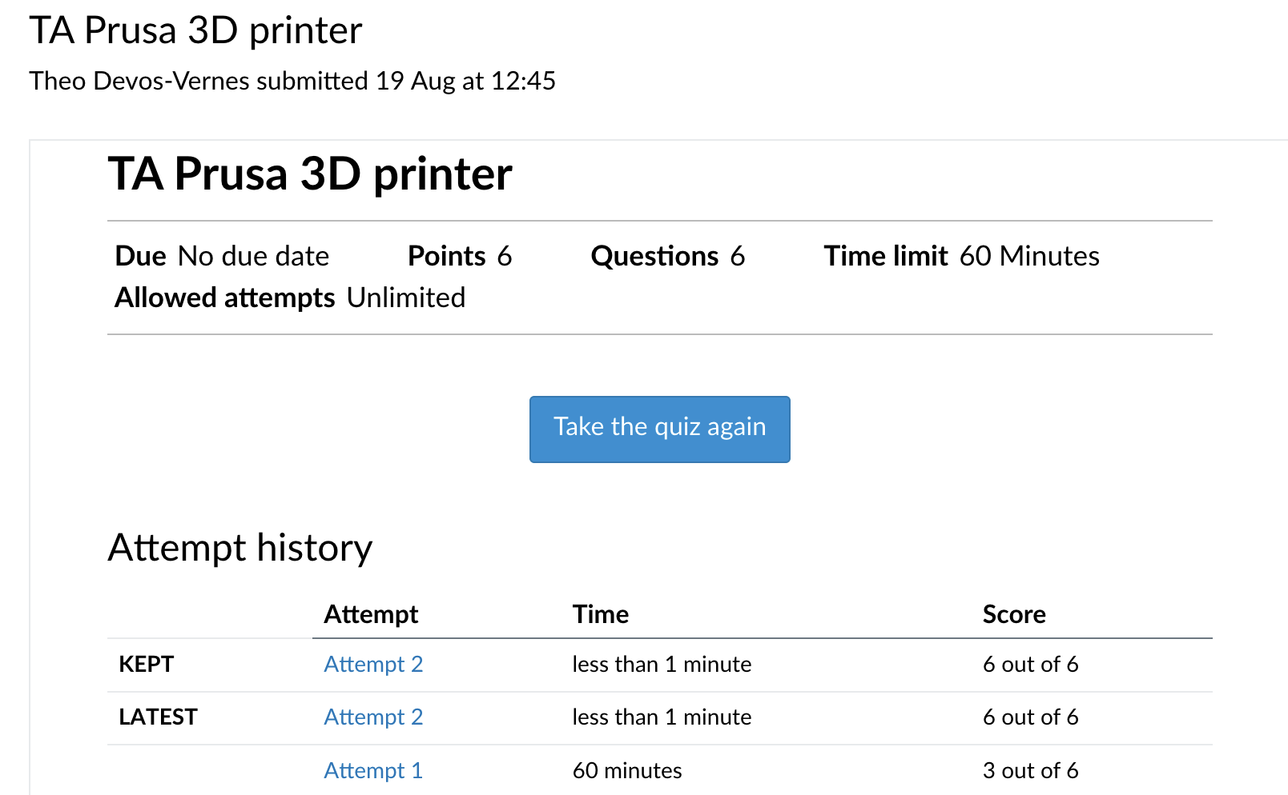
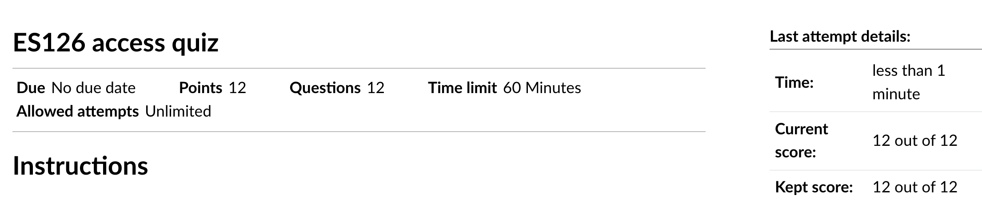
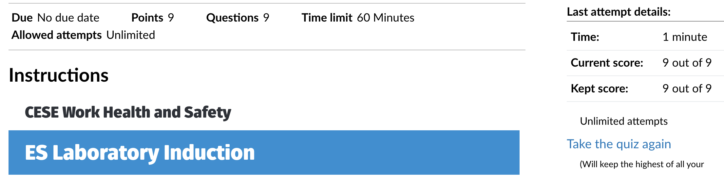
OnShape – Deadline 11/09/2026
Complete the Intro to Part design Onshape training module. Once complete you should get a pdf certificate. Paste a screenshot of the certificate below.
Your name needs to be somewhere
ONSHAPE Intro to Part design certificate

Once you have access to the NUTeams OnShape, complete the 2 NUTEAMS online induction exercises: NU Teams - Onshape introduction 1 (Lachlan’s example) and NUTeams – Onshape introduction 2. Provide screenshots of each
Screenshot of NU Teams - Onshape introduction 1 (Lachlan’s example)
Screenshot of NU Teams - Onshape introduction 2
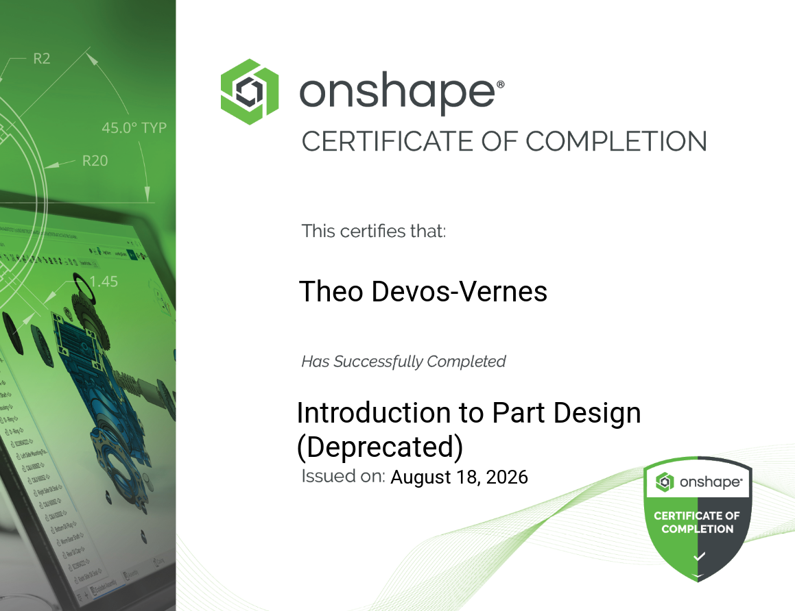

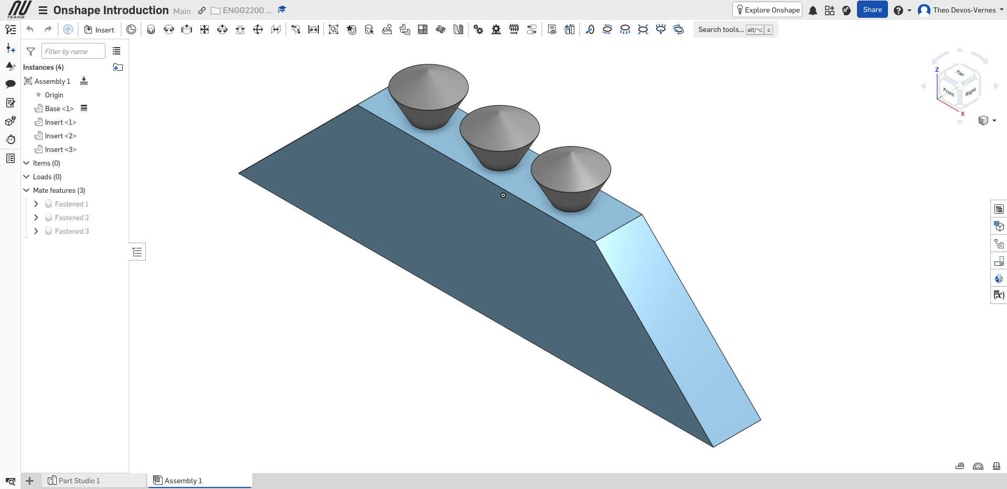

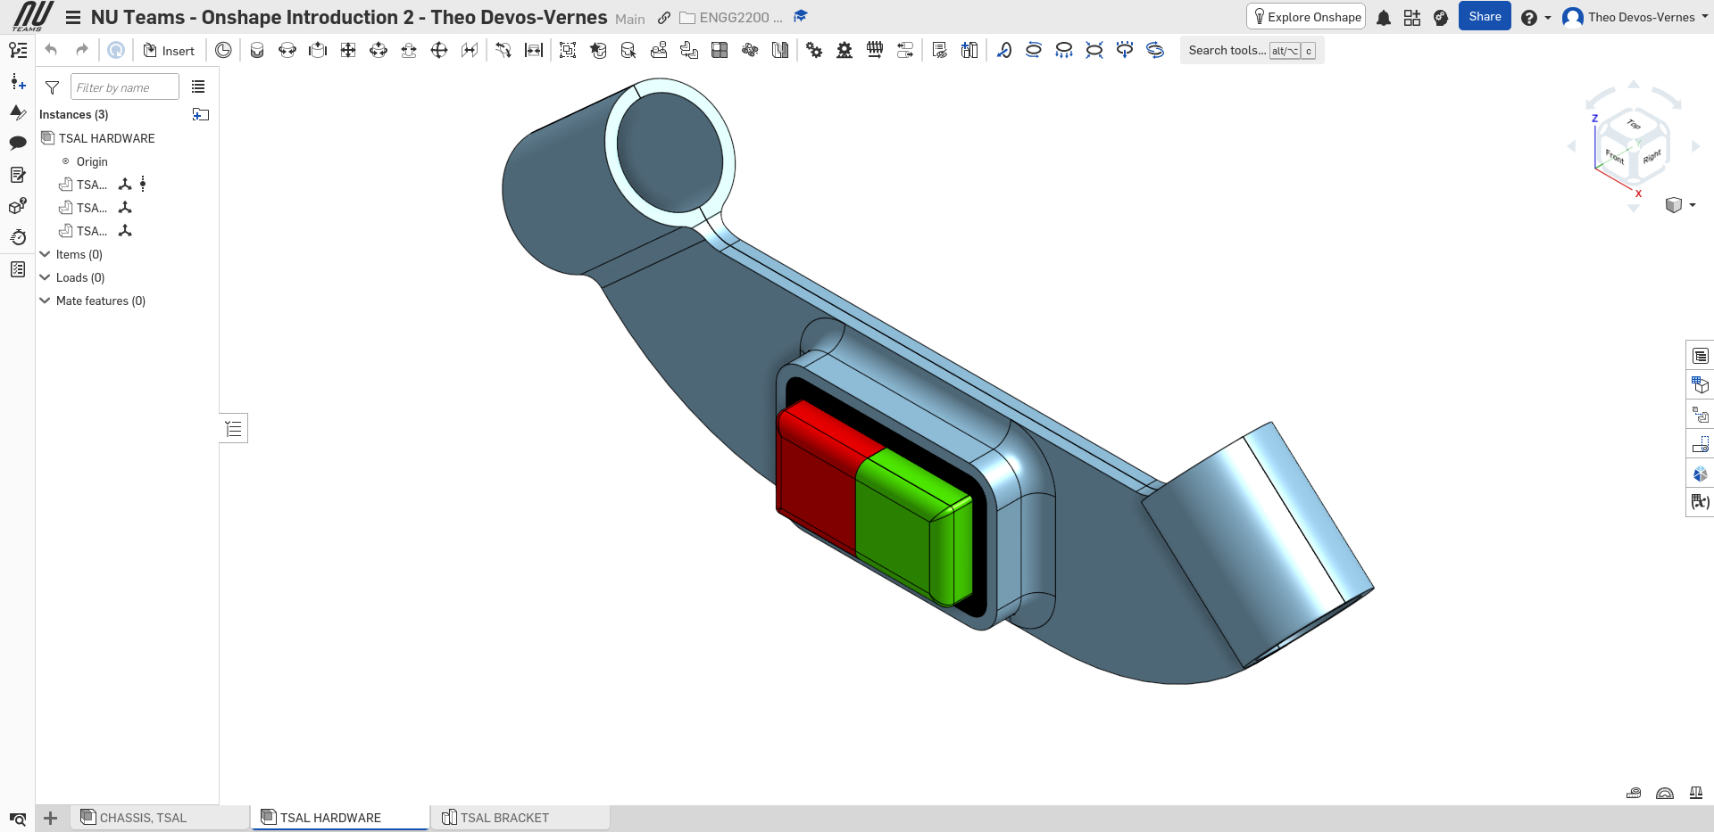
GitHub – Deadline 11/09/2026
Provide a screenshot of your Commit History after competing GitHub Zero to Hero
It should look like the following example.
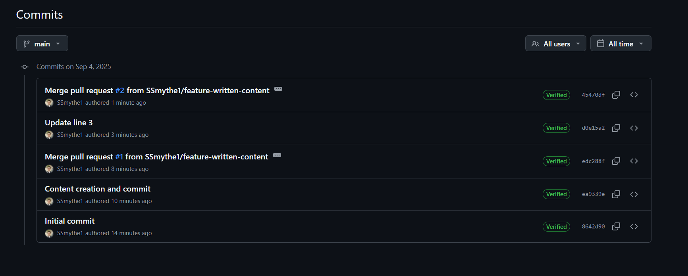

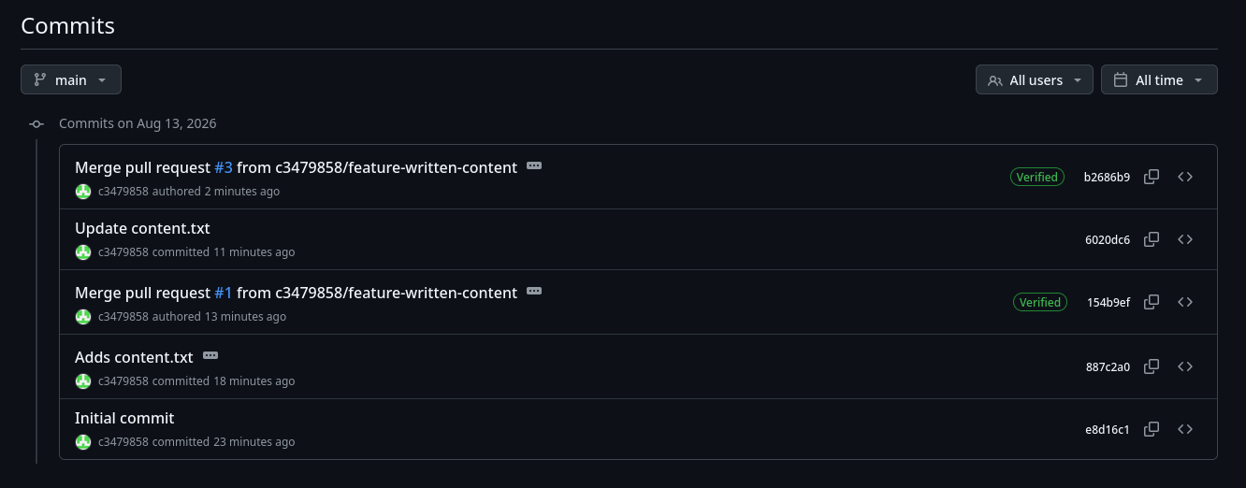
NOTE: I have been told that not all commits need to be verified, just the merge pull requests
LabTools – Deadline 11/09/2026
Provide a photo of yourself with an Approver and your completed Lab Tools Zero to Hero setup all in frame together.

You
Approver
Z2H Device
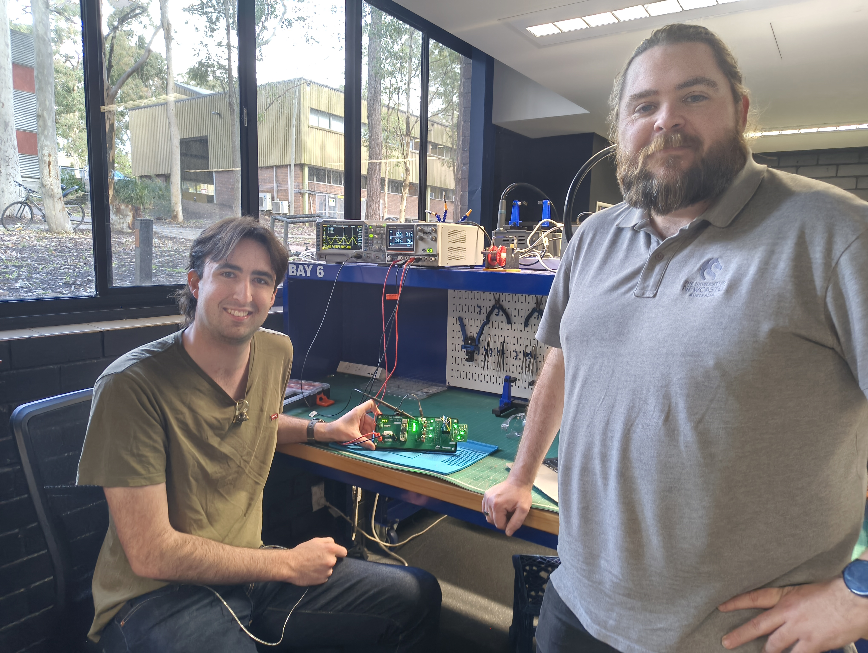

PCB Zero to Hero – Deadline 11/09/2026
Provide a photo of yourself with an Approver and your completed PCB Zero to Hero setup all in frame together.
You
Approver
Z2H Device
Provide a screenshots of your PCB in KiCad as a schematic and as a populated board.
Ensure your name is silkscreened onto your board in KICAD.
Make sure you remember to add your name to the title block
Screenshot from KICAD of your schematic (Schematic editor).
Screenshot from KICAD of your finished PCB (PCB Editor). Your name should be on the silkscreen somewhere
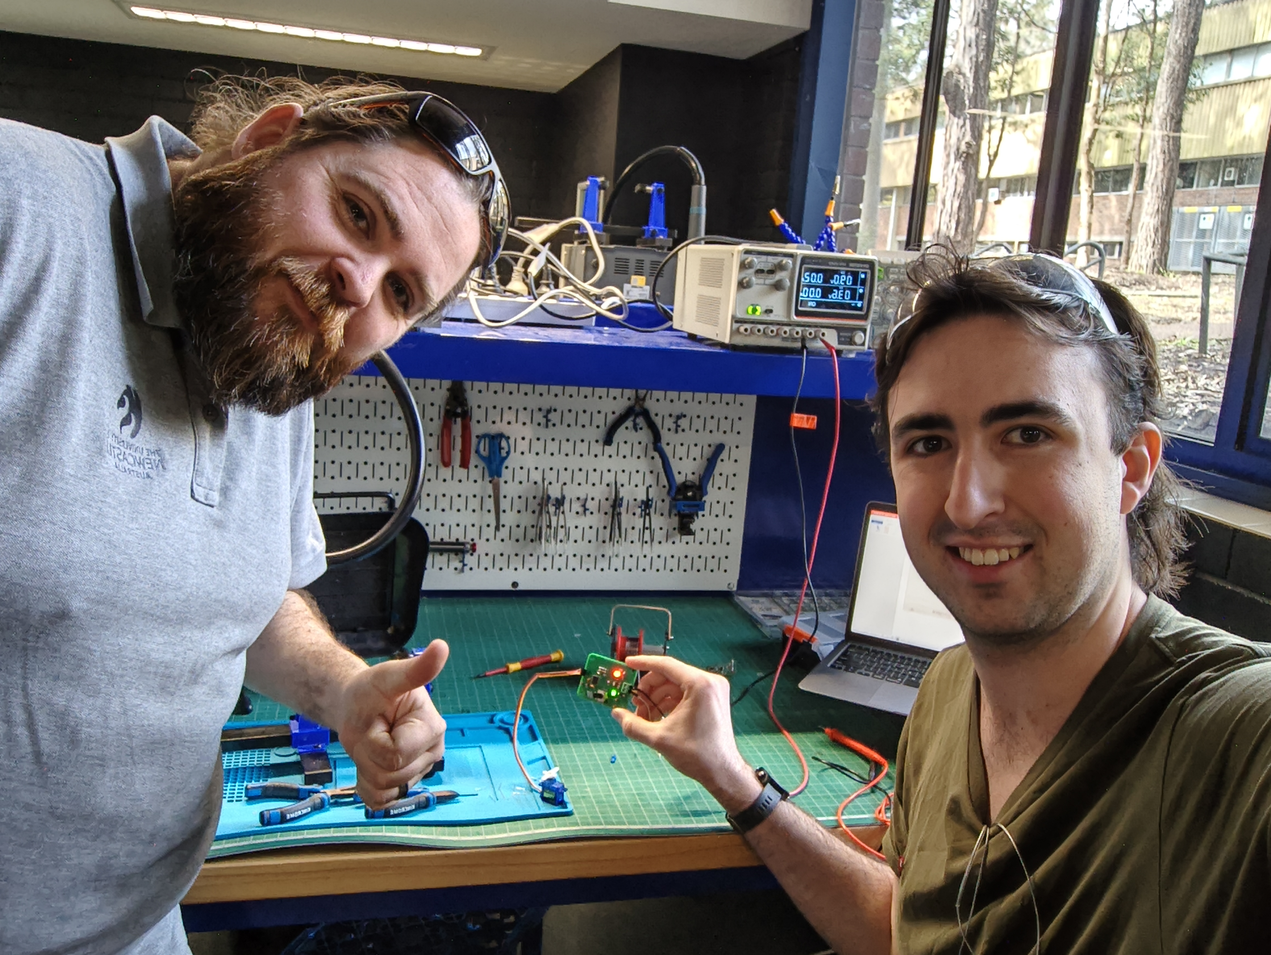

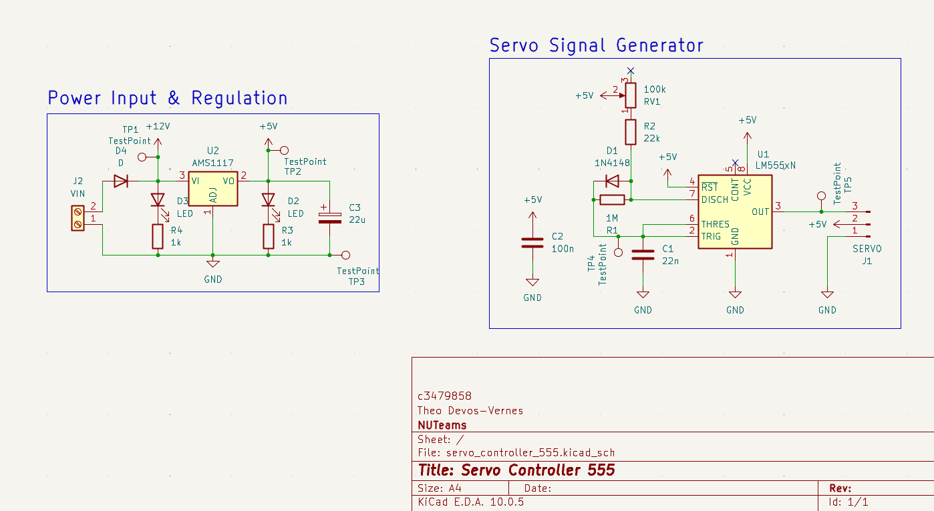
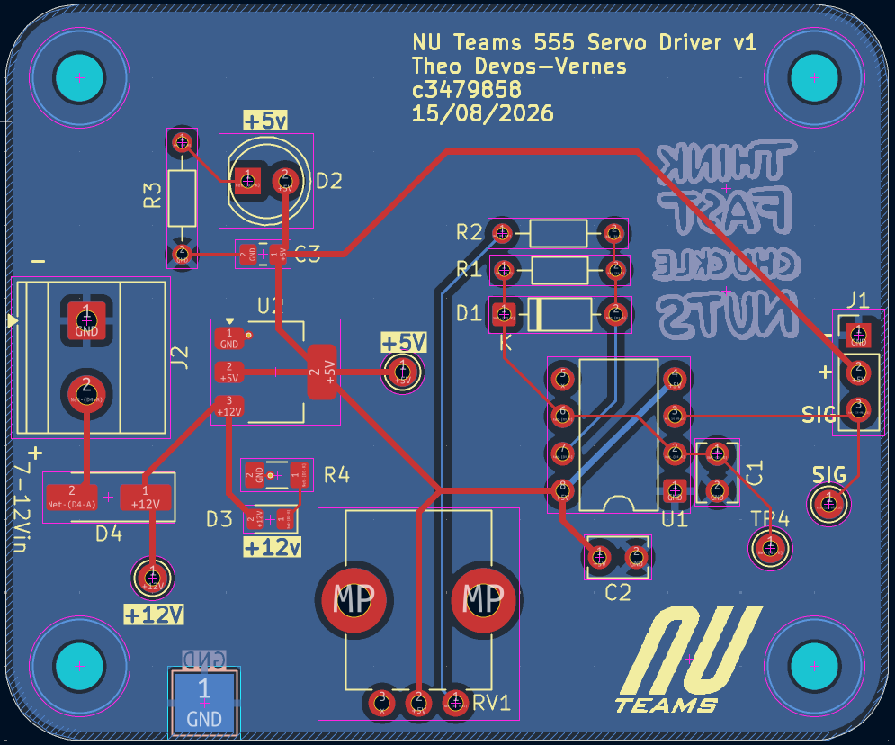
3D printing Zero to Hero – Deadline 11/09/2026
Provide a photo of yourself with an Approver and your completed hook from your Zero to Hero all in frame together.
You
Approver
Z2H Device

Provide a screenshot demonstrating functional use of the variable layer height function.
Screenshot from Prusa slicer, after slicing file, with legend (top left) set to height, demonstrating function use of variable layer height
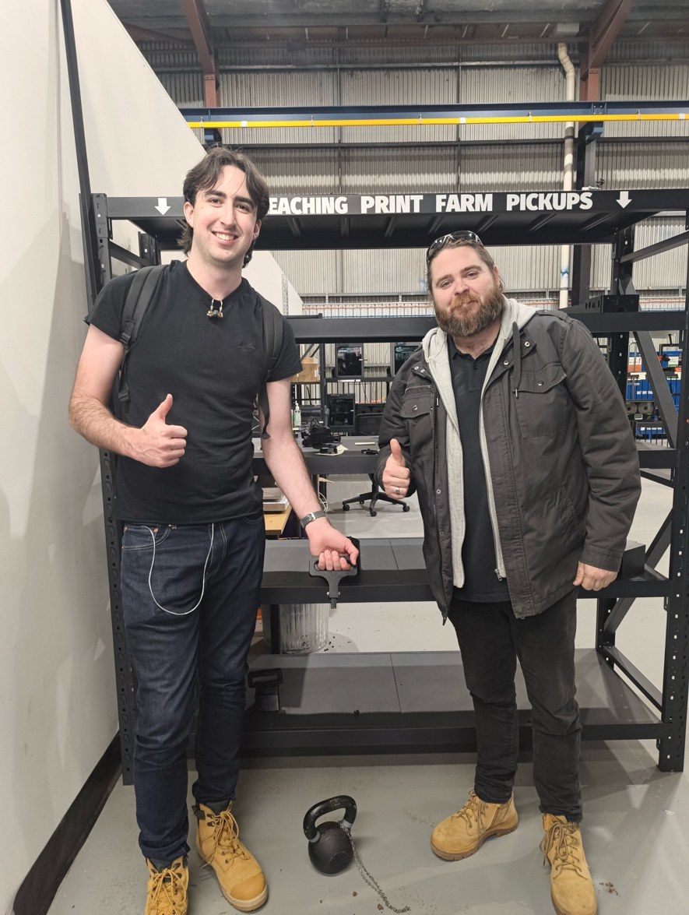
NOTE: Forgot to take photo before demonstrating failure by yanking, assessor can confirm that the part held the required weight.

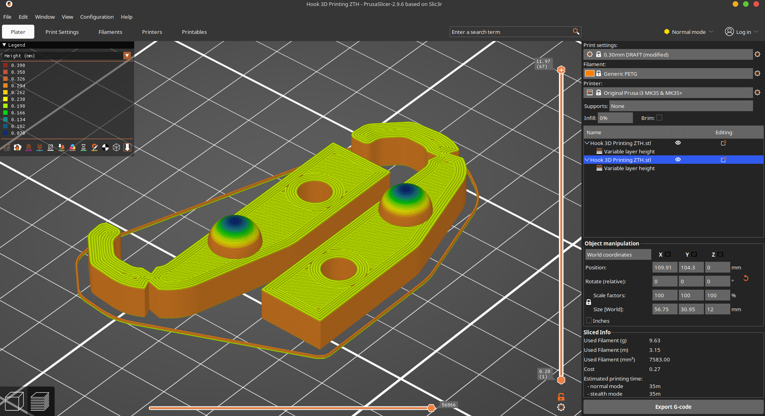
Arduino Zero to Hero – Deadline 11/09/2026
Provide a photo of yourself with an Approver and your completed Arduino Zero to Hero setup all in frame together.
You
Approver
Z2H Device
Provide a screenshot(s) of your code with useful comments such that a person unfamiliar with the task could understand the code.
Screen shot(s) of Arduino code

