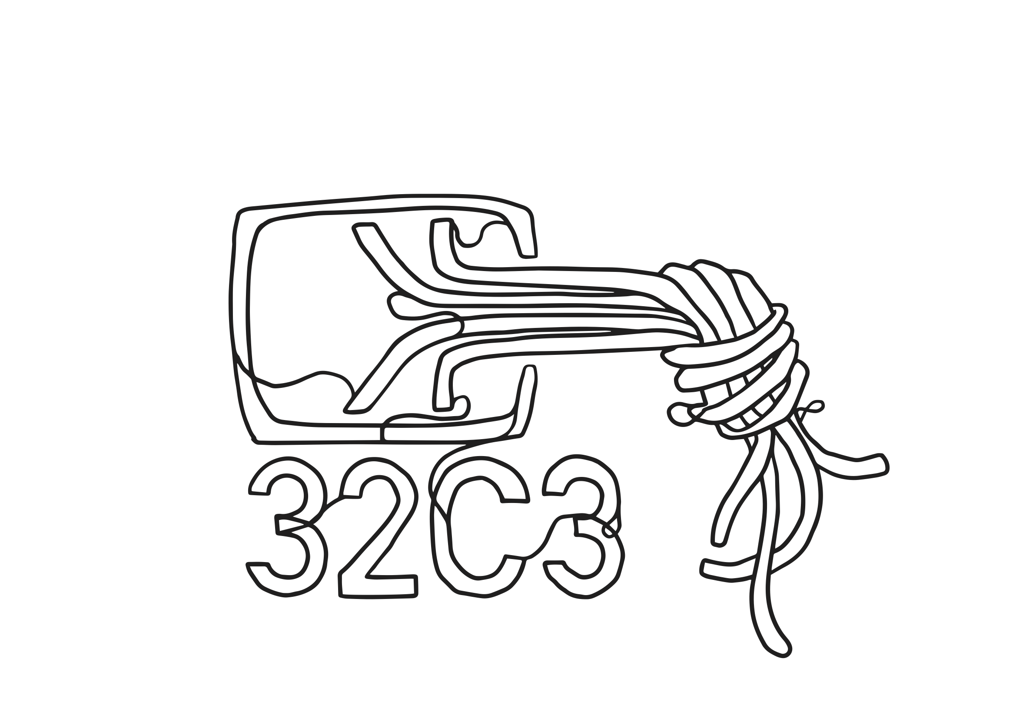
32c3 Bar Runner Howto
Moin! Welcome to the 32c3 Bar Team. Even if you have been a bar runner/bar support during the previous congresses read this howto carefully.

Important (internal) phone numbers

Bar Supervisor | 1720
Bar Saal 1 Rangfoyer (Exploit Bar) | 1711
Bar Saal 3 (Uptime Bar) | 1712
Bar Saal 1 Foyer (DDos Bar) | 1713
Bar Foyer Saal D-G (Crypto Bar) | 1714
Bar Runner 1 | 1721
Bar Runner 2 | 1722

Runner Howto
- Shifts start/end at the „BOC“ at the back of hall H
- First of all: Safety first!
- In case of an accident oder medical emergency, call the CERT DECT 112
- Wear gloves
- Be careful with the pallet jack
  - maximum loading height is two boxes. Yes even empty boxes.
- Ramp operation
  - never walk in front of the pallet jack down the ramp
  - be careful with the operation height of the pallet jack especially at the end/beginning oder intermediate stop of the ramp or you will hit the ground

