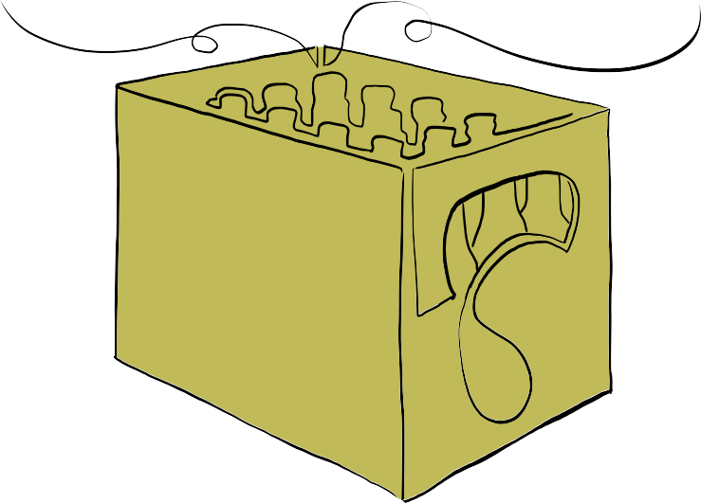
R T F M

Please take the time to read the following instructions carefully before your first shift as a bottle angel. Our beverage dealer wants the empty bottles back neatly sorted, so you can save yourself and all other angels a lot of work by doing things right the first time. If in doubt, please ask!

If you want to wear gloves for hygienic reasons or to protect you against broken glass when handling bottles, feel free to do so. We have plenty of them available. After your shift, you may want to disinfect your hands. We have plenty of Sterilium, too (if it is empty, just get a new bottle from the CERT). However, please DON'T PANIC! The CERT assured us that regularly washing your hands will protect you from more than 98% of possible threats.

c3bottl.es credentials: _REDACTED_ / _REDACTED_

Important phone numbers:

1720 Bar Supervisor
1721 + 1722 Bar Runner
4265 MichiK (for c3bottl.es issues)
How-to: Collection

- Bottle collection works best in teams of three angels: One handles the pallet truck and two get the empty bottles/crates.
- You need a pallet truck. Try to get one of the shorter ones. The large one will only fit into elevator D.
- You need some (10-15 is a good number) empty crates. If only few crates are available, you have to take what is available. If you have plenty, you may decide between taking a variety of crates and sort bottles “in place” when emptying drop points or just swapping full crates with empty ones. What you do depends on your preferred working style and on the amount of bottles you expect. Sorting right on the tour may save some work later. When replacing crates at drop points, try to use 4x5 = 20 0,5 L crates. These fit most types of bottles.
- At least one person on the team should use a mobile device and log in on https://c3bottl.es/ with the credentials posted next to this how-to. This web application shows all drop points in the building either as a list or on a map and their state reported by the visitors. When visiting and emptying them, you should document your visit accordingly. If used correctly by the visitors as well as by the collectors, the application has the potential to make your work a lot easier. Just click around a bit on the website – it should be self-explanatory. If you still have trouble, please call MichiK at 4265. If you think you found a bug, please report it on Github.
- Do not drive on the parquet floor with pallet trucks. Try to get some other means of transportations to visit the drop points in the western part of the building (Saal 3/4, Foyer A/B/C, Foyer G).

How-to: Sorting
- We use a number of crate types as well as a number of bottle types. In addition, the visitors bring their own bottles and leave them to our disposal. Please sort all the bottles thoroughly and don't put them where they seem to fit best. If you are unsure, put them on the “Undecided” pile or ask someone. You will save everyone a lot of work.
- Rule of thumb: The size of the bottle has to match the crate (0,5 L bottles belong in 4x5 crates, 0,33 L bottles belong in 4x6 crates) and the color of the bottle has to match the color of the crate (green bottles → green crates).

Types of crates
- Water crates: black, round corners, 4x5 = 20 0,5 L bottles
- Club Mate crates: yellow, 4x5 = 20 0,5 L bottles
- Flora Power etc. crates: black, 4x5 = 20 0,5 L bottles
- Völkner crates: black, 2x6 = 12 0,33 L bottles
- Premium Cola crates: black, 4x6 = 24 0,33 L bottles
- Fritz Cola crates: black, 4x6 = 24 0,33 L bottles
- Premium beer crates: green, 4x6 = 24 0,33 L bottles
- Spezi crates: light bliue, 4x6 = 24 0,33 L bottles
- Dithmarscher beer crates: green, ??? 0,33 L beer bottles

Types of bottles
- Club Mate, Flora Power etc. 0,5 L bottles
These belong in the black Flora Power or yellow Club Mate crates.
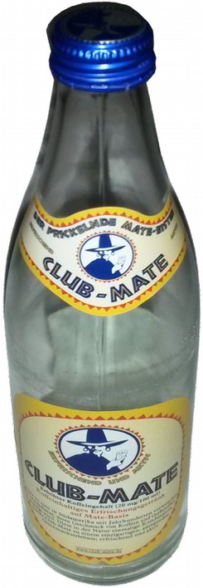 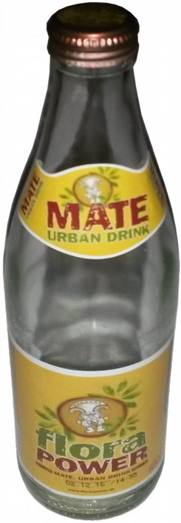 also: 1337mate 0,5 L, Fritz Cola 0,5 L, ...
- Premium Cola, Fritz Cola (and other Fritz variants), Biozisch, etc. clear 0,33 L bottles
These belong in the black Premium or Fritz crates or in the light blue Spezi crates.
(NOT IN THE GREEN CRATES!)
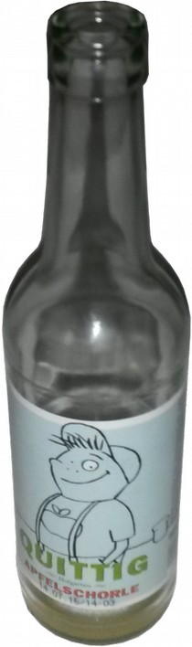 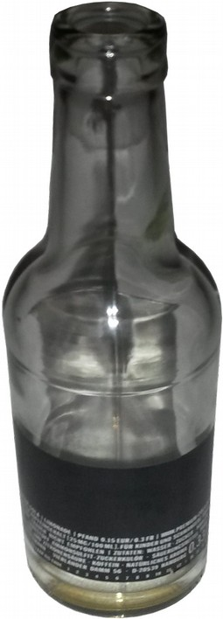 also: 1337mate 0,33 L, Fritz Cola and Fritz Limo 0,33 L, Spezi 0,33 L, …
- Premium beer and other green 0,33 L (beer) bottles
These belong in the green Premium beer crates. (NOT IN THE BLACK CRATES!)
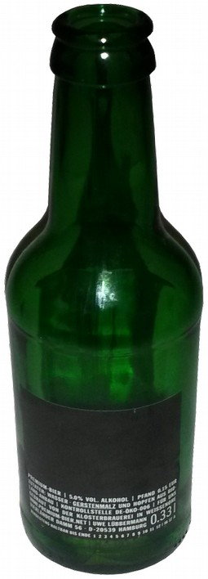 also: Jever, Beck's etc. 0,33 L, ...
- Viva con Agua laut/leise 0,5 L disposable bottles
These belong in the black water crates with round corners.
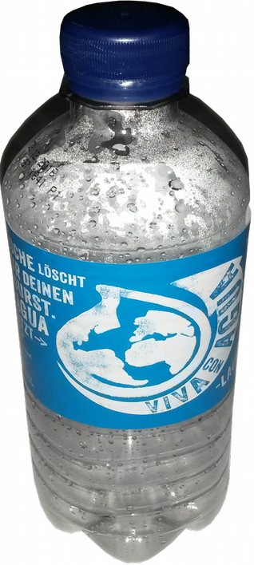 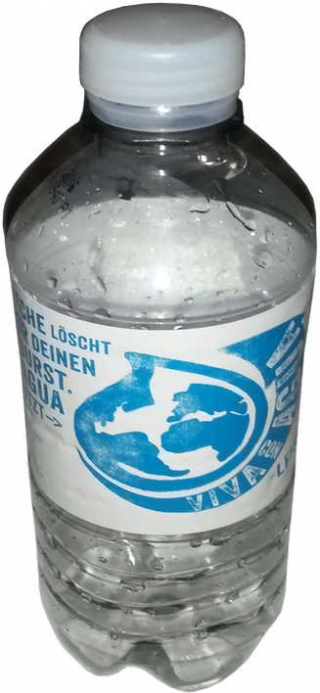
- Dithmarscher 0,33 L bottles
These belong in the flat green Dithmarscher crates.
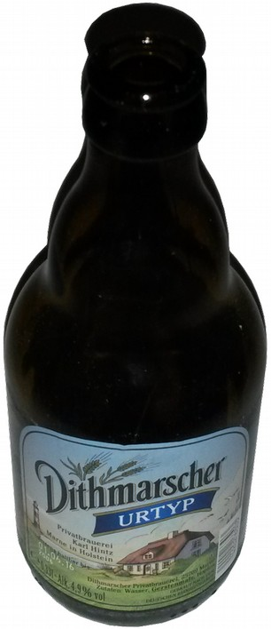 also: Astra 0,33 L, ...

