

Republic of the Philippines
Tarlac State University
COLLEGE OF COMPUTER STUDIES
Tarlac City, Tarlac
Tel. No. (045) 6068173

Case Study: Simulation of CPU Scheduling Algorithms

Submitted By:
Austria, Marc Cedrick S.

Submitted To:
Ma’am Jo Anne Cura

May 07, 2026

- Introduction

CPU scheduling is a critical function of an operating system that determines how processes are allocated access to the central processing unit (CPU) (Shoaib & Farooqui, 2014; Qureshi, 2014). In a multiprogramming environment where multiple processes are loaded into memory simultaneously, the operating system must decide which process executes at a given time (Harki et al., 2020; Shakor, 2021). This decision-making process directly affects system performance, responsiveness, and overall efficiency (Shoaib & Farooqui, 2014; Shakor, 2021).

The need for CPU scheduling arises because processes compete for limited CPU resources (Qureshi, 2014; Goel & Garg, 2013). Without an effective scheduling mechanism, some processes may experience long waiting times, while others may monopolize the CPU (Bandarupalli & Nutulapati, 2012; Goel & Garg, 2013). To address this, different scheduling algorithms are designed with specific strategies to manage process execution. These strategies aim to optimize key performance metrics such as waiting time, turnaround time, throughput, and CPU utilization (Agrawal et al., 2021; Reddy, 2023).

CPU scheduling algorithms can be broadly categorized into preemptive and non-preemptive types (Harki et al., 2020; Qureshi, 2014). Preemptive algorithms allow the operating system to interrupt a currently running process to allocate CPU time to another process, improving responsiveness (Goel & Garg, 2013; Reddy, 2023). In contrast, non-preemptive algorithms allow a process to run until it completes or voluntarily releases the CPU (Goel & Garg, 2013; Agrawal et al., 2021). Each type has its own advantages and trade-offs, making them suitable for different system requirements and workloads (Shakor, 2021; Agrawal et al., 2021).

Purpose of the Case Study

The purpose of this case study is to provide a practical application of theoretical concepts related to CPU scheduling in operating systems. While scheduling algorithms are often discussed in lectures and textbooks, implementing them through a simulation program allows for a deeper understanding of how they function in real-world scenarios. This hands-on approach helps bridge the gap between theory and practice.

Another goal of this case study is to analyze and compare the behavior of different CPU scheduling algorithms under various conditions. By simulating multiple processes with different arrival times, burst times, and priorities, the program allows users to observe how each algorithm handles process execution. This makes it easier to identify the strengths and weaknesses of each scheduling method.

Additionally, the case study aims to enhance problem-solving and programming skills by requiring the development of a modular and efficient system. It encourages careful planning, logical thinking, and attention to detail, especially when handling preemptive and non-preemptive scheduling. Through this process, students gain valuable experience in designing algorithms and interpreting their outputs.

Objectives
The program is designed to achieve the following objectives:
- To implement multiple CPU scheduling algorithms, including:
  - First-Come, First-Served (FCFS)
  - Shortest Job First (SJF) – Non-preemptive
  - Shortest Remaining Time (SRT) – Preemptive
  - Round Robin (RR)
  - Priority Scheduling
  - Priority Scheduling with Round Robin
- To allow user input for process details such as:
  - Number of processes
  - Process identifiers
  - Arrival time
  - Burst time
  - Priority values
  - Time quantum (for applicable algorithms)
- To simulate the execution of processes based on the selected scheduling algorithm
- To generate a Gantt Chart that visually represents process execution over time
- To compute and display performance metrics, including:
  - Waiting Time (WT) per process
  - Turnaround Time (TAT) per process
  - Average Waiting Time
  - Average Turnaround Time
- To ensure the program is modular, readable, and well-documented with clear explanations of logic and functionality

- Body
First Come First Serve (FCFS)
First-Come, First-Served (FCFS) is one of the simplest CPU scheduling algorithms, where processes are executed strictly in the order they arrive in the ready queue. Once a process is allocated the CPU, it runs until completion without interruption, making it a non-preemptive algorithm. Its main advantage is simplicity and fairness, as every process gets executed in arrival order. However, it suffers from poor performance in terms of waiting time and can lead to the convoy effect, where short processes are delayed behind long ones (Shoaib & Farooqui, 2014).
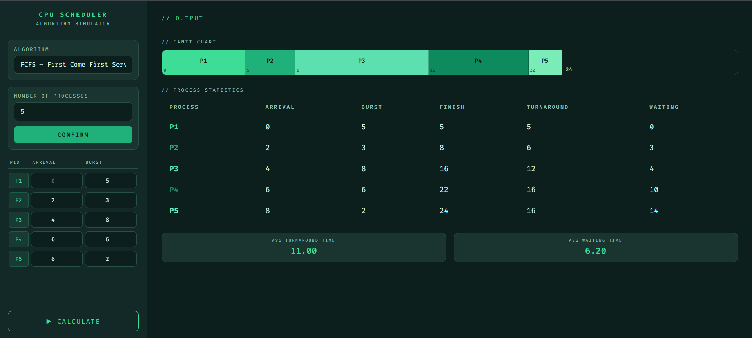
Fig 1.1 FCFS Scheduling Process Input, Output, Gantt chart, and Result (Test Case 1)
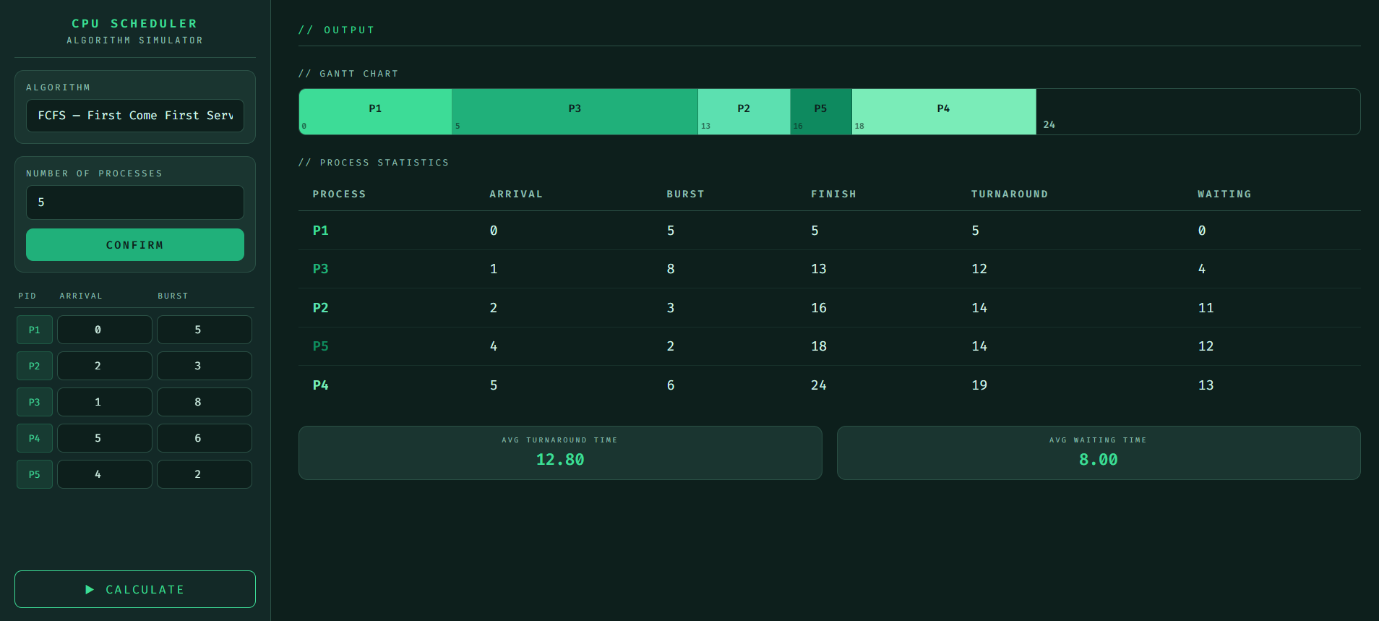
Fig 1.2 FCFS Scheduling Process Input, Output, Gantt chart, and Result (Test Case 2)

Shortest Job First (SJF)
Shortest Job First (SJF) is a non-preemptive scheduling algorithm that selects the process with the smallest CPU burst time for execution next. This approach is effective in minimizing the average waiting time and improving overall efficiency. However, it requires prior knowledge or estimation of burst times, which is not always feasible in real systems. Additionally, longer processes may suffer from starvation if shorter jobs continuously arrive (Pemasinghe & Rajapaksha, 2022).
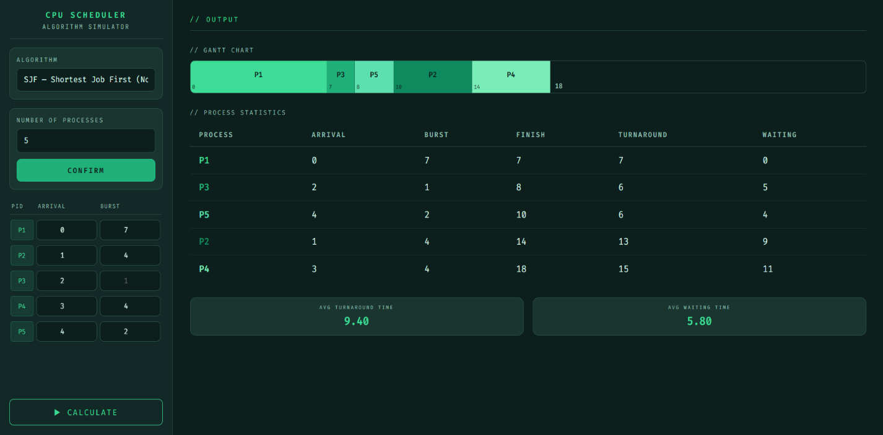
Fig 2.1 SJF Scheduling Process Input, Output, Gantt chart, and Result (Test Case 1)

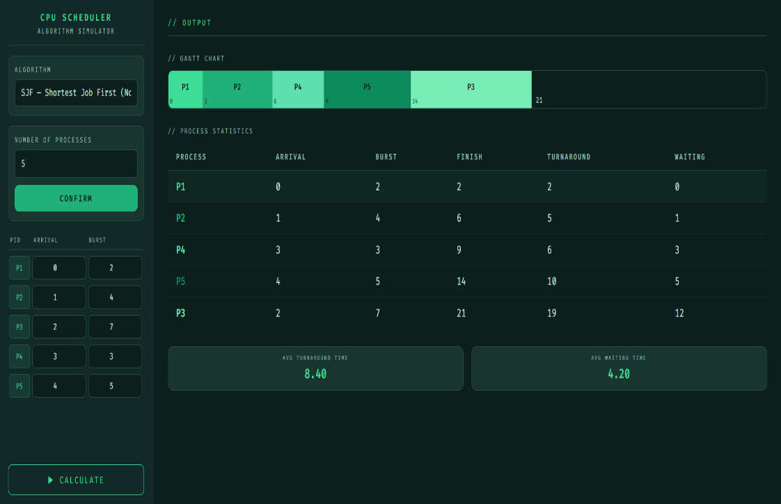
Fig 2.2 SJF Scheduling Process Input, Output, Gantt chart, and Result (Test Case 2)

Shortest Remaining Time (SRT)
Shortest Remaining Time (SRT), also known as the preemptive version of SJF, selects the process with the smallest remaining execution time. If a new process arrives with a shorter burst time than the currently running process, the CPU is preempted and assigned to the new process. This improves responsiveness and reduces average waiting time, but it introduces higher overhead due to frequent context switching and may also cause starvation for longer processes (González-Rodríguez & Otero-Cerdeira, 2024).
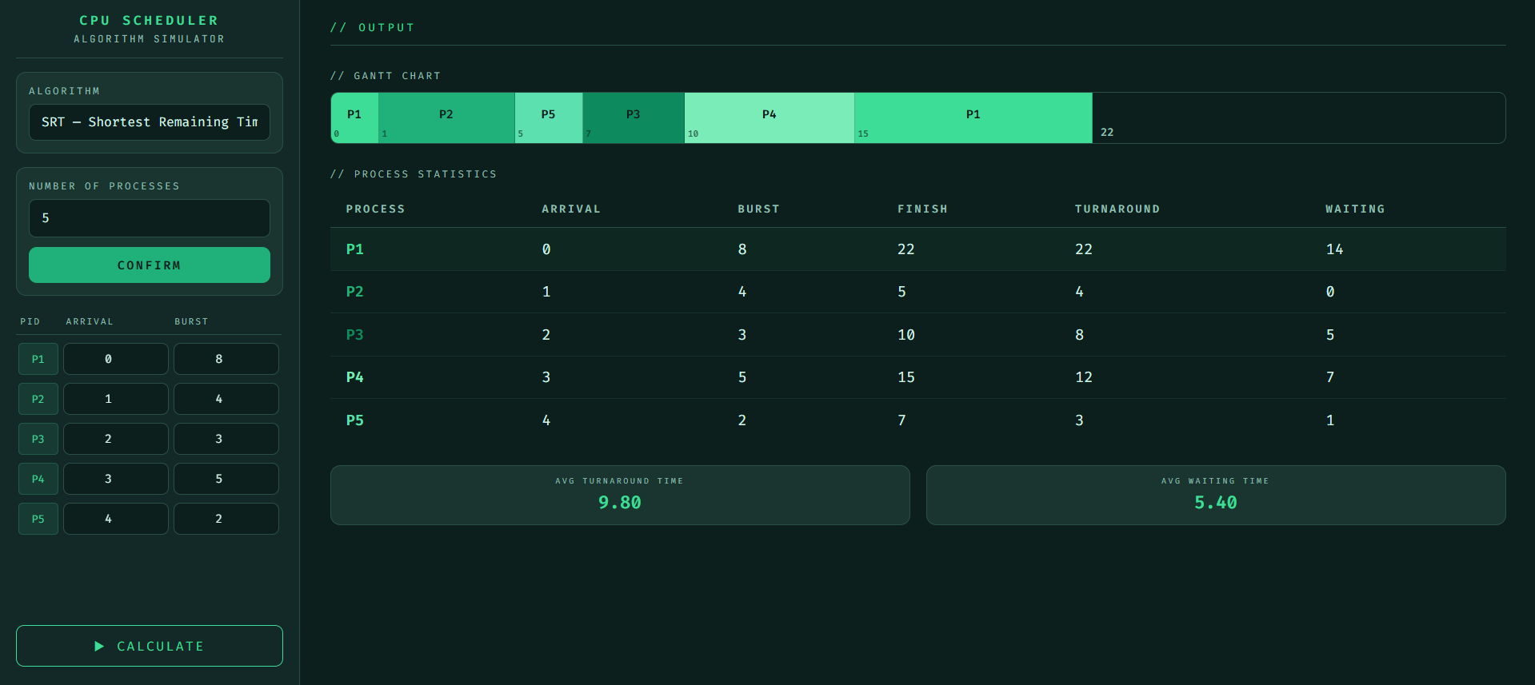
Fig 3.1 SRT Scheduling Process Input, Output, Gantt chart, and Result (Test Case 1)
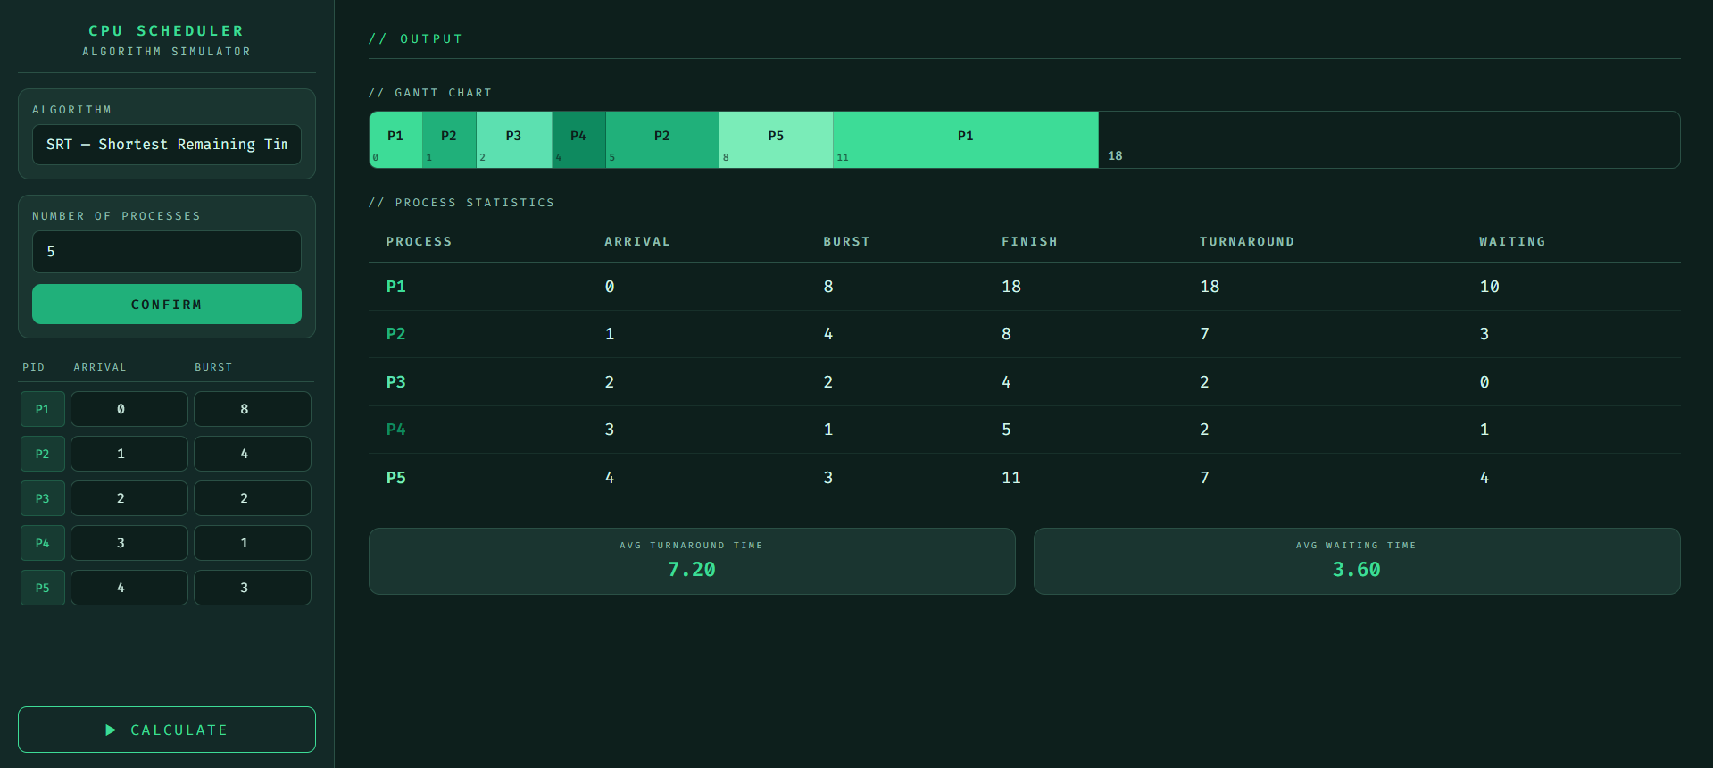
Fig 3.2 SRT Scheduling Process Input, Output, Gantt chart, and Result (Test Case 2)

Round Robin (RR)
Round Robin (RR) is a preemptive scheduling algorithm in which each process is assigned a fixed time quantum and executed in cyclic order. If a process does not finish within its time slice, it is moved to the end of the ready queue. This method ensures fairness and provides good response time, especially in time-sharing systems. However, its efficiency heavily depends on the size of the time quantum; too small leads to excessive context switching, while too large reduces it to FCFS behavior (Olofintuyi & Omotehinwa, 2020).
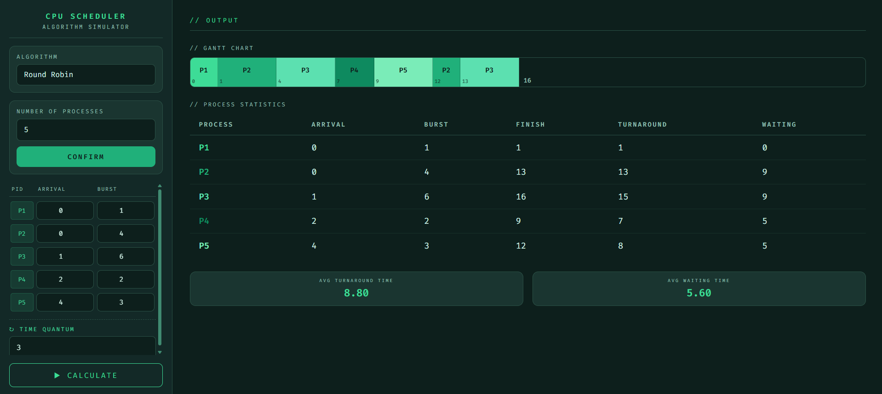
Fig 4.1 RR Scheduling Process Input, Output, Gantt chart, and Result (Test Case 1)

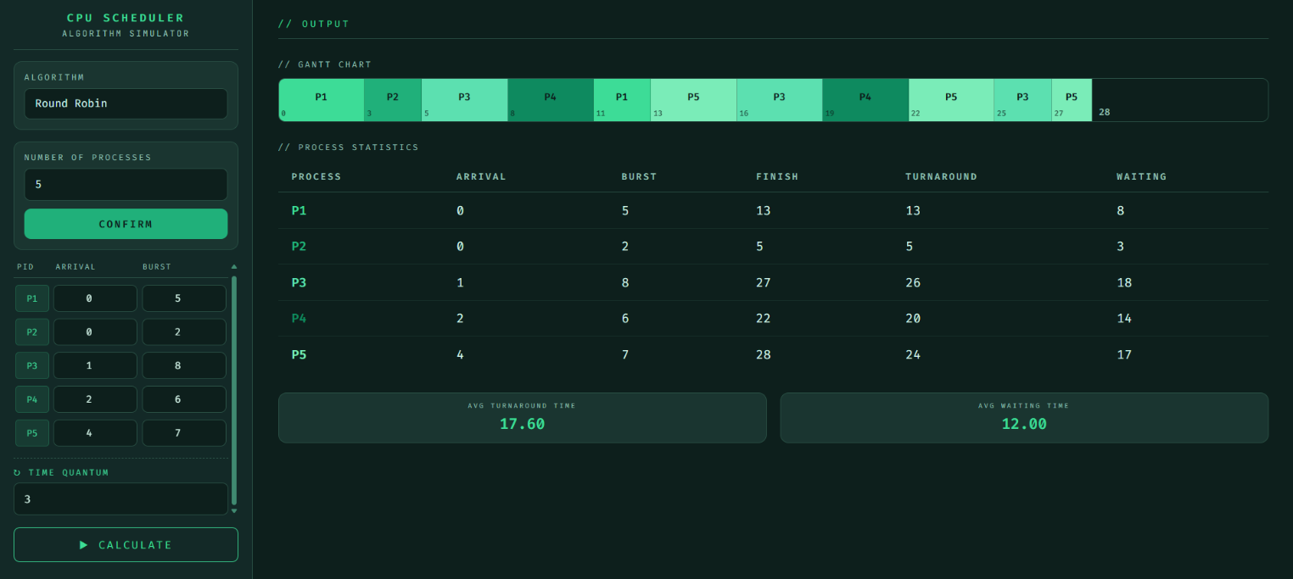Fig 4.2 RR Scheduling Process Input, Output, Gantt chart, and Result (Test Case 2)
Priority Scheduling
Priority Scheduling assigns a priority level to each process, and the CPU is allocated to the process with the highest priority. This algorithm can be either preemptive or non-preemptive depending on system design. It is advantageous for ensuring that critical tasks are executed first, but it can lead to starvation of low-priority processes and issues like priority inversion if not properly managed (Reddy, 2023).
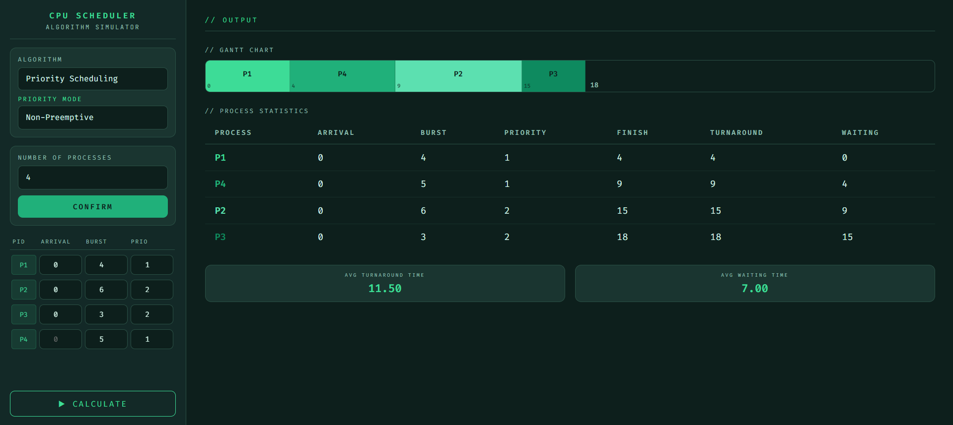
Fig 5.1 Priority Scheduling Process Input, Output, Gantt chart, and Result (NP) (Test Case 1)
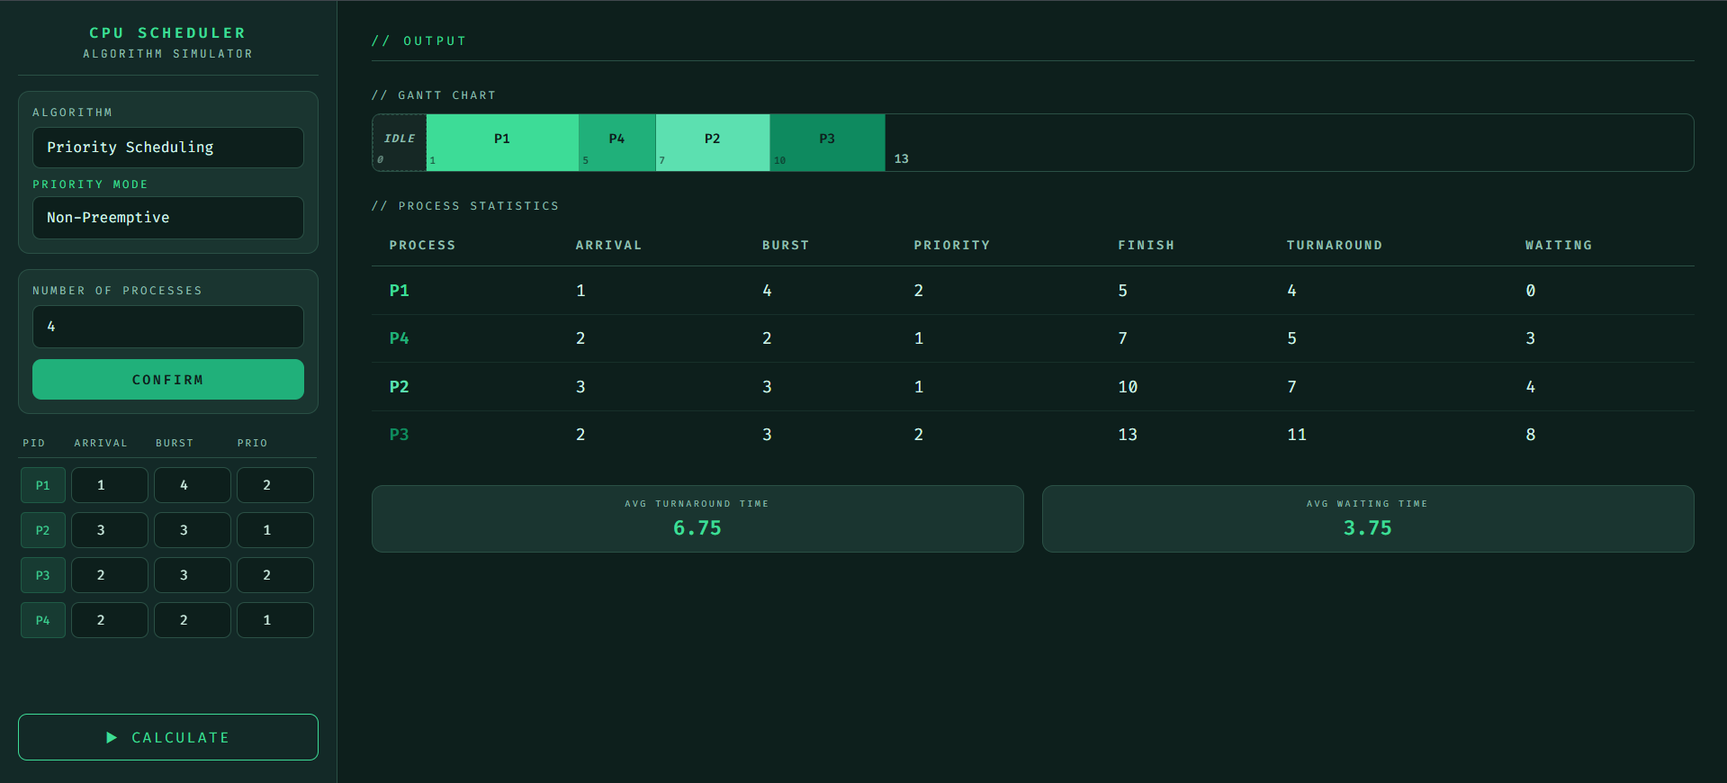Fig 5.2 Priority Scheduling Process Input, Output, Gantt chart, and Result (NP) (Test Case 2)
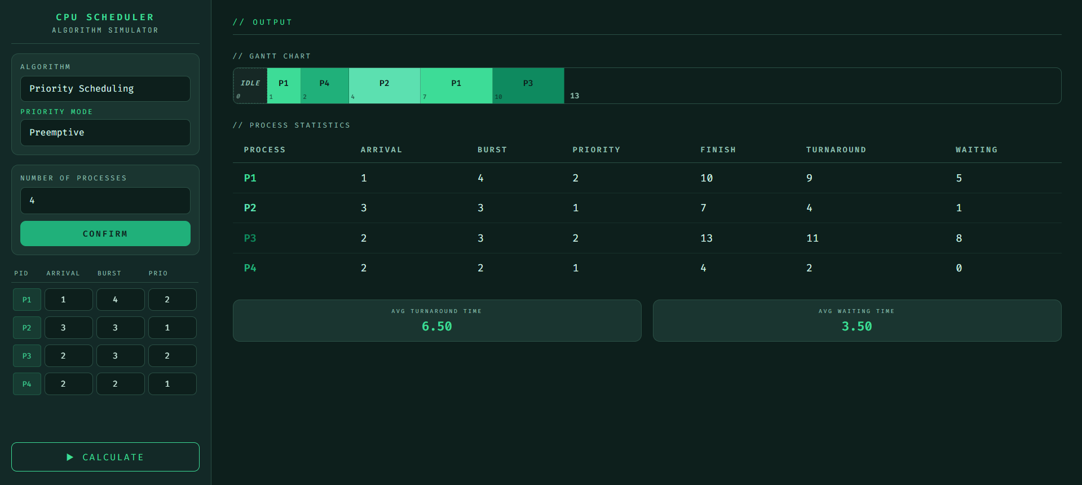
Fig 5.3 Priority Scheduling Process Input, Output, Gantt chart, and Result (P) (Test Case 3)
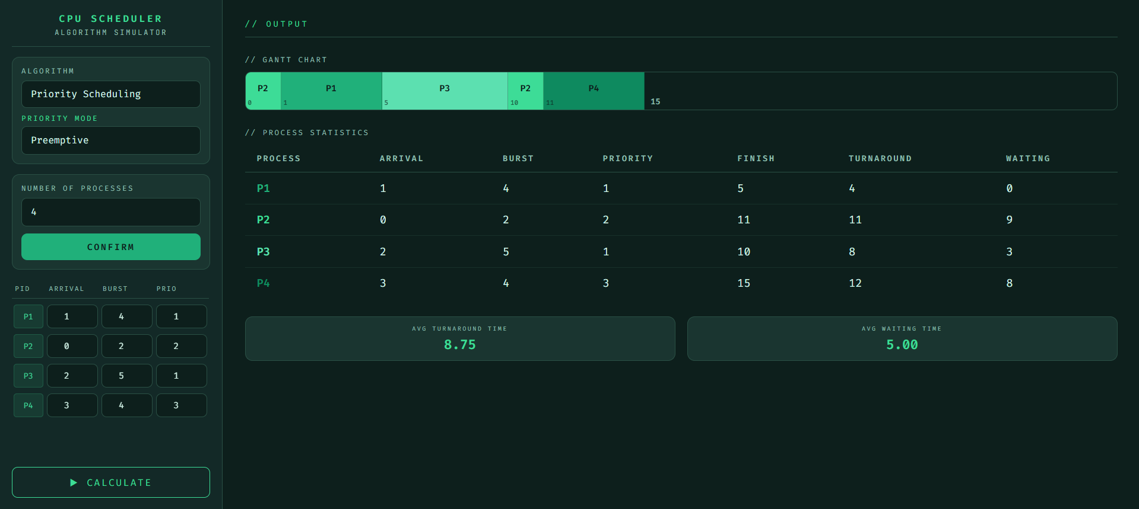
Fig 5.4 Priority Scheduling Process Input, Output, Gantt chart, and Result (P) (Test Case 4)

Priority with Round Robin (Priority + RR)
Priority Scheduling with Round Robin is a hybrid approach where processes are grouped based on priority levels, and within each level, Round Robin scheduling is applied. This method is typically preemptive and aims to combine fairness with priority handling. It reduces starvation compared to pure priority scheduling while still maintaining responsiveness. However, it is more complex to implement and may still disadvantage lower-priority processes if higher-priority queues dominate CPU time (Pemasinghe & Rajapaksha, 2022).
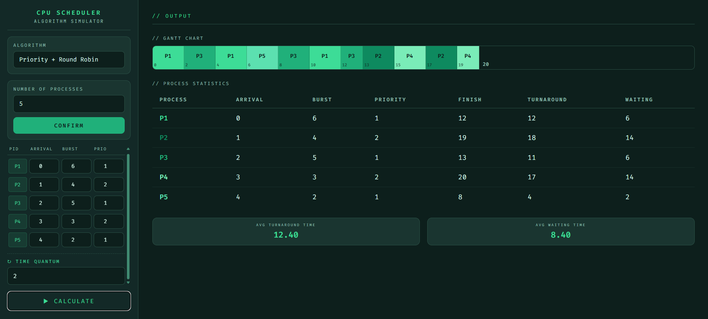
Fig 6.1 Priority with RR Scheduling Process Input, Output, Gantt chart, and Result (High Value) (Test Case 1)
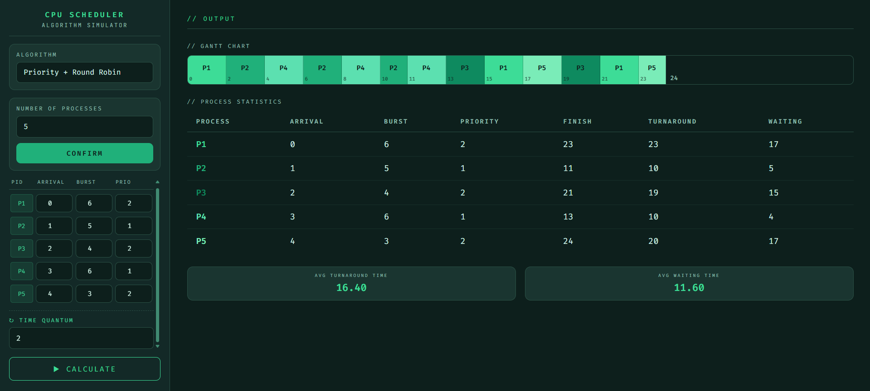
Fig 6.2 Priority with RR Scheduling Process Input, Output, Gantt chart, and Result (Low Value) (Test Case 2)

- Summary
This case study provided valuable insights into the behavior and implementation of different CPU scheduling algorithms in operating systems. Through the development of the simulation program, it became evident that each scheduling algorithm has its own strengths and limitations depending on the workload and system requirements. Implementing the algorithms helped deepen the understanding of process management, scheduling policies, and how operating systems optimize CPU utilization.
One of the key insights gained was the importance of balancing fairness and efficiency in CPU scheduling. For example, the First-Come, First-Served (FCFS) algorithm is simple and easy to implement, but it may lead to long waiting times due to the convoy effect. Shortest Job First (SJF) and Shortest Remaining Time (SRT) were observed to minimize average waiting time, making them more efficient in many cases. However, these algorithms may cause starvation for longer processes. Round Robin (RR), on the other hand, improved fairness and responsiveness by allocating equal CPU time slices to processes, making it more suitable for time-sharing systems. Priority Scheduling demonstrated how important processes can be executed earlier, although low-priority processes may suffer from starvation without additional techniques such as aging.
The study also highlighted the practical relevance of CPU scheduling in modern operating systems. Scheduling algorithms are essential in ensuring smooth multitasking, efficient resource utilization, and responsive user interaction in computers, smartphones, and servers. Real-world operating systems often combine multiple scheduling strategies to achieve better overall performance depending on the nature of the tasks being executed.
Several challenges were encountered during the implementation of the scheduling simulator. One difficulty involved handling preemptive algorithms, particularly updating process execution dynamically while accurately tracking waiting and turnaround times. Another challenge was generating a correct and organized Gantt Chart representation for process execution. These issues were addressed by carefully designing modular functions, testing the program with different process scenarios, and validating computed results manually. Proper debugging and step-by-step verification also helped ensure the correctness and reliability of the simulation program.
Overall, the case study successfully demonstrated how CPU scheduling algorithms work in practice and emphasized their significance in operating system design and performance optimization.
- References
Agrawal, P., Gupta, A. K., & Mathur, P. (2021). CPU scheduling in operating system: A review. Springer. https://link.springer.com/chapter/10.1007/978-981-15-9689-6_31
Bandarupalli, S. B., & Nutulapati, N. P. (2012). A novel CPU scheduling algorithm–preemptive & non-preemptive. https://www.academia.edu/download/86385915/DO2644844490.pdf
Goel, N., & Garg, R. B. (2013). A comparative study of CPU scheduling algorithms. arXiv. https://arxiv.org/abs/1307.4165
Harki, N., Ahmed, A., & Haji, L. (2020). CPU scheduling techniques: A review on novel approaches strategy and performance assessment. Journal of Applied Science and Technology. https://jastt.org/index.php/jasttpath/article/view/15
Qureshi, I. (2014). CPU scheduling algorithms: A survey. International Journal of Advanced Networking. https://www.academia.edu/download/38799315/V5I4-1.pdf
Reddy, S. S. (2023). Comparative analysis of CPU scheduling algorithms for performance efficiency. https://www.researchgate.net/publication/395844892
Shakor, M. Y. (2021). Scheduling and synchronization algorithms in operating system: A survey. https://www.researchgate.net/publication/356513035
Shoaib, M., & Farooqui, M. Z. (2014). A comparative review of CPU scheduling algorithms. https://www.researchgate.net/publication/276205562
González-Rodríguez, M., & Otero-Cerdeira, L. (2024). Study and evaluation of CPU scheduling algorithms. Heliyon. https://www.cell.com/heliyon/fulltext/S2405-8440(24)05990-5
Olofintuyi, S. S., & Omotehinwa, T. O. (2020). A survey of variants of round robin CPU scheduling algorithms. https://fjs.fudutsinma.edu.ng/index.php/fjs/article/view/513
Pemasinghe, S., & Rajapaksha, S. (2022). Comparison of CPU scheduling algorithms: FCFS, SJF, SRTF, round robin, priority based, and multilevel queuing. IEEE. https://ieeexplore.ieee.org/document/9929533/

- Repository Link

Program Link:
https://c3d22.github.io/CPU-Algo_Simulator/
Codes:
https://github.com/c3d22/CPU-Algo_Simulator
Video Link:
https://drive.google.com/drive/u/0/folders/11Svjs0x4n2V9rgThcnT7BSM0wsJTinfz

- Source Code

HTML

<!DOCTYPE html>
<html lang="en">
<head>
<meta charset="UTF-8">
<meta name="viewport" content="width=device-width, initial-scale=1.0">
<title>CPU Scheduling Simulator</title>

<!-- ─── Stylesheets (modular CSS) ─── -->
<link rel="stylesheet" href="css/base.css"> <!-- reset, variables, fonts -->
<link rel="stylesheet" href="css/layout.css"> <!-- sidebar + output panel -->
<link rel="stylesheet" href="css/controls.css"> <!-- form inputs, buttons, cards -->
<link rel="stylesheet" href="css/process.css"> <!-- process input table rows -->
<link rel="stylesheet" href="css/gantt.css"> <!-- gantt chart + idle blocks -->
<link rel="stylesheet" href="css/stats.css"> <!-- results table + avg cards -->
<link rel="stylesheet" href="css/responsive.css"> <!-- breakpoints / split-screen -->
</head>
<body>

<div class="general">

<!-- ════════════════════════════════════
LEFT PANEL — Configuration
════════════════════════════════════ -->
<aside class="config">

<!-- App title -->
<div class="logo">
<h1>CPU SCHEDULER</h1>
<div class="sub">Algorithm Simulator</div>
</div>

<!-- Algorithm selection card -->
<div class="card">
<label for="algorithm">Algorithm</label>
<select id="algorithm">
<option value="fcfs">FCFS — First Come First Serve</option>
<option value="sjf">SJF — Shortest Job First</option>
<option value="srt">SRT — Shortest Remaining Time</option>
<option value="round_robin">Round Robin</option>
<option value="priority">Priority Scheduling</option>
<option value="priority_rr">Priority + Round Robin</option>
</select>

<!--
Priority mode sub-dropdown.
Shown only when "Priority Scheduling" is selected.
Toggled by ui.js → handleAlgoChange()
-->
<div id="priorityModeWrap" class="priority-mode-wrap" aria-hidden="true">
<label for="priorityMode">Priority Mode</label>
<select id="priorityMode">
<option value="non_preemptive">Non-Preemptive</option>
<option value="preemptive">Preemptive</option>
</select>
</div>
</div>

<!-- Number of processes card -->
<div class="card">
<label for="numOfInputs">Number of Processes</label>
<input type="number" id="numOfInputs" min="1" max="20" placeholder="e.g. 4">
<button id="confirmButton">CONFIRM</button>
</div>

<!--
Dynamically generated process rows (arrival, burst, optional priority).
Populated by ui.js → generateInputs()
-->
<div class="inputFields" id="inputFields"></div>

<!-- Calculate button — hidden until processes are confirmed -->
<button class="calc-btn" id="calcBtn">&#9654; CALCULATE</button>

</aside>

<!-- ════════════════════════════════════
RIGHT PANEL — Output
════════════════════════════════════ -->
<main class="output" id="outputPanel">
<div class="output-title">// OUTPUT</div>

<!-- Shown before first calculation -->
<div class="empty-state" id="emptyState">
<div class="icon">&#11041;</div>
<p>Awaiting process data</p>
</div>

<!-- Gantt chart — hidden until first run -->
<div class="gantt-wrap" id="ganttWrap">
<div class="section-label">// Gantt Chart</div>
<div class="gantt-scroll">
<div class="gantt-chart" id="ganttChart"></div>
</div>
</div>

<!-- Process statistics table — hidden until first run -->
<div id="statsWrap">
<div class="section-label">// Process Statistics</div>
<div class="table-scroll">
<table class="stats-table" id="statsTable">
<thead>
<tr>
<th>Process</th>
<th>Arrival</th>
<th>Burst</th>
<!-- Priority column shown only for priority-based algorithms -->
<th class="col-priority">Priority</th>
<th>Finish</th>
<th>Turnaround</th>
<th>Waiting</th>
</tr>
</thead>
<tbody id="statsBody"></tbody>
</table>
</div>
</div>

<!-- Average metrics — hidden until first run -->
<div class="avg-row" id="avgRow">
<div class="avg-card">
<div class="av-label">Avg Turnaround Time</div>
<div class="av-value" id="avgTAT">—</div>
</div>
<div class="avg-card">
<div class="av-label">Avg Waiting Time</div>
<div class="av-value" id="avgWT">—</div>
</div>
</div>

</main>
</div>

<!-- ─── JavaScript modules (load order matters) ───
Algorithms are self-contained; main.js ties everything together.
-->
<script src="js/algorithms/fcfs.js"></script>
<script src="js/algorithms/sjf.js"></script>
<script src="js/algorithms/srt.js"></script>
<script src="js/algorithms/roundRobin.js"></script>
<script src="js/algorithms/priority.js"></script>
<script src="js/algorithms/priorityRR.js"></script>
<script src="js/utils/helpers.js"></script>
<script src="js/utils/renderer.js"></script>
<script src="js/ui.js"></script>
<script src="js/main.js"></script>

</body>
</html>

CSS [base.css]

/*
* base.css
* ─────────────────────────────────────────────
* Global reset, CSS custom properties (design
* tokens), and font imports.
* Everything else inherits from these variables.
*/

@import url('https://fonts.googleapis.com/css2?family=JetBrains+Mono:wght@400;600;700&family=Fira+Code:wght@400;600&display=swap');

/* ── Hard reset ── */
*, *::before, *::after {
margin: 0;
padding: 0;
box-sizing: border-box;
}

/* ── Design tokens ── */
:root {
/* Backgrounds */
--bg: #0d1f1c;
--panel: #132927;
--card: #1a3530;

/* Accent palette */
--accent: #3ddc97;
--accent2: #20b07a;
--muted: #408A71;

/* Text */
--text: #d4f5e9;
--label: #8fbfaf;

/* Borders */
--border: #2a5045;

/* Typography */
--mono: 'Fira Code', monospace; /* labels, headings, code-like text */
--sans: 'JetBrains Mono', monospace; /* body / general UI text */

/* Sidebar width (used in layout.css + responsive.css) */
--sidebar-w: 300px;
}

/* ── Base body ── */
body {
font-family: var(--sans);
background: var(--bg);
color: var(--text);
min-height: 100vh;
overflow-x: hidden;
}

CSS [controls.css]

/*
* controls.css
* ─────────────────────────────────────────────
* Styles for all interactive form controls:
* cards, selects, number inputs, confirm button,
* calculate button, and priority mode toggle.
*/

/* ── Card wrapper ── */
.card {
background: var(--card);
border: 1px solid var(--border);
border-radius: 10px;
padding: 12px;
flex-shrink: 0;
}

/* Card field label */
.card label {
display: block;
font-size: 10px;
letter-spacing: 2px;
color: var(--label);
text-transform: uppercase;
margin-bottom: 6px;
font-family: var(--mono);
}

/* ── Shared input / select styles ── */
select,
input[type="number"] {
width: 100%;
padding: 10px 12px;
font-family: var(--mono);
font-size: 13px;
background: var(--bg);
border: 1px solid var(--border);
border-radius: 7px;
color: var(--text);
outline: none;
transition: border-color 0.2s;
appearance: none;
}
select:focus,
input[type="number"]:focus {
border-color: var(--accent);
}

/* ── Priority mode sub-dropdown ── */
/* Hidden by default; toggled via JS when Priority algo is selected */
.priority-mode-wrap {
display: none;
margin-top: 8px;
}
.priority-mode-wrap[aria-hidden="false"] {
display: block;
}
.priority-mode-wrap label {
color: var(--accent) !important; /* distinguish from regular labels */
}

/* ── Confirm button ── */
#confirmButton {
width: 100%;
margin-top: 10px;
padding: 10px;
font-family: var(--mono);
font-size: 12px;
letter-spacing: 2px;
background: var(--accent2);
color: #0d1f1c;
border: none;
border-radius: 8px;
cursor: pointer;
font-weight: 700;
transition: background 0.2s, transform 0.1s;
text-transform: uppercase;
}
#confirmButton:hover { background: var(--accent); transform: translateY(-1px); }
#confirmButton:active { transform: translateY(0); }

/* ── Calculate button ── */
/* Hidden until processes are confirmed via generateInputs() */
.calc-btn {
width: 100%;
padding: 11px;
font-family: var(--mono);
font-size: 13px;
letter-spacing: 2px;
background: transparent;
color: var(--accent);
border: 1px solid var(--accent);
border-radius: 8px;
cursor: pointer;
transition: all 0.2s;
text-transform: uppercase;
display: none;
flex-shrink: 0;
}
.calc-btn.visible { display: block; }
.calc-btn:hover { background: var(--accent); color: #0d1f1c; }

CSS[gantt.css]

/*
* gantt.css
* ─────────────────────────────────────────────
* Gantt chart container and individual blocks.
* Idle blocks (CPU gaps) get a distinct dashed
* style to stand out from process blocks.
*/

/* ── Outer wrapper (hidden until first run) ── */
.gantt-wrap { display: none; }
.gantt-wrap.visible { display: block; }

/* ── Horizontal scroll wrapper ── */
.gantt-scroll {
overflow-x: auto;
scrollbar-width: thin;
scrollbar-color: var(--muted) transparent;
}
.gantt-scroll::-webkit-scrollbar { height: 4px; }
.gantt-scroll::-webkit-scrollbar-thumb { background: var(--muted); border-radius: 4px; }

/* ── Chart flex row ── */
.gantt-chart {
display: flex;
align-items: stretch;
min-height: 58px;
border-radius: 8px;
overflow: hidden;
border: 1px solid var(--border);
width: max-content;
min-width: 100%;
}

/* ── Individual process block ── */
.gantt-block {
display: flex;
flex-direction: column;
align-items: center;
justify-content: center;
font-family: var(--mono);
font-size: 12px;
font-weight: 700;
min-width: 48px;
padding: 8px 4px 18px; /* bottom padding reserves space for timestamp */
border-right: 1px solid rgba(0,0,0,0.25);
color: #0d1f1c; /* dark text on coloured background */
position: relative;
transition: filter 0.15s;
}
.gantt-block:hover { filter: brightness(1.15); }

/* Last child is the final end-time label, not a real block */
.gantt-block:last-child {
border-right: none;
min-width: auto;
padding: 0 8px;
background: transparent !important;
color: var(--label);
font-size: 11px;
font-weight: 400;
justify-content: flex-end;
align-items: flex-end;
padding-bottom: 4px;
}

/* Start-time stamp shown at bottom-left of each block */
.gtime {
font-size: 9px;
opacity: 0.65;
position: absolute;
bottom: 3px;
left: 4px;
}

/* ── Idle / CPU gap block ── */
/*
* Rendered when no process is ready to run.
* e.g. all arrivals > 0 leaves a gap at the start.
*/
.gantt-idle {
background: rgba(255,255,255,0.04) !important;
border: 1px dashed var(--border);
color: var(--label) !important;
font-style: italic;
font-size: 10px !important;
font-weight: 400 !important;
letter-spacing: 1px;
}

CSS[layout.css]

/*
* layout.css
* ─────────────────────────────────────────────
* Two-column flex layout:
* .general → flex container (full viewport)
* .config → fixed-width left sidebar
* .output → scrollable right panel
*/

/* ── Wrapper ── */
.general {
display: flex;
height: 100vh;
overflow: hidden;
}

/* ── Left sidebar (config panel) ── */
.config {
width: var(--sidebar-w);
min-width: var(--sidebar-w);
height: 100vh;
background: var(--panel);
border-right: 1px solid var(--border);
display: flex;
flex-direction: column;
padding: 20px 16px;
gap: 14px;
overflow: hidden; /* inner .inputFields scrolls instead */
}

/* App logo / title block */
.logo {
text-align: center;
padding-bottom: 12px;
border-bottom: 1px solid var(--border);
flex-shrink: 0;
}
.logo h1 {
font-family: var(--mono);
font-size: 13px;
letter-spacing: 3px;
color: var(--accent);
text-transform: uppercase;
font-weight: 700;
}
.logo .sub {
font-size: 10px;
color: var(--label);
letter-spacing: 2px;
margin-top: 3px;
}

/* ── Right output panel ── */
.output {
flex: 1;
height: 100vh;
overflow-y: auto;
padding: 28px 30px;
display: flex;
flex-direction: column;
gap: 24px;
scrollbar-width: thin;
scrollbar-color: var(--muted) transparent;
}
.output::-webkit-scrollbar { width: 5px; }
.output::-webkit-scrollbar-thumb { background: var(--muted); border-radius: 4px; }

/* Output panel header */
.output-title {
font-family: var(--mono);
font-size: 11px;
letter-spacing: 3px;
color: var(--accent);
text-transform: uppercase;
border-bottom: 1px solid var(--border);
padding-bottom: 10px;
flex-shrink: 0;
}

/* Section sub-labels (Gantt Chart, Process Statistics) */
.section-label {
font-family: var(--mono);
font-size: 10px;
letter-spacing: 2px;
color: var(--label);
text-transform: uppercase;
margin-bottom: 10px;
}

/* Empty state shown before any calculation */
.empty-state {
flex: 1;
display: flex;
flex-direction: column;
align-items: center;
justify-content: center;
gap: 10px;
opacity: 0.3;
font-family: var(--mono);
}
.empty-state .icon { font-size: 42px; }
.empty-state p {
font-size: 11px;
letter-spacing: 2px;
text-transform: uppercase;
}

CSS[process.css]
/*
* process.css
* ─────────────────────────────────────────────
* Styles for the dynamically generated process
* input table: scroll container, header row,
* individual process rows, PID badge, and the
* optional Time Quantum input for Round Robin.
*/

/* ── Scrollable container for process rows ── */
.inputFields {
flex: 1;
overflow-y: auto;
scrollbar-width: thin;
scrollbar-color: var(--muted) transparent;
padding-right: 2px;
min-height: 0; /* allow flex shrink inside column */
}
.inputFields::-webkit-scrollbar { width: 4px; }
.inputFields::-webkit-scrollbar-thumb { background: var(--muted); border-radius: 4px; }

/* ── Table wrapper ── */
.process-table {
display: none;
flex-direction: column;
}
.process-table.visible { display: flex; }

/* ── Column header row ── */
.table-header {
display: grid;
/* default: PID | Arrival | Burst */
grid-template-columns: 44px 1fr 1fr;
gap: 6px;
padding: 6px 4px;
font-family: var(--mono);
font-size: 9px;
letter-spacing: 1.5px;
color: var(--label);
text-transform: uppercase;
border-bottom: 1px solid var(--border);
margin-bottom: 4px;
}

/* ── Individual process row ── */
.process-row {
display: grid;
grid-template-columns: 44px 1fr 1fr; /* overridden inline for priority */
gap: 5px;
align-items: center;
padding: 4px 2px;
border-radius: 6px;
transition: background 0.15s;
animation: rowIn 0.22s ease both;
}
.process-row:hover { background: rgba(61,220,151,0.05); }

/* Staggered slide-in animation per row */
@keyframes rowIn {
from { opacity: 0; transform: translateX(-8px); }
to { opacity: 1; transform: translateX(0); }
}

/* PID badge (e.g. "P1") */
.pid-label {
font-family: var(--mono);
font-size: 11px;
color: var(--accent);
text-align: center;
background: rgba(61,220,151,0.1);
border-radius: 4px;
padding: 8px 0;
border: 1px solid rgba(61,220,151,0.2);
}

/* Compact number inputs inside each row */
.process-row input[type="number"] {
padding: 7px 6px;
font-size: 12px;
text-align: center;
}

/* ── Time Quantum section (Round Robin / Priority+RR) ── */
.tq-section {
margin-top: 10px;
padding-top: 10px;
border-top: 1px dashed var(--border);
animation: rowIn 0.25s ease both;
}
.tq-section label {
font-family: var(--mono);
font-size: 10px;
letter-spacing: 2px;
color: var(--accent);
text-transform: uppercase;
display: block;
margin-bottom: 6px;
}

CSS[responsive.css]

/*
* responsive.css
* ─────────────────────────────────────────────
* Breakpoints for split-screen and small-window
* use cases.
*
* Breakpoints:
* ≤ 900px → narrow split-screen / tablet
* ≤ 600px → stacked single-column / mobile
*/

/* ── Narrow split-screen (e.g. 50% of 1080p or tablet landscape) ── */
@media (max-width: 900px) {

:root {
--sidebar-w: 240px; /* shrink sidebar to save space */
}

/* Reduce sidebar padding */
.config {
padding: 14px 12px;
gap: 10px;
}

/* Smaller logo */
.logo h1 { font-size: 11px; letter-spacing: 2px; }
.logo .sub { font-size: 9px; }

/* Tighter cards */
.card { padding: 10px; }

/* Reduce font sizes slightly */
select,
input[type="number"] {
font-size: 12px;
padding: 8px 10px;
}

/* Gantt blocks shrink */
.gantt-block {
font-size: 11px;
min-width: 38px;
padding: 6px 3px 16px;
}

/* Stats table font */
.stats-table { font-size: 13px; }
.stats-table th { font-size: 10px; padding: 9px 10px; }
.stats-table td { padding: 9px 10px; }

/* Output padding */
.output { padding: 20px 18px; gap: 18px; }
}

/* ── Stacked single-column (very narrow: mobile or tiny split) ── */
@media (max-width: 600px) {

/* Stack sidebar above output */
.general {
flex-direction: column;
height: auto;
overflow: visible;
}

/* Sidebar becomes full-width header */
.config {
width: 100%;
min-width: unset;
height: auto;
max-height: 55vh; /* cap so output is still visible */
border-right: none;
border-bottom: 1px solid var(--border);
overflow-y: auto;
}

/* Output becomes full-width scrollable below */
.output {
height: auto;
min-height: 50vh;
padding: 16px;
}

/* Allow body to scroll vertically */
body { overflow-y: auto; }

/* Avg cards stack nicely */
.avg-card { min-width: 80px; }

/* Process rows tighter */
.pid-label { font-size: 10px; padding: 6px 0; }
.process-row input[type="number"] { font-size: 11px; padding: 5px 4px; }
}

CSS[stats.css]

/*
* stats.css
* ─────────────────────────────────────────────
* Process statistics table and average metric
* cards shown after each algorithm run.
*/

/* ── Stats wrapper (hidden until first run) ── */
#statsWrap { display: none; }

/* Horizontal scroll for narrow screens */
.table-scroll {
overflow-x: auto;
scrollbar-width: thin;
scrollbar-color: var(--muted) transparent;
}
.table-scroll::-webkit-scrollbar { height: 4px; }
.table-scroll::-webkit-scrollbar-thumb { background: var(--muted); border-radius: 4px; }

/* ── Statistics table ── */
.stats-table {
width: 100%;
border-collapse: collapse;
font-family: var(--mono);
font-size: 15px;
min-width: 420px; /* prevents squishing on very narrow views */
}

/* Column headers */
.stats-table th {
text-align: left;
padding: 11px 16px;
font-size: 11px;
letter-spacing: 2px;
color: var(--label);
text-transform: uppercase;
border-bottom: 1px solid var(--border);
white-space: nowrap;
}

/* Data cells */
.stats-table td {
padding: 11px 16px;
border-bottom: 1px solid rgba(42,80,69,0.35);
white-space: nowrap;
}
.stats-table tr:last-child td { border-bottom: none; }
.stats-table tr:hover td { background: rgba(61,220,151,0.04); }

/* PID column — coloured per process */
.stats-table .pid-col { font-weight: 700; }

/*
* Priority column — only visible for priority-based algorithms.
* Toggled by renderer.js → renderStats()
*/
.col-priority { display: none; }

/* ── Average metric cards ── */
.avg-row {
display: none;
gap: 12px;
flex-wrap: wrap;
}
.avg-row.visible { display: flex; }

.avg-card {
flex: 1;
min-width: 100px;
background: var(--card);
border: 1px solid var(--border);
border-radius: 10px;
padding: 10px 14px;
text-align: center;
}

/* Metric label */
.av-label {
font-family: var(--mono);
font-size: 8px;
letter-spacing: 2px;
color: var(--label);
text-transform: uppercase;
margin-bottom: 5px;
}

/* Metric value */
.av-value {
font-family: var(--mono);
font-size: 18px;
color: var(--accent);
font-weight: 700;
}

JAVASCRIPT[fcfs.js]

/**
* js/algorithms/fcfs.js
* ─────────────────────────────────────────────
* First-Come, First-Served (FCFS) — Non-preemptive
*
* Core logic:
* Processes are sorted by arrival time and executed
* one after another in that order. The CPU never
* interrupts a running process. If the CPU becomes
* free before the next process arrives, it waits
* (idle gap) until that process is ready.
*
* Complexity: O(n log n) due to sort.
*
* @param {Object[]} procs - Raw process array from getProcesses()
* @param {Object[]} gantt - Shared gantt list; blocks are pushed here
* @returns {Object[]} - Array of buildStat() result objects
*/
function runFCFS(procs, gantt) {
/* Sort a copy by arrival time (stable, ascending) */
const p = cloneProcesses(procs).sort((a, b) => a.arrival - b.arrival);

let time = 0; /* current clock */

return p.map(proc => {
/* If CPU is idle waiting for this process, advance clock */
if (time < proc.arrival) time = proc.arrival;

/* Run the process to completion (non-preemptive) */
gantt.push({ pid: proc.pid, start: time, end: time + proc.burst });
const finish = time + proc.burst;
time = finish;

return buildStat(proc, finish);
});
}

JAVASCRIPT[priority.js]

/**
* js/algorithms/priority.js
* ─────────────────────────────────────────────
* Priority Scheduling — Non-Preemptive & Preemptive
*
* Convention: LOWER priority number = HIGHER urgency.
* e.g. priority 0 runs before priority 5.
*
* ── Non-Preemptive ──────────────────────────
* Core logic:
* When the CPU is free, the highest-priority
* process in the ready queue is selected and
* runs to completion. No interruption occurs
* even if a higher-priority process arrives.
*
* ── Preemptive ──────────────────────────────
* Core logic:
* At every clock tick, the scheduler re-evaluates
* the ready queue. If a newly arrived process has
* higher priority than the running one, it
* immediately preempts it. Consecutive ticks of
* the same process are merged in the Gantt chart.
*/

/**
* runPriorityNonPreemptive()
*
* @param {Object[]} procs - Raw process array
* @param {Object[]} gantt - Shared gantt list
* @returns {Object[]} - Stat results
*/
function runPriorityNonPreemptive(procs, gantt) {
const p = cloneProcesses(procs).map((x, i) => ({ ...x, i }));
const done = new Array(p.length).fill(false);
const results = [];
let time = 0;

while (results.length < p.length) {
/* Ready queue: arrived and not yet completed */
const ready = p.filter(x => !done[x.i] && x.arrival <= time);

if (!ready.length) { time++; continue; }

/* Select highest priority (lowest number); tie-break by arrival */
ready.sort((a, b) => a.priority - b.priority || a.arrival - b.arrival);
const proc = ready[0];

/* Run selected process to completion */
gantt.push({ pid: proc.pid, start: time, end: time + proc.burst });
time += proc.burst;
done[proc.i] = true;
results.push(buildStat(proc, time));
}

return results;
}

/**
* runPriorityPreemptive()
*
* @param {Object[]} procs - Raw process array
* @param {Object[]} gantt - Shared gantt list
* @returns {Object[]} - Stat results
*/
function runPriorityPreemptive(procs, gantt) {
const p = cloneProcesses(procs);
let time = 0;
let prevPid = null; /* for Gantt block merging */

while (p.some(x => x.remaining > 0)) {
/* Ready queue: arrived and still has remaining burst */
const ready = p.filter(x => x.remaining > 0 && x.arrival <= time);

if (!ready.length) { time++; prevPid = null; continue; }

/* Pick highest priority at this tick */
ready.sort((a, b) => a.priority - b.priority || a.arrival - b.arrival);
const proc = ready[0];

if (proc.pid !== prevPid) {
/* Preemption or new start — open a new Gantt block */
gantt.push({ pid: proc.pid, start: time, end: time + 1 });
prevPid = proc.pid;
} else {
/* Continue same process — extend current block */
gantt[gantt.length - 1].end++;
}

proc.remaining--;
time++;
if (proc.remaining === 0) proc.finish = time;
}

return p.map(proc => buildStat(proc, proc.finish));
}

JAVASCRIPT[priorityRR.js]

/**
* js/algorithms/priorityRR.js
* ─────────────────────────────────────────────
* Priority Scheduling with Round Robin
*
* Core logic:
* Combines priority and round-robin scheduling:
* - Processes are ordered by priority (lower = higher urgency).
* - Within the same priority level, processes share
* the CPU in round-robin fashion using the given quantum.
* - When a new process is admitted to the queue, it is
* inserted at the correct priority position (not the back),
* so a high-priority newcomer runs before lower-priority ones
* already waiting.
*
* Complexity: O(n * ceil(burst / quantum)) with priority sort overhead.
*
* @param {Object[]} procs - Raw process array
* @param {number} quantum - Time quantum for RR within same priority
* @param {Object[]} gantt - Shared gantt list
* @returns {Object[]} - Stat results
*/
function runPriorityRR(procs, quantum, gantt) {
const p = cloneProcesses(procs);
const added = new Array(p.length).fill(false);
const queue = []; /* stores process indices, ordered by priority */
let time = 0;

/**
* enqueue()
* Inserts a process index into the queue at the correct
* position based on its priority (lower number = earlier).
* Within the same priority, new arrivals go to the back
* (FIFO among equals), preserving round-robin fairness.
*
* @param {number} idx - Index into the process array p[]
*/
function enqueue(idx) {
let insertAt = queue.length; /* default: append to back */

for (let i = 0; i < queue.length; i++) {
if (p[idx].priority < p[queue[i]].priority) {
insertAt = i; /* found a lower-priority process — insert before it */
break;
}
}

queue.splice(insertAt, 0, idx);
added[idx] = true;
}

/* Seed the queue with processes arriving at t ≤ 0 */
p.forEach((x, i) => { if (x.arrival <= 0) enqueue(i); });

while (queue.length) {
const idx = queue.shift();
const proc = p[idx];

/* Execute for min(remaining, quantum) ticks */
const exec = Math.min(proc.remaining, quantum);
gantt.push({ pid: proc.pid, start: time, end: time + exec });
time += exec;
proc.remaining -= exec;

/* Admit newly arrived processes (inserted by priority) */
p.forEach((x, i) => {
if (!added[i] && x.arrival <= time) enqueue(i);
});

if (proc.remaining > 0) {
/* Not done — re-enqueue by priority (may yield to higher-priority) */
enqueue(idx);
} else {
proc.finish = time;
}
}

return p.map(proc => buildStat(proc, proc.finish));
}

JAVASCRIPT[eoundRobin.js]

/**
* js/algorithms/roundRobin.js
* ─────────────────────────────────────────────
* Round Robin (RR)
*
* Core logic:
* Each process is given a fixed time slice (quantum).
* The ready queue is maintained in FIFO order.
* When a process's quantum expires, it is moved to
* the back of the queue if it still has remaining
* burst time. Newly arrived processes are admitted
* to the queue after each quantum completes.
*
* Admission order: processes that arrive during a
* quantum are added AFTER the current process is
* re-queued (if not finished), preserving fairness.
*
* Complexity: O(n * ceil(burst / quantum))
*
* @param {Object[]} procs - Raw process array
* @param {number} quantum - Time quantum (TQ)
* @param {Object[]} gantt - Shared gantt list
* @returns {Object[]} - Stat results
*/
function runRoundRobin(procs, quantum, gantt) {
const p = cloneProcesses(procs);
const added = new Array(p.length).fill(false); /* tracks queue admission */
const queue = []; /* FIFO ready queue (stores process indices) */
let time = 0;

/* Seed the queue with processes arriving at or before t=0 */
p.forEach((x, i) => {
if (x.arrival <= 0) { queue.push(i); added[i] = true; }
});

while (queue.length) {
const idx = queue.shift();
const proc = p[idx];

/* Execute for min(remaining, quantum) ticks */
const exec = Math.min(proc.remaining, quantum);
gantt.push({ pid: proc.pid, start: time, end: time + exec });
time += exec;
proc.remaining -= exec;

/* Admit any processes that arrived during this quantum */
p.forEach((x, i) => {
if (!added[i] && x.arrival <= time) { queue.push(i); added[i] = true; }
});

if (proc.remaining > 0) {
/* Process not done — re-queue it at the back */
queue.push(idx);
} else {
/* Process finished */
proc.finish = time;
}
}

return p.map(proc => buildStat(proc, proc.finish));
}

JAVASCRIPT[sjf.js]

/**
* js/algorithms/sjf.js
* ─────────────────────────────────────────────
* Shortest Job First (SJF) — Non-preemptive
*
* Core logic:
* At each scheduling decision point (when the CPU
* becomes free), the algorithm picks the available
* process with the smallest burst time.
* "Available" means: arrived AND not yet completed.
* Once a process starts, it runs to completion.
*
* Ties in burst time are broken by arrival time (FCFS).
*
* Complexity: O(n²) — each completion scans the ready queue.
*
* @param {Object[]} procs - Raw process array
* @param {Object[]} gantt - Shared gantt list
* @returns {Object[]} - Stat results
*/
function runSJF(procs, gantt) {
/* Tag each process with its original index to track completion */
const p = cloneProcesses(procs).map((x, i) => ({ ...x, i }));
const done = new Array(p.length).fill(false);
const results = [];
let time = 0;

while (results.length < p.length) {
/* Build the ready queue: arrived and not yet done */
const ready = p.filter(x => !done[x.i] && x.arrival <= time);

if (!ready.length) {
/* No process ready — advance clock to the next arrival */
time++;
continue;
}

/* Pick the shortest burst; break ties by arrival order */
ready.sort((a, b) => a.burst - b.burst || a.arrival - b.arrival);
const proc = ready[0];

/* Execute the chosen process to completion */
gantt.push({ pid: proc.pid, start: time, end: time + proc.burst });
time += proc.burst;
done[proc.i] = true;
results.push(buildStat(proc, time));
}

return results;
}

JAVASCRIPT[srt.js]
/**
* js/algorithms/srt.js
* ─────────────────────────────────────────────
* Shortest Remaining Time (SRT) — Preemptive SJF
*
* Core logic:
* At every clock tick, the scheduler picks the
* process with the smallest REMAINING burst time
* from those that have already arrived.
* If a new process arrives with a shorter remaining
* time than the current one, the current process is
* preempted immediately.
*
* Consecutive ticks belonging to the same process
* are merged into a single Gantt block for clarity.
*
* Complexity: O(n²) — tick-by-tick with ready-queue scan.
*
* @param {Object[]} procs - Raw process array
* @param {Object[]} gantt - Shared gantt list
* @returns {Object[]} - Stat results
*/
function runSRT(procs, gantt) {
const p = cloneProcesses(procs);
let time = 0;
let prevPid = null; /* track last running PID to merge gantt blocks */

/* Run until every process has 0 remaining time */
while (p.some(x => x.remaining > 0)) {
/* Ready queue: arrived and still has work */
const ready = p.filter(x => x.remaining > 0 && x.arrival <= time);

if (!ready.length) {
/* CPU idle — advance one tick */
time++;
prevPid = null;
continue;
}

/* Preemptive choice: shortest remaining time */
ready.sort((a, b) => a.remaining - b.remaining || a.arrival - b.arrival);
const proc = ready[0];

if (proc.pid !== prevPid) {
/* New process (or preemption) — start a new gantt block */
gantt.push({ pid: proc.pid, start: time, end: time + 1 });
prevPid = proc.pid;
} else {
/* Same process continues — extend the current block */
gantt[gantt.length - 1].end++;
}

proc.remaining--;
time++;

/* Mark finish time when all burst is consumed */
if (proc.remaining === 0) proc.finish = time;
}

return p.map(proc => buildStat(proc, proc.finish));
}

JAVASCRIPT[main.js]

/**
* js/main.js
* ─────────────────────────────────────────────
* Application entry point.
*
* Responsibilities:
* - Listen for the Calculate button click
* - Read the selected algorithm from the dropdown
* - Dispatch to the correct algorithm module
* - Pass results to the renderer
*
* This file intentionally contains NO scheduling logic
* and NO DOM rendering — it is a pure coordinator.
*
* Dependency load order (see index.html <script> tags):
* helpers.js → renderer.js → algorithm files → ui.js → main.js
*/

/**
* runAlgorithm()
* ──────────────
* Reads user input, selects the appropriate scheduling
* function, runs it, and triggers output rendering.
*
* Input: DOM state (algorithm dropdown, process rows)
* Output: Gantt chart + stats table rendered in #outputPanel
*/
function runAlgorithm() {
const algo = algoSelect.value; /* from ui.js */
const processes = getProcesses(); /* from ui.js */

if (!processes.length) return;

const gantt = []; /* populated by algorithm functions */
let results = [];

/* ── Dispatch to the correct algorithm module ── */
switch (algo) {

case 'fcfs':
/* First-Come First-Served — see js/algorithms/fcfs.js */
results = runFCFS(processes, gantt);
break;

case 'sjf':
/* Shortest Job First (Non-Preemptive) — see js/algorithms/sjf.js */
results = runSJF(processes, gantt);
break;

case 'srt':
/* Shortest Remaining Time (Preemptive) — see js/algorithms/srt.js */
results = runSRT(processes, gantt);
break;

case 'round_robin':
/* Round Robin — see js/algorithms/roundRobin.js */
results = runRoundRobin(processes, getTimeQuantum(), gantt);
break;

case 'priority': {
/* Priority Scheduling — mode chosen by sub-dropdown */
const mode = document.getElementById('priorityMode').value;
results = (mode === 'preemptive')
? runPriorityPreemptive(processes, gantt) /* js/algorithms/priority.js */
: runPriorityNonPreemptive(processes, gantt); /* js/algorithms/priority.js */
break;
}

case 'priority_rr':
/* Priority + Round Robin — see js/algorithms/priorityRR.js */
results = runPriorityRR(processes, getTimeQuantum(), gantt);
break;

default:
console.warn(`Unknown algorithm: ${algo}`);
return;
}

/* ── Render output ── */
/* Pass showPrio=true only for priority-based algorithms
so the Priority column appears in the stats table */
renderOutput(gantt, results, needsPriority());
}

/* ── Wire up the Calculate button ── */
calcBtn.addEventListener('click', runAlgorithm);

JAVASCRIPT[ui.js]

/**
* js/ui.js
* ─────────────────────────────────────────────
* UI layer: handles all user interaction with the
* left configuration panel.
*
* Responsibilities:
* - Show/hide the Priority Mode sub-dropdown
* - Generate dynamic process input rows
* - Read process data from the DOM
* - Build the Time Quantum input section
*
* Does NOT run algorithms or touch the output panel —
* that is handled by main.js and renderer.js.
*/

/* ── DOM references ── */
const algoSelect = document.getElementById('algorithm');
const priorityModeWrap = document.getElementById('priorityModeWrap');
const confirmButton = document.getElementById('confirmButton');
const calcBtn = document.getElementById('calcBtn');
const inputFieldsEl = document.getElementById('inputFields');

/* ────────────────────────────────────────
Algorithm-type helpers
Used by both ui.js and main.js
──────────────────────────────────────── */

/** Returns true when the selected algorithm uses priority values */
function needsPriority() {
return ['priority', 'priority_rr'].includes(algoSelect.value);
}

/** Returns true when the selected algorithm uses a time quantum */
function needsTimeQuantum() {
return ['round_robin', 'priority_rr'].includes(algoSelect.value);
}

/** Reads and returns the time quantum input value (default 2) */
function getTimeQuantum() {
return parseInt(document.getElementById('timeQuantum')?.value) || 2;
}

/* ────────────────────────────────────────
handleAlgoChange()
Called whenever the algorithm dropdown changes.
Shows/hides the Priority Mode sub-dropdown and
regenerates input rows if they already exist.
──────────────────────────────────────── */
function handleAlgoChange() {
const isPriority = algoSelect.value === 'priority';

/* Toggle sub-dropdown visibility and ARIA attribute */
priorityModeWrap.style.display = isPriority ? 'block' : 'none';
priorityModeWrap.setAttribute('aria-hidden', String(!isPriority));

/* Re-generate rows live if a table already exists */
if (document.getElementById('processTable')) generateInputs();
}

/* ────────────────────────────────────────
generateInputs()
Builds the process input table inside #inputFields.
Columns: PID | Arrival | Burst [| Priority]
Appends a Time Quantum row for RR-based algorithms.
──────────────────────────────────────── */
function generateInputs() {
const n = parseInt(document.getElementById('numOfInputs').value);

if (!n || n < 1 || n > 20) {
alert('Please enter a number between 1 and 20.');
return;
}

/* Clear any previous table */
inputFieldsEl.innerHTML = '';
calcBtn.classList.add('visible');

const withPrio = needsPriority();
const withTQ = needsTimeQuantum();

/* Grid column definition: 3 columns normally, 4 with priority */
const gridCols = withPrio ? '40px 1fr 1fr 1fr' : '40px 1fr 1fr';

/* ── Table container ── */
const table = document.createElement('div');
table.className = 'process-table visible';
table.id = 'processTable';

/* ── Column header ── */
const header = document.createElement('div');
header.className = 'table-header';
header.style.gridTemplateColumns = gridCols;
header.innerHTML = withPrio
? '<span>PID</span><span>ARRIVAL</span><span>BURST</span><span>PRIO</span>'
: '<span>PID</span><span>ARRIVAL</span><span>BURST</span>';
table.appendChild(header);

/* ── One row per process ── */
for (let i = 0; i < n; i++) {
const row = document.createElement('div');
row.className = 'process-row';
row.style.gridTemplateColumns = gridCols;
row.style.animationDelay = `${i * 0.04}s`; /* staggered entry */

row.innerHTML = `
<div class="pid-label">P${i + 1}</div>
<input type="number" class="arrival" min="0" placeholder="0">
<input type="number" class="burst" min="1" placeholder="1">
${withPrio ? '<input type="number" class="priority" min="0" placeholder="0">' : ''}
`;
table.appendChild(row);
}

/* ── Optional Time Quantum input ── */
if (withTQ) table.appendChild(buildTQSection());

inputFieldsEl.appendChild(table);
}

/**
* buildTQSection()
* Creates the Time Quantum input DOM node.
* Appended at the bottom of the process table.
*
* @returns {HTMLElement}
*/
function buildTQSection() {
const div = document.createElement('div');
div.className = 'tq-section';
div.id = 'tqSection';
div.innerHTML = `
<label>&#8635; Time Quantum</label>
<input type="number" id="timeQuantum" min="1" placeholder="e.g. 2">
`;
return div;
}

/* ────────────────────────────────────────
getProcesses()
Reads all process input rows from the DOM
and returns a clean process array.

Output shape per process:
{ pid, arrival, burst, remaining, priority }
──────────────────────────────────────── */
function getProcesses() {
return Array.from(document.querySelectorAll('.process-row')).map((row, i) => {
const burst = parseInt(row.querySelector('.burst').value) || 1;
const prioEl = row.querySelector('.priority');
const arrival = parseInt(row.querySelector('.arrival').value) || 0;

return {
pid: `P${i + 1}`,
arrival,
burst,
remaining: burst, /* used by preemptive algorithms */
priority: prioEl ? (parseInt(prioEl.value) || 0) : 0
};
});
}

/* ── Event listeners ── */
algoSelect.addEventListener('change', handleAlgoChange);
confirmButton.addEventListener('click', generateInputs);

