课程实验报告
课程名称 | 数据结构 | 班级 |  | 实验日期 | 2023.12.1
姓名 |  | 学号 |  | 实验成绩
实验名称 | 实验四 图的基本操作和应用
实  验  目  的  及  要  求 | - 掌握基于不同存储结构的图结构的创建算法；  - 掌握图结构的深度优先和广度优先遍历算法；  - 掌握图结构的最小生成树的算法；  - 理解并掌握图的任意两点之间的最短路径求解算法；  - 掌握如何使用图结构解决实际问题；  - 培养学生探究式学习能力和创新精神；  - 培养学生使用基本算法解决实际问题的能力。
实  验  环  境 | 操作系统：（如Windows 10）  开发环境：（如Visual C++ 6.0、或CodeBlocks或Visual Studio 2017等）
实  验  内  容 | - 根据图的抽象数据类型的定义，请采用邻接矩阵来存储图1，采用邻接表来存储图2，并完成如下操作：  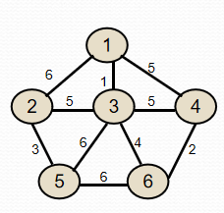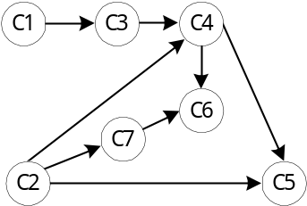  图1 无向图 图2 有向图  - 对图1无向图进行深度优先遍历和广度优先遍历。  - 对图1无向图采用Kruskal算法和Prim算法得出最小生成树。  - 对图2有向图进行拓扑排序，并输出。  实现要求：  实现无向图类和有向图类，编写测试main()函数，实例化无向图类对象和有向图类对象。  2.编制校园导航程序。依托青岛理工大学校园，给出主要建筑的名称信息及有路线连通的建筑之间的距离，抽象为图的数据结构，编程给出从任一建筑出发去校园另一建筑位置的最优路线及其距离。  实现要求：  - 构建带权有向图，并在附录中给出；  （2）实现Dijkstra算法或者Floyd算法；  （3）程序运行时，给出校园所有建筑物供用户选择，选出起点和终点，给出最短路径及距离。  实现提示：  - 编写测试main函数  - ⽤户界⾯能够进⾏交互；  （3）测试数据（或者自定义其他输入，或者使用文件）。
调  试  过  程  及  实  验  结  果 | 实验一：  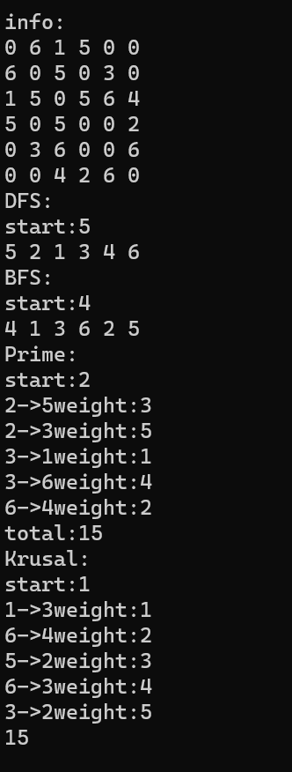  实验二：  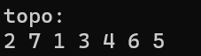  实验三：  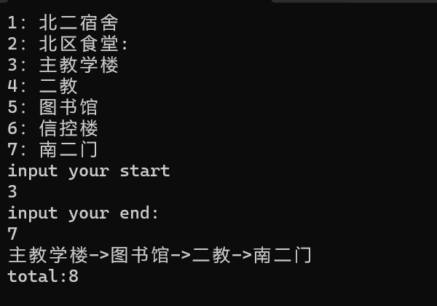
总  结 | 通过此次作业，我深刻理解了图这种非线性数据结构的特点和应用。邻接矩阵和邻接表是两种常用的图储存结构，邻接矩阵适用于稠密图，而邻接表则适用于稀疏图。DFS和BFS分别基于深度优先搜索和广度优先搜索思想，用于图的遍历。PRIM和KRUSKAL是最小生成树算法，PRIM基于贪心算法，KRUSKAL基于并查集。拓扑排序用于有向无环图的顺序安排，Dijkstra算法则用于求解单源最短路径问题。通过这些算法的学习和实现，我对图的特性和算法的应用有了更深入的理解。
附  录 | 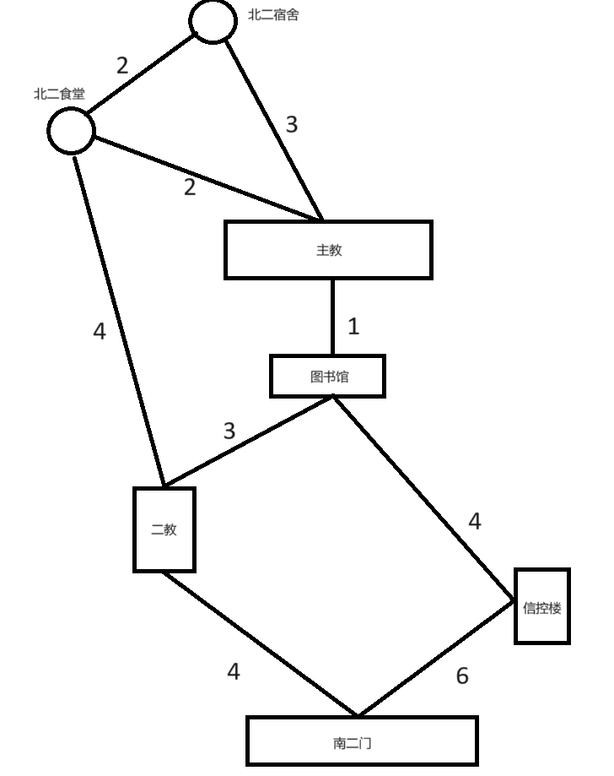  //实验一：  #pragma once  #pragma once  //Queue.h  template <class DataType>  struct QueueNode  {  struct QueueNode* m_Link;  DataType m_Data;  QueueNode() {}  };  template <class DataType>  class Queue  {  public:  Queue();  void Push(DataType);  DataType Pop();  bool IsEmpty();  private:  QueueNode <DataType>* m_Head;  QueueNode <DataType>* m_Tail;  };  #pragma once  //PriorityQueue.h  #pragma once  template <class DataType>  struct PriorityQueueNode  {  struct PriorityQueueNode* m_Link;  DataType m_Data;  int m_weight;  PriorityQueueNode() {}  };  template <class DataType>  class PriorityQueue  {  public:  PriorityQueue();  void Push(DataType, int);  DataType Pop();  bool IsEmpty();  private:  PriorityQueueNode <DataType>* m_Head;  PriorityQueueNode <DataType>* m_Tail;  };  //Queue.cpp  #pragma once  #include"Queue.h"  #include<iostream>  template<class DataType>  Queue<DataType>::Queue()//构造  {  m_Head = nullptr;  m_Tail = nullptr;  }  template<class DataType>  void Queue<DataType>::Push(DataType Data)//入队  {  QueueNode<DataType>* node = new QueueNode <DataType>();  node->m_Data = Data;  node->m_Link = nullptr;  if (!m_Tail)  {  m_Tail = node; m_Head = node;  }  else  {  m_Head->m_Link = node;  m_Head = node;  }  }  template<class DataType>  DataType Queue<DataType>::Pop()//出队  {  if (m_Tail)  {  DataType temp;  struct QueueNode<DataType>* node = m_Tail;  temp = node->m_Data;  m_Tail = node->m_Link;  delete node;  return temp;  }  else  {  std::cout << "L no data"; exit(-1);  }  }  template<class DataType>  bool Queue<DataType>::IsEmpty()//判断是否为空  {  if (!m_Tail)  return true;  else  return false;  }  //PriorityQueue.cpp  #include"PriorityQueue.h"  #include<iostream>  template<class DataType>  PriorityQueue<DataType>::PriorityQueue()//构造  {  m_Head = nullptr;  m_Tail = nullptr;  }  template<class DataType>  void PriorityQueue<DataType>::Push(DataType Data, int weight)//入队  {  PriorityQueueNode<DataType>* node = new PriorityQueueNode <DataType>();  node->m_Data = Data;  node->m_weight = weight;  node->m_Link = nullptr;  if (!m_Tail)  {  m_Tail = node; m_Head = node;  }  else  {  if (node->m_weight < m_Tail->m_weight)  {  node->m_Link = m_Tail;  m_Tail = node;  }  else  {  PriorityQueueNode<DataType>* temp = m_Tail;  while (temp != m_Head)  {  if (node->m_weight > temp->m_Link->m_weight) temp = temp->m_Link;  else break;  }  node->m_Link = temp->m_Link;  temp->m_Link = node;  if (temp == m_Head) m_Head = node;  }  }  }  template<class DataType>  DataType PriorityQueue<DataType>::Pop()//出队  {  if (m_Tail)  {  DataType temp;  struct PriorityQueueNode<DataType>* node = m_Tail;  temp = node->m_Data;  m_Tail = node->m_Link;  delete node;  return temp;  }  else  {  std::cout << "L no data"; exit(-1);  }  }  template<class DataType>  bool PriorityQueue<DataType>::IsEmpty()//判断是否为空  {  if (!m_Tail)  return true;  else  return false;  }  #include <iostream>  #include"PriorityQueue.cpp"  #include"Queue.cpp"  #define INF 2147483647;  struct Arc//储存边的信息  {  int SVex;  int EVex;  int weight;  };  class AdjList  {  public:  AdjList();  void DFS(int);  void BFS(int);  void Krusal(int);  void Prime(int);  private:  void InitKrusal();//初始化  void KrusalHelper(int);//辅助  void PrimeHelper(int);//辅助  void DFSHelper(int);//辅助  void BFSHelper(int);//辅助  int GetMin(int*);//Prime求目前最小的边  int SetFind(int*,int);//并查集的寻根  int Union(int*,int,int);//并查集合并  static PriorityQueue<Arc> LPQ;//Krusal求最小  int* Vex;//点的信息  int** Arc;//邻接矩阵  int num;//点的个数  static int* Visit;//遍历的辅助数组  static Queue<int> QUEUE;//BFS辅助队列  };  //静态变量初始化  PriorityQueue<Arc> AdjList::LPQ;  Queue<int> AdjList::QUEUE;  int* AdjList::Visit = nullptr;  int main()  {  AdjList graph;  std::cout << "DFS:" << std::endl;  std::cout << "start:";  int start = 0;  std::cin >> start;  graph.DFS(start);  std::cout << std::endl;  std::cout << "BFS:" << std::endl;  std::cout << "start:";  std::cin >> start;  graph.BFS(start);  std::cout << std::endl;  std::cout << "Prime:" << std::endl;  std::cout << "start:";  std::cin >> start;  graph.Prime(start);  std::cout << "Krusal:" << std::endl;  std::cout << "start:";  std::cin >> start;  graph.Krusal(start);  }  AdjList::AdjList()//初始化  {  std::cout << "Vex num" << std::endl;  std::cin >> num;  Vex = new int[num]();  Arc = new int* [num];  for (int i = 0; i < num; i++)  {  Vex[i] = i + 1;  }  for (int i = 0; i < num; i++)  {  Arc[i] = new int[num]();  }  std::cout << "info:" << std::endl;  for (int i = 0; i < num; i++)  {  for(int j = 0; j < num; j++)  {  std::cin >> Arc[i][j];  }  }  Visit = new int[num]();  }  void AdjList::DFS(int VEX)  {  DFSHelper(VEX);  for (int i = 0; i < num; i++) Visit[i] = 0;  }  void AdjList::BFS(int VEX)  {  BFSHelper(VEX);  for (int i = 0; i < num; i++) Visit[i] = 0;  }  void AdjList::Krusal(int VEX)  {  InitKrusal();  KrusalHelper(VEX-1);  }  void AdjList::Prime(int VEX)  {  PrimeHelper(VEX-1);  }  void AdjList::InitKrusal()  {  struct Arc m_Arc;  for (int i = 0; i < num; i++)  {  for (int j = 0; j < num; j++)  {  if(Arc[i][j] != 0)  {  m_Arc.SVex = i;  m_Arc.EVex = j;  m_Arc.weight = Arc[i][j];  LPQ.Push(m_Arc,m_Arc.weight);  }  }  }  }  void AdjList::KrusalHelper(int)  {  int sum = 0;  int flag = 0;  struct Arc m_Arc;  int* Set = new int[num]();  for (int i = 0; i < num; i++) Set[i] = -1;//初始化集合数组  while (!LPQ.IsEmpty() && flag<num-1)  {  m_Arc = LPQ.Pop();  if (SetFind(Set, m_Arc.SVex) != SetFind(Set, m_Arc.EVex))//如果两者不属于同一集合，既二者不相连通  {  std::cout << m_Arc.SVex + 1 << "->" << m_Arc.EVex + 1 << "weight:" << m_Arc.weight << std::endl;  sum += m_Arc.weight;  Union(Set, SetFind(Set, m_Arc.SVex), SetFind(Set, m_Arc.EVex));  flag++;  }  }  std::cout << sum << std::endl;  }  void AdjList::PrimeHelper(int VEX)  {  int* LowCast = new int[num]();  int* from = new int[num]();  int sum = 0;  for (int i = 0; i < num; i++)//初始化辅助数组  {  if (Arc[VEX][i])  {  LowCast[i] = Arc[VEX][i];  from[i] = VEX;  }  else  {  LowCast[i] = INF;  from[i] = VEX;  }  }  LowCast[VEX] = 0;  for (int i = 0; i < num - 1; i++)  {  int flag = GetMin(LowCast);//直接输出，在GetMin中进行了是否联通的判断  std::cout << from[flag] + 1 << "->" << flag + 1 << "weight:" << LowCast[flag] << std::endl;  sum += LowCast[flag];  VEX = flag;  for (int i = 0; i < num; i++) // 对辅助数组进行更改  {  if (Arc[VEX][i] && Arc[VEX][i] < LowCast[i])  {  LowCast[i] = Arc[VEX][i];  from[i] = VEX;  }  }  LowCast[VEX] = 0;  }  std::cout << "total:" << sum << std::endl;  }  void AdjList::DFSHelper(int VEX)  {  std::cout << VEX << ' ';  Visit[VEX - 1] = 1;  for (int i = 0; i < num; i++)  {  if (Arc[VEX - 1][i] && !Visit[i])  {  DFSHelper(Vex[i]);  }  }  }  void AdjList::BFSHelper(int VEX)  {  if(!Visit[VEX-1])  {  std::cout << VEX << ' ';  Visit[VEX - 1] = 1;  }  for (int i = 0; i < num; i++)  {  if (Arc[VEX - 1][i] && !Visit[i])  {  QUEUE.Push(Vex[i]);  }  }  while (!QUEUE.IsEmpty())  {  BFSHelper(QUEUE.Pop());  }  }  int AdjList::GetMin(int* LowCast)  {  int flag = 0; int Min = INF;  for (int i = 0; i < num; i++)  {  if (LowCast[i]!=0 && LowCast[i] < Min)//为0的点为已经连进了树中  {  Min = LowCast[i];  flag = i;  }  }  return flag;  }  int AdjList::SetFind(int* Set,int Node)  {  int temp = Node;  while (Set[temp] >= 0)  {  temp = Set[temp];  }  return temp;  }  int AdjList::Union(int* Set,int Root1,int Root2)  {  if ((-Set[Root1]) > (-Set[Root2]))  {  Set[Root1] += Set[Root2];  Set[Root2] = Root1;  return Root1;  }  else  {  Set[Root2] += Set[Root1];  Set[Root1] = Root2;  return Root2;  }  }  //实验二：  #pragma once  #include<iostream>  #include<CString>  template <class DataType>  struct NODE  {  struct NODE* m_Link;  DataType m_Data;  NODE() {}  };  template <class DataType>  class Stack  {  public:  Stack();  void Push(DataType);  DataType Pop();  DataType GetTop();  bool IsEmpty();  private:  NODE<DataType>* m_Head;  int m_Top;  };  //stack.cpp  #pragma once  #include"Stack.h"  template <class DataType>  Stack <DataType> ::Stack()//初始化  {  m_Head = nullptr;  m_Top = 0;  }  template <class DataType>  void Stack <DataType>::Push(DataType Data)//入栈  {  NODE<DataType>* node = new NODE<DataType>();  node->m_Link = m_Head;  m_Head = node;  node->m_Data = Data;  m_Top++;  }  template <class DataType>  DataType Stack <DataType> ::Pop()//出栈  {  if (m_Top != 0)  {  DataType Data;  struct NODE<DataType>* node = m_Head;  Data = node->m_Data;  //std::cout << node->m_Data << std::endl;  m_Head = node->m_Link;  delete node;  m_Top--;  return Data;  }  else  {  std::cout << "S no data" << std::endl;  exit(-1);  }  }  template <class DataType>  bool Stack <DataType> ::IsEmpty()//检查是否为空  {  if (!m_Head)  return true;  else  return false;  }  template <class DataType>  DataType Stack <DataType> ::GetTop()//获得栈顶元素  {  if (m_Head)  return m_Head->m_Data;  else  return 0;  }  #include<iostream>  #include"Stack.cpp"  struct VEX  {  int InDegree;  int OutDegree;  int m_num;  struct ARC* m_Next;  VEX()  {  InDegree = 0;  OutDegree = 0;  m_num = 0;  m_Next = nullptr;  }  };  struct ARC  {  int m_EVex;  struct ARC* m_Next;  ARC()  {  m_EVex = 0;  m_Next = nullptr;  }  };  class AdjList  {  public:  AdjList();  void ShowAdj();  void TopoSort();  private:  struct VEX* m_Vex;  int num;//节点数  Stack<VEX> STACK;  };  int main()  {  AdjList Graph;  std::cout << "graph:" << std::endl;  Graph.ShowAdj();  std::cout << "topo:" << std::endl;  Graph.TopoSort();  return 0;  }  AdjList::AdjList()  {  std::cout << "num:" << std::endl;  std::cin >> num;  m_Vex = new struct VEX[num]();  for (int i = 0; i < num; i++)  {  std::cout << "Node number " << i + 1 << ":" << std::endl;  m_Vex[i].m_num = i + 1;  std::cout << "ARC(input EndVex or end input by '-1'):" << std::endl;  while(1)  {  struct ARC* Arc = new struct ARC();  std::cin >> Arc->m_EVex;  if (Arc->m_EVex == -1)  {  delete Arc;  break;  }  Arc->m_EVex -= 1; m_Vex[Arc->m_EVex].InDegree++;  Arc->m_Next = m_Vex[i].m_Next; m_Vex[i].m_Next = Arc;  m_Vex[i].OutDegree++;  }  }  }  void AdjList::ShowAdj()  {  for (int i = 0; i < num; i++)  {  std::cout << "Node number :" << m_Vex[i].m_num << "Indegree:" << m_Vex[i].InDegree << std::endl;  struct ARC* temp = m_Vex[i].m_Next;  while (temp)  {  std::cout << m_Vex[i].m_num << "->" << temp->m_EVex + 1 << ' ' ;  temp = temp->m_Next;  }  std::cout << std::endl;  }  }  void AdjList::TopoSort()//使用栈的一种策略，优先深度，如果使用队列，那么右优先广度  {  struct VEX* Vex = new struct VEX [num]();  for (int i = 0; i < num; i++) Vex[i] = m_Vex[i];  int* Visit = new int[num]();  struct VEX Node;  struct ARC* Temp = nullptr;  for (int i = 0; i < num; i++)  {  if (Vex[i].InDegree == 0)  {  STACK.Push(Vex[i]);  Visit[i] = 1;  }  }  while (!STACK.IsEmpty())  {  Node = STACK.Pop();  std::cout << Node.m_num << ' ';  Temp = Node.m_Next;  while (Temp)  {  Vex[Temp->m_EVex].InDegree--;  Temp = Temp->m_Next;  }  for (int i = 0; i < num; i++)  {  if (Visit[i]==0 && Vex[i].InDegree == 0)  {  STACK.Push(Vex[i]);  Visit[i] = 1;  }  }  }  delete[]Vex;  }  //实验三：  #pragma once  #pragma once  #include<iostream>  #include<CString>  template <class DataType>  struct NODE  {  struct NODE* m_Link;  DataType m_Data;  NODE() {}  };  template <class DataType>  class Stack  {  public:  Stack();  void Push(DataType);  DataType Pop();  DataType GetTop();  bool IsEmpty();  private:  NODE<DataType>* m_Head;  int m_Top;  };  //stack.cpp  #pragma once  #include"Stack.h"  template <class DataType>  Stack <DataType> ::Stack()//初始化  {  m_Head = nullptr;  m_Top = 0;  }  template <class DataType>  void Stack <DataType>::Push(DataType Data)//入栈  {  NODE<DataType>* node = new NODE<DataType>();  node->m_Link = m_Head;  m_Head = node;  node->m_Data = Data;  m_Top++;  }  template <class DataType>  DataType Stack <DataType> ::Pop()//出栈  {  if (m_Top != 0)  {  DataType Data;  struct NODE<DataType>* node = m_Head;  Data = node->m_Data;  //std::cout << node->m_Data << std::endl;  m_Head = node->m_Link;  delete node;  m_Top--;  return Data;  }  else  {  std::cout << "S no data" << std::endl;  exit(-1);  }  }  template <class DataType>  bool Stack <DataType> ::IsEmpty()//检查是否为空  {  if (!m_Head)  return true;  else  return false;  }  template <class DataType>  DataType Stack <DataType> ::GetTop()//获得栈顶元素  {  if (m_Head)  return m_Head->m_Data;  else  return 0;  }  #include <iostream>  #include"Stack.cpp"  #define INF 2147483647  #define VEXNUM 7  struct VEXNODE  {  int m_num;  std::string VexName;  VEXNODE()  {m_num = 0;}  };  struct Arc//储存边的信息  {  int SVex;  int EVex;  int weight;  };  class AdjList  {  public:  AdjList(int Map[][7],std::string*);  void DFS(int);  void BestPath(int, int);  private:  void DFSHelper(int);//辅助  void BestPathHelper(int, int);//Dijkstra  int GetMin(int*);//求目前最小的边  struct VEXNODE* Vex;//点的信息  int** Arc;//邻接矩阵  int num;//点的个数  static int* Visit;//遍历的辅助数组  };  AdjList::AdjList(int Map[][7],std::string* MapNode)//初始化  {  num = VEXNUM;  Vex = new struct VEXNODE[num]();  Arc = new int* [num];  for (int i = 0; i < num; i++)  {  Vex[i].m_num = i;  Vex[i].VexName = MapNode[i];  }  for (int i = 0; i < num; i++)  {  Arc[i] = new int[num]();  Arc[i] = Map[i];  }  Visit = new int[num]();  }  void AdjList::DFS(int VEX)  {  DFSHelper(VEX);  for (int i = 0; i < num; i++) Visit[i] = 0;  }  void AdjList::BestPath(int start, int end)  {  BestPathHelper(start-1, end-1);  for (int i = 0; i < num; i++) Visit[i] = 0;  }  void AdjList::BestPathHelper(int start, int end)//from prime？  {  int* LowCast = new int[num]();  int* from = new int[num]();  int VEX = Vex[start].m_num;//初始化  for (int i = 0; i < num; i++)//初始化辅助数组  {  if (Arc[VEX][i])  {  LowCast[i] = Arc[VEX][i];  from[i] = VEX;  }  else  {  LowCast[i] = INF;  from[i] = VEX;  }  }  LowCast[VEX] = 0;//路径长度  from[VEX] = -1;//源自节点  Visit[VEX] = 1;//是否被访问过  int flag = 0;  for (int i = 0; i < num - 1; i++)  {  flag = GetMin(LowCast);  Visit[flag] = 1;  for (int i = 0; i < num; i++)  {  if(i != start)//起始节点跳过  {  if (Arc[flag][i] != 0)  {  int temp = LowCast[flag] + Arc[flag][i];//如果新路径权值小，则改变来源节点与最小路径  if (temp < LowCast[i])  {  LowCast[i] = temp;  from[i] = flag;  }  }  }  }  VEX = flag;  }  Stack<int> STACK;  int temp = end;  while (temp != -1)  {  STACK.Push(temp);  temp = from[temp];  }  while (1)  {  std::cout << Vex[STACK.Pop()].VexName;  if (!STACK.IsEmpty()) std::cout << "->";  else break;  }  std::cout << std::endl;  std::cout << "total:" << LowCast[end] << std::endl;  }  void AdjList::DFSHelper(int VEX)  {  std::cout << VEX << ' ';  Visit[VEX - 1] = 1;  for (int i = 0; i < num; i++)  {  if (Arc[VEX - 1][i] && !Visit[i])  {  DFSHelper(Vex[i].m_num);  }  }  }  int AdjList::GetMin(int* LowCast)  {  int flag = 0; int Min = INF;  for (int i = 0; i < num; i++)  {  if (LowCast[i] != 0 && Visit[i]!=1 && LowCast[i] < Min)//from prrime add Visit[i]!=1  {  Min = LowCast[i];  flag = i;  }  }  return flag;  }  int* AdjList::Visit = nullptr;  int main()  {  int Map[7][7] = {  {0,2,3,0,0,0,0},  {2,0,2,4,0,0,0},  {3,2,0,0,1,0,0},  {0,4,0,0,3,0,4},  {0,0,1,3,0,4,0},  {0,0,0,0,4,0,6},  {0,0,0,4,0,6,0}  };  std::string MapNode[7] = {  "北二宿舍",  "北区食堂",  "主教学楼",  "二教",  "图书馆",  "信控楼",  "南二门"  };  std::cout << "1：北二宿舍" << std::endl;  std::cout << "2：北区食堂:" << std::endl;  std::cout << "3：主教学楼" << std::endl;  std::cout << "4：二教" << std::endl;  std::cout << "5：图书馆" << std::endl;  std::cout << "6：信控楼" << std::endl;  std::cout << "7：南二门" << std::endl;  int start, end;  std::cout << "input your start" << std::endl;  std::cin >> start;  std::cout << "input your end:" << std::endl;  std::cin >> end;  AdjList Graph(Map,MapNode);  Graph.BestPath(start, end);  }

