课程实验报告
课程名称 | 数据结构 | 班级 |  | 实验日期 | 2023.12.8
姓名 |  | 学号 |  | 实验成绩
实验名称 | 实验五 查找综合
实  验  目  的  及  要  求 | 1.掌握查找表、动态查找表、静态查找表和；  2.掌握线性表中顺序查找和折半查找的方法；  3.学会哈希函数的构造方法，处理冲突的机制以及哈希表的查找；  4.平均查找长度的概念及计算。
实  验  环  境 | 操作系统：Windows 11  开发环境：Visual Studio 2022
实  验  内  容 | 1. 静态查找表技术  依据顺序查找算法和折半查找算法的特点，对下面的两个查找表选择一个合适的算法，编写出完整的程序。并完成问题：  查找表1 ： { 8 ，15 ，19 ，26 ，33 ，41 ，47 ，52 ，64 ，90 } ，查找key = 41  查找表2 ： {12 ，76 ，29 ，15 ，62 ，35 ，33 ，89 ，48 ，20 } ，查找key =35  查找key=41的算法： 比较次数：  查找key=35的算法： 比较次数：  并分析平均查找长度。  2.动态查找表技术  将序列：122、99、250、110、300、280 作为二叉排序树的结点的关键字值，生成二叉排序树。完成下列操作：  - 查找关键字key=80，若没有，加入到二叉树相应位置  - 查找关键字key=99，若找到，把该结点删除  要求：编程实现二叉排序树的建立、插入和删除；并分析平均查找长度  - 哈希表查找技术  将序列：19 14 23 1 68 20 84 27 55 11 10 79 构造哈希表进行存储。（哈希函数采用除留余数法）  要求分别使用线性探测法和链地址法解决冲突。并分析平均查找长度。
调  试  过  程  及  实  验  结  果 | 实验一：  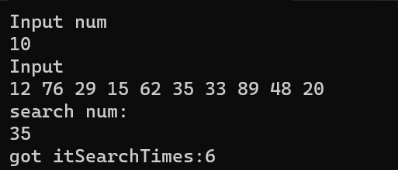  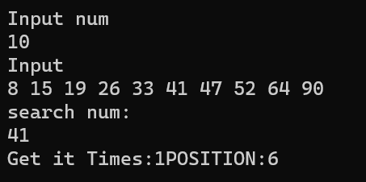  实验二  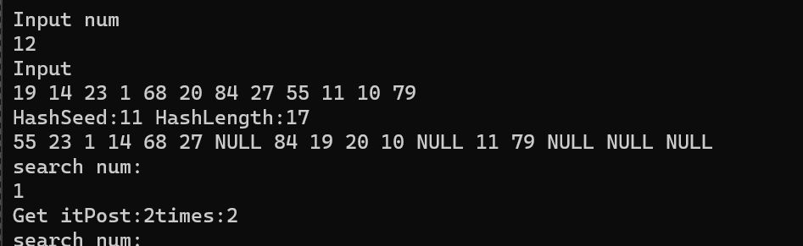  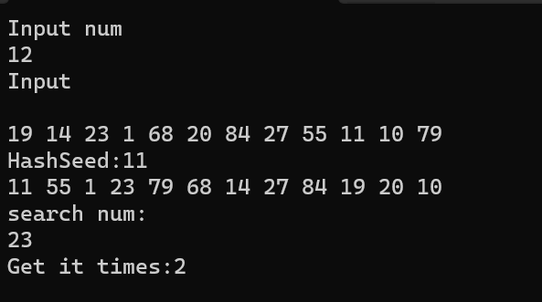  实验三：  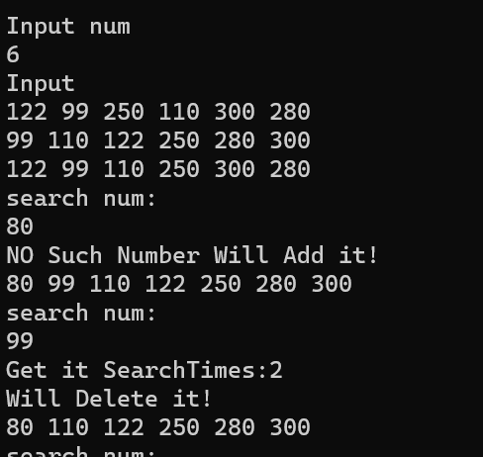
总  结 | 通过完成数据结构查找作业，我深刻体会到不同查找算法的优劣。顺序查找如生活中的逐个查找，二分查找像猜数字，哈希是找到合适的盒子，而二叉搜索树则是有序排列。每个算法都有独特之处，理解它们如同拓展人生思维，寻找最优解的过程。
附  录 | //实验一，search  #include <iostream>  int main()  {  std::cout << "Input num" << std::endl;  int num;  std::cin >> num;  int* Input = new int[num]();  std::cout << "Input" << std::endl;  for (int i = 0; i < num; i++) std::cin >> Input[i];  std::cout << "search num:" << std::endl;  int Search; std::cin >> Search;  int i;  for (i = 0; i < num; i++)  {  if (Input[i] == Search) break;  }  if (i < num) std::cout << "got it" << "SearchTimes:" << i + 1;  else std::cout << "no such num";  }  //实验二BinSearch:  #include <iostream>  int main()  {  std::cout << "Input num" << std::endl;  int num;  std::cin >> num;  int* Input = new int[num]();  std::cout << "Input" << std::endl;  for (int i = 0; i < num; i++) std::cin >> Input[i];  std::cout << "search num:" << std::endl;  int Search; std::cin >> Search;  int Times = 0;  int start = 0; int end = num - 1;  int mid = (start + end) / 2;  while (start < end)  {  if (Input[mid] < Search) start = mid;  else if (Input[mid] > Search) end = mid;  else  {  std::cout << "Get it Times:" << Times + 1 << "POSITION:" << mid +1 << std::endl;  break;  }  mid = (start + end) / 2;  }  if(start>=end) std::cout << "no such num" << std::endl;  }  //实验二：  #include <iostream>  class BiSearchTree  {  public:  BiSearchTree() { m_Data = 0; left = nullptr; right = nullptr; BF = 0; }  BiSearchTree* CreatTree();  void HeadTraversal(BiSearchTree*);  void MidTraversal(BiSearchTree*);  void TailTraversal(BiSearchTree*);  void Search(BiSearchTree*, int);  private:  void DELETE(BiSearchTree*, BiSearchTree*);  void CreatTreeHelper(BiSearchTree*, BiSearchTree*);  int Deep(BiSearchTree*);  BiSearchTree* GetMax(BiSearchTree*);  int m_Data;  BiSearchTree* left;  BiSearchTree* right;  int BF;//balance factor  };  int main()  {  BiSearchTree* TREE = nullptr;  TREE = TREE->CreatTree();  TREE->MidTraversal(TREE);  std::cout << std::endl;  TREE->HeadTraversal(TREE);  std::cout << std::endl;  std::cout << "search num:" << std::endl;  int Search; std::cin >> Search;  TREE->Search(TREE, Search);  TREE->MidTraversal(TREE);  std::cout << std::endl;  }  BiSearchTree* BiSearchTree::CreatTree()  {  std::cout << "Input num" << std::endl;  int num;  std::cin >> num; if (!num) return nullptr;  std::cout << "Input" << std::endl;  BiSearchTree* ROOT = new BiSearchTree();  std::cin >> ROOT->m_Data; ROOT->left = nullptr; ROOT->right = nullptr;  for (int i = 1; i < num; i++)  {  BiSearchTree* TREE = new BiSearchTree();  std::cin >> TREE->m_Data;  TREE->left = nullptr; TREE->right = nullptr;  CreatTreeHelper(ROOT, TREE);  }  return ROOT;  }  void BiSearchTree::CreatTreeHelper(BiSearchTree* T, BiSearchTree* NODE)  {  while (1)  {  while (T->m_Data > NODE->m_Data && T->left) T = T->left;  while (T->m_Data < NODE->m_Data && T->right) T = T->right;  //仅有这三种情况时找到应该的位置  //如果使用递归，插入后返回时会有一些情况会重复插入，也就是搜索二叉树有多个位置符合同一节点要求  //使用这种方法，查找不需要回退  if ((!T->left && !T->right) || (!T->left && T->right->m_Data > NODE->m_Data) || (!T->right && T->left->m_Data < NODE->m_Data))  break;  }  if (T->m_Data > NODE->m_Data)  {  NODE->left = T->left;  T->left = NODE;  }  else if (T->m_Data < NODE->m_Data)  {  NODE->right = T->right;  T->right = NODE;  }  }  void BiSearchTree::HeadTraversal(BiSearchTree* T)  {  if (T != nullptr)  {  std::cout << T->m_Data << ' ';  HeadTraversal(T->left);  HeadTraversal(T->right);  }  return;  }  void BiSearchTree::MidTraversal(BiSearchTree* T)  {  if (T != nullptr)  {  MidTraversal(T->left);  std::cout << T->m_Data << ' ';  MidTraversal(T->right);  }  return;  }  void BiSearchTree::TailTraversal(BiSearchTree* T)  {  if (T != nullptr)  {  TailTraversal(T->left);  TailTraversal(T->right);  std::cout << T->m_Data << ' ';  }  return;  }  void BiSearchTree::Search(BiSearchTree* T, int SearchNum)  {  int SearchTimes = 0;  BiSearchTree* ROOT = T;  while (T)  {  if (T->m_Data > SearchNum) T = T->left;  else if (T->m_Data < SearchNum) T = T->right;  else  {  std::cout << "Get it " << "SearchTimes:" << SearchTimes + 1 << std::endl;  std::cout << "Will Delete it!" << std::endl;  DELETE(ROOT, T);  break;  }  SearchTimes++;  }  if (!T)  {  std::cout << "NO Such Number ";  std::cout << "Will Add it!" << std::endl;  BiSearchTree* TREE = new BiSearchTree();  TREE->m_Data = SearchNum;  TREE->left = nullptr; TREE->right = nullptr;  CreatTreeHelper(ROOT, TREE);  }  }  int BiSearchTree::Deep(BiSearchTree* T)  {  int DOL = 0; int DOR = 0;  if (T == nullptr) return 0;  DOL = Deep(T->left);  DOR = Deep(T->right);  if (DOL >= DOR) return ++DOL;  else return ++DOR;  }  BiSearchTree* BiSearchTree::GetMax(BiSearchTree* T)  {  while (T->right) T = T->right;  return T;  }  void BiSearchTree::DELETE(BiSearchTree* T, BiSearchTree* NODE)  {  BiSearchTree* Father = T;  while (1)  {  while (T->m_Data > NODE->m_Data)  {  Father = T;  T = T->left;  }  while (T->m_Data < NODE->m_Data)  {  Father = T;  T = T->right;  }  if ((!T->left && !T->right) || (!T->left && T->right->m_Data > NODE->m_Data) || (!T->right && T->left->m_Data < NODE->m_Data) || T->m_Data==NODE->m_Data)  break;  }  if (!T->left) Father->left = T->right;  else if (!T->right) Father->right = T->left;  else  {  BiSearchTree* Temp = GetMax(T->left);//找到T的左子树的最大节点  Temp->right = T->right;//T的所有右子树都比Temp大直接连上  //判断T是父节点的左孩子还是右孩子  if (Father->left == T) Father->left = Temp;  else if (Father->right == T) Father->right = Temp;  if (T->left != Temp)//如果Temp不是T的左孩子，也就是T的左子树有右孩子  {  while (Temp->left) Temp = Temp->left;//找到Temp最小的孩子  //Temp最小的孩子也比T除Temp以外的所有节点大，因此直接连接到Temp最小的孩子的左孩子上  Temp->left = T->left;  }  }  }  //实验三：Hash  // Hash.cpp : 此文件包含 "main" 函数。程序执行将在此处开始并结束。  //  #include <iostream>  enum state{EMPTY,DELETE,EXIST};  struct hash  {  int Data;  state m_state;  hash() { Data = 0; m_state = EMPTY; }  };  class HASH  {  public:  HASH();  void Search(int);  private:  int GetPrime(int);  int num;  int HashLength;  hash* Hash;  int HashSeed;  };  int main()  {  HASH hash;  std::cout << "search num:" << std::endl;  int Search; std::cin >> Search;  hash.Search(Search);  }  HASH::HASH()  {  std::cout << "Input num" << std::endl;  num;  std::cin >> num;  int* Input = new int[num]();  std::cout << "Input" << std::endl;  for (int i = 0; i < num; i++) std::cin >> Input[i];  HashSeed = GetPrime(num);  std::cout << "HashSeed:" << HashSeed << ' ';  HashLength = GetPrime(num / (0.7));  std::cout << "HashLength:" << HashLength << std::endl;  Hash = new hash[HashLength]();  int Post;  for (int i = 0; i < num; i++)  {  Post = Input[i] % HashSeed;  int flag = 1;  while (Hash[Post].m_state == EXIST)  {  Post = (Input[i] + flag) % HashLength;  flag++;  }  Hash[Post].Data = Input[i]; Hash[Post].m_state = EXIST;  }  for (int i = 0; i < HashLength; i++)  {  if (Hash[i].m_state == EXIST) std::cout << Hash[i].Data << ' ';  else std::cout << "NULL" << ' ';  }  std::cout << std::endl;  }  void HASH::Search(int SearchNum)  {  int flag = 1;  int Post = SearchNum % HashLength;  int times = 0;  while (Hash[Post].m_state != EMPTY)  {  if (Hash[Post].m_state == EXIST && Hash[Post].Data == SearchNum)  {  std::cout << "Get it" << "Post:" << Post << "times:" << times + 1 << std::endl;  break;  }  Post = (SearchNum + flag) % HashLength;  flag++;  times++;  }  if(Hash[Post].m_state == EMPTY) std::cout << "Null";  }  int HASH::GetPrime(int num)  {  while (num)  {  int i;  for (i = 2; i < sqrt(num); i++)  {  if (num % i == 0) break;  }  if (i >= sqrt(num)) break;  num--;  }  return num;  }  //实验三Hash List：  // HashList.cpp : 此文件包含 "main" 函数。程序执行将在此处开始并结束。  //  #include <iostream>  struct hash  {  int Data;  struct hash* Next;  hash() { Data = 0; Next = nullptr; }  };  class HASH  {  public:  HASH();  void Search(int);  private:  int GetPrime(int);  int num;  int HashLength;  hash* Hash;  int HashSeed;  };  int main()  {  HASH hash;  std::cout << "search num:" << std::endl;  int Search; std::cin >> Search;  hash.Search(Search);  }  HASH::HASH()  {  std::cout << "Input num" << std::endl;  num;  std::cin >> num;  int* Input = new int[num]();  std::cout << "Input" << std::endl;  for (int i = 0; i < num; i++) std::cin >> Input[i];  HashSeed = GetPrime(num);  std::cout << "HashSeed:" << HashSeed << ' ' << std::endl;  HashLength = num;  Hash = new struct hash[HashLength]();  int Post;  for (int i = 0; i < HashLength; i++)  {  Post = Input[i] % HashSeed;  hash* temp = new hash();  temp->Data = Input[i];  temp->Next = Hash[Post].Next;  Hash[Post].Next = temp;  }  hash* temp;  for (int i = 0; i < HashLength; i++)  {  temp = Hash[i].Next;  while (temp)  {  std::cout << temp->Data << ' ';  temp = temp->Next;  }  }  std::cout << std::endl;  }  void HASH::Search(int SearchNum)  {  int times = 0;  int Post = SearchNum % HashSeed;  hash* temp = Hash[Post].Next;  while (temp)  {  if (temp->Data == SearchNum)  {  std::cout << "Get it " << "times:" << times + 1 << std::endl;  break;  }  temp = temp->Next;  times++;  }  if (!temp) std::cout << "NULL" << std::endl;  }  int HASH::GetPrime(int num)  {  while (num)  {  int i;  for (i = 2; i < sqrt(num); i++)  {  if (num % i == 0) break;  }  if (i >= sqrt(num)) break;  num--;  }  return num;  }

