**Dr. Seuss and World War Two**

Before he was Dr. Seuss he was the political cartoonist Theodore Geisel. In the years leading up to World War Two many people in the United States (and Canada) believed in a policy called Isolationism. They believed that it was best to isolate the United States (and Canada) from overseas conflicts so that they would not be "pulled" into another war in Europe. Throughout the 1930's the Isolationists had a strong influence over the American (and to a lesser extent Canadian) government. As the dictatorships (Japan, Italy and Germany) began expand in the mid-late 1930's several people (and groups) began to pressure the government to take action and stand up to this growing threat. One of these people was Jewish-American Theodore Geisel, a political cartoonist for a New York newspaper called PM. During the war he would work directly for the American government creating propaganda for the war effort. Below are sample examples of his work .

Cartoons regarding Isolationism (and Appeasement) vs. Intervention

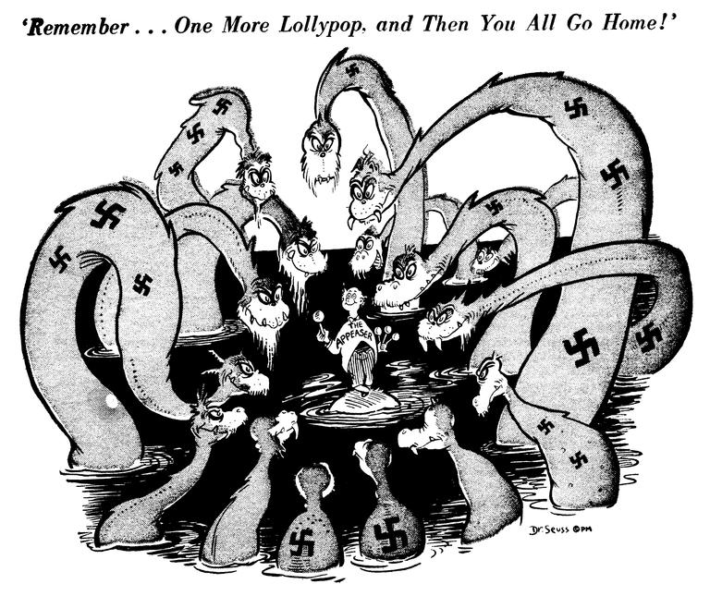

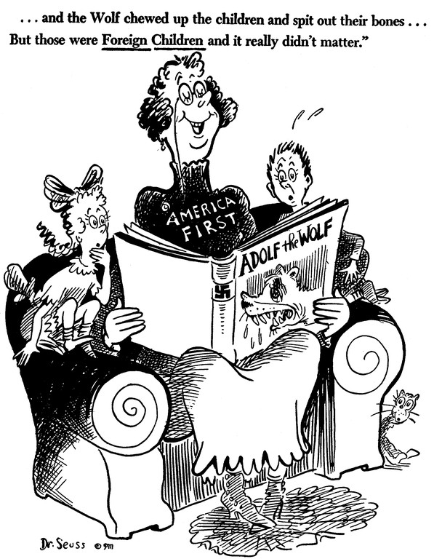

America First was the name of the leading Isolationist group in America.

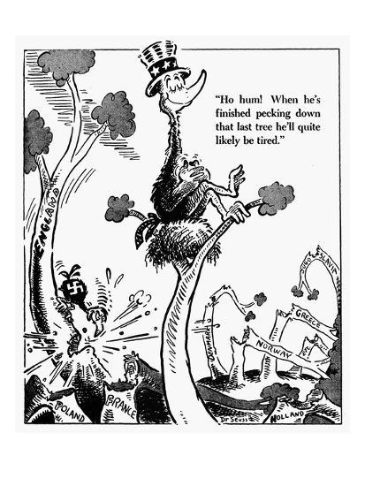

There was a belief among the Isolationists that if they ignored war it would ignore them.

Then on December 7, 1941 - The Japanese attacked Pearl Harbor - proving that no matter how much America wished to remain Isolated they could not.

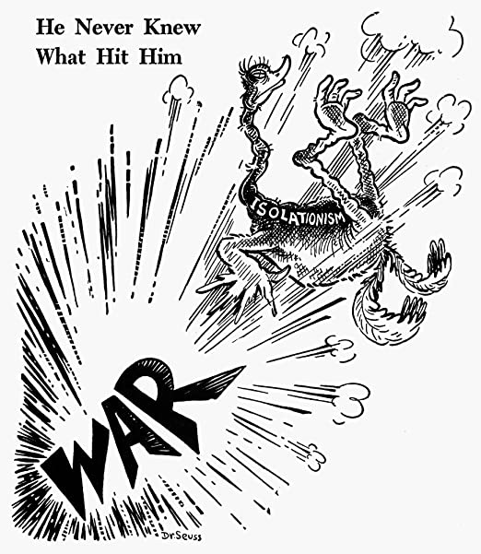

Once the USA was in the War Theodore Geisel directly worked for the US War Department.

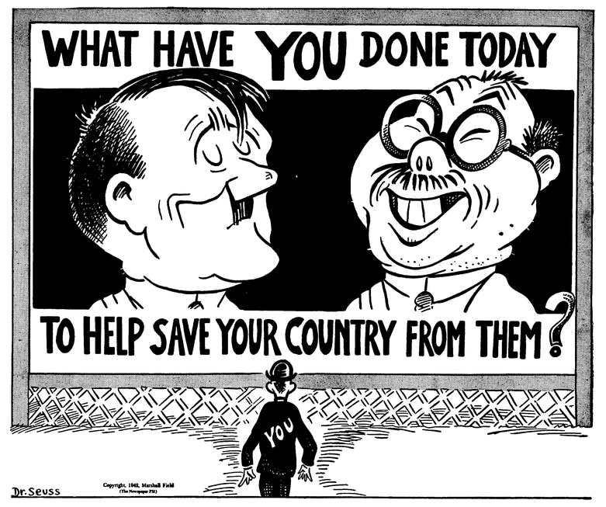

The Importance of War Bonds - Citizens Financing the War Efoort

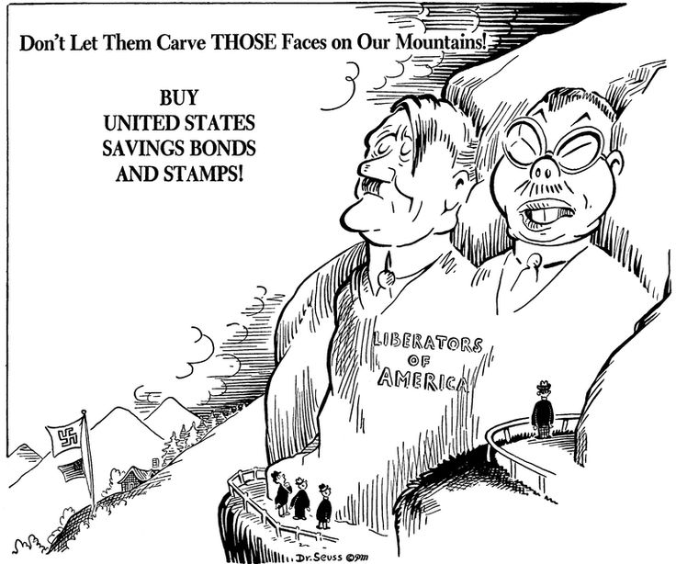

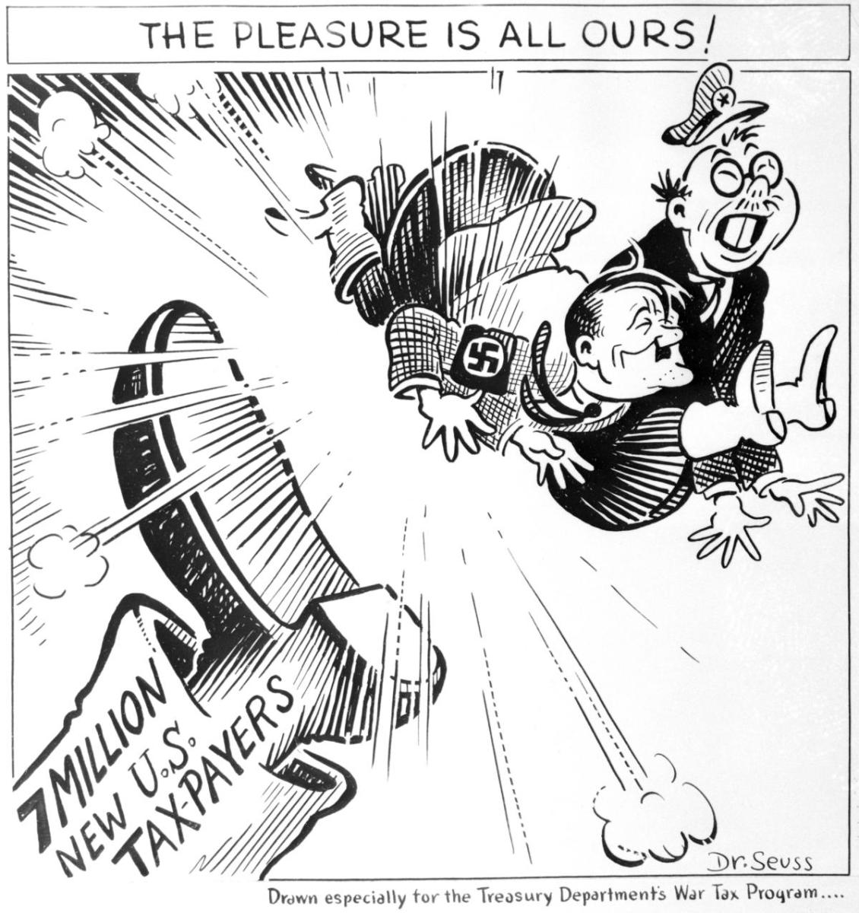

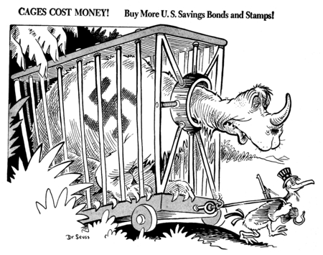

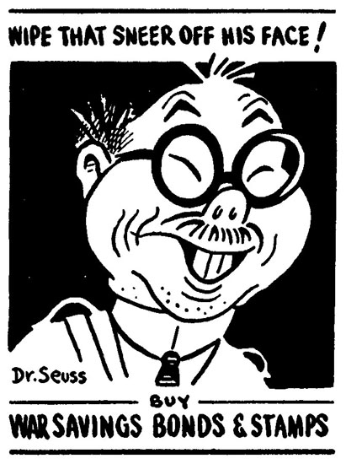

The Importance of Rationing - Gas in the first one and Gas and Rubber in the second.

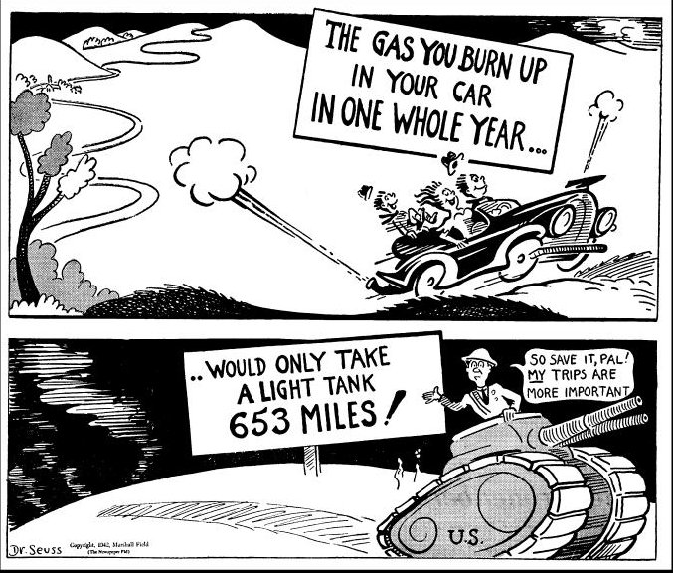

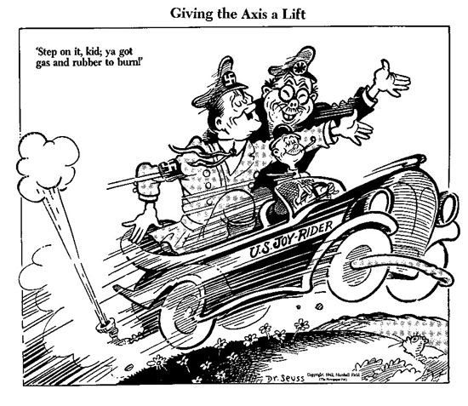

Dr. Seuss became a beloved children's author after the war however in his work for the US government during the war he, like many citizens, was angered at the Japanese sneak attack on Pearl Harbor and his cartoons mirror the hostility shown towards the Japanese during the war.

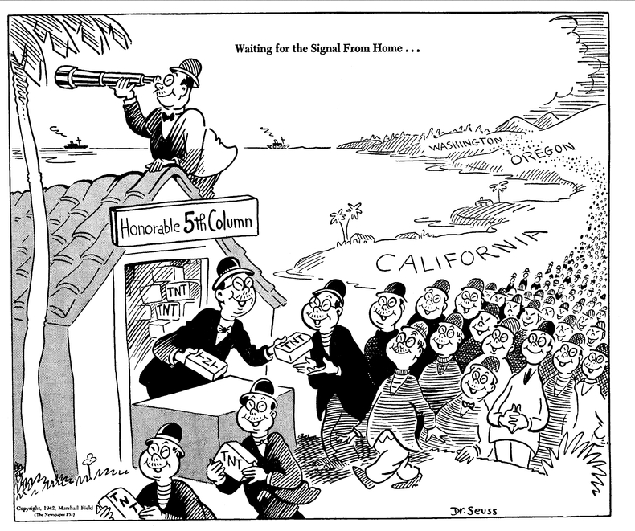

The "fifth column" refers to the fear of a group within a country who are sympathetic or working for the enemy.