Capstone Initial Results and Code

Connell O'Leary

March 20, 2017

setwd("C:/Users/Connell/Documents/R")  
df1 <- read.csv("Independent.Variables.Total.csv")

**Correlation for Language Test Scores Grades 4&6, 6&8, 4&8**

cor(df1[,c(2,3)], use="complete.obs", method="pearson")

## Grade.4.Language Grade.6.Language  
## Grade.4.Language 1.0000000 0.9641289  
## Grade.6.Language 0.9641289 1.0000000

cor(df1[,c(3,4)], use="complete.obs", method="pearson")

## Grade.6.Language Grade.8.Language  
## Grade.6.Language 1.0000000 0.9818791  
## Grade.8.Language 0.9818791 1.0000000

cor(df1[,c(2,4)], use="complete.obs", method="pearson")

## Grade.4.Language Grade.8.Language  
## Grade.4.Language 1.0000000 0.9929347  
## Grade.8.Language 0.9929347 1.0000000

**Correlation for Math Test Scores Grades 4&6, 6&8, 4&8**

cor(df1[,c(5,6)], use="complete.obs", method="pearson")

## Grade.4.Math Grade.6.Math  
## Grade.4.Math 1.000000 0.975553  
## Grade.6.Math 0.975553 1.000000

cor(df1[,c(6,7)], use="complete.obs", method="pearson")

## Grade.6.Math Grade.8.Math  
## Grade.6.Math 1.0000000 0.9806946  
## Grade.8.Math 0.9806946 1.0000000

cor(df1[,c(5,7)], use="complete.obs", method="pearson")

## Grade.4.Math Grade.8.Math  
## Grade.4.Math 1.0000000 0.9485096  
## Grade.8.Math 0.9485096 1.0000000

**Assigning Colours for each Borough**

df1$color<- factor(df1$Borough, levels=c("Manhattan", "Bronx", "Brooklin", "Queens", "Staten Island"), labels=rainbow(5))

**Visulaizing Correlations - corrgram**

library(corrgram)

## Warning: package 'corrgram' was built under R version 3.2.5

## Warning: replacing previous import by 'magrittr::%>%' when loading  
## 'dendextend'

corrgram(df1[,2:3], order=TRUE, lower.panel=panel.shade, upper.panel=panel.pie, text.panel=panel.txt,   
 main="NYC Grade 4 and Grade 6 Language Tests")

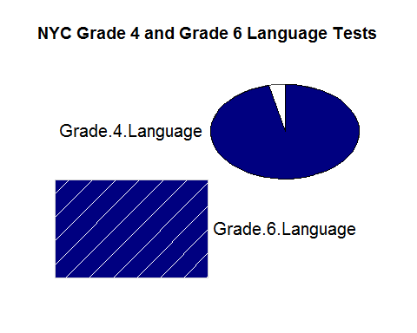

corrgram(df1[,3:4], order=TRUE, lower.panel=panel.shade, upper.panel=panel.pie, text.panel=panel.txt,   
 main="NYC Grade 6 and Grade 8 Language Tests")

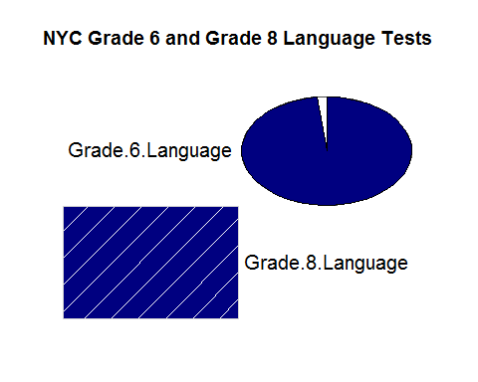

corrgram(df1[, c(2,4)], order=TRUE, lower.panel=panel.shade, upper.panel=panel.pie, text.panel=panel.txt,   
 main="NYC Grade 4 and Grade 8 Language Tests")

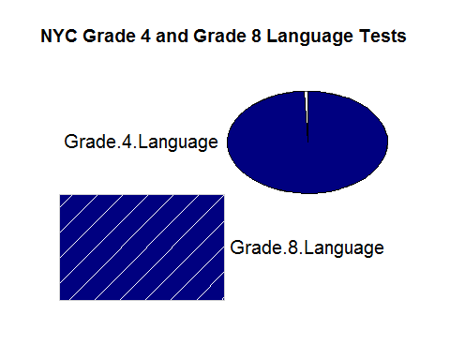

corrgram(df1[, 2:4], order=TRUE, lower.panel=panel.shade, upper.panel=panel.pie, text.panel=panel.txt,   
 main="NYC Grades 4, 6 & 8 Language Tests")

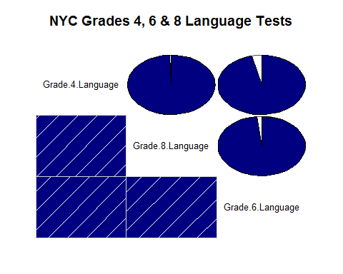

corrgram(df1[, 5:6], order=TRUE, lower.panel=panel.shade, upper.panel=panel.pie, text.panel=panel.txt,   
 main="NYC Grade 4 and Grade 6 Math Tests")

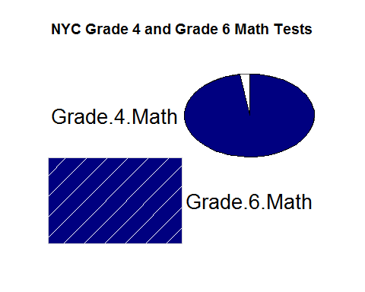

corrgram(df1[, 6:7], order=TRUE, lower.panel=panel.shade, upper.panel=panel.pie, text.panel=panel.txt,   
 main="NYC Grade 6 and Grade 8 Math Tests")

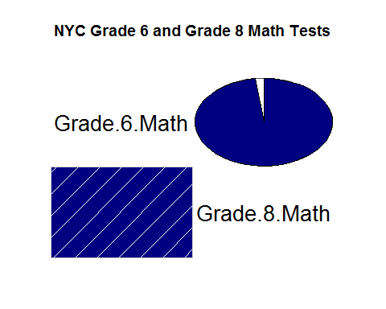

corrgram(df1[, c(5,7)], order=TRUE, lower.panel=panel.shade, upper.panel=panel.pie, text.panel=panel.txt,   
 main="NYC Grade 4 and Grade 8 Math Tests")

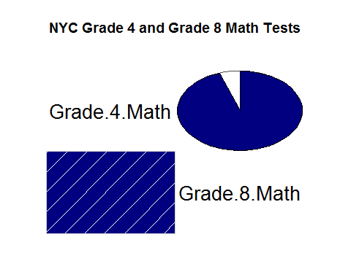

corrgram(df1[, 5:7], order=TRUE, lower.panel=panel.shade, upper.panel=panel.pie, text.panel=panel.txt,   
 main="NYC Grades 4,6, & 8 Math Tests")

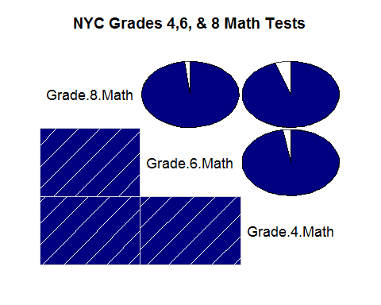

**Scatter Plots for Language Correlation**

plot(df1$Grade.4.Language~df1$Grade.6.Language, main="Grade 4 and 6 Language Test Results Compared",   
 xlab="Grade 4", ylab = "Grade 6", pch=16, col=as.character(df1$color))  
legend("topleft", pch=16, col=as.character(df1$color), legend=unique(df1$Borough), text.font = 1, cex = 0.75)  
abline(lm(df1$Grade.4.Language~df1$Grade.6.Language), col="black")

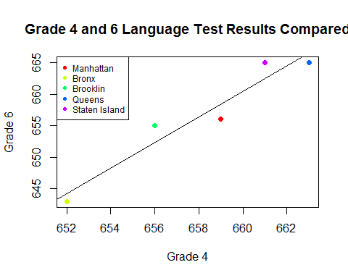

plot(df1$Grade.6.Language~df1$Grade.8.Language, main="Grade 6 and 8 Language Test Results Compared",   
 xlab="Grade 6", ylab = "Grade 8", pch=16, col=as.character(df1$color))  
legend("topleft", pch=16, col=as.character(df1$color), legend=unique(df1$Borough), text.font = 1, cex = 0.75)  
abline(lm(df1$Grade.6.Language~df1$Grade.8.Language), col="black")

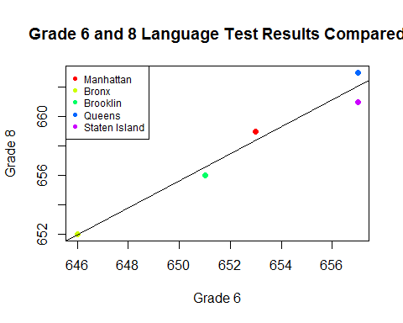

plot(df1$Grade.4.Language~df1$Grade.8.Language, main="Grade 4 and 8 Language Test Results Compared",   
 xlab="Grade 4", ylab = "Grade 8", pch=16, col=as.character(df1$color))  
legend("topleft", pch=16, col=as.character(df1$color), legend=unique(df1$Borough), text.font = 1, cex = 0.75)  
abline(lm(df1$Grade.4.Language~df1$Grade.8.Language), col="black")

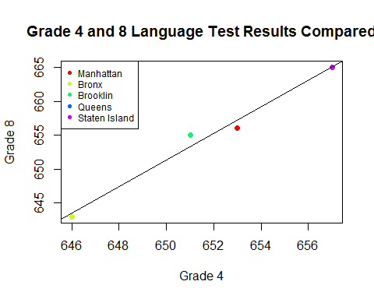

pairs(df1[,c(2:4)], main="Language Test Results: Grades 4,6,& 8", col=as.character(df1$color), pch=16)

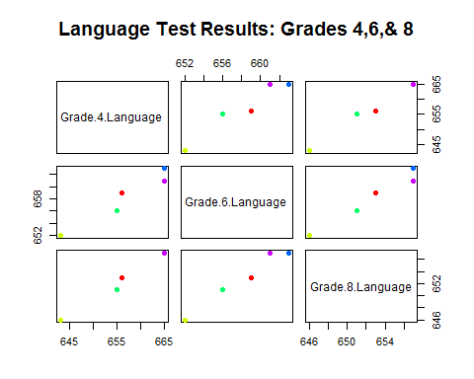

**Scatter Plots for Math Correlation**

plot(df1$Grade.4.Math~df1$Grade.6.Math, main="Grade 4 and 6 Math Test Results Compared",   
 xlab="Grade 4", ylab = "Grade 6", pch=16, col=as.character(df1$color))  
legend("topleft", pch=16, col=as.character(df1$color), legend=unique(df1$Borough), text.font = 1, cex = 0.75)  
abline(lm(df1$Grade.4.Math~df1$Grade.8.Math), col="black")

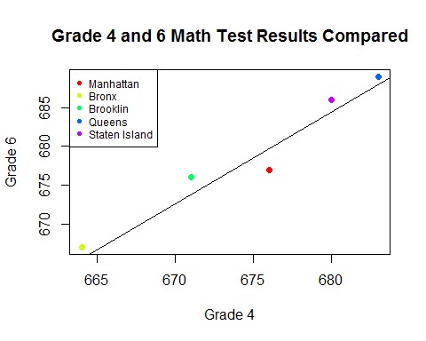

plot(df1$Grade.6.Math~df1$Grade.8.Math, main="Grade 6 and 8 Math Test Results Compared",   
 xlab="Grade 6", ylab = "Grade 8", pch=16, col=as.character(df1$color))  
legend("topleft", pch=16, col=as.character(df1$color), legend=unique(df1$Borough), text.font = 1, cex = 0.75)  
abline(lm(df1$Grade.6.Math~df1$Grade.8.Math), col="black")

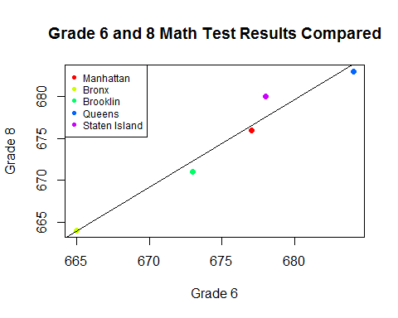

plot(df1$Grade.4.Math~df1$Grade.8.Math, main="Grade 4 and 8 Math Test Results Compared",   
 xlab="Grade 4", ylab = "Grade 8", pch=16, col=as.character(df1$color))  
legend("topleft", pch=16, col=as.character(df1$color), legend=unique(df1$Borough), text.font = 1, cex = 0.75)  
abline(lm(df1$Grade.4.Math~df1$Grade.8.Math), col="black")

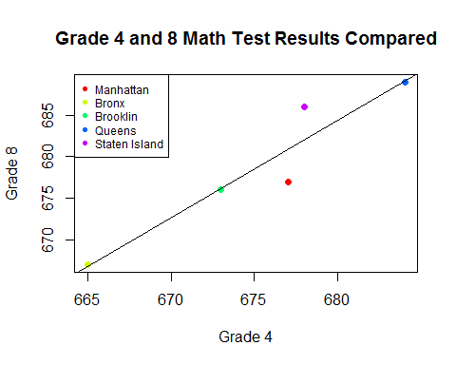

pairs(df1[,c(5:7)], main="Math Test Results: Grades 4,6,& 8", col=as.character(df1$color), pch=16)

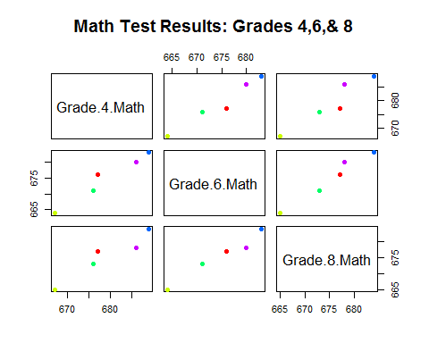

**Multivariate Regression - Grade 4 and 2008 Class Size**

mod.grade4 <- lm(cbind(Grade.4.Language, Grade.4.Math)~Class.Size.2008, data = df1)  
mod.grade4

##   
## Call:  
## lm(formula = cbind(Grade.4.Language, Grade.4.Math) ~ Class.Size.2008,   
## data = df1)  
##   
## Coefficients:  
## Grade.4.Language Grade.4.Math  
## (Intercept) 542.500 562.000   
## Class.Size.2008 4.885 5.000

summary(mod.grade4)

## Response Grade.4.Language :  
##   
## Call:  
## lm(formula = Grade.4.Language ~ Class.Size.2008, data = df1)  
##   
## Residuals:  
## 1 2 3 4 5   
## 6.0385 -11.8462 0.1538 5.2692 0.3846   
##   
## Coefficients:  
## Estimate Std. Error t value Pr(>|t|)   
## (Intercept) 542.500 84.851 6.394 0.00775 **  
## Class.Size.2008 4.885 3.623 1.348 0.27031   
## ---  
## Signif. codes: 0 '***' 0.001 '**' 0.01 '*' 0.05 '.' 0.1 ' ' 1  
##   
## Residual standard error: 8.261 on 3 degrees of freedom  
## Multiple R-squared: 0.3773, Adjusted R-squared: 0.1698   
## F-statistic: 1.818 on 1 and 3 DF, p-value: 0.2703  
##   
##   
## Response Grade.4.Math :  
##   
## Call:  
## lm(formula = Grade.4.Math ~ Class.Size.2008, data = df1)  
##   
## Residuals:  
## 1 2 3 4 5   
## 5 -10 -1 7 -1   
##   
## Coefficients:  
## Estimate Std. Error t value Pr(>|t|)   
## (Intercept) 562.000 78.672 7.144 0.00565 **  
## Class.Size.2008 5.000 3.359 1.489 0.23334   
## ---  
## Signif. codes: 0 '***' 0.001 '**' 0.01 '*' 0.05 '.' 0.1 ' ' 1  
##   
## Residual standard error: 7.659 on 3 degrees of freedom  
## Multiple R-squared: 0.4248, Adjusted R-squared: 0.2331   
## F-statistic: 2.216 on 1 and 3 DF, p-value: 0.2333

**Multivariate Regression - Grade 6 and 2010 Class Size**

mod.grade6 <- lm(cbind(Grade.6.Language, Grade.6.Math)~Class.Size.2010, data = df1)  
mod.grade6

##   
## Call:  
## lm(formula = cbind(Grade.6.Language, Grade.6.Math) ~ Class.Size.2010,   
## data = df1)  
##   
## Coefficients:  
## Grade.6.Language Grade.6.Math  
## (Intercept) 633.4615 629.9615   
## Class.Size.2010 0.9231 1.6731

summary(mod.grade6)

## Response Grade.6.Language :  
##   
## Call:  
## lm(formula = Grade.6.Language ~ Class.Size.2010, data = df1)  
##   
## Residuals:  
## 1 2 3 4 5   
## 3.3846 -5.4615 -1.4615 3.6923 -0.1538   
##   
## Coefficients:  
## Estimate Std. Error t value Pr(>|t|)   
## (Intercept) 633.4615 25.7055 24.643 0.000146 ***  
## Class.Size.2010 0.9231 0.9564 0.965 0.405660   
## ---  
## Signif. codes: 0 '***' 0.001 '**' 0.01 '*' 0.05 '.' 0.1 ' ' 1  
##   
## Residual standard error: 4.362 on 3 degrees of freedom  
## Multiple R-squared: 0.2369, Adjusted R-squared: -0.01741   
## F-statistic: 0.9315 on 1 and 3 DF, p-value: 0.4057  
##   
##   
## Response Grade.6.Math :  
##   
## Call:  
## lm(formula = Grade.6.Math ~ Class.Size.2010, data = df1)  
##   
## Residuals:  
## 1 2 3 4 5   
## 5.8846 -9.4615 -2.4615 6.1923 -0.1538   
##   
## Coefficients:  
## Estimate Std. Error t value Pr(>|t|)   
## (Intercept) 629.962 44.177 14.260 0.000747 ***  
## Class.Size.2010 1.673 1.644 1.018 0.383663   
## ---  
## Signif. codes: 0 '***' 0.001 '**' 0.01 '*' 0.05 '.' 0.1 ' ' 1  
##   
## Residual standard error: 7.496 on 3 degrees of freedom  
## Multiple R-squared: 0.2567, Adjusted R-squared: 0.008954   
## F-statistic: 1.036 on 1 and 3 DF, p-value: 0.3837

**Multivariate Regression - Grade 8 and 2012 Class Size**

mod.grade8 <- lm(cbind(Grade.8.Language, Grade.8.Math)~Class.Size.2012, data = df1)  
mod.grade8

##   
## Call:  
## lm(formula = cbind(Grade.8.Language, Grade.8.Math) ~ Class.Size.2012,   
## data = df1)  
##   
## Coefficients:  
## Grade.8.Language Grade.8.Math  
## (Intercept) 599.259 615.167   
## Class.Size.2012 1.926 2.167

summary(mod.grade8)

## Response Grade.8.Language :  
##   
## Call:  
## lm(formula = Grade.8.Language ~ Class.Size.2012, data = df1)  
##   
## Residuals:  
## 1 2 3 4 5   
## 3.66667 -5.25926 -0.25926 1.88889 -0.03704   
##   
## Coefficients:  
## Estimate Std. Error t value Pr(>|t|)   
## (Intercept) 599.259 32.714 18.318 0.000355 ***  
## Class.Size.2012 1.926 1.175 1.639 0.199757   
## ---  
## Signif. codes: 0 '***' 0.001 '**' 0.01 '*' 0.05 '.' 0.1 ' ' 1  
##   
## Residual standard error: 3.862 on 3 degrees of freedom  
## Multiple R-squared: 0.4724, Adjusted R-squared: 0.2965   
## F-statistic: 2.686 on 1 and 3 DF, p-value: 0.1998  
##   
##   
## Response Grade.8.Math :  
##   
## Call:  
## lm(formula = Grade.8.Math ~ Class.Size.2012, data = df1)  
##   
## Residuals:  
## 1 2 3 4 5   
## 5.5000 -8.6667 -0.6667 6.0000 -2.1667   
##   
## Coefficients:  
## Estimate Std. Error t value Pr(>|t|)   
## (Intercept) 615.167 59.197 10.392 0.0019 **  
## Class.Size.2012 2.167 2.126 1.019 0.3832   
## ---  
## Signif. codes: 0 '***' 0.001 '**' 0.01 '*' 0.05 '.' 0.1 ' ' 1  
##   
## Residual standard error: 6.988 on 3 degrees of freedom  
## Multiple R-squared: 0.2571, Adjusted R-squared: 0.009466   
## F-statistic: 1.038 on 1 and 3 DF, p-value: 0.3832

**Stepwise Regression Grade 4**

lm(Grade.4.Language ~ Class.Size.2008 + Farmers.Markets.Days + Total.Wifi.Hotposts + Total.Libraries + Violent.Crimes+ Property.Crimes + Housing.Starts +  
Total.Businesses + Vocational.Courses, data=df1, direction="both")

## Warning in lm.fit(x, y, offset = offset, singular.ok = singular.ok, ...):  
## extra argument 'direction' is disregarded.

##   
## Call:  
## lm(formula = Grade.4.Language ~ Class.Size.2008 + Farmers.Markets.Days +   
## Total.Wifi.Hotposts + Total.Libraries + Violent.Crimes +   
## Property.Crimes + Housing.Starts + Total.Businesses + Vocational.Courses,   
## data = df1, direction = "both")  
##   
## Coefficients:  
## (Intercept) Class.Size.2008 Farmers.Markets.Days   
## 264.16544 15.85314 0.02528   
## Total.Wifi.Hotposts Total.Libraries Violent.Crimes   
## 0.03437 0.15765 NA   
## Property.Crimes Housing.Starts Total.Businesses   
## NA NA NA   
## Vocational.Courses   
## NA

step(lm(Grade.4.Language ~ Class.Size.2008 + Total.Wifi.Hotposts + Total.Libraries, data=df1, direction="both"))

## Warning in lm.fit(x, y, offset = offset, singular.ok = singular.ok, ...):  
## extra argument 'direction' is disregarded.

## Start: AIC=-15.18  
## Grade.4.Language ~ Class.Size.2008 + Total.Wifi.Hotposts + Total.Libraries  
##   
## Df Sum of Sq RSS AIC  
## <none> 0.05 -15.180  
## - Total.Libraries 1 33.39 33.44 15.501  
## - Total.Wifi.Hotposts 1 176.14 176.19 23.811  
## - Class.Size.2008 1 321.21 321.26 26.814

##   
## Call:  
## lm(formula = Grade.4.Language ~ Class.Size.2008 + Total.Wifi.Hotposts +   
## Total.Libraries, data = df1, direction = "both")  
##   
## Coefficients:  
## (Intercept) Class.Size.2008 Total.Wifi.Hotposts   
## 276.93951 15.34311 0.03433   
## Total.Libraries   
## 0.15743

step(lm(Grade.4.Language + Grade.4.Math ~ Class.Size.2008 + Total.Wifi.Hotposts + Total.Libraries, data=df1, direction="both"))

## Warning in lm.fit(x, y, offset = offset, singular.ok = singular.ok, ...):  
## extra argument 'direction' is disregarded.

## Start: AIC=6.25  
## Grade.4.Language + Grade.4.Math ~ Class.Size.2008 + Total.Wifi.Hotposts +   
## Total.Libraries  
##   
## Df Sum of Sq RSS AIC  
## <none> 3.52 6.250  
## - Total.Libraries 1 162.28 165.80 23.507  
## - Total.Wifi.Hotposts 1 604.83 608.35 30.007  
## - Class.Size.2008 1 1201.27 1204.79 33.423

##   
## Call:  
## lm(formula = Grade.4.Language + Grade.4.Math ~ Class.Size.2008 +   
## Total.Wifi.Hotposts + Total.Libraries, data = df1, direction = "both")  
##   
## Coefficients:  
## (Intercept) Class.Size.2008 Total.Wifi.Hotposts   
## 600.53259 29.67126 0.06362   
## Total.Libraries   
## 0.34708

**Stepwise Regression Grade 6**

lm(Grade.6.Language ~ Class.Size.2010 + Farmers.Markets.Days + Total.Wifi.Hotposts + Total.Libraries + Violent.Crimes+ Property.Crimes + Housing.Starts +  
Total.Businesses + Vocational.Courses, data=df1, direction="both")

## Warning in lm.fit(x, y, offset = offset, singular.ok = singular.ok, ...):  
## extra argument 'direction' is disregarded.

##   
## Call:  
## lm(formula = Grade.6.Language ~ Class.Size.2010 + Farmers.Markets.Days +   
## Total.Wifi.Hotposts + Total.Libraries + Violent.Crimes +   
## Property.Crimes + Housing.Starts + Total.Businesses + Vocational.Courses,   
## data = df1, direction = "both")  
##   
## Coefficients:  
## (Intercept) Class.Size.2010 Farmers.Markets.Days   
## 616.25303 1.43066 -0.21449   
## Total.Wifi.Hotposts Total.Libraries Violent.Crimes   
## 0.01713 0.08130 NA   
## Property.Crimes Housing.Starts Total.Businesses   
## NA NA NA   
## Vocational.Courses   
## NA

step(lm(Grade.6.Language ~ Class.Size.2010 + Total.Wifi.Hotposts + Total.Libraries, data=df1, direction="both"))

## Warning in lm.fit(x, y, offset = offset, singular.ok = singular.ok, ...):  
## extra argument 'direction' is disregarded.

## Start: AIC=6.2  
## Grade.6.Language ~ Class.Size.2010 + Total.Wifi.Hotposts + Total.Libraries  
##   
## Df Sum of Sq RSS AIC  
## <none> 3.490 6.2023  
## - Total.Libraries 1 9.312 12.802 10.7007  
## - Total.Wifi.Hotposts 1 45.578 49.068 17.4189  
## - Class.Size.2010 1 70.513 74.003 19.4733

##   
## Call:  
## lm(formula = Grade.6.Language ~ Class.Size.2010 + Total.Wifi.Hotposts +   
## Total.Libraries, data = df1, direction = "both")  
##   
## Coefficients:  
## (Intercept) Class.Size.2010 Total.Wifi.Hotposts   
## 551.14416 3.59436 0.01747   
## Total.Libraries   
## 0.08314

step(lm(Grade.6.Language + Grade.6.Math ~ Class.Size.2010 + Total.Wifi.Hotposts + Total.Libraries, data=df1, direction="both"))

## Warning in lm.fit(x, y, offset = offset, singular.ok = singular.ok, ...):  
## extra argument 'direction' is disregarded.

## Start: AIC=15.92  
## Grade.6.Language + Grade.6.Math ~ Class.Size.2010 + Total.Wifi.Hotposts +   
## Total.Libraries  
##   
## Df Sum of Sq RSS AIC  
## <none> 24.39 15.925  
## - Total.Libraries 1 66.55 90.95 20.504  
## - Total.Wifi.Hotposts 1 340.37 364.77 27.449  
## - Class.Size.2010 1 532.55 556.95 29.565

##   
## Call:  
## lm(formula = Grade.6.Language + Grade.6.Math ~ Class.Size.2010 +   
## Total.Wifi.Hotposts + Total.Libraries, data = df1, direction = "both")  
##   
## Coefficients:  
## (Intercept) Class.Size.2010 Total.Wifi.Hotposts   
## 1.039e+03 9.878e+00 4.773e-02   
## Total.Libraries   
## 2.223e-01

**Stepwise Regression Grade 8**

lm(Grade.8.Language ~ Class.Size.2012 + Farmers.Markets.Days + Total.Wifi.Hotposts + Total.Libraries + Violent.Crimes+ Property.Crimes + Housing.Starts +  
Total.Businesses + Vocational.Courses, data=df1, direction="both")

## Warning in lm.fit(x, y, offset = offset, singular.ok = singular.ok, ...):  
## extra argument 'direction' is disregarded.

##   
## Call:  
## lm(formula = Grade.8.Language ~ Class.Size.2012 + Farmers.Markets.Days +   
## Total.Wifi.Hotposts + Total.Libraries + Violent.Crimes +   
## Property.Crimes + Housing.Starts + Total.Businesses + Vocational.Courses,   
## data = df1, direction = "both")  
##   
## Coefficients:  
## (Intercept) Class.Size.2012 Farmers.Markets.Days   
## 467.81264 6.25424 0.14259   
## Total.Wifi.Hotposts Total.Libraries Violent.Crimes   
## 0.01291 0.02855 NA   
## Property.Crimes Housing.Starts Total.Businesses   
## NA NA NA   
## Vocational.Courses   
## NA

step(lm(Grade.8.Language ~ Class.Size.2012 + Total.Wifi.Hotposts + Total.Libraries, data=df1, direction="both"))

## Warning in lm.fit(x, y, offset = offset, singular.ok = singular.ok, ...):  
## extra argument 'direction' is disregarded.

## Start: AIC=-3.75  
## Grade.8.Language ~ Class.Size.2012 + Total.Wifi.Hotposts + Total.Libraries  
##   
## Df Sum of Sq RSS AIC  
## <none> 0.477 -3.7454  
## - Total.Libraries 1 1.971 2.449 2.4307  
## - Total.Wifi.Hotposts 1 39.903 40.380 16.4445  
## - Class.Size.2012 1 83.501 83.979 20.1056

##   
## Call:  
## lm(formula = Grade.8.Language ~ Class.Size.2012 + Total.Wifi.Hotposts +   
## Total.Libraries, data = df1, direction = "both")  
##   
## Coefficients:  
## (Intercept) Class.Size.2012 Total.Wifi.Hotposts   
## 519.88589 4.51666 0.01400   
## Total.Libraries   
## 0.03734

step(lm(Grade.8.Language + Grade.8.Math ~ Class.Size.2012 + Total.Wifi.Hotposts + Total.Libraries, data=df1, direction="both"))

## Warning in lm.fit(x, y, offset = offset, singular.ok = singular.ok, ...):  
## extra argument 'direction' is disregarded.

## Start: AIC=-21.44  
## Grade.8.Language + Grade.8.Math ~ Class.Size.2012 + Total.Wifi.Hotposts +   
## Total.Libraries  
##   
## Df Sum of Sq RSS AIC  
## <none> 0.01 -21.439  
## - Total.Libraries 1 47.75 47.76 17.284  
## - Total.Wifi.Hotposts 1 270.06 270.07 25.946  
## - Class.Size.2012 1 513.87 513.88 29.163

##   
## Call:  
## lm(formula = Grade.8.Language + Grade.8.Math ~ Class.Size.2012 +   
## Total.Wifi.Hotposts + Total.Libraries, data = df1, direction = "both")  
##   
## Coefficients:  
## (Intercept) Class.Size.2012 Total.Wifi.Hotposts   
## 993.89737 11.20461 0.03642   
## Total.Libraries   
## 0.18379