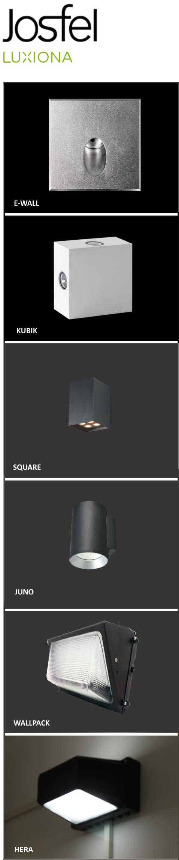

**Familia «nombreFamiliaRetilap»**

EWALL

|  |  |  |  |  |  |  |  |
| --- | --- | --- | --- | --- | --- | --- | --- |
| ITEM CODE | SUBFAMILY NAME | COLOR | REAL POWER | REAL LM | LUMEN EFFICIENCY | BEAM ANGLE | COLOR TEMPERATURE |
|  |  |  |  |  |  |  |  |

KUBIK

|  |  |  |  |  |  |  |  |
| --- | --- | --- | --- | --- | --- | --- | --- |
| ITEM | SUBFAMILY | COLOR | REAL POWER | REAL LM | LUMEN EFFICIENCY | BEAM ANGLE | COLOR TEMPERATURE |
|  |  |  |  |  |  |  |  |

|  |
| --- |
|  |