**Overview**

Cloud Portal Hub is an ecommerce-based company. They currently have an Azure subscription and an Azure tenant in place.

**Current Environment**

* The company has an ecommerce application that is hosted in Azure. The order information for this application is stored as JSON documents in a Cosmos DB account. The data must be queried using Structured Query Language.
* Any changes to the order data must be reflected immediately across all partitions.
* All reads that are carried out on the order data must fetch the most recent writes
* There are other Azure based resources that are made available to external partners
* The external partners would use their own credentials and authenticate with the company’s identity management solution.
* The storage of the ecommerce application settings is maintained via the use of the Azure Key vault
* The ecommerce application must use Azure App Service authentication and Azure Active Directory

The company has another application named “productionapp” that is deployed via an Azure Kubernetes cluster. The Architecture diagram for the application is given below

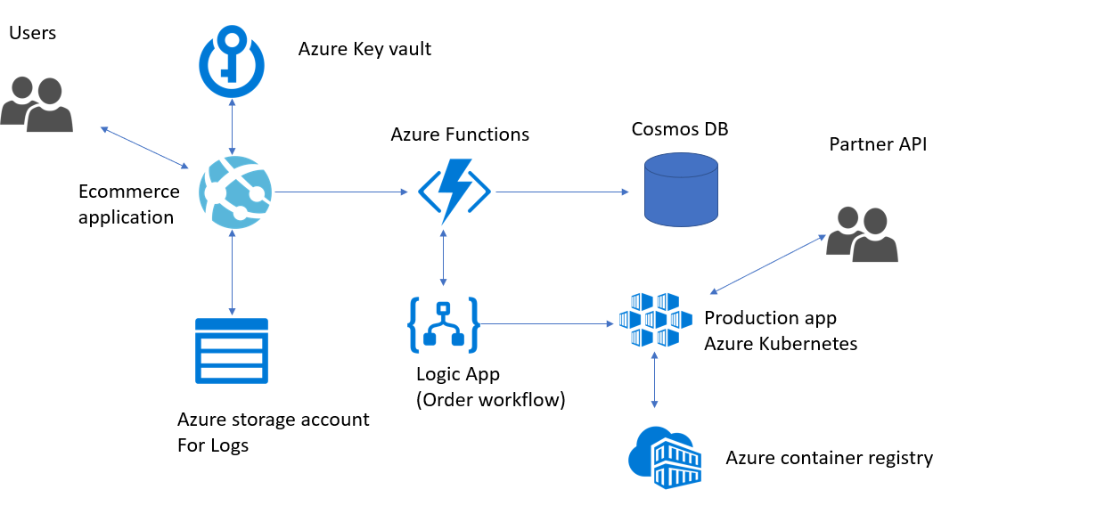

* All images for the Kubernetes cluster would be stored in the Azure container registry
* Monitoring should be enabled for Kubernetes cluster

The Azure Logic App Order workflow also interfaces with an external API. The API call sometimes fails due to communication timeouts. The timeouts occurs after 10 seconds. The external API should only receive up to 5 connection attempts within one minute.

The Cosmos DB account contains a collection that stores all order-based data. One of the records in the collection is shown below

{

"id":"1",

"customers":[

{

"familyName":"Dsouza",

"giveName":"John",

"customerid":5

}

],

"line_items":[

{

"quantity":1,

"id":8,

"price":99.99,

"productid":6,

"name":"ProductA",

"tax-items":[

{

"title":"State",

"price":"3.8",

"rate":"0.08"

}

]

}

],

"address":{

"city":"NewYork"

}

}

Question 1:

You have to retrieve all order line items sorted alphabetically by the city.

How should you complete the below statement?

[Larger image](javascript:void(0))

[[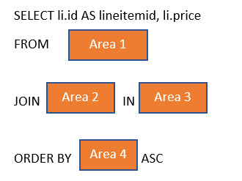](javascript:void(0))](javascript:void(0))

Which of the following would go into Area 1?

Answer: O.Order

Which of the following would go into Area 2?

Answer : li

Which of the following would go into Area 3?

O.line_items

Which of the following would go into Area 4?

O.address.city

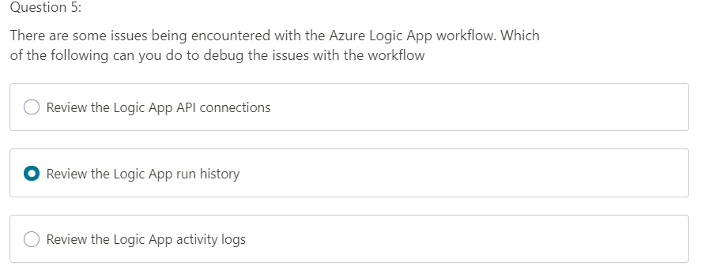

Question 6:

You have to update the Azure Logic App OrderWorkflow to work with the issues encountered with the external API.

You have to complete the below section for this requirement

[Larger image](javascript:void(0))

[[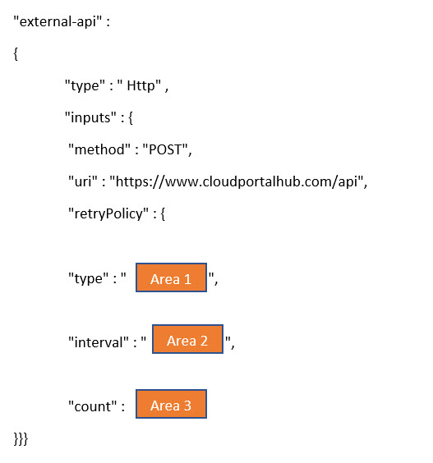](javascript:void(0))](javascript:void(0))

Which of the following will go into Area ?

Type = fixed

Interval=10

Count=5