**Overview**

CloudPoralHub currently has a set of services that they host in their on-premises data center. They want to migrate their workloads onto Azure. They currently have the following infrastructure in their on-premises data center

* A Windows Server 2016 machine that hosts BizTalk Server 2016. This machine runs the following workflows
  + Ocean Transport - This gathers information about containers that arrives at various shipping ports.
  + Inland Transport - This gathers information about various inland operations.
* The virtual machine supports the following REST API’s
  + Container API – This provides container information about the containers such as the weight and contents of the container
  + Location API – This gives information on the location of the shipping ports
  + Shipping API – This gives shipping information that can be used on a shipping web site
* Currently all of the data resides in a Mongo DB database.
* The shipping web site is available via http://cloudportalhub.com

The company is planning for the following solution to migrate onto Azure

* The virtual machine will be migrated onto an Azure virtual machine using Azure Site Recovery

The complete architecture is given below

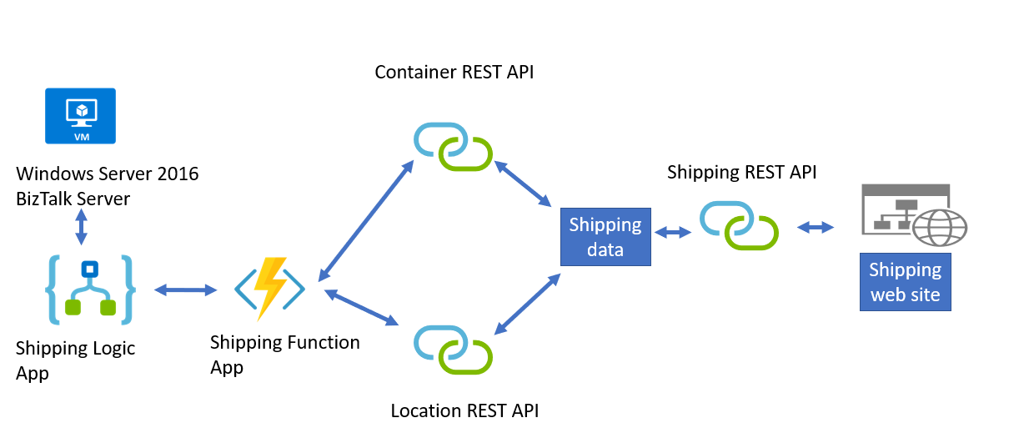

The shipping logic app must meet the following requirements

* It must support industry-standard protocol X12 message formats for various messages
* It must be able to secure resources to the corporate VNet and use dedicated storage resources with a fixed costing model.
* All on-premises connectivity must be maintained to support legacy applications

The shipping Azure function app must implement secure endpoints by using app-level security and include Azure Active Directory

The REST API’s must meet the following requirements

* Secure resources to a corporate VNet
* Automatically scale capacity on peak demand
* Minimize costs

The shipping data must be migrated to Azure with minimum costs and downtime.

The following issues are encountered when the resources have been migrated to Azure

* The Azure virtual machine is showing high network latency, jitter and high CPU utilization.
* The VM is critical and has not been backed up in the past
* The VM must enable a quick restore from a 7-day snapshot and also include the option of a local restore of disks in case of failure