Response with Time Delay – step – ramp – sin

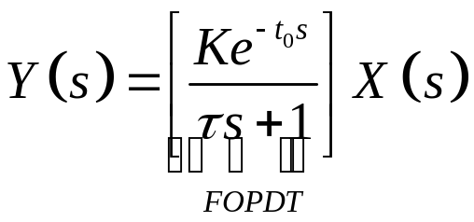

The term in brackets is an important transfer function used to approximate the response of higher-order processes. We call it a first-order-plus-dead-time (FOPDT) transfer Function.

The effect of the time delay on the three responses presented in this section is as follows:

Step response

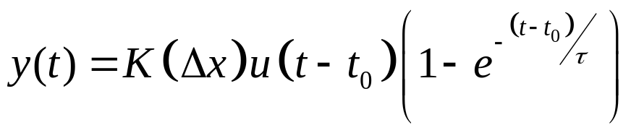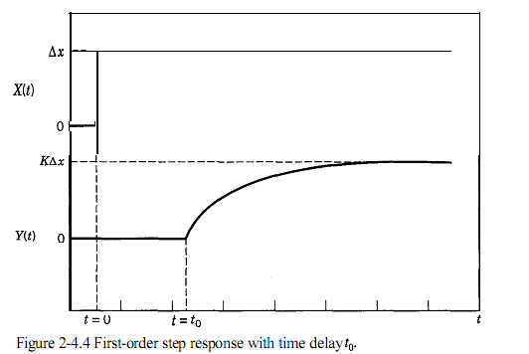

Ramp response
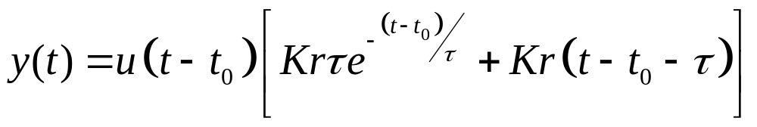
Note that the effect of the time delay in the long-term response is that the output ramp lags the input ramp by the sum of the time delay and the time constant.

Sinusoidal response

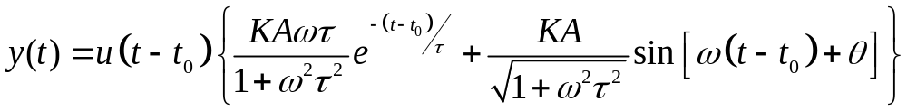

The only effect of the time delay on the long-term response is to increase the phase lag by omega and t0,. This increase in phase lag is proportional to the frequency of the input sine wave. The phase lag 0 is the same as in Eq. 2-4.9.

