2-4.5 Response of a Lead-Lag Unit

A device that is commonly used for dynamic compensation in feedforward controllers, known as a lead-lag unit, has the following transfer function:

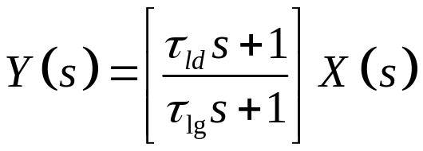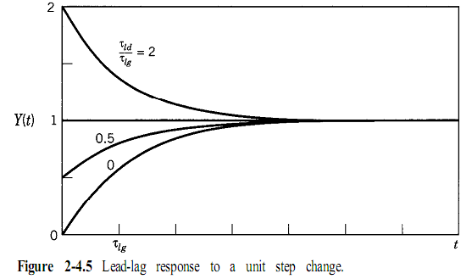

Step Response

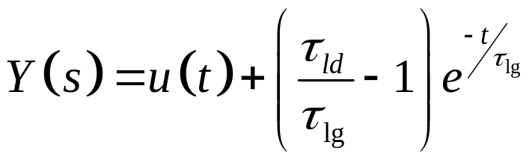

Ramp Response
Impulse Response
Pulse Response

