Response of second-order systems

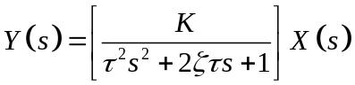

For The Response Is
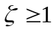 overdamped = monotonic and stable
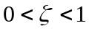 underdamped = oscillatory and stable
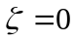 undamped = sustained oscillations
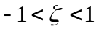 unstable = growing oscillations
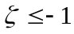 run-away = monotonic unstable

The case of l = 1 is sometimes called critically damped, but this is only the borderline case. Its response is monotonic and stable, just like the overdamped response.

For our purposes, we need consider only the two cases of real and complex roots, which we will call overdamped and underdamped, respectively. The following sections present the specific response equations for step, ramp, and sinusoidal inputs for both of these cases.

Overdamped Responses

Step Response
Ramp Response
Sinusoidal Response

