Linearization  2-6.1 Linearization of Functions of One Variable  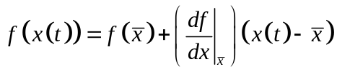  This is the basic linearization formula.  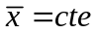  The right hand side of the equation is linear in the variable x(t) | 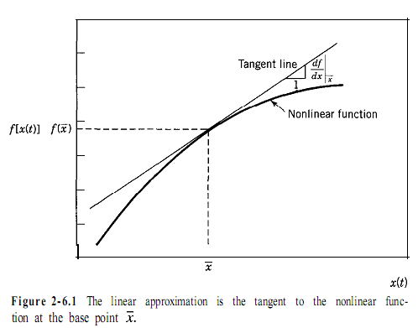
Taylor serie:

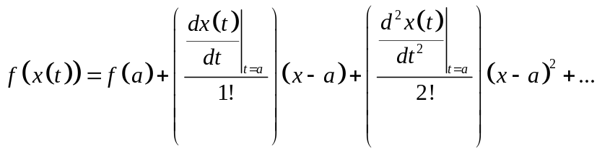

A es el punto alrededor donde se realizaraá la linealización

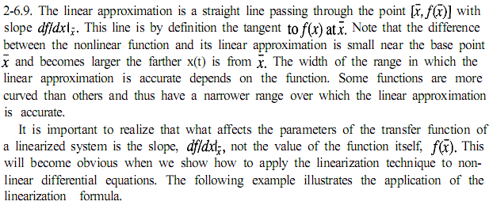

Example

Linearize the arrhenius equation for the temperature dependence of chemical reaction rate coefficients. For a reaction with a coefficient 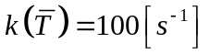and an energy of activation 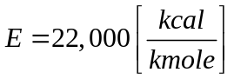, estime the error in the slope of the function in the range 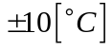 around 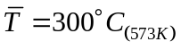

Apply the linearization formula, Eq. 2-6.9, to Eq. 2-6.6.
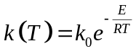

Linearization:
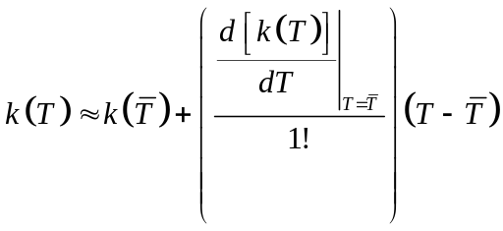
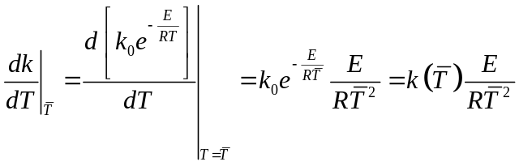
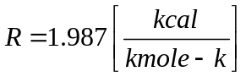
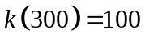
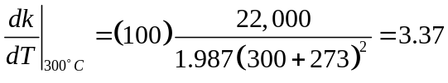

And the line approximation of the fuction is:
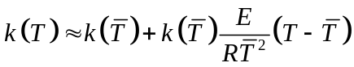

recta tangente al punto T testada.

 |  | Linear approximation | Original | Absolute error | Relative error
T=290°C | 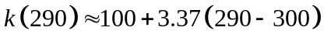 | 66.3 | 70.95 | 6.55% | 4.65
T=300°C | 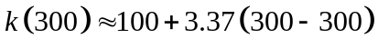 | 100 | 100 | 0 | 0
T=310°C | 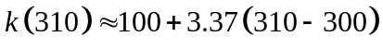 | 133.7 | 139.3 | 4.020% | 5.6%

However, the error of 35% in the parameters is usually satisfactory for many control system calculations.

