Dead time processes

In processes involving the movement of mass, deadtime is a significant factor in the process dynamics. It is a delay in the response of a process after some variable is changed, during which no information is known about the new state of the process. It may also be known as the transportation lag or time delay.

Deadtime is the worst enemy of good control and every effort should be made to minimize it. All process response curves are shifted to the right by the presence of deadtime in a process (Figure 4.9). Once the deadtime has passed, the process starts responding with its characteristic speed, called the process sensitivity.

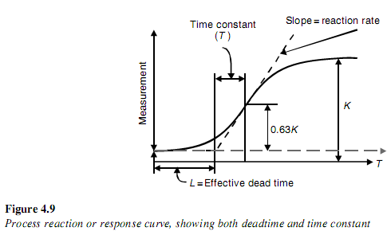

Reduction of deadtime

The aim of good control is to minimize deadtime and to minimize the ratio of deadtime to the time constant. The higher this ratio, the less likely that the control system will work properly.
Deadtime can be reduced by reducing transportation lags, which can be done by increasing the rates of pumping or agitation, reducing the distance between the measuring instrument and the process, etc.

Dead time or transport delay

For a pure dead-time process, whatever happens at the input is repeated at the output өd time units later, where өd is the dead time. This would be seen, for example, in a long pipeline if the liquid blend was changed at the input or the liquid temperature was changed at the input and the effects were not seen at the output until the travel time in the pipe has expired.

In practice, the mathematical analysis of uncontrolled processes containing time delays is relatively simple, but a time delay, or a set of time delays, within a feedback loop tends to lend itself to very complex mathematics.
In general, the presence of time delays in control systems reduces the effectiveness of the controller. In well-designed systems the time delays (dead times) should be kept to the minimum.

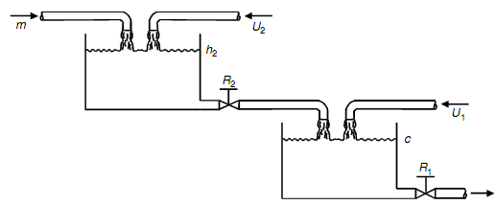
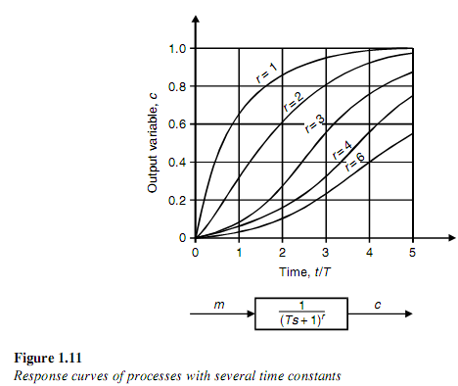
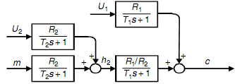

Effect of Dead Time

We have seen how the direct substitution method allows us to study the effect of various loop parameters on the stability of the feedback control loop. Unfortunately, the method fails when any of the blocks on the loop contains a dead-time (transportation lag or time delay) term. This is because the dead time introduces an exponential function of the Laplace transform variable into the characteristic equation. This means that this equation is no longer a polynomial, and the methods we have learned in this section no longer apply. An increase in dead time tends to reduce the ultimate loop gain very rapidly. This effect is similar to the effect of increasing the nondominant time constants of the loop in that it is relative to the magnitude of the dominant time constant. We will study the exact effect of dead time on loop stability when we consider the method of frequency response in Chapter 9.

We must point out that the exchanger we have used in this chapter is a distributed-parameter system; that is, the temperature of the process fluid is distributed throughout the exchanger. The transfer functions for such systems usually contain a least one dead-time term, which, for simplicity, we have ignored.

An estimate of the ultimate gain and frequency of a loop with dead time may sometimes be obtained by using an approximation to the dead-time transfer function. A popular approximation is the first-order Padé approximation, which is given by:

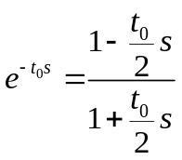

where t₀, is the dead time. More accurate higher-order approximations are also available, but they are too complex to be practical. The following example illustrates the use of the Padé approximation with the direct substitution method.

Example:

ULTIMATE GAIN AND FREQUENCY OF FIRST-ORDER PLUS DEAD-TIME PROCESS

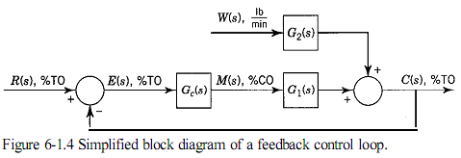

Principes and practice of automatic process control 2E
DEAD TIME

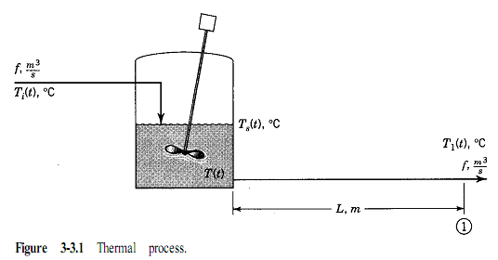

Considere the process shown. We are interested in knowing how T(t) respond to changes in inlet and sorrounding temperatures.

- The pipe between the tank and point 1 is well insulated.
- Second, the flow of liquid through the pipe is ideal plug flow (highly turbulent) with no energy diffusion or dispersion so that there is essentially no backmixing of the liquid in the pipe.

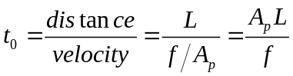
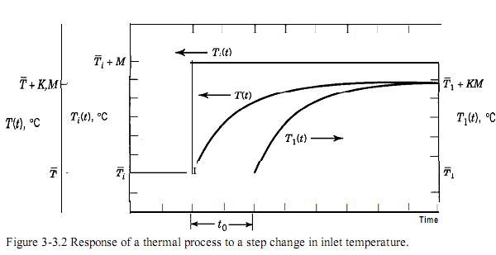

Different physical variables travel at different velocities:
- Electric voltage and current travel at the speed of light: 300,000 km/s, or
- 984,106 ft/s.
- Liquid flow and pressure travel at the speed of sound in the fluid: 340 m/s, or
- ft/s.
- Temperature, composition, and other fluid properties travel at the velocity of the
- fluid: typically, up to 5 m/s (15 ft/s) for liquids and 60 m/s (200 ft/s) for gases.
- Solid properties travel at the velocity of the solid, such as coal in a conveyor, cake in a filter bed, and paper in a paper machine.

From this information, we can see that for the distances typical of industrial process control systems, pure dead time is significant only for temperature, composition, and other fluid and solid properties that are propagated through space by the moving fluid or solid.

Even when pure dead time (dead time due to transportation) is negligible relative to the process time constant, the response of many processes may appear to exhibit dead time due to the combination of several first-order processes in series, as we shall see in Chapters 4 and 6.

This pseudo-dead time cannot be easily evaluated from fundamental principles and must be obtained empirically by approximation of the process response. Methods to carry out such empirical evaluation will be presented in Chapter 7.

Because dead time is an integral part of processes, it must be accounted for in the transfer functions. Equation 2-1.8 indicates that the Laplace transform of a delayed function is equal to the Laplace transform of the nondelayed function times the term e^{-t}₀^{s}

Before concluding this section, we must stress that one of the worst things that can
happen to a feedback control loop is a significant amount of dead time in the loop. The
performance of feedback control loops is severely affected by dead time, as we will see
in Chapters 6,8, and 9. Thus processes and control systems should be designed to keep
the dead time to a minimum. Some steps we can take to minimize dead time include
putting the measurements as close to the equipment as possible, selecting rapidly re-

