3-5 Gas process example (incomplete)

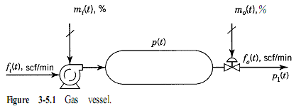

Consider the gas vessel shown in Fig. 3-5.1. A fan blows air into a tank, and from the tank the air flows out through a valve. For purposes of this example, let us suppose that the air flow delivered by the fan is given by:

air flow delivered by the fan is given by:  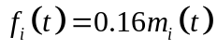  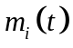: signal to fan %  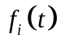: gas flow in scf/min, | The flow through the valve is expressed by 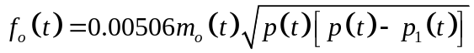  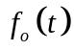: gas flow, scf/min  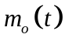: signal to valve, %  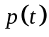: pressure in tank, psia  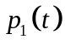: downstream pressure from valve, psia
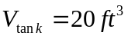  Process ocurrs iso-thermally at 60°F | Condiciones iniciales de estado estable son:  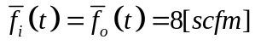  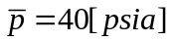  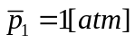  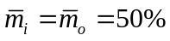

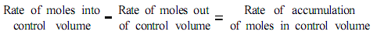

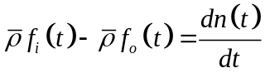 | : molal density of gas at standard conditions, 0.00263  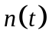: moles of gas in tank, lbmoles  1 eq.  3 unknown variables 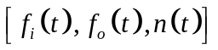
2 eq.
3 unknown variables
3 eq.
4 unknown variables 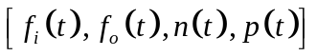
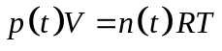  → 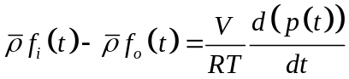 3eq,3unk | Because the pressure in the tank is low, the ideal gas equation of state can be used  to relate the moles in the tank to the pressure.  4 eq  4 unknown variables

The set of Eqs. 3-5.1 through 3-5.4 constitutes the mathematical model for this process. The solution of this set of equations describes, considering the assumptions taken, how the pressure in the tank (the output) responds to changes in m,(t), m,(t), and p,(t) (the inputs). | So far we have completed the first step of the procedure, outlined at the end of Section 3-2. Before proceeding to the second step, we must realize that the expression forf,(t), Eq. 3-5.3, is a nonlinear equation. The Laplace transformation can be applied only to linear equations. Thus, before continuing to the second step, we must linearize all the nonlinear terms. This linearization is done using Taylor Series expansion as presented in Chapter 2.
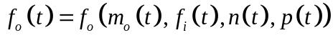 | We have to linearize ¡¡¡¡¡

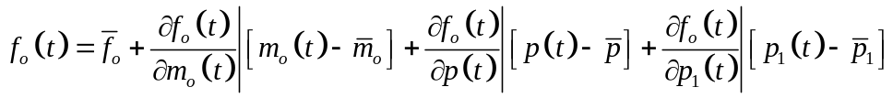
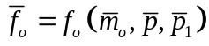

We can now proceed with the next two steps of the procedure, which call for writing the steady-state equations, subtracting them from their respective counterparts, and defining the required deviation variables. First we write a steady-state mole balance around the tank. | 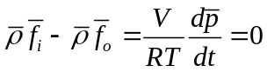
Subtracting this equation from Eq. 3-5.10 gives | 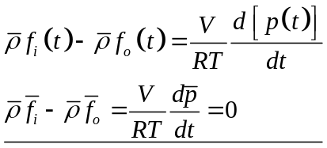  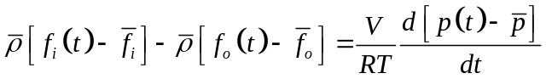
Defining the following deviation variables: | 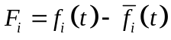  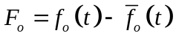  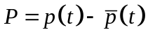
 | 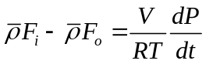
Writing the steady-state equation for the fan and subtracting it from Eq. 3-5.2 give | 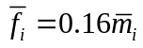  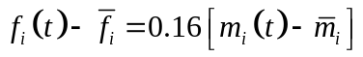  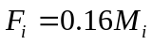
 | 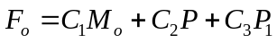
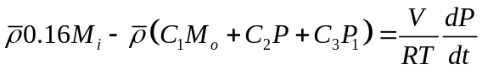
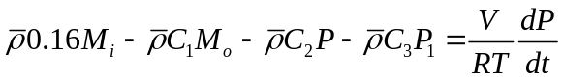

taking the Laplace transform and rearranging, yield | 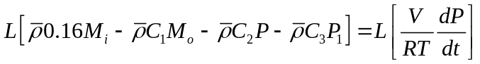  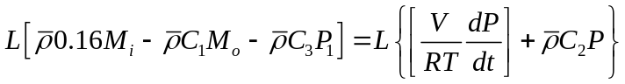  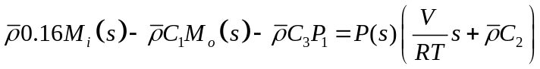  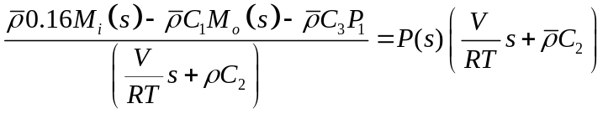  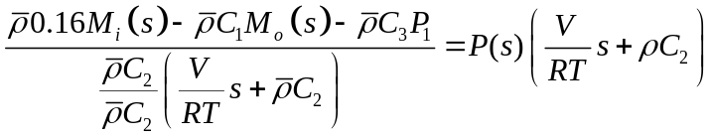  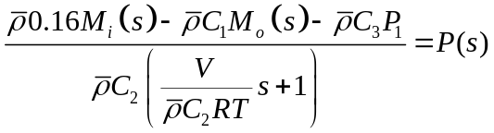  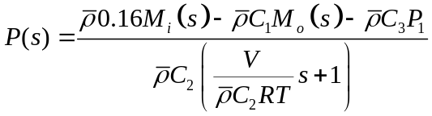
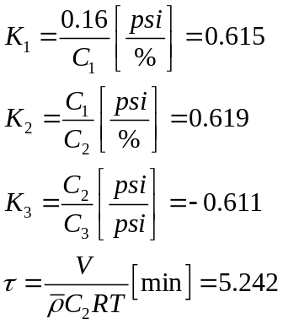 | 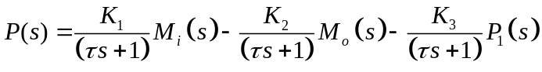
 | By superposition:  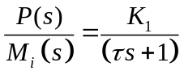  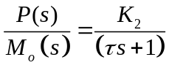  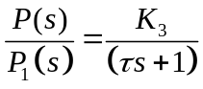 | 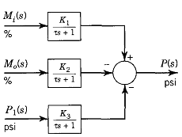  OJO con K3

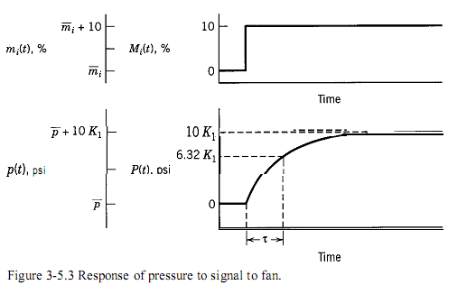

At this point, we should reformulate the procedure for obtaining the transfer functions. This is necessary because we now realize that linearization of nonlinear terms is an important step in the procedure.

- Write the set of unsteady-state equations that describes the process. This is called modeling.
- Linearize the model if necessary.
- Write the steady-state equations at the initial conditions.
- Subtract the two sets of equations, and define the deviation variables.
- Obtain the Laplace transform of the linear model in deviation variables.
- Obtain the transfer functions by solving the Laplace transform explicitly for the transformed output variable(s).

