3 Firts order dynamic System

The modeling of industrial processes usually starts with a balance of a conserved quantity: mass or energy. The balance can be written as:

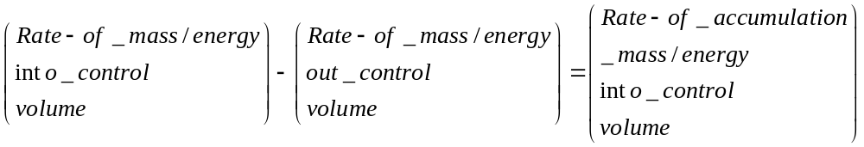

In processes where chemical reactions are not present, the moles are also conserved. Thus in these processes, we may substitute the term moles for mass in the balance equation.

In writing these balances, and all other auxiliary equations, we call on our knowledge of many areas of process engineering, such as thermodynamics, heat transfer, fluid flow, mass transfer, and reaction engineering. This makes the modeling of industrial processes most interesting and challenging!

