4-1.1 Noninteracting Level Process – tank – pump

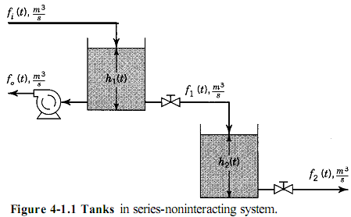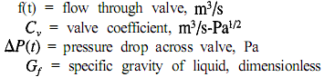
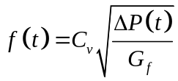  Because the tanks are open to the  atmosphere and the valves discharge  to atmospheric pressure, the pressure  drop across each valve is given by:  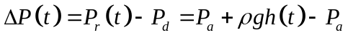  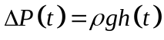  Asi la ecuacion de la valvula es:  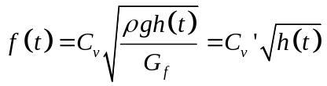  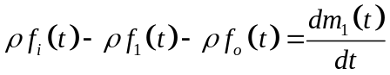  M1(t) es la masa acumulada en el tanque 1  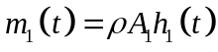  Sustituyendo:  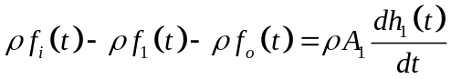  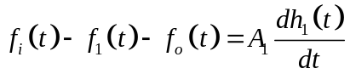  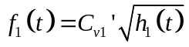 | Sustituyendo:  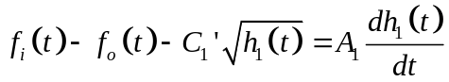  Para el segundo tanque:  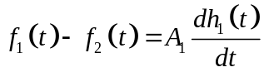  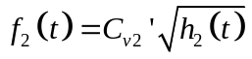  Linealizando:  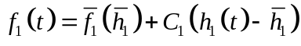  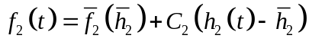  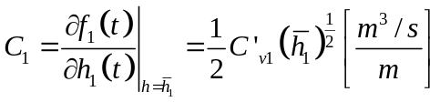  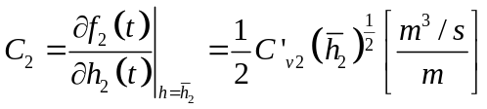  These equations provide a set of linea equations that describes the process around the linearization values h1 tasted and h2 tested  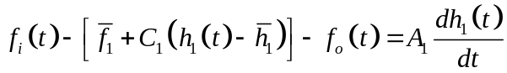  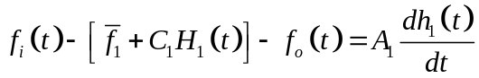  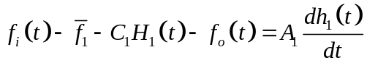

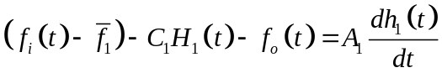
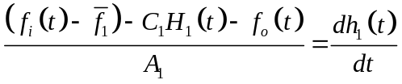
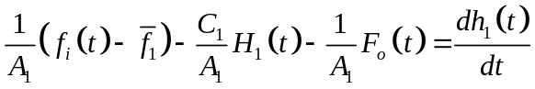

Definiendo:

 