4-1.1 Noninteracting Level Process

Consider the set of tanks shown in Fig. 4-1.1. In this process all the tanks are open to the atmosphere, and the temperature is constant. The openings of the valves remain constant, and the flow of liquid through the valves is given by  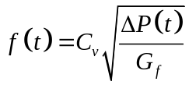 | 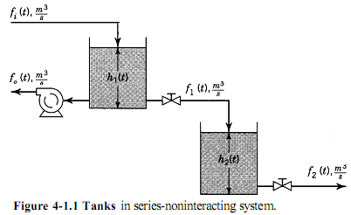
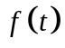: flow through valve, m3/s
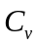: valve coefficient, m3/sPa1/2
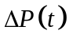: pressure drop across valve, Pa.
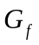: specific gravity of liquid, dimensionless
Because the tanks are open to the atmosphere and the valves discharge to atmospheric pressure, the pressure drop across each valve is given by | 