4-2 Interactive systems

Interacting systems are more frequently encountered in industry than noninteracting systems; this section presents three examples. The differences in dynamic response between the noninteracting and interacting systems are also presented.

Let us rearrange the tanks of Fig. 4-1.1 to result in the new process shown in Fig. 4-2.1. In this case the pressure drop, AP(t), across the valve between the two tanks is given by:
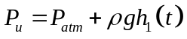
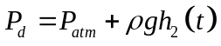
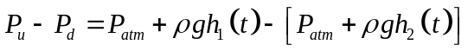
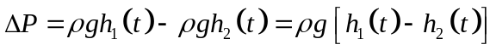
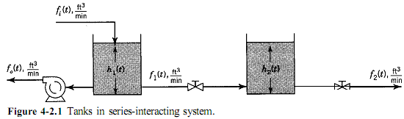
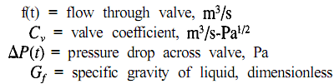
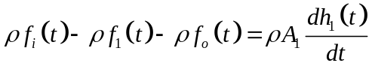
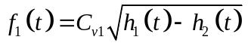
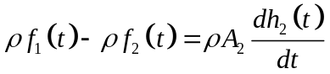
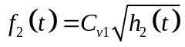 desprecia la presión atmosférica
Linealizando f1 y f2:  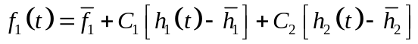  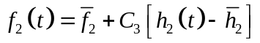  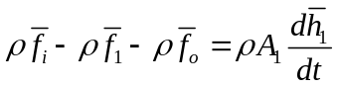  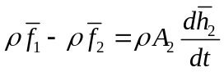 | 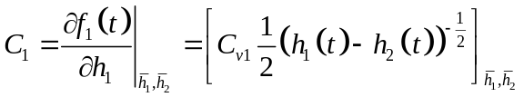  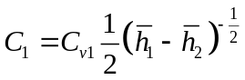  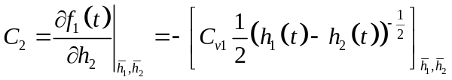  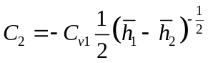
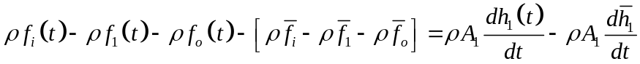
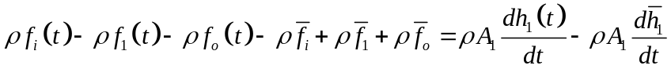
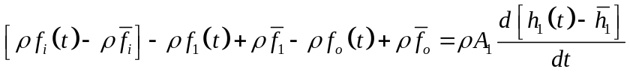
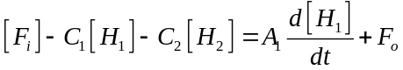
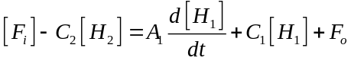
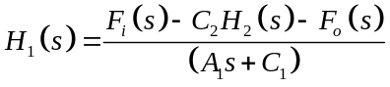
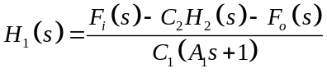
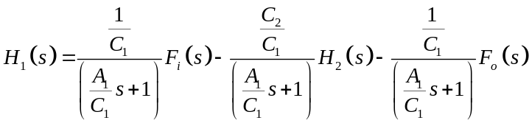
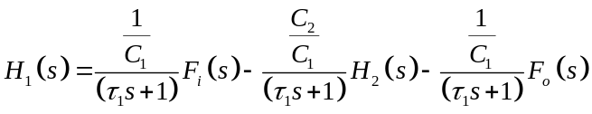
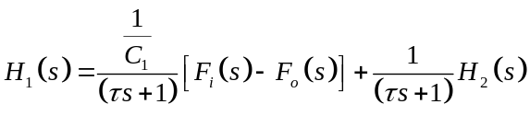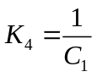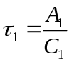
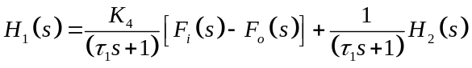

Para el tanque 2
Restando:
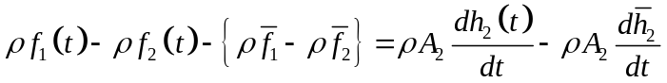
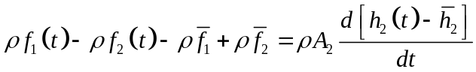

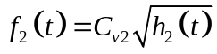
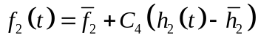
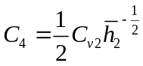
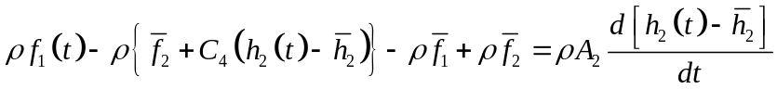
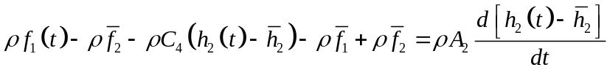
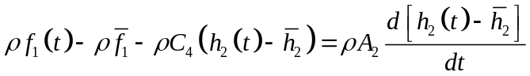

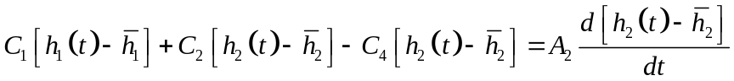
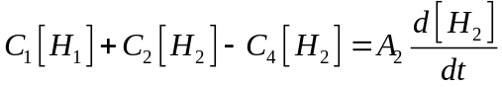
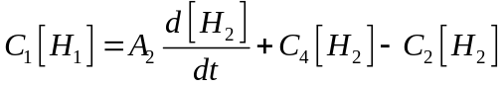
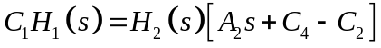
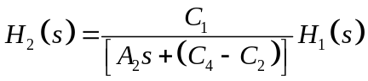
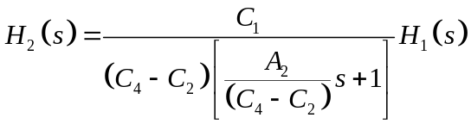
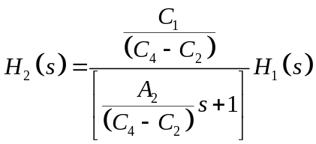
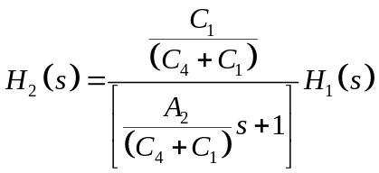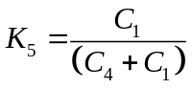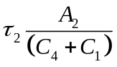

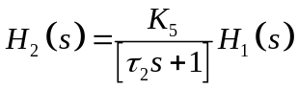

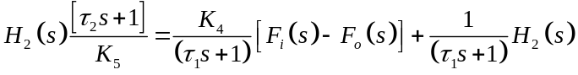
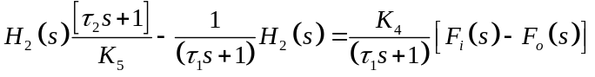
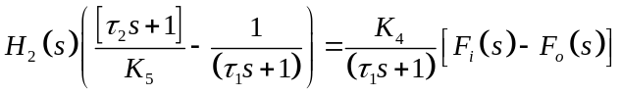
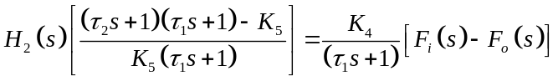

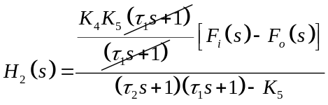

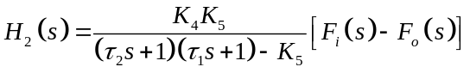 desde aqui podemos identificar una realimentacion positiva
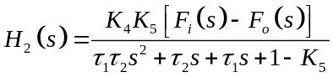
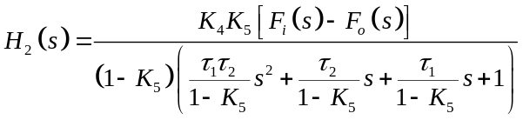

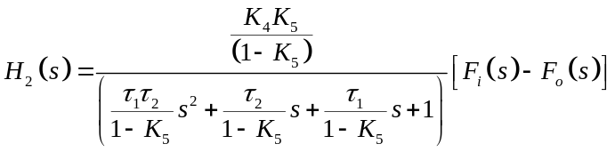

Por superposición:  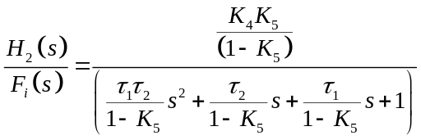  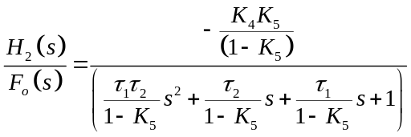 | 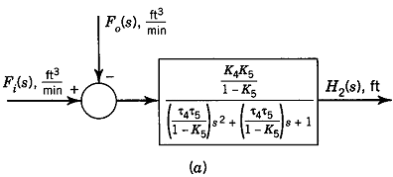

Otra manera mas corta de realizarlo es
Mediante reconocer una realimentacion
Positiva
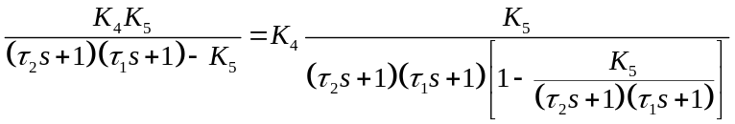
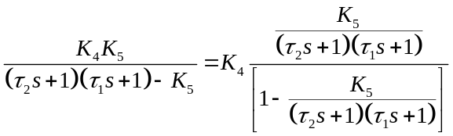
Aqui vemos una realimentacion positiva:

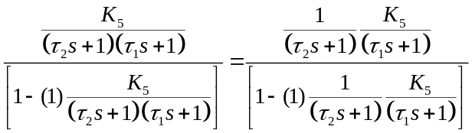

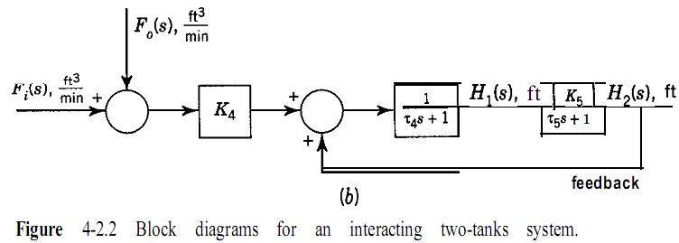

H2(s) is another input to obtain H,(s), as indicated by the “feedback path.” Oftentimes, we referred to this type of system as “interacting lags.”

At this time, there are several things we can learn by comparing the transfer functions of the interacting and noninteracting systems. Consider Fig. 4-2.3, which shows a block diagram of a noninteracting system and one of an interacting system. For the noninteracting system, the transfer function is:  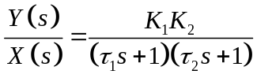  As presented in Section 2-5, the “effective” time constants are the negatives of the reciprocals of the roots of the denominator of the transfer function. For the foregoing transfer function, the effective time constants are equal to the individual values; that is, 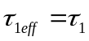, 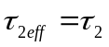 | 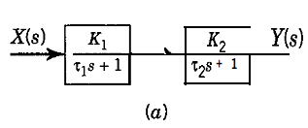
For the interacting system, the transfer function is  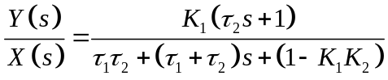 | 