4-2.2 Thermal Tanks with Recycle

Consider the process shown in Fig. 4-2.4. This process is essentially the same one described in Section 4-1.2 except that a recycle stream to the first tank has been added.  Let us suppose that this recycle stream is a constant 20% of the total flow out from the process. In addition, let us accept the same assumptions as in Section 4-1.2.  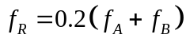  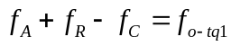  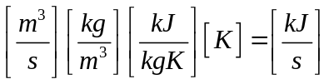 | 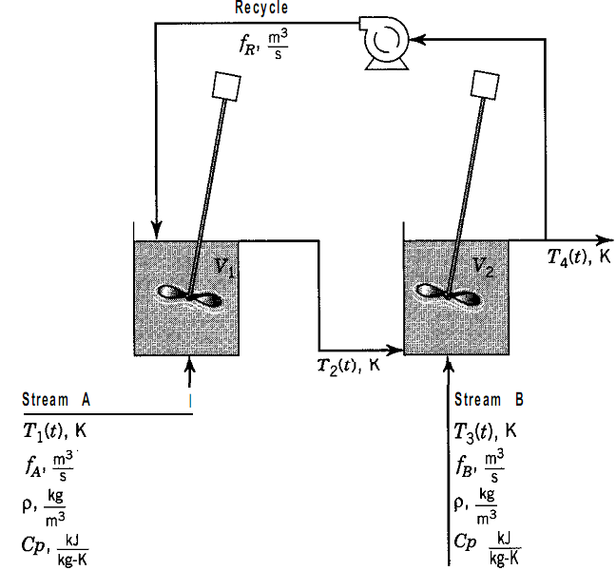
Lets write an unsteady-state energy balance on the contents of the first tank:
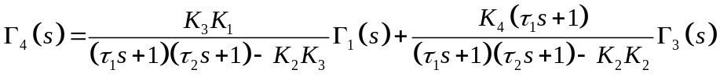
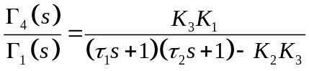 | 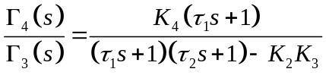
Figure 4-2.5 shows two different ways to draw the block diagram. Figure 4-2.5a is developed by chaining Eqs. 4-2.14 and 4-2.15. Figure 4-2.5b is the graphical representation of Eq. 4-2.16. The feedback path in Fig. 4-2.5a shows graphically the interactive nature of this process.
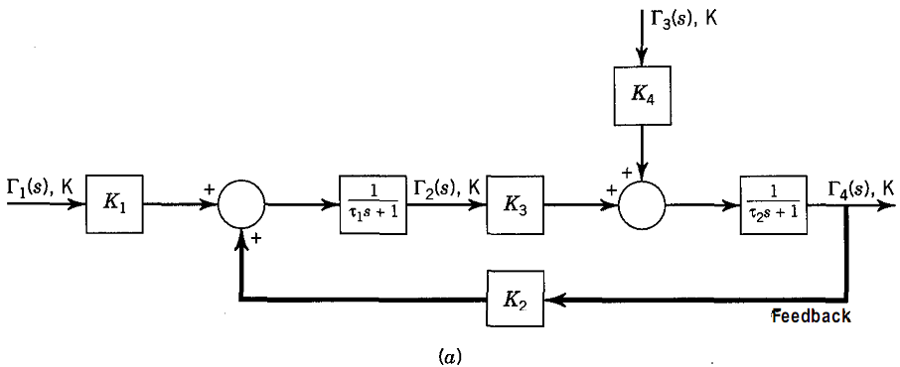
El termino que tiene un derivador, (un termino en el numerador) responde mas rapido que el de abajo.  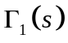: responde mas rapido que 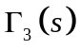, debido al termino derivativo en el numerador. | 